Building ResumeFlow AI 2.0: backend, desktop app and Chrome extension
Oct 27, 2026 · @Tim McCarthy

Overview
ResumeFlow 2.0 is built as three parts from one repo: a local backend and two front ends that both use it. npm run release builds the backend and the desktop installer together; the extension is built on its own.
Part | Build command | What you get
Backend | node scripts/build-sidecar.mjs | backend\dist\resumeflow-backend\resumeflow-backend.exe (a folder, not a single file)
Desktop app | cd desktop; npm run release | desktop\src-tauri\target\release\bundle\nsis\ResumeFlow AI_2.0.0_x64-setup.exe, with the backend inside
Chrome extension | cd desktop; npm run build:extension | extension\workspace\ (the rest of extension\ is plain JavaScript and needs no build)
Both front ends use the backend on http://127.0.0.1:8765 and the data folder %LOCALAPPDATA%\ResumeFlowAI, so they show the same candidates, jobs and applications. Run every command in PowerShell from the resumeflow-ai folder.
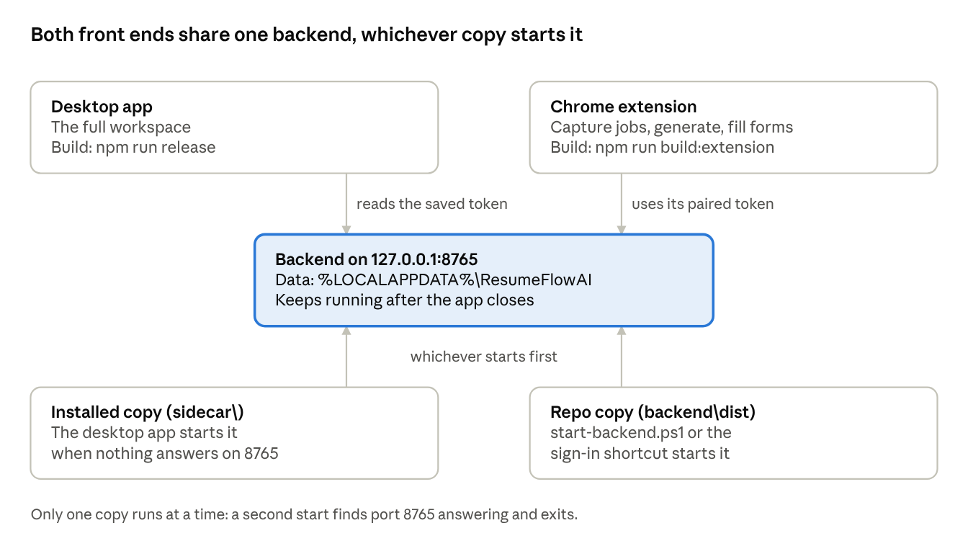
how the parts connect · 2 front ends, 1 backend, 2 backend copies
Each front end talks to the backend on port 8765. The backend that runs is whichever copy started first; Keeping versions in step explains why both copies should be the same build.

One-time setup
Install these once per PC; later builds reuse them.
Tool | Needed for | Notes
Python 3.15 | Backend | Used through the project's own environment, backend\.venv
Node.js with npm | UI, extension page, build scripts | In PowerShell, use npm.cmd if script execution is disabled
Rust 1.90 or newer | Desktop app | The Tauri shell is compiled with Cargo
Visual Studio Build Tools (C++) | Desktop app | Rust needs the Microsoft C++ linker on Windows
Then create the Python environment, with the packaging extras that include PyInstaller, and install the UI packages:
cd backend
py -3.15 -m venv .venv
.venv\Scripts\python -m pip install -e ".[dev,package]"
cd ..\desktop
npm install
Run npm install again whenever desktop\package.json changes, and the pip install line whenever backend\pyproject.toml changes.

Before every build
Stop the running backend first. Since 2.0 it keeps running after the desktop app closes, and Windows will not let the build or the installer replace an exe that is in use.
- Close the desktop app and any extension side panels.
- Stop the backend:
Stop-Process -Name resumeflow-backend -ErrorAction SilentlyContinue
If it was started from the development environment instead, end pythonw.exe running resumeflow in Task Manager.
First 2.0 build: the copy in backend\dist dates from before 2.0 (built 27 Oct 2026, 11:18). It has no pairing and no 2.0 database changes, and start-backend.ps1 and pair.cmd use it whenever it exists. Rebuild it before you use the extension.

Build the backend on its own
One command packs the backend into an exe and tests the packed exe; it stops with an error if either step fails. Use this when you only need the backend, for the extension or for starting at sign-in.
node scripts/build-sidecar.mjs
- Pack: PyInstaller runs backend\packaging\resumeflow-backend.spec and writes backend\dist\resumeflow-backend\ (resumeflow-backend.exe plus _internal\). It is one-folder on purpose: keep the folder together.
- Test the packed exe: it starts on a free port with a throwaway data folder, imports a sample DOCX and PDF resume, matches a job, generates and saves the files, runs a batch job and copies a template style. Success prints [sidecar] smoke test passed: ….
To re-test an existing build without packing again, add --smoke-only. To use a different Python, set RESUMEFLOW_PYTHON to its path first.
Start it (port 8765, no window; a second start just reports that it is already running):
powershell -ExecutionPolicy Bypass -File scripts\backend\start-backend.ps1
Start it at every Windows sign-in (adds a Startup shortcut; -Remove takes it away):
powershell -ExecutionPolicy Bypass -File scripts\backend\install-startup.ps1
Check it: open http://127.0.0.1:8765/health in a browser; it answers with the backend's version. The exe also takes pair (shows a 6-digit pairing code, valid 5 minutes) and show-token (prints the saved token).

Build the desktop app installer
npm run release builds everything the installer needs, the backend included, and writes one setup file.
cd desktop
npm run release
It runs, in order:
- npm run build: type-checks and builds the React UI.
- npm run build:sidecar: packs and tests the backend, as in the previous section.
- Compiles the Tauri shell in release mode and copies backend\dist\resumeflow-backend\ into the app as sidecar\.
- Writes desktop\src-tauri\target\release\bundle\nsis\ResumeFlow AI_2.0.0_x64-setup.exe.
Install: run the setup file. It installs for the current user and needs no admin rights. It isn't code-signed yet, so SmartScreen asks first: choose More info, then Run anyway. To update, stop the backend (see Before every build) and run the new setup file.
What the installed app does each time it opens:
- If a backend already answers on port 8765, the app uses it and reads the saved token from %LOCALAPPDATA%\ResumeFlowAI\api_token. No pairing is needed.
- If nothing answers, it starts its own copy, sidecar\resumeflow-backend.exe in the install folder, with no window.
- Closing the app leaves the backend running, so the extension keeps working.
Development builds (npm run tauri dev) use port 8766 and the repo's .dev-data folder, and node scripts/dev-browser.mjs uses port 8767, so neither touches your real data.

Build the Chrome extension
Only the extension's workspace page (the React screens for candidates, settings and applications) is built; the side panel, options page and page scripts are plain JavaScript.
cd desktop
npm run build:extension
This writes extension\workspace\, which is not kept in git.
First time:
- Open chrome://extensions, turn on Developer mode, click Load unpacked and choose the extension folder. Its ID is always ocfabkpfecphnpllkgbhopleplbogifp; the backend allows only that ID.
- Make sure the backend is running (desktop app open, start-backend.ps1, or the sign-in shortcut).
- Run scripts\backend\pair.cmd and enter the 6-digit code in the extension's Options page (right-click the toolbar icon, then Options) within 5 minutes.
After a rebuild, or any change under extension\: click the reload button on the ResumeFlow card in chrome://extensions. The pairing is kept; pair again only if the extension reports it is not connected.

Keeping versions in step
Rebuild the backend and the desktop app together with npm run release, then install the new setup file. After that, both copies of the backend are the same build.
There are two copies because each start-up path uses its own:
- backend\dist\resumeflow-backend\ is used by start-backend.ps1, the sign-in shortcut and pair.cmd.
- sidecar\ in the installed app is used when the desktop app finds no backend running.
Both use port 8765 and the same database, and whichever starts first serves both front ends. A newer backend upgrades the database when it starts; an older copy started later may then fail to start or misbehave. If you rebuild only the backend, reinstall the desktop app as well.
Version numbers: set the same version in all six places before a release build. The installer's file name comes from tauri.conf.json; /health reports the one in __init__.py.
File | Field | Now
backend\pyproject.toml | version | 2.0.0
backend\resumeflow\__init__.py | __version__ | 2.0.0
desktop\package.json | version | 2.0.0
desktop\src-tauri\tauri.conf.json | version | 2.0.0
desktop\src-tauri\Cargo.toml | version under [package] | 2.0.0
extension\manifest.json | version | 2.0.0
Cargo.lock picks up the new Cargo version on the next build.

Troubleshooting
Most build failures come from a backend that is still running; stop it and build again.
Symptom | Cause | Fix
PyInstaller can't remove or write backend\dist (access denied) | The backend from dist is still running | Stop it (Before every build), then build again
The installer can't replace a file that is in use | The installed app's backend is still running | Stop it, then run the setup file again
[sidecar] smoke test failed: … | A step of the packed-exe test failed; the message names it | Run the backend tests, fix what fails, build again
npm says running scripts is disabled | PowerShell execution policy | Use npm.cmd instead of npm
Rust can't find link.exe | Visual Studio C++ build tools missing | Install them (One-time setup)
The desktop app can't reach the backend | Nothing answers on port 8765, or the token file is missing | Open http://127.0.0.1:8765/health, start the backend, check the logs in %LOCALAPPDATA%\ResumeFlowAI\logs
The extension says it isn't connected | Not paired yet, or the saved token changed | Run pair.cmd and enter the new code
/health shows an older version | An older backend copy started first | Stop it and start the new build (Keeping versions in step)

Quick reference
Task | Command
Stop the backend | Stop-Process -Name resumeflow-backend -ErrorAction SilentlyContinue
Build and test the backend | node scripts/build-sidecar.mjs
Re-test the backend build | node scripts/build-sidecar.mjs --smoke-only
Build the desktop installer (backend included) | cd desktop; npm run release
Build the extension's workspace page | cd desktop; npm run build:extension
Start the backend | powershell -ExecutionPolicy Bypass -File scripts\backend\start-backend.ps1
Start it at sign-in / stop doing so | powershell -ExecutionPolicy Bypass -File scripts\backend\install-startup.ps1 (add -Remove to undo)
Pair the extension | scripts\backend\pair.cmd
Backend tests | cd backend; .venv\Scripts\python -m pytest
Frontend tests and type-check | cd desktop; npm test; npm run typecheck

