Designer Test Plan

Pramari, LLC
Designer Test Plan
September 9th, 2008

State diagram test plans:

1. Creating a new layout
Preconditions:
1. Program is open.
Steps:
1. File > New
2. Choose a new layout and give a name for it.
3. Click "Finish".
Postconditions:
1. A new layout with the selected floorplan should be opened.
2. Loading an existing layout
Preconditions:
1. Program is open
2. Existing layouts exist to be opened
Steps:
1. File > Manage Layouts
2. Select the layout you want from previously saved layouts
3. Click "Finish"
Postconditions:
1. New layout should open, and it should look the same as when it was last saved.
3. Play / Pause / Stop state machine test
Preconditions:
1. Program is open.
2. Layout is loaded.
3. Program is started in the default "pause" position.
Steps:
1. Press "play". The "play" button should gray out, and the "pause" and "stop" buttons should be clickable.
2. Press "pause". The "pause" button should gray out, and the "play" and "stop" buttons should be clickable.
3. Press "stop". The "pause" and "stop" buttons should gray out, and the "play" button should become clickable.
4. Press "play". The "play" button should gray out, and the "pause" and "stop" buttons should be clickable.
5. Press "stop". The "pause" and "stop" buttons should gray out, and the "play" button should become clickable.
Postconditions:
The program should be in the stopped state, with the "stop" button grayed out and the other buttons clickable.
4. Create this layout in designer:

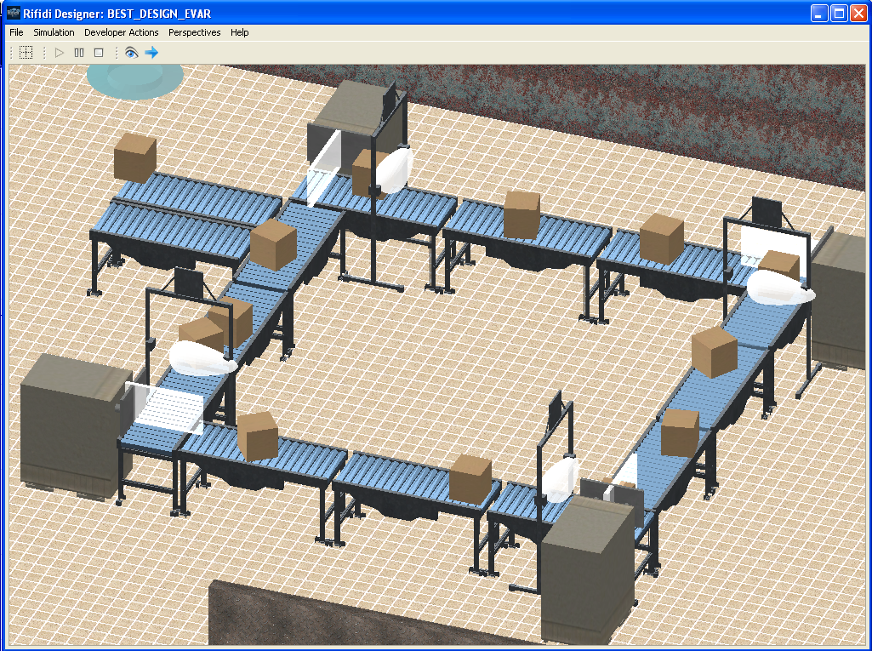
This setup will create a system where boxes are continuously fed into a closed loop. When turned on, it will stress the system and expose the points of failure.
In order to work, the following must function correctly:
1. Conveyors
2. Push arm/Gate combinations
3. Box producers
Specific Object Properties Checklist:
Each thing to be checked should include test in each of the play/pause/stop states, and while the object itself is on or off.
1. Conveyor
a. Adjust speed.
b. Adjust name.
2. Gate
a. Adjust name
3. Box producer
a. Adjust speed
b. Adjust name
4. Push arm
a. Adjust speed
b. Adjust name
5. Infrared
a. Adjust name

