Extraction of Go-Board Position using Morphological Image Processing

Matthew Roseman
EECS 490 Midterm, Professor: Frank Merat

Abstract:
This paper outlines the morphological and various other image processing methods used in order to detect the pieces and their location on the board for the board game go. While many methods of detecting a go game position attempt to find the underlying grid, this method finds the rough size and angle of the board, the coordinates of the pieces on the board, and finally extrapolates the underlying grid from this data.
Introduction:
There have been many different methods used in the past. Some use Hough transform to find the underlying board [1][2][3], while others use feature detection algorithms such as SIFT [4]. Detecting the underlying grid of a go board using Hough transform falls apart as the board fills up and less and less of the grid is visible. This method would work for a go game tracking program, meaning the empty board is detected, and as the game progresses, each new piece is detected on top of that board; However, this requires that the board and camera are at a fixed position, so that the initial grid detection remains true. Using SIFT or other feature detection algorithms to find features of the go board and then later detect the board when covered in pieces potentially suffers from additional issues as the Hough transform method does. Also feature detection and object recognition training is a computationally expensive process, and these features may not be found on all boards of different materials and design.
The method discussed in this paper involves a two step process starting with a Hough transform in order to detect the rough angle and size of the go-board within the image. After the rough position of the board is detected, the rest of the image can be removed in order to remove noise that could be detected as game-pieces. The second step is to threshold the image into two black and white images. One of these thresholds the black pieces and the other thresholds the white pieces, although similar processes are performed on both. With these binary images I perform morphological image processing functions in order to remove any noise and further isolate each piece. By the end I have an accurate coordinate for the center of every piece. Finally with the coordinates of the pieces and the rough initial board angle/size, I can extrapolate the underlying grid, and determine the position of all the pieces.
Methods Used:
While this method also uses a Hough transform, it is used only for detecting the game board, and the edges of the game board should never be covered even with a full board. This means that it is much more independent to the current game position, and should work just as well on an empty board as on a full board. Also the resolution of the Hough transform can be lowered since extreme accuracy is not of highest importance. This involves using a smaller number of theta and rho bins, which results in less accuracy, but a faster computation time. Below (Fig. 1) is an image of a Hough transform performed on an image of a go-board. First I find the two angles that have the most peaks (I count peaks found 90 degrees apart to both count for the same board angle, since I know it is a square board). After finding the board angle I find the maximum and minimum peaks.
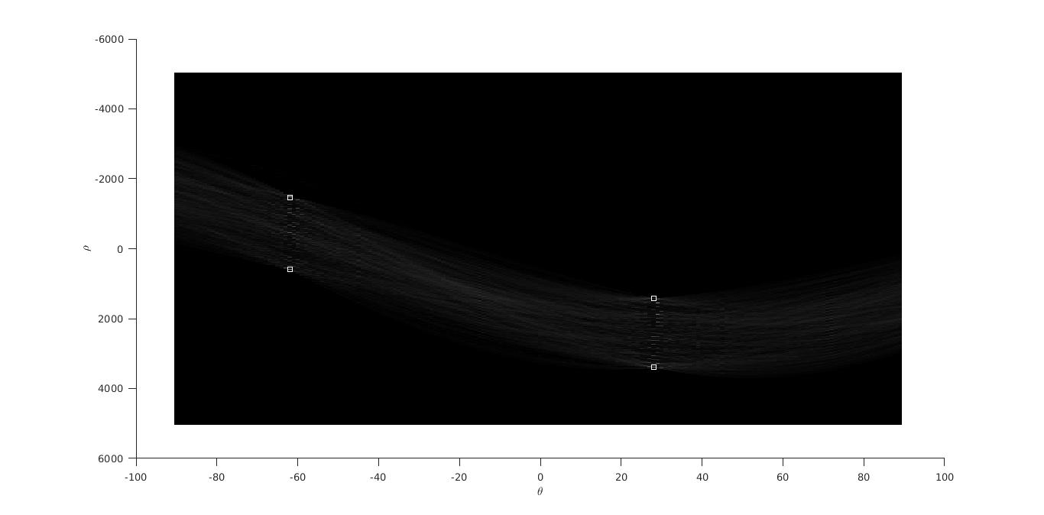
Figure 1. Hough Transform performed on a go-board. There are four markers indicating the peaks that are used to determine the boards angle and size.
Using these peaks, I can construct a rough square around the go board (Fig. 2), and ignore anything outside this square.
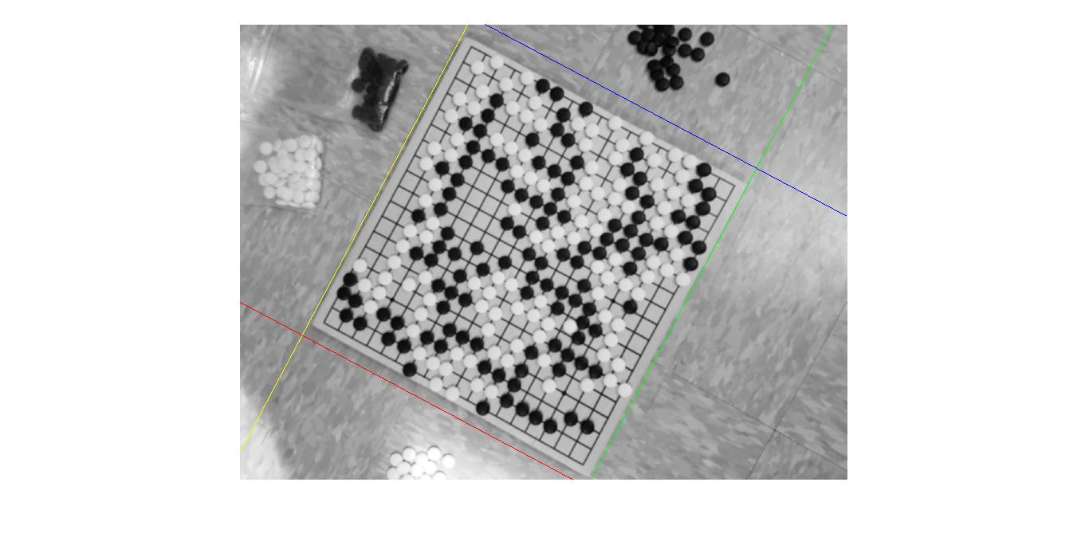
Figure 2. This image shows the go board image with four lines surrounding it. These lines correspond to the four peaks in Fig. 1.
Now that I know the rough board angle, I can rotate the image to make the board straight (Fig. 3). This makes the later process of guessing the grid easier. Also I invert the image (Fig. 4) so that I can use the same methods to find the white and black pieces. These black and white images are actually just the grayscale representation of the blue pixel values. This is to help differentiate the white pieces from the background board.
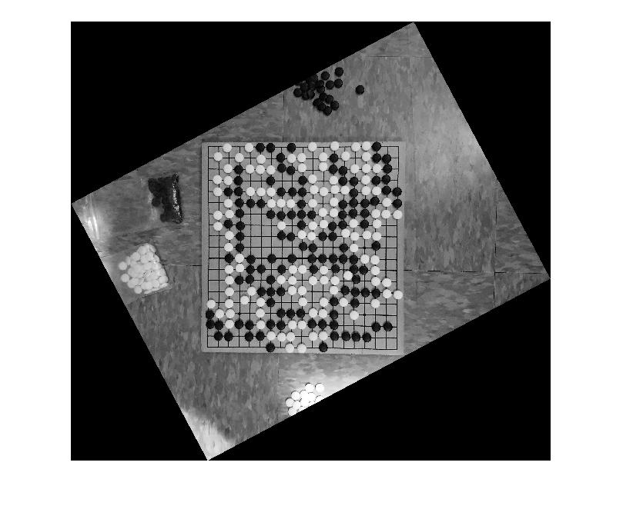
Figure 3. The original image converted to grayscale from it’s blue pixel values and rotated by the calculated board angle.
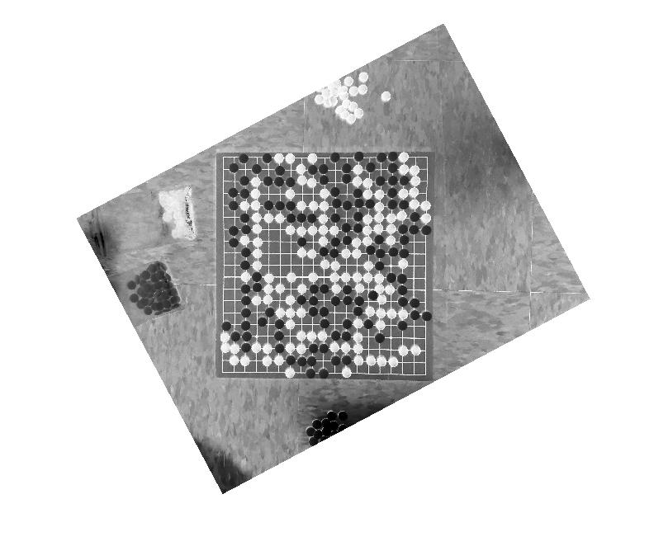
Figure 4. This is just Fig. 3 but with inverted values.
Now these two images need to be thresholded and converted to binary images (Fig. 5,6).

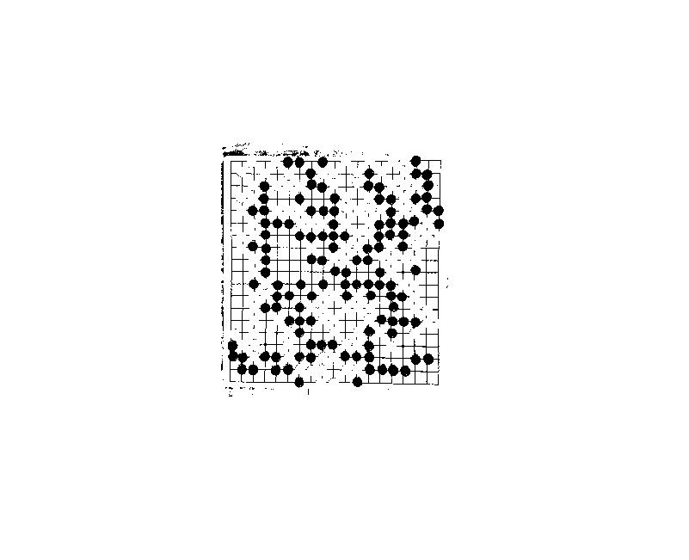
Figure 4. The board thresholded. The black pieces shown represent the black pieces in the original picture.
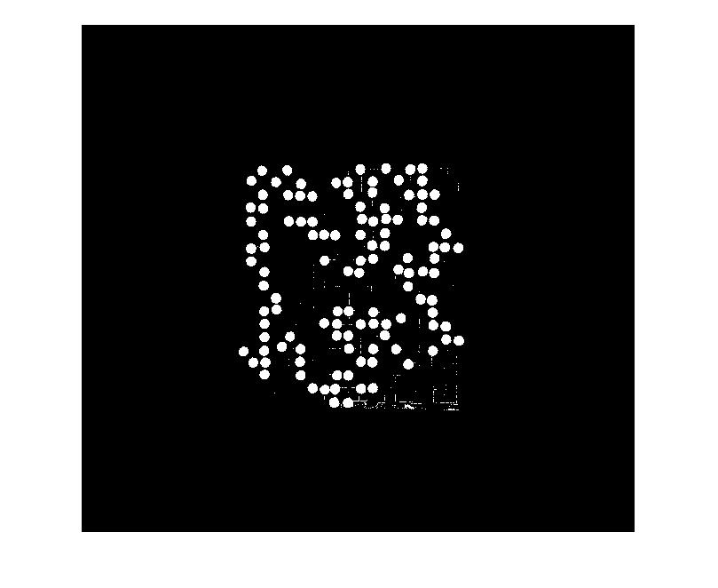
Figure 5. The board thresholded. The white pieces show represent the white pieces in the original picture.
Now I start to use morphological image processing to remove the noise in these images and leave only the pieces. The first step is to remove the small groups of pixels left over from thesholding. In Fig. 4 they are primarily lines from the grid lines found on the board. In Fig. 5 they are parts of the light board that are light enough that they weren't thresholded. To do this I use Matlabs imopen() function with a disk structuring element of 16 radius. This performs an erosion followed by a dilation with the same structuring element, so that anything not eroded away initially is dilated back to its original state. The radius of the disk determines how small the regions that are removed will be. Because the pieces have a radius larger than 16 they remain, but the general noise surrounding them is completely removed.
Next I perform just an erosion. The purpose of this is to ensure that all the pieces are separated. Later on I need to find data about each region, and if two piece regions are connected, then my algorithm will consider them one piece. I also use a disk structuring element here with a radius of 25.
Finally I do another erosion, but this time the structuring element is a 1x100 rectangle and a 100x1 rectangle. These remove everything except for the pixels that surround the board, but weren’t cut off by the rough crop I performed first. Then I subtract this from the image before this erosion (tophat method) and am left with an image with the black border removed. Fig. 6 shows a good example of the types of pixels I hope to remove.
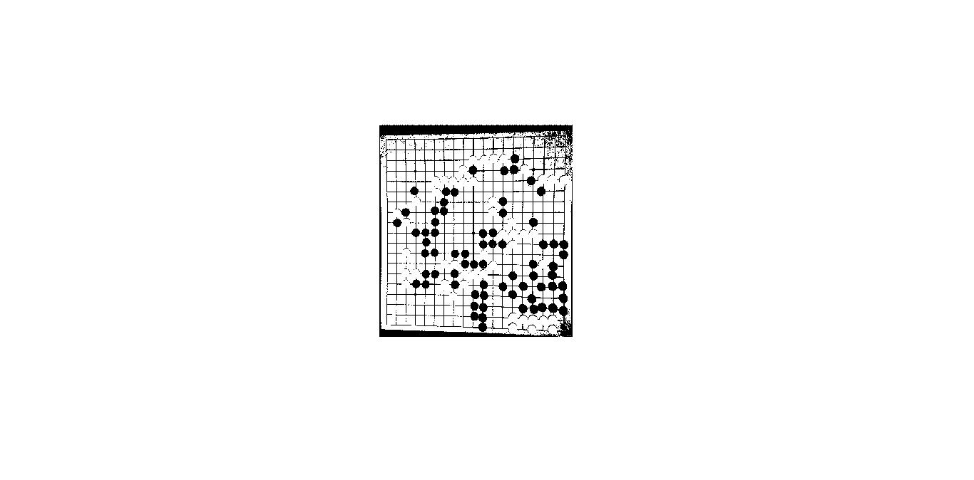
Figure 6. A different board than the previous figures. This shows the black pixels that show up beyond the go-board but before the rough square mask.
This erosion serves a dual purpose. If the previous erosion, which was used to disconnect any touching pieces, still left some pieces connected, then this top hat operation should remove those connections. Because the length of the rectangles are longer than the diameter of a single piece but shorter than 2*diameter, or the width of 2 connected pieces, a section will be cut out of these combined pieces. This erosion actually disconnects the pieces, and since I don’t need perfect circles, doesn’t harm the later calculation of the pieces centers.
At this point I now have something resembling Fig. 7,8. I then use Matlabs regionprops() function to find the radius and centers of each region.
Because of the chance that smaller or larger regions didn’t get removed due to image processing, I also find the mode radius of the regions plus or minus a range accuracy threshold. Then I ignore any regions that don’t fall within this mode range.

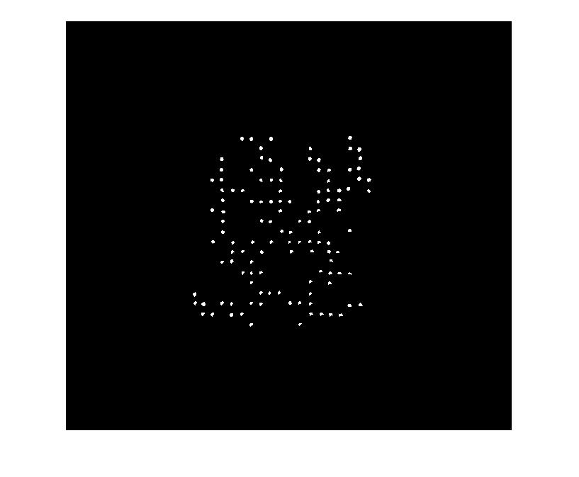
Figure 7. The result of morphological image processing on the black pieces.
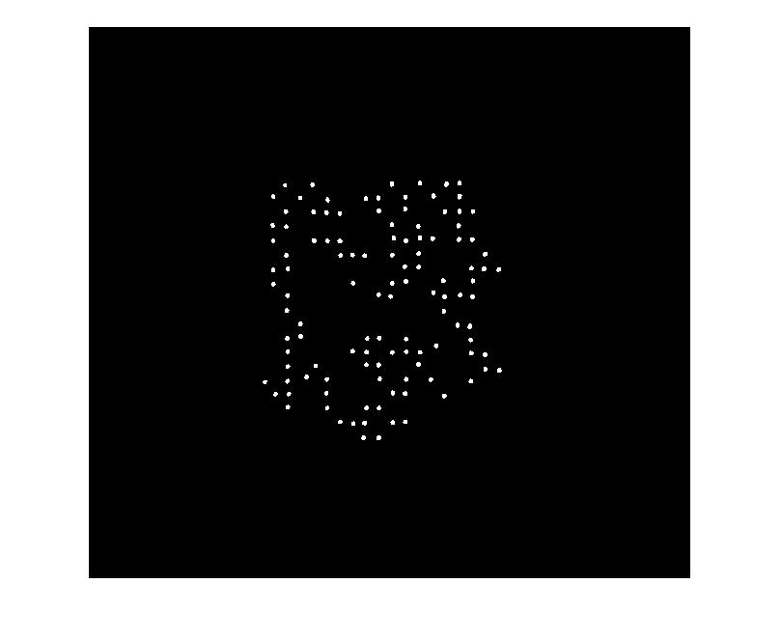
Figure 8. The result of morphological image processing on the white pieces.
Finally in order to find the grid that these pieces lay on top of I find the leftmost, topmost, bottommost, and rightmost centers. Using this information I find the corners of the grid. Note if no pieces lie on one or more of the outermost edges of the grid, I will end up with a grid smaller than 19x19. However, this means the grid lines aren’t obscured and I can use the Hough transform computed earlier to easily find in which direction the grid completes. With the row and column values for the grid lines and the coordinates of the pieces I produce an image like Fig. 9.

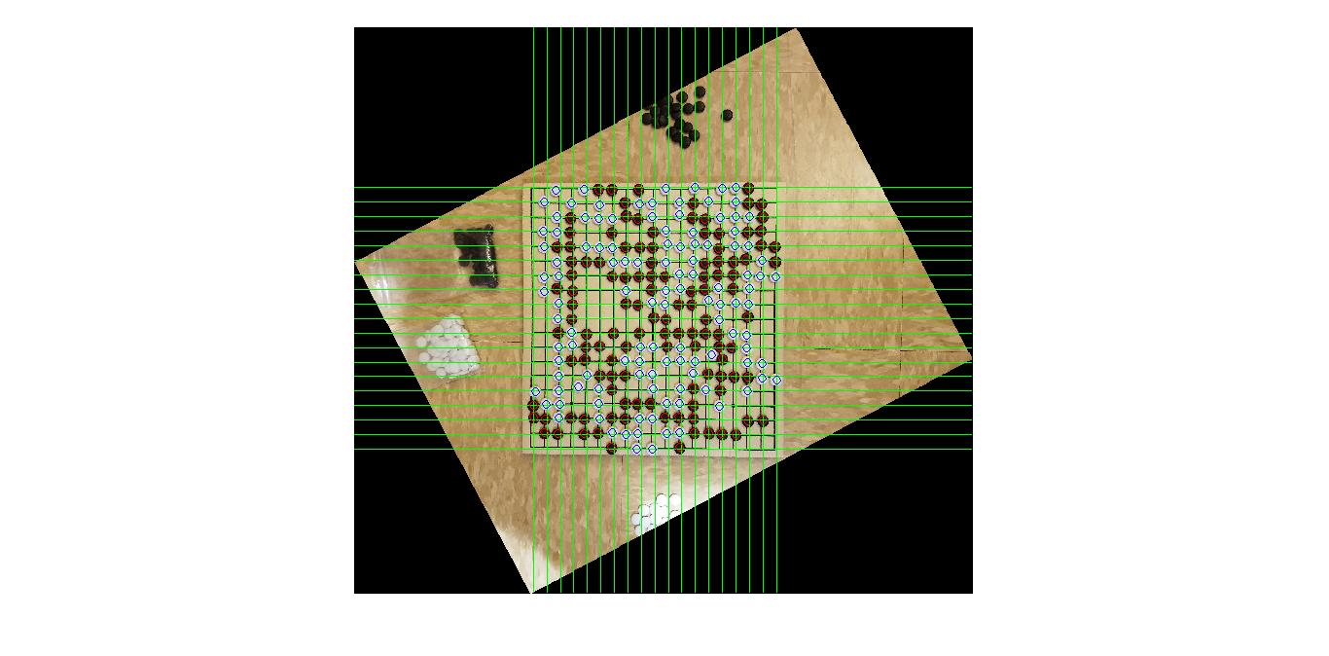
Figure 9. The final result. There are red circles indicating black stones, blue circles indicating white stones, and green lines indicating the calculated grid lines.
Discussion of Results:
This method was designed to fix the problems a majority of go-board extraction algorithm face. Namely detecting the board and the grid lines on that board. The principal way of solving this is by not doing that at all. While Hough is used, it is used simply to get a rough estimate of board angle and size. However, because this method chooses to rely on the pieces instead of the grid it suffers from the opposite problem. Instead of suffering when the board is full, it suffers when the board is sparse. An easy way to solve this dilemma is to combine the two methods. After detecting the number of pieces, if the board is scarce, you know the grid lines are mainly visible and a Hough transform will work well. On the other hand if the board is full, then predicting the grid using just the pieces will work better.
The code I am using assumes that the picture is taken at a top down angle, but presumably the same principles that other methods use for more acute angle images, specifically in regards to dealing with the vanishing point of the grid lines, can apply to the calculation of the board edges.
Perhaps the greatest weakness to this method is lighting differences. When thresholding the image to binary, variable lighting on the board can cause uneven conversion. For example if the lighting is too bright in one corner, the white pieces not in that corner may convert to binary smoothly, but the board in the lighter corner could also be converted causing issues.
As long as there are no game pieces directly next to the board, such that they are outside the buffer zone indicated in Fig. 2, this algorithm is consistent in finding pieces. As mentioned previously, even with grid columns and rows missing pieces, generating the grid from the pieces is a simple and pretty accurate process. In order to extract the game into a digital format, one would just need to find the nearest grid point, green lines in Fig. 9.

asdf

