**Lab 1 (Due 9/7)**

Complete part a.

File Name: CIS-17B_Lab_2_LastName_FirstName.zip

**Homework 1 (Due 9/14)**

Complete parts b, c, d, e, f, and g.

File Name: CIS-17B_Homework_1_LastName_FirstName.zip

**Figure 2.6. The Company Chart**

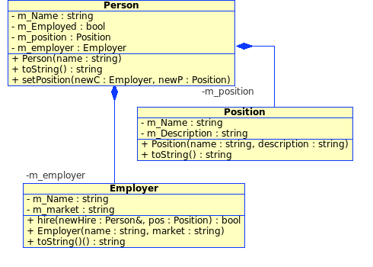

a. Write classes for Person, Position, and Employer as described in the UML.

b. For Person::getPosition() and getEmployer(), create and return something funny if the person has not yet been hired by a company.

c. For the hire(...) function, set the Person's state so that future calls to getPosition() and getEmployer() give the correct result.

d. In the main() program, create at least two Employers, the "StarFleet Federation" and the "Borg."

e. Create at least two employees, Jean-Luc Picard and Wesley Crusher.

f. For each class, write a toString() function that gives you a string representation of the object.

g. Write a main program that creates some objects and then prints out each company's list of employees.