Visual Studio 2015 was used for this entire project. The templates are listed in each synopsis of the assignment problems.

Number 1 and 2 screen shot this shows the 3 different cases of a number being too big, to small, or correct. It shows the local host with the static ip address and the projects all in one solution. The templates are the WCF service application and Windows form as per the assignment instructions.

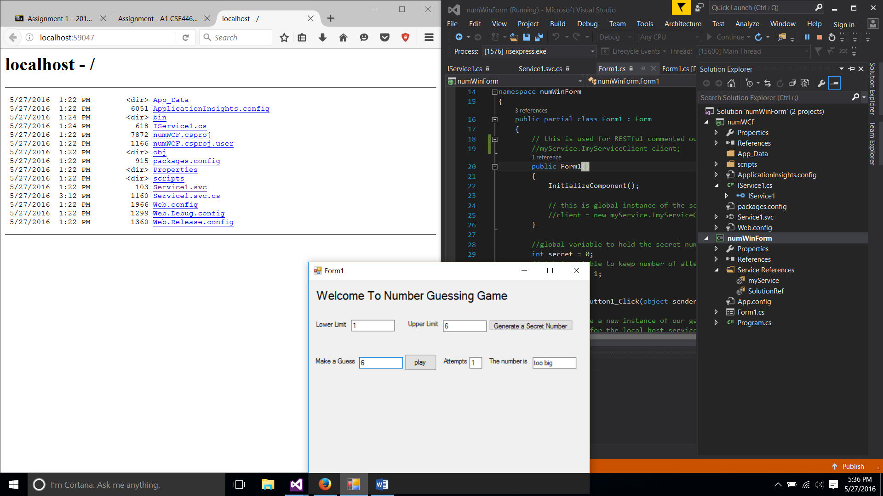

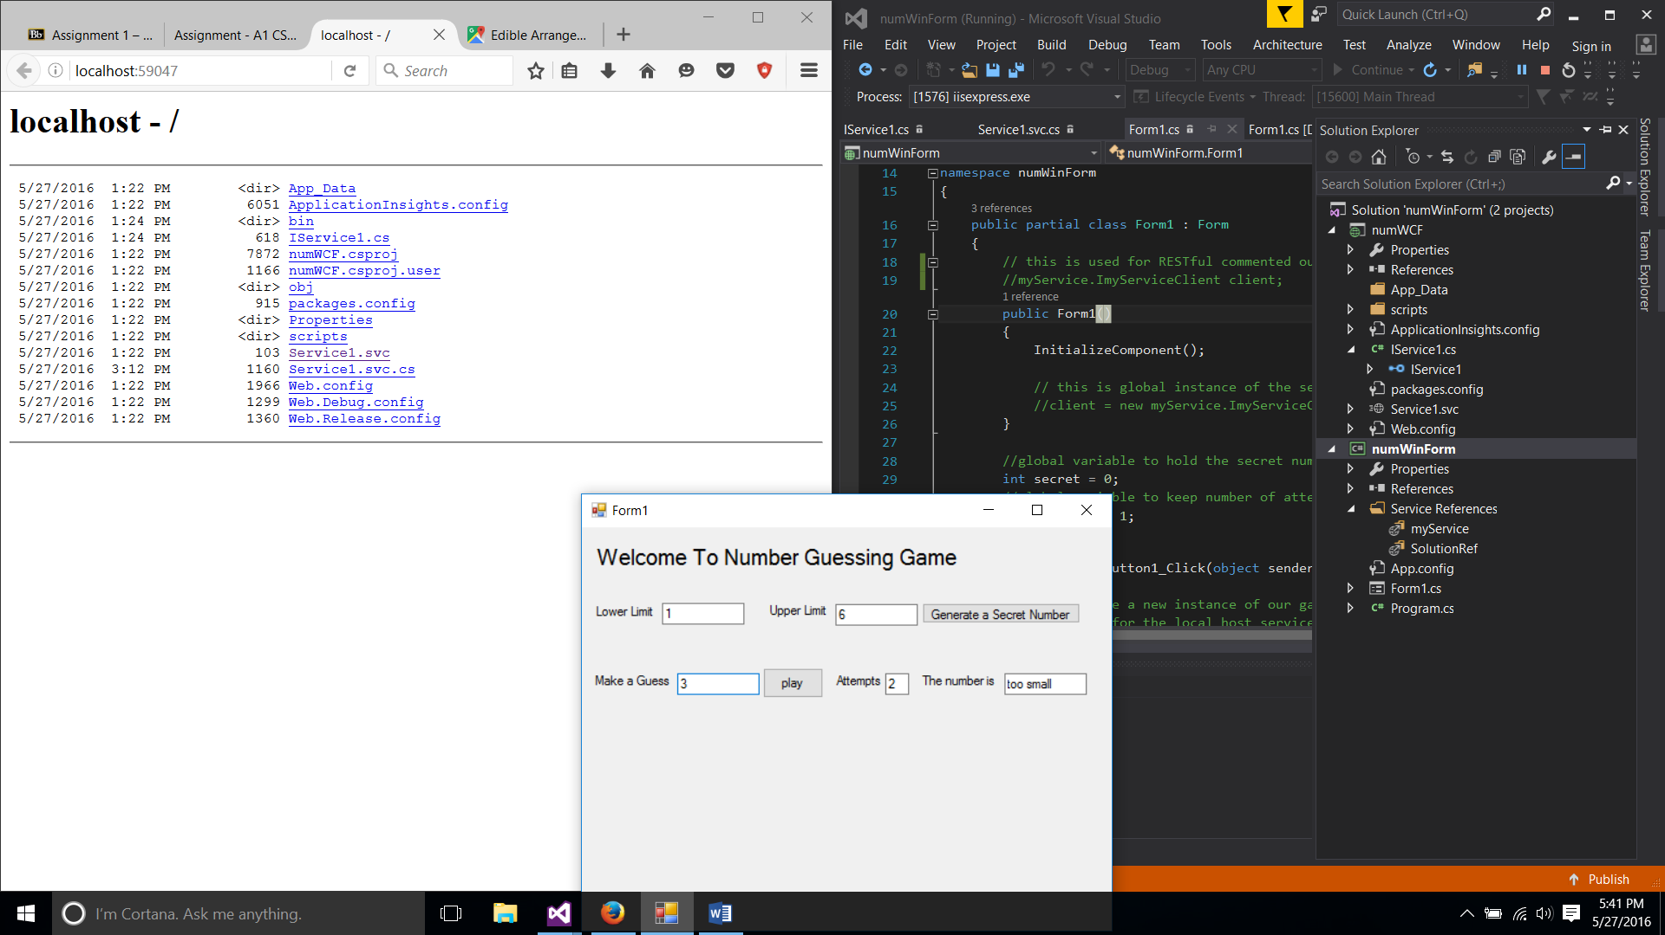

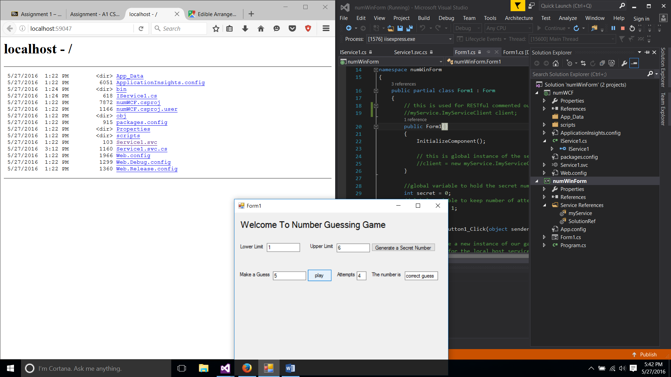

Number 3 and 4

As seen in the comments I split this into 3 projects because it is easier to read and if debugging needed to be done it is a lot easier when the code is divided. VERY IMPORTANT THIS NEEDS TO BE RAN AS AN ADMINISTRATOR IN ORDER TO RUN! These are all console applications. The host application is the service that creates the self-hosting environment and needs to be running in order to start the self-hosting service. The myservice application contains the NumberGuess class and the callMyService application is used to consume the service. To ensure this works properly you must first create the instance of the host and that will open the self-hosting environment and then the run the callMyService application which will open up a console application and implements the NumberGuess class. The screen shot depicts the two console windows, the one on the right is the self-hosting application which lets you know the host is open and the one on the left is the application that consumes it and implements the NumberGuess application. It shows all the different outputs of each guess and when the correct guess is made.

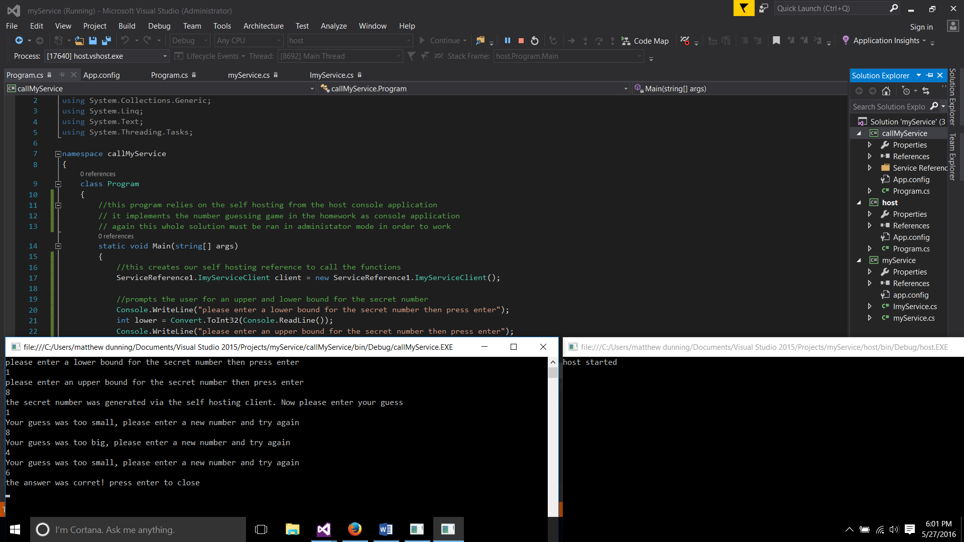

Number 5 and 6 implement the RESTful service (WCF service application) of the NumberGuess game consumed by a ASP.NET web application. For this the WCF service should be ran first . After you create an instance of that create an instance of the web application. You will have two pages opened up in the browser now. You can check for yourself by manually inputting the subdirectories to test each RESTful call to see that they work, but the web application will do that for you. The screen shots depict the three instances of the NumberGuess class either too big, too small, or correct.

