Matthew Kirt-Dunning

CSE 446 assignment 2

Banking User Manual

1. The workflow web service that I created prompts the user to enter his user name and password (user name: matt password: password) which then uses a code activity that verifies that the users credentials are correct. If the user enters the correct password it uses another code activity that randomly generates an account balance. Once the user sees his account balance they have the choice to deposit more money into their account. They are then prompted to send an encrypted message to the bank and place any query they please. ( this application does not send a message to anyone just displays that it does) It then asks the user if he or she wants to see the encrypted message and then displays the encrypted message and what the decrypted message is to the screen just so the user knows that the message was properly encrypted.
2. The interface is a console application that prompts the user for all of their information and walks them through the application flow. The program interface contains data contract information that allows the user to access the methods in the workflow from a local host that can update their account balance if they decide too. This program also contains the asu encrypt and decrypt service which is used to encrypt and decrypt the message that the person wants to send to the bank.
3. UML class diagram

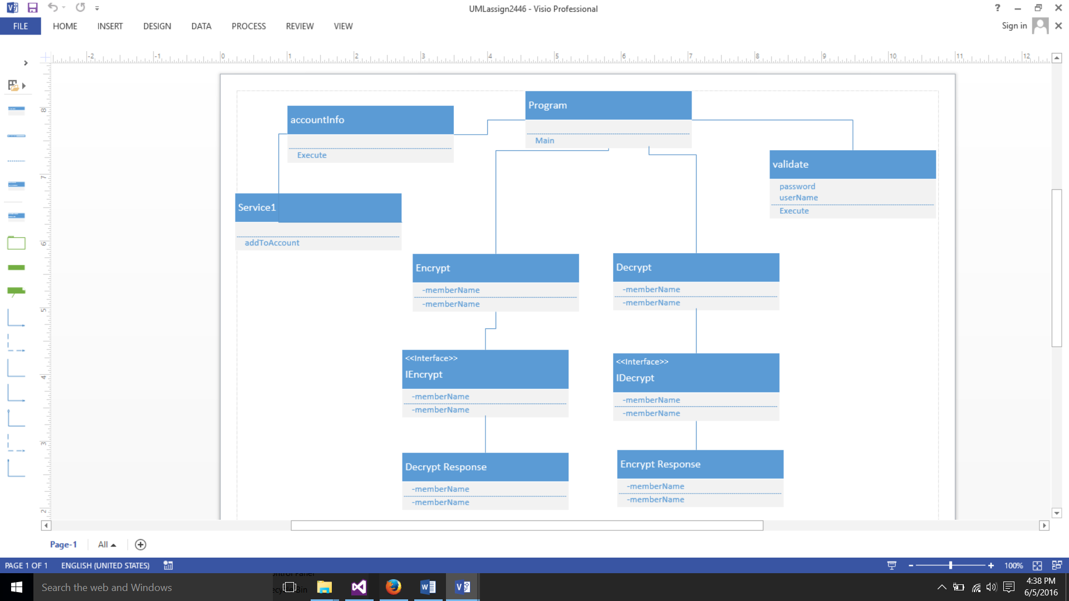

1. Screen shots

