Correct file path and existing name entered return results for the search function.

(the file path is located in the wcf directory)

Please read comments in wcf service for full information on how to operate the program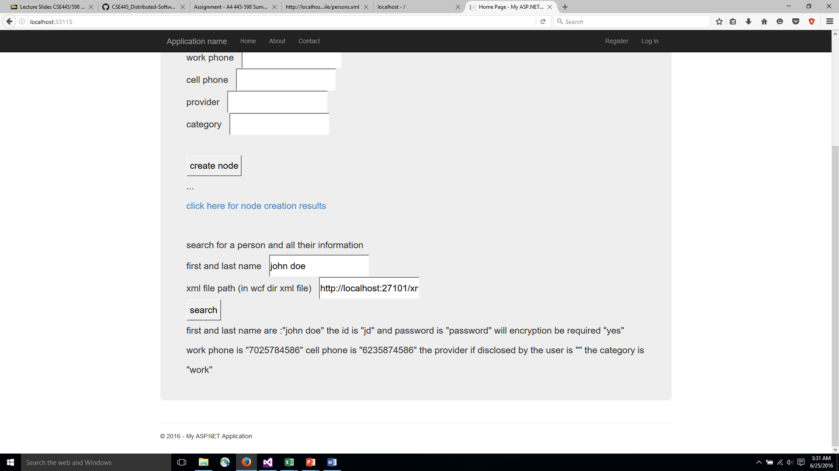

No such name in the xml file but a proper file location

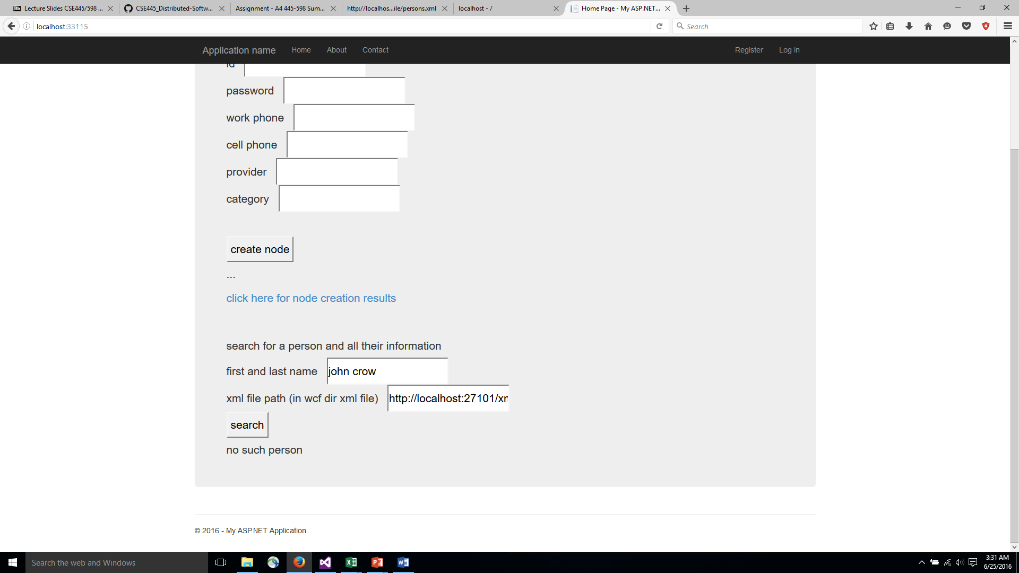

Proper name but a bad xml file location

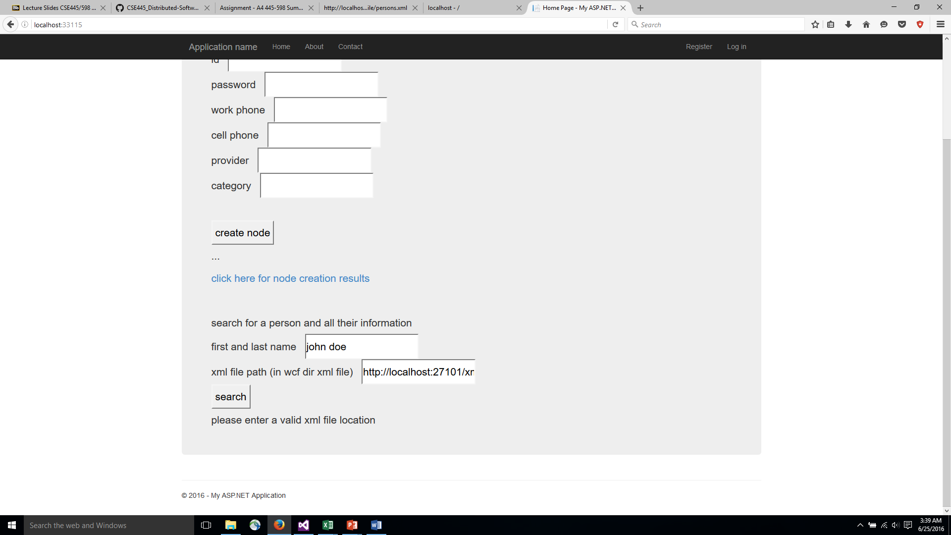

Creating a new node in the xml document for a person

The xml file location is in the wcf dir please see the code comments for more information on how to use

Entering all the information and pressing create node

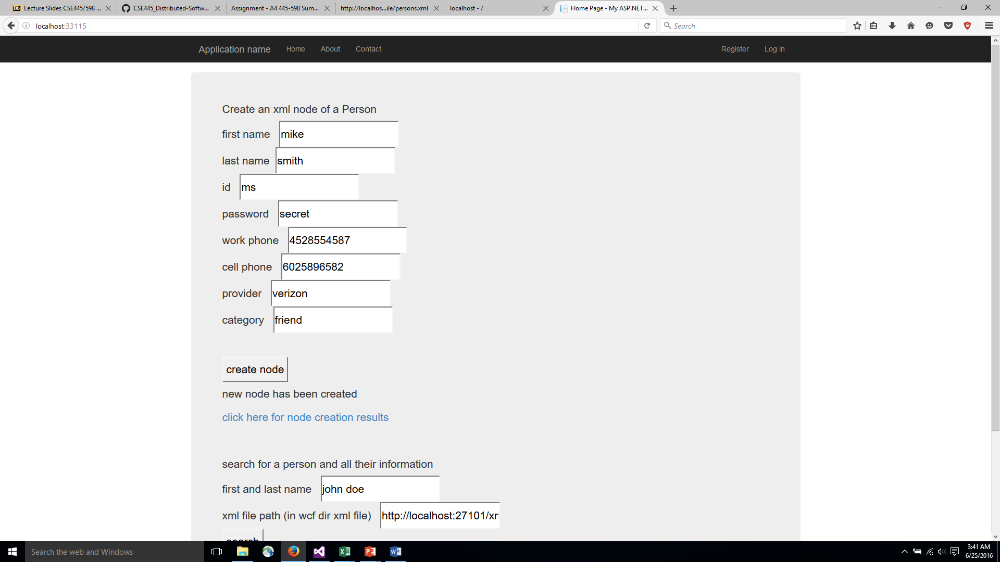

Clicking on the hyperlink to view the results

If the page was already displayed from the wcf client you will have to press refresh in order to see the appended results

