[**Position analysis**](http://www.ooeasy.com/archives/5622)

Contrast with the foreigner's article and my own drawings, some analysis.

[original.](https://hedgopia.com/cot-peek-into-future-through-futures-how-hedge-funds-are-positioned-95/)

1, oil, but also rise. Net long positions continued to increase.

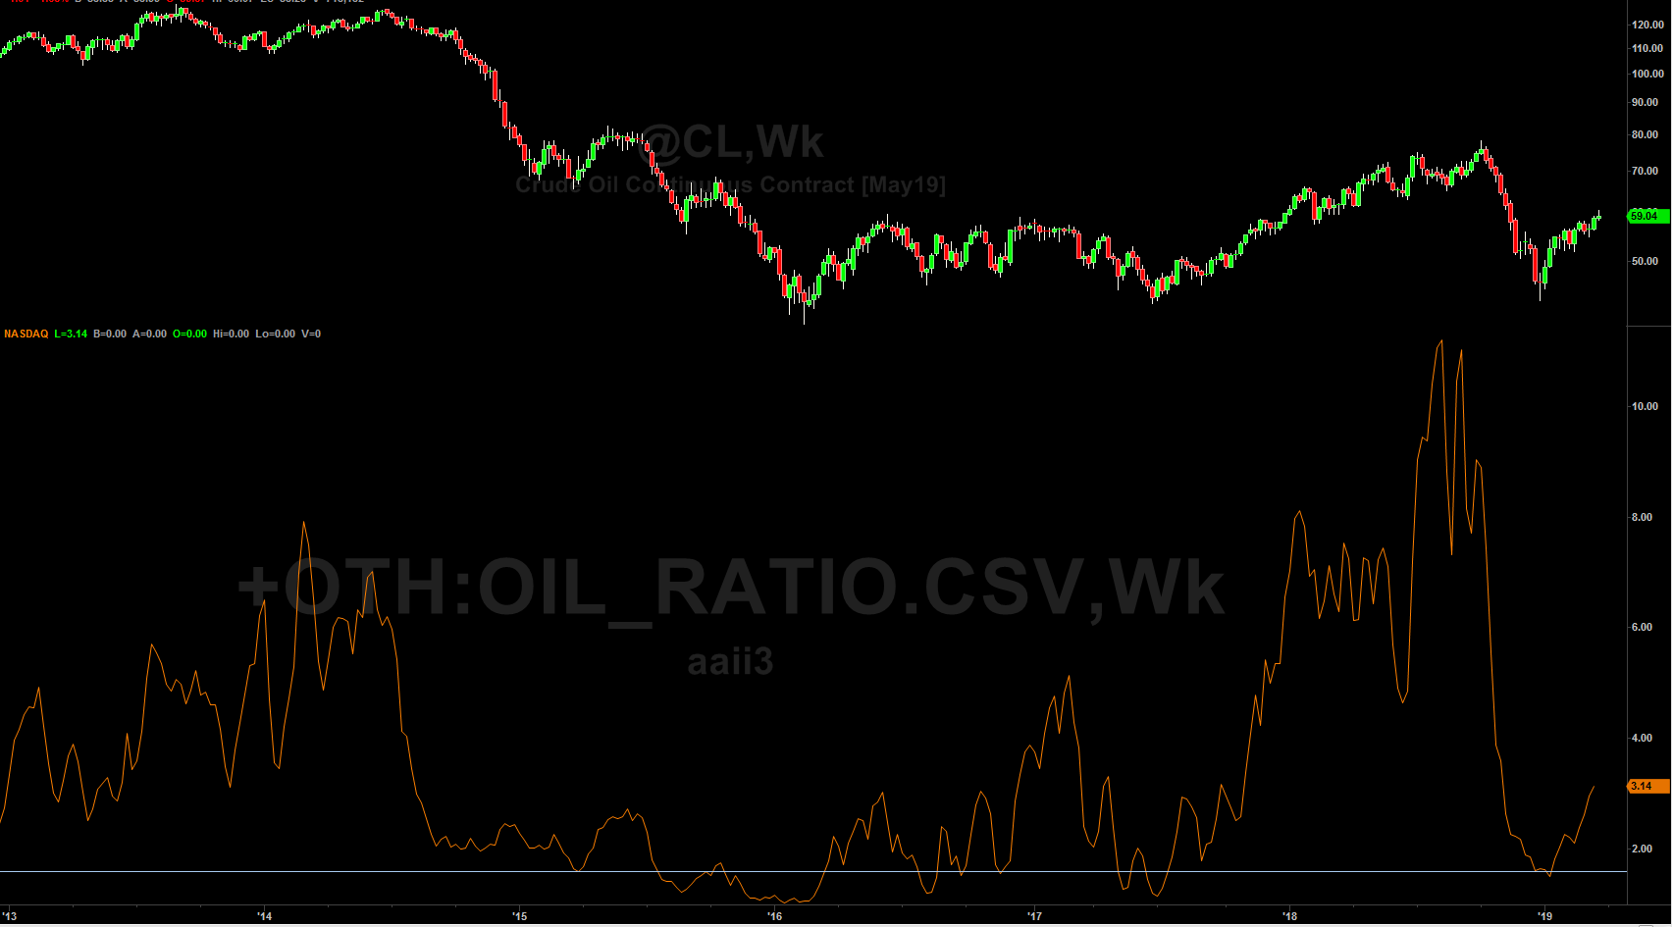

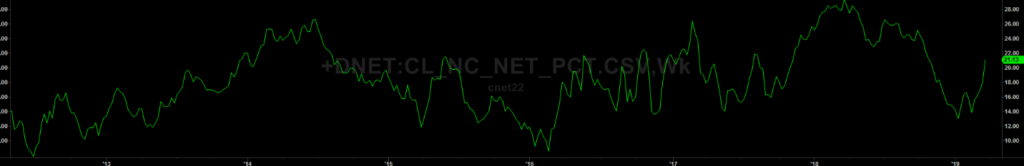

Oil position analysis, weekly level. Continue to be bullish.

2. ES, continue to be bullish.

Net long increased significantly.

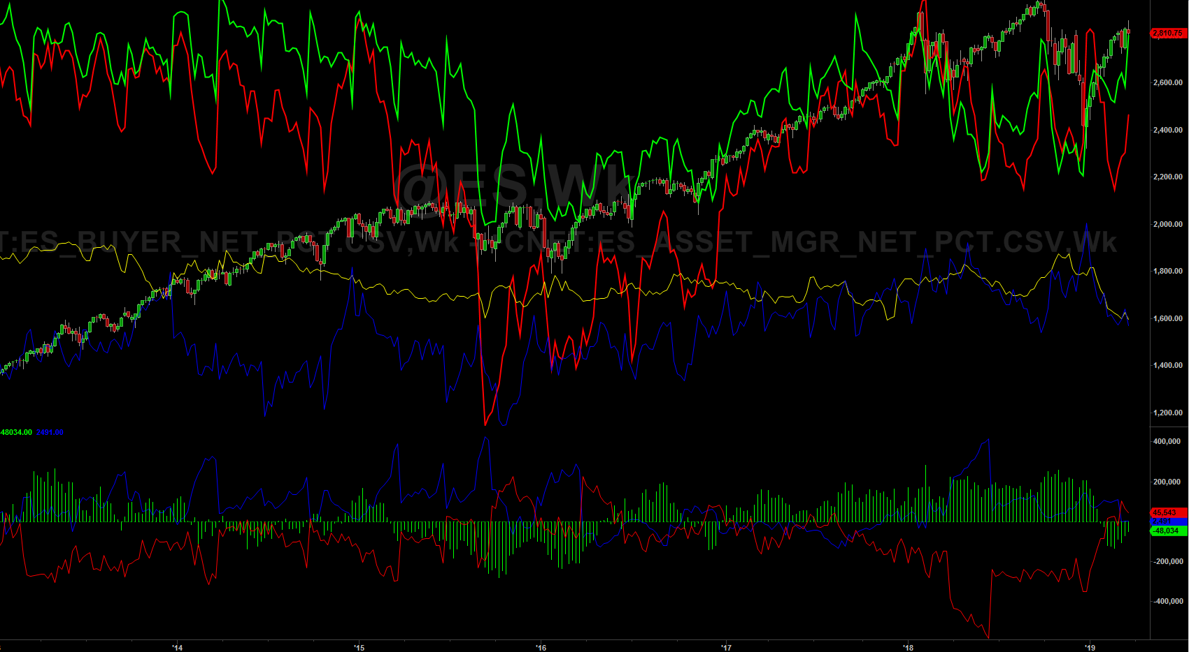

3. VX net long positions continued to decline. Good market. It's dangerous if we consolidate for a while in the oversold area.

posted on[March 24, 2019](http://www.ooeasy.com/archives/5622)Classification[knowledge and skills](http://www.ooeasy.com/archives/category/%e7%9f%a5%e8%af%86)label[CBOT](http://www.ooeasy.com/archives/tag/cbot)[in position analysis Leave a Comment](http://www.ooeasy.com/archives/5622#respond)

[**How to Trade Using Commitment of Traders Data | Emini Note**](http://www.ooeasy.com/archives/5146)

cftc data is built into tradestation. There are indicators for downloading some tradestations on the webpage, and I will study them later. ; 5 points mentioned above

1. Use SP data instead of E-MINI data, because E-MINI has become a battlefield for intraday trading. Okay, I paint both. After watching for a period of time, you can choose which report to keep.

2. Use an indicator to judge overbought and oversold. (I use RSI to see, or CCI to see) Time is limited, first engage in MACD, RSI, then CCI, stochRSI

3. Market crash signal: reached 52 week high, and then professional investors switched from long to short.

3.1 The bulk is net long, and at the same time the stock market reaches a new 52-week high; commercials change from net long to net short. If the market falls from a maximum of 10% in the future, then it is confirmed. #Big crash in all markets, there are professionals short.

4. Track other markets, such as oil and bonds.

5. If there is a large amount of capital, exchange the currency into other currencies once or twice a year. (There is a big change in the foreign exchange rate)

posted on[November 14, 2018](http://www.ooeasy.com/archives/5146)Classification[knowledge and skills](http://www.ooeasy.com/archives/category/%e7%9f%a5%e8%af%86)label[CBOT](http://www.ooeasy.com/archives/tag/cbot) , [the CFTC](http://www.ooeasy.com/archives/tag/cftc)[on How to Trade Using Commitment of Traders Data | Emini notes Leave a comment](http://www.ooeasy.com/archives/5146#respond)

[**CFTC basic knowledge, skills and ideas**](http://www.ooeasy.com/archives/5142)

http://graphics.thomsonreuters.com/11/02/cftc.htmlHere is a website where you can see the data drawing of cftc. He has put together several large-scale paintings of the same category. Draw a bar chart, useful.

<https://freecotdata.com/how-to-use/>

The graph drawn on this website has been adjusted for interest in positions.

I think this approach may be more objective. Not only the percentage of positions, but also the effects of extreme values.

Drawing is mainly to meet the following two needs

1.To measure the ratio of the current position to the interest in the position

Solution: Use net long positions / position interest.

Most futures do not need to be adjusted by open interest, but some relatively large changes are needed, such as vix, CL.

2. It depends on the distance between the current position and the historical limit position.

Solution: After meeting the first requirement, compare the limit values ​​within 5 years.

3. My excel uses future data (the author uses data of comprehensive options), and I think that only futures data may be more advanced.

Make the following pictures whenever you have time, and compare them.

4. The author draws the following two types of data for commodities, without considering swap:

1 producer & user: (use its algorithm to exclude swap data)

2 speculators

I have implemented his method in excel.

Judging from the results of the study, large-value hedgers are most successful on the one hand in anticipating market turning points.

cftc sometimes delayed release of data

[**\* Delayed release date due to a Federal holiday.**](http://www.cftc.gov/marketreports/commitmentsoftraders/releaseschedule/index.htm)

Generally, before the fourth witch day of each quarter, spreads positions will increase sharply, and they may go up or down. We will see if there is more information for judging the ups and downs in the future.

**doubt:**

1. How is the SPREADS in CFTC traded?

This is relatively hidden, so if it is a brokerage company, if someone is long and others are short, will it be counted as spreads (should not be, it is the same trader), so that we can study the specific spreads later.

extract:

The sudden increase in spreads, I understand as arbitrage in different months.

1: Positions. The data are the positions in each category. Long indicates long positions, short indicates short positions, and Spreading indicates unilateral positions of traders who hold both long and short positions of the same symbol. They are regarded as arbitrage orders. . Note that Long and Short do not contain Spreading. For example: A swap trader A buys 500 lots of wheat in the market and sells 700 lots of wheat contracts in other months. If there is only one dealer in the market, the Swap Dealer column in the CFTC report should be Long: 0; Short: 200; spreading: 500.

Source: <http://futures.hexun.com/2012-03-22/139622021.html>

The CFTC released Tuesday's data.

<http://www.cftc.gov/MarketReports/CommitmentsofTraders/index.htm>

Barchart provides three types of reports. The pictures don't look good.

[Commitments of Traders Report](http://www.barchart.com/futures/cot.php#1)  
[Commitments of Traders Disaggregated Report](http://www.barchart.com/futures/cot.php#2)  
[Commitments of Traders Financial Traders (TTF) Report](http://www.barchart.com/futures/cot.php#3)

**Commitments of Traders Report (this traditional report still fails to clarify the motivation behind all transactions)**

There are three types of information (including options positions):

    Commercials, consisting of Producer / Merchant / Processor / User and Swap Dealers (Red Line), they should be from hedging destinations.

    Non-Commercials or Large Speculators (non-commercial), consisting of Managed Money (Managed Funds, Asset Management Institutions) and Other Reportables (Green Line)

    Small Speculators (Blue Line)

[Non-commercial long + non-commercial short + 2 (arbitrage position)] + [commercial short position + commercial long position] + [non-reporting long + non-reporting short] = 2 (open position)

Businesses (value maintainers) follow strong trends, and they will follow the trend, not just hedging, such as S & P futures.

The CFTC still has this traditional report listed at the end

E-MINI S & P 500 STOCK INDEX-CHICAGO MERCANTILE EXCHANGE

[**Commitments of Traders Disaggregated Report**](http://www.cftc.gov/idc/groups/public/@commitmentsoftraders/documents/file/disaggregatedcotexplanatorynot.pdf)**(This information is more transparent) ## I use this to analyze the bulk. ES is in the financial report.**

There are four types of information:

**Producer / Merchant / Processor / User;**   Spot traders (participants in the manufacturing, processing, packaging, and processing of commodities), have a spot background and need to hedge through the commodity futures market. The increase in the proportion of positions held by spot traders helps to alleviate price fluctuations.

**Swap Dealers;** The increase in the proportion of swap dealers' holdings has exacerbated market volatility. Traders with risk hedging needs. Mainly engaged in commodity swap business. Their counterparties are those hedge funds, speculators, or traditional commercial clients (for risk management purposes).

[Reference 1](http://blog.sina.com.cn/s/blog_562a622e0100veyl.html)

Adding the two categories above is actually a commercial position.

The following two types of additions are actually non-commecial

**Managed Money; and Asset Management Agency (Managed Fund)**

**Other Reportables.** Not in the above three categories

You can [download](http://www.cftc.gov/marketreports/commitmentsoftraders/historicalcompressed/index.htm) it from [Disaggregated Futures-and-Options Combined Reports: here](http://www.cftc.gov/marketreports/commitmentsoftraders/historicalcompressed/index.htm) , each field is listed here [Variable Names for the Comma Delimited Commitment of Traders Files](http://www.cftc.gov/marketreports/commitmentsoftraders/deanexplanatory)   , [please refer to Explanatory Notes for](http://www.cftc.gov/MarketReports/CommitmentsofTraders/ExplanatoryNotes/index.htm) specific explanation

Most fields are self-explanatory, and I will explain a few more.

Tot_Rept_Positions_Long_All: All long positions. Note that spreading needs to be added.

NonRept_Positions_Long_All = open_interest_all – Tot_Rept_Positions_Long_All

That is, the total interest in position minus the long position is an unreported long position, and the total interest in position minus the short position is an unreported short position. From this, it can be estimated that the reported amount accounts for the percentage of the interest in the position, so you don't need to pay attention .

Conc_Gross_LE_4_TDR_Long_All: The report shows the percents of open interest held by the largest four and eight reportable traders,

Research on the Relationship between CFTC Position Report and Silver Trend

notes:

1. The price of silver is at a high level, but the net short position of swap traders suddenly decreases sharply. This indicates that silver prices may peak short-term.

2, the silver price to do interval consolidation or shock down. At this time, if the swap traders' net shorts show signs of bottoming out and stabilize, the silver price will be bullish in the market.

3. The operation method of managing funds is exactly the opposite of that of swap traders, which can be regarded as the counterparty of swap traders. A round of silver prices may be initiated by swap traders or driven by managed funds. If the two data confirm each other, the prediction of the silver price will be higher.

The Impact of Traders' Positions on the Futures Market by Zhang Lifang's Notes

Case: COMEX-CU copper position data, NYMEX-WTI crude oil position data

The position structure and net position are analyzed. It can be found that swap dealers hold the top positions. A certain percentage of hedging positions is maintained. Spot traders mainly sell hedging, swap traders mainly buy hedging (providing liquidity)

Due to the negative or weak correlation between commodity futures and stocks, bonds and other assets, and the anti-inflation effect of commodity futures, investors in the allocation of asset portfolios, according to their own risk tolerance, include commodity futures or commodity index funds portfolio.

posted on[November 14, 2018](http://www.ooeasy.com/archives/5142)Classification[knowledge and skills](http://www.ooeasy.com/archives/category/%e7%9f%a5%e8%af%86)label[CBOT](http://www.ooeasy.com/archives/tag/cbot) , [CFTC](http://www.ooeasy.com/archives/tag/cftc)[to CFTC basic knowledge and skills and ideas Leave a Comment](http://www.ooeasy.com/archives/5142#respond)

[**Trading with CBOT data: tradestation**](http://www.ooeasy.com/archives/3411)

[A video with indicators on how to use CBOT](https://www.tradestation.com/university/video/mastering-the-art-of-tradestation-advanced-charting-price-activity-based-charts/) . Tradestation has built-in indicators. So you don't need to import CBOT data.

It also introduces a VIX indicator (including for radarscreen), which can be used to look at the underlying implied volatility, and can be used to determine whether the option price is expensive.

posted on[July 28, 2018](http://www.ooeasy.com/archives/3411)Classification[knowledge and skills](http://www.ooeasy.com/archives/category/%e7%9f%a5%e8%af%86)label[CBOT](http://www.ooeasy.com/archives/tag/cbot) , [VIX](http://www.ooeasy.com/archives/tag/vix) , [the option](http://www.ooeasy.com/archives/tag/%e6%9c%9f%e6%9d%83)[to use data CBOT trading: tradestation Leave a comment](http://www.ooeasy.com/archives/3411#respond)

[**cbot analysis of the largest traders**](http://www.ooeasy.com/archives/2509)

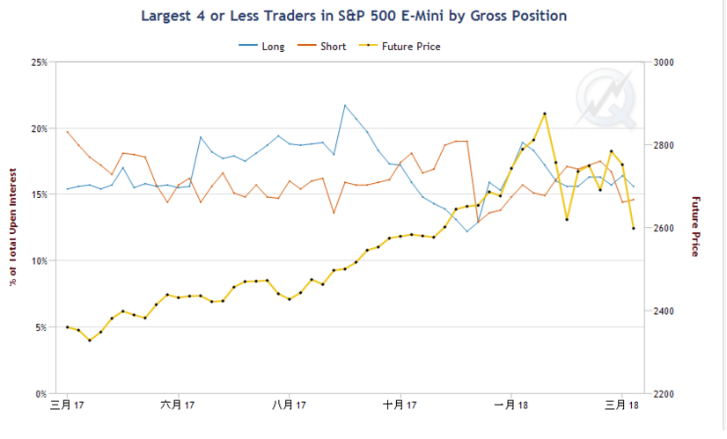

**Concentration Ratios (long form only)**

The report shows the percents of open interest held by the largest four and eight reportable traders, without regard to whether they are classified as commercial or non-commercial. The concentration ratios are shown with trader positions computed on a gross long and gross short basis and on a net long or net short basis.

What difference. One is the longest 4 shortest traders, and the other is the longest 4 shortest traders. It should be roughly similar.

The “Net Position” ratios are computed after offsetting each trader's equal long and short positions. A reportable trader with relatively large, balanced long and short positions in a single market, therefore, may be among the four and eight largest traders in both the gross long and gross short categories, but will probably not be included among the four and eight largest traders on a net basis.

posted on[May 5, 2018](http://www.ooeasy.com/archives/2509)Classification[knowledge and skills](http://www.ooeasy.com/archives/category/%e7%9f%a5%e8%af%86)label[CBOT](http://www.ooeasy.com/archives/tag/cbot)[in cbot largest trader of analysis Leave a Comment](http://www.ooeasy.com/archives/2509#respond)

[**VIX futures data entry and analysis**](http://www.ooeasy.com/archives/945)

In order to avoid making mistakes in the future, continue to study the VIX index.

1. Manually entered VIX data. Although the price of the VIX index in recent months is still relatively high (19.46), the price of futures is not high (the contracts in March, April and May are around 17). 17 is the median of a long history (the last 20 years), and the market is still not so pessimistic about the subsequent March and April.

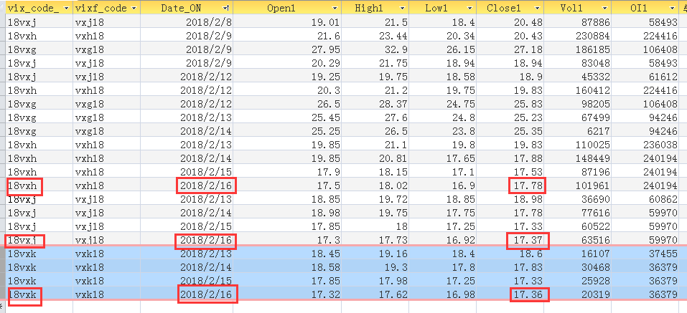

Of course, vix close to 20 will not make the market easy, release the panic under the callback is needed.

2.CBOT data was entered

The net long position of vix (blue line) of hedge funds has been increasing, and so has the buyer (red line). It is actually a warning signal before the plunge, but because this cycle is too long, it is too difficult to determine where the critical point is. Often it can only be confirmed after the fact, and we have time to study how to give early warning.

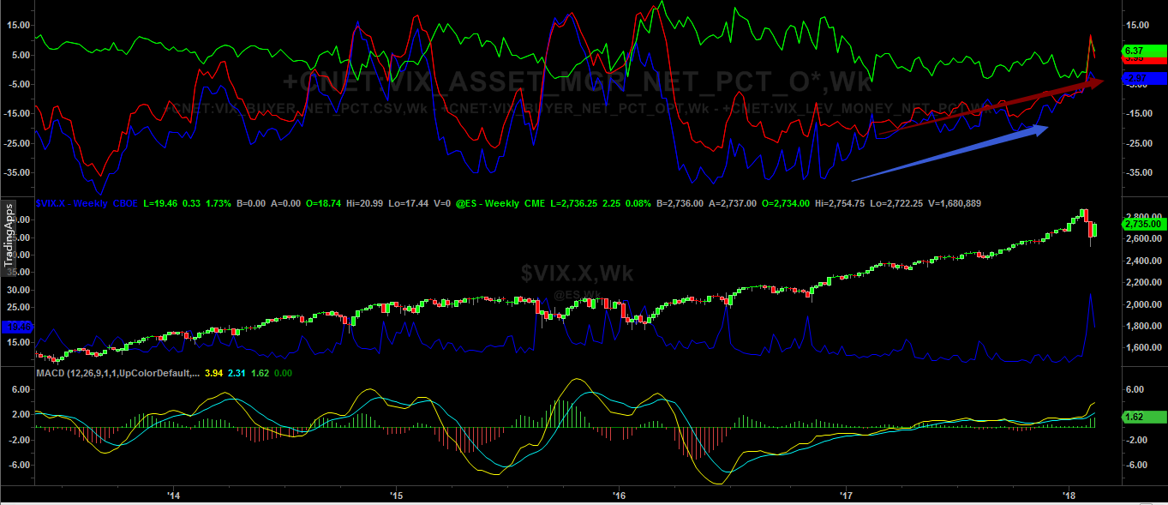

posted on[February 17, 2018](http://www.ooeasy.com/archives/945)Classification[knowledge and skills](http://www.ooeasy.com/archives/category/%e7%9f%a5%e8%af%86)label[CBOT](http://www.ooeasy.com/archives/tag/cbot) , [VIX](http://www.ooeasy.com/archives/tag/vix)[to VIX futures data entry and analysis Leave a Comment](http://www.ooeasy.com/archives/945#respond)

[**Backtesting strategy: Buy based on CBOT position data**](http://www.ooeasy.com/archives/1220)

Just preliminary research, because it will not be used for trading, it does not need to refine the parameters and code, and the time cost is too high.

Backtesting strategy: Buy based on CBOT position data

First, data1: es, data2: es positions are net long positions.  
1. If the ESD weekly chart macd gold fork buys 1 lot of es, the macd death fork exits. Time frame: about 9 years.  
I made about 662 points (50 points per point). The maximum retracement is too large and needs to be optimized.

2. If the macd golden fork of the buyer weekly chart buys es, the dead fork exits. Better performance, earned 858 points

3. If you buy and hold still (assuming roll over cost is 0), you can earn more than 1,000 points. More than macd's strategy.

Consider optimization strategies later.

================== Backtest code ==================

inputs:  
Price (Close) [DisplayName = “Price”, ToolTip =  
“Enter an EasyLanguage expression to use in the moving average calculations.”],  
Length (20) [DisplayName = “Length”, ToolTip =  
“Enter the number of bars used in the calculation of the moving average. "],  
FastLength (12) [DisplayName =“ FastLength ”, ToolTip =  
“ Enter number of bars to use in calculation of shorter length moving average. ”],  
SlowLength (26) [DisplayName = "SlowLength", ToolTip =  
"Enter number of bars to use in calculation of longer length moving average."],  
MACDLength (9) [DisplayName = "MACDLength", ToolTip =  
"Moving Average Convergence Divergence Length. Enter the number of bars to use in smoothing the MACD value. "];

variables:  
MyMACD (0, Data2),  
MACDAvg (0, Data2),  
MACDDiff (0, Data2);

MyMACD = MACD (Close, FastLength, SlowLength) of Data2;  
MACDAvg = XAverage (MyMACD, MACDLength) of Data2;  
MACDDiff = MyMACD – MACDAvg;

{CB> 2 check used to avoid spurious cross confirmation at CB = 2 (at CB = 1,  
MyMACD and MACDAvg will be the same)}  
// if CurrentBar> 2 and MACDDiff crosses over 0 and Price> AverageFC (Price, Length) then  
if CurrentBar> 2 and MACDDiff crosses over 0 then  
Buy (! (“MacdLE”)) next bar at market;

posted on[February 14, 2018](http://www.ooeasy.com/archives/1220)Classification[knowledge and skills](http://www.ooeasy.com/archives/category/%e7%9f%a5%e8%af%86)label[CBOT](http://www.ooeasy.com/archives/tag/cbot) , [bulk](http://www.ooeasy.com/archives/tag/%e5%a4%a7%e5%ae%97) , [futures](http://www.ooeasy.com/archives/tag/%e6%9c%9f%e8%b4%a7)[on back-tested strategy: buy based on CBOT open interest data Leave a Comment](http://www.ooeasy.com/archives/1220#respond)

[**Analysis of CIT reports**](http://www.ooeasy.com/archives/1227)

Open interest in CIT Reports is not the same as Legacy Reports open interest.

CIT has more open interest than legacy open interest, but the trends are the same.

CRON

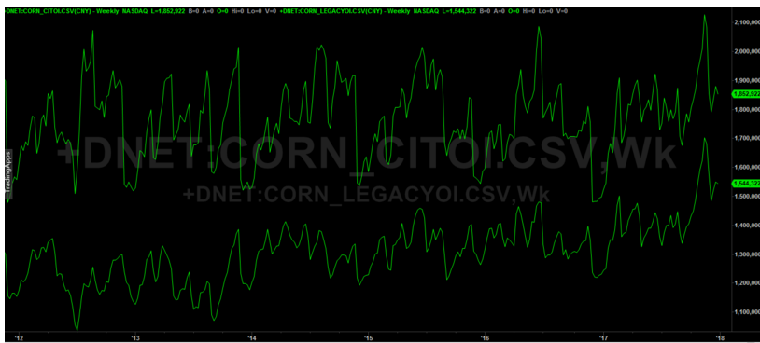

KC

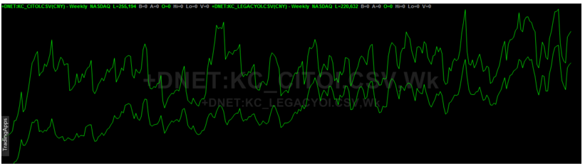

2. Over time, the proportion of NC_COMMERCIAL (money managers) in most futures has increased. It means that money managers play a more important role, and active trading strategies are used more.

For example, in the CORN monthly chart, green represents the percentage of non-commercial positions in positions, and blue line represents the percentage of index traders' positions in positions interest. Positions do not include spread positions.

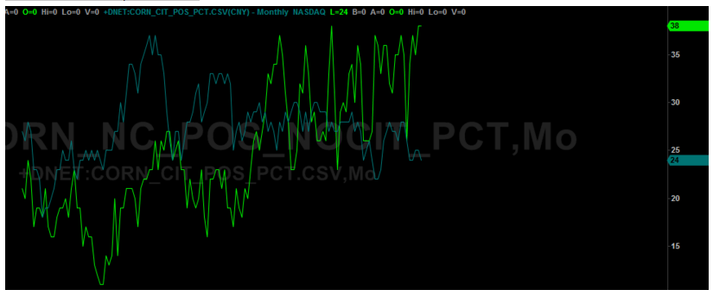

Like KC (coffee)

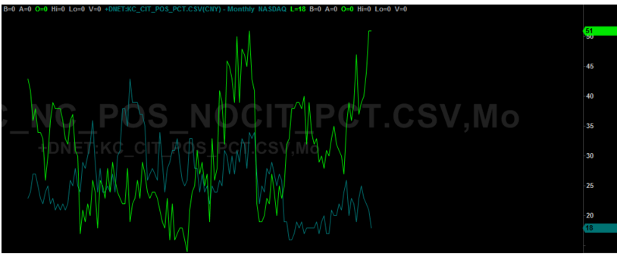

Like S (soybeans)

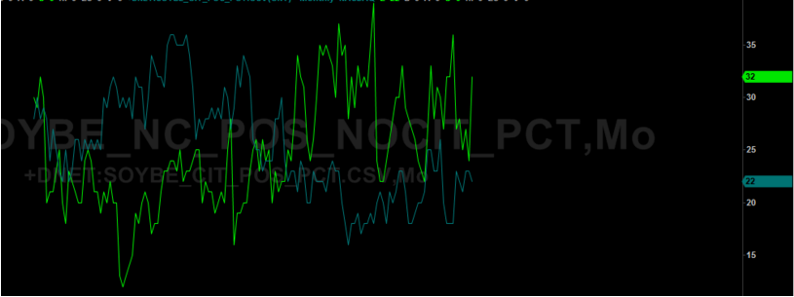

BO (soybean oil)

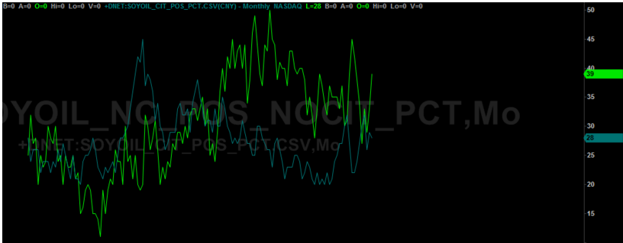

Other strategies, in short, should pay attention to the movement of non commercial / money managers, index traders play a limited role. The following is an explanation of money managers

Money managers are a diverse group of traders, including a range of investors, most importantly hedge funds, CPOs, CTAs, proprietary trading desks of banks or investment firms, and institutional investors. They follow more active trading strategies and take positions on both sides of the market (long and short), seeking to take advantage of arbitrage and speculation opportunities, which enables them to earn positive returns in rising and declining markets  
(Mayer 2009).

posted on[February 3, 2018](http://www.ooeasy.com/archives/1227)Classification[knowledge and skills](http://www.ooeasy.com/archives/category/%e7%9f%a5%e8%af%86)label[CBOT](http://www.ooeasy.com/archives/tag/cbot) , [the CFTC](http://www.ooeasy.com/archives/tag/cftc) , [CIT](http://www.ooeasy.com/archives/tag/cit) , [the bulk of](http://www.ooeasy.com/archives/tag/%e5%a4%a7%e5%ae%97)[the analysis report of CIT Leave a Comment](http://www.ooeasy.com/archives/1227#respond)

[**Supplemental Report (CIT)**](http://www.ooeasy.com/archives/950)

I am going to write a few articles about CBOT. I personally think that this CBOT is public data, too many people use it, and there may be problems with the accuracy of the data. Require merchants to disclose transaction data? Is this realistic? Obviously it is not in their interest, and the data required to be released are not necessarily scientific, and the regulatory authorities are not technical experts. Then investment banks and trading companies will obviously try every means to bypass the report, so that this report becomes useless.

However, as a research target, we can roughly see the flow of funds. Perhaps the CBOT report is only useful for large institutions, and for individual investors, it is mainly the price and trading volume that are important. I study it mainly for interest, weekly level operation, and bulk, futures index, without this ability, that is what the institutions do.

The CIT report was issued in January 2007.

In a December 5, 2006 press release, the CFTC announced that, in addition to the existing weekly Commitments of Traders reports, a supplemental report would be published beginning January 5, 2007.

The new report will show aggregate futures and option positions of Noncommercial, Commercial, and Index Traders in 12 selected agricultural commodities;

The contract inside is part of the agricultural product. The CFTC believes that some agricultural products require such reports to reflect more accurate information, while other financial futures and commodities do not.

The new supplemental report will be restricted to selected commodity futures markets that are included in commodity indices. The Commission believes that these are the markets where the advent of commodity index trading has raised questions as to whether the current classification of traders into noncommercials and commercials has become inadequate and misleading. No  
such concern has been expressed about financial futures markets or the many commodity futures markets that are not included in commodity indices.

At this time, the new report will be limited to agricultural futures markets, and, therefore, it will not include energy and metals futures markets.

12 agricultural products

corn, soybeans, wheat, soybean oil, wheat, cotton no. 2, coffee C, sugar no. 11, cocoa, live cattle, lean hogs, feeder cattle.

The reason for publishing this report is that before, commercial traders were mainly traditional hedgers, that is, manufacturers, etc. But later, a large number of positions in commercial traders were held by non-traditional hedgers (non-traditional hedgers ( eg, swap dealers)) Although swap dealers are also hedges, they are hedges in the financial sense, not hedges in the spot market. As a result, the commercial net long position cannot reflect the actual market.

More specifically, the primary issue addressed in the request for comments is that, over time, for some commodities the nature of the positions reflected by the COT reports has changed significantly. Prior to 1991, both the long and the short side of the commercial open interest listed in the COT reports represented traditional hedgers (producers, processors, manufacturers

To address this issue, the CFTC decided to issue a supplementary report on "Index Traders" in the following format:

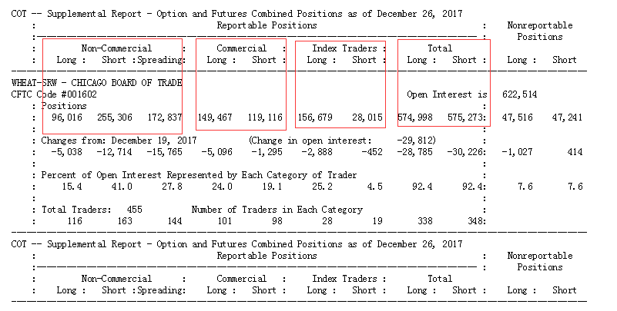

The comparison between the non-commercial, commercial and traditional reports in the figure above does not include index traders. CFTC separates the index traders in commercial and non-commercial and becomes separate index traders.

These so-called “Index Traders” will be drawn from both the current Noncommercial and the Commercial categories.

The index traders from the commercial section are mainly entities that hedge positions in the OTC market.

Coming from the Commercial category will be entities whose positions predominantly reflect hedging of OTC transactions involving commodity indices—for example, swap dealers holding long futures positions to hedge short OTC commodity index exposure opposite institutional traders such as  
pension funds.

The index traders from the non-commercial part are mainly passive investments of some managed funds, pension funds and other institutions in the bulk index. It exists as an asset allocation.

Coming from the Noncommercial category will be managed funds, pension funds and other institutional investors that generally seek exposure to commodity prices as an asset class in an unleveraged and passively-managed  
manner using a standardized commodity index.

The strategy of these index traders is mainly long, [and then roll positions](http://www.cftc.gov/MarketReports/CommitmentsofTraders/ExplanatoryNotes/index.htm) .

All of these traders—whether coming from the noncommercial or commercial categories—are generally replicating a commodity index by establishing long futures positions in the component markets and then rolling those positions forward from future to future using a fixed methodology.

reference:

http://www.cftc.gov/idc/groups/public/@commitmentsoftraders/documents/file/executivesummaryofcotnotice.pdf

posted on[January 17, 2018](http://www.ooeasy.com/archives/950)Classification[knowledge and skills](http://www.ooeasy.com/archives/category/%e7%9f%a5%e8%af%86)label[CBOT](http://www.ooeasy.com/archives/tag/cbot)[in Supplemental Report (CIT) Description Leave a Comment](http://www.ooeasy.com/archives/950#respond)

[**A Working Paper note**](http://www.ooeasy.com/archives/1222)

in conclusion:

Financial investors have played an increasing and often dominating role in commodity derivative markets since the early 2000s which has changed the nature and microstructure of these markets. The most important trends in the last decade can be summarized as

1. strongly increasing trading volumes and open interest positions with an increasing share of financial investors who do not trade based on fundamentals;
2. largely extended trading  
   hours related to electronic trading and technological improvements, increased speed and complexity;
3. ncreasing variety of investment products and strategies with a trend from  
   passive to active trading strategies, including new generations of index products, ETPs / ETFs, an increasing share of trend following trading strategies, and the emergence of HFT;
4. lack of transparency regarding classes of traders and trading strategies given the multiple roles of financial investors and large commercial traders, such as physical commodity companies and trading houses;
5. intensifying interconnectedness between financial  
   and commodity markets given the role of financial investors (as well as large commercial traders) that invest in commodities as an asset class in their portfolio.

The current CBOT classification is too vague to distinguish between traders and trading purposes

The current classification of traders that is largely based on CFTC  
definitions where commercial traders are typically equated with informed hedgers and financial investors with noise and uninformed speculators abstracts too much from the reality in commodity markets given the multiple and interrelated roles of traders.

the boundaries between the physical commodity business and financial investments have become blurred.

The current pattern is increasingly beneficial to big traders.

Generally, most agree that the market has become more profitable for large commodity companies and trading houses with own financial services units.

posted on[January 3, 2018](http://www.ooeasy.com/archives/1222)Classification[knowledge and skills](http://www.ooeasy.com/archives/category/%e7%9f%a5%e8%af%86)label[CBOT](http://www.ooeasy.com/archives/tag/cbot) , [the CFTC](http://www.ooeasy.com/archives/tag/cftc) , [futures](http://www.ooeasy.com/archives/tag/%e6%9c%9f%e8%b4%a7)[certain Working Paper notes Leave a Comment](http://www.ooeasy.com/archives/1222#respond)

[**Description of the money managers role**](http://www.ooeasy.com/archives/1224)

Money managers are a diverse group of traders, including a range of investors, most importantly hedge funds, CPOs, CTAs, proprietary trading desks of banks or investment firms, and institutional investors. They follow more active trading strategies and take positions on both sides of the market (long and short), seeking to take advantage of arbitrage and speculation opportunities, which enables them to earn positive returns in rising and declining markets  
(Mayer 2009).

The trading strategies of money managers are as follows, and retail traders can follow Technical / Algorithmic traders

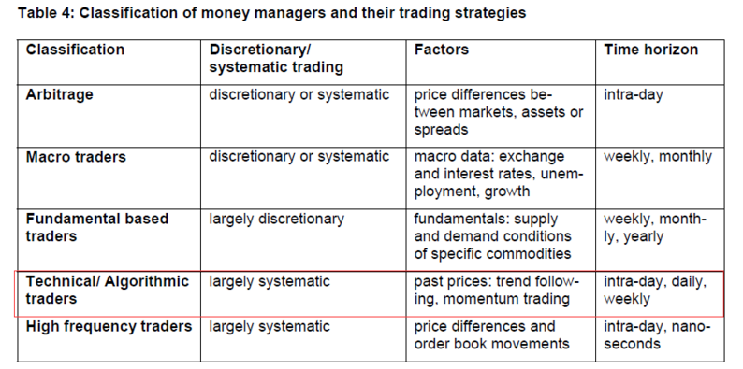

Technical trading systems are widely used. According to 2012 statistics, 30% to 40% of professional foreign exchange traders use technical trading systems.

Algorithmic / machine trading now accounts for the main volume in many markets.

There are different strategies, look at patterns, based on statistics, moving average system, kinetic energy indicators (relative to the price changes of N days ago).

Bulk markets are highly controlled, and it is important for retail traders to follow money managers.

The leading independent energy trading houses are Vitol, Glencore, Trafigura, Mercuria and Gunvor that together handled more than US $ 15 million barrels of oil a day in 2012. Glencore and Trafigura form a duopoly that controls as much as 60% of some markets such as zinc. For aluminium, the big three commercial players are Alcoa, Norsk Hydro and Rusal. The so called  
ABCD group of the US Archer Daniels Midland (ADM), Bunge and Cargill and the French Louis Dreyfus that dominates global trade in agriculture, handles about half of the world's grain and soybeans trade flows. In smaller markets such as coffee, cotton, cocoa or sugar relatively unknown companies command extraordinary power. For instance, the Germany-based and family-owned Neumann Kaffee Gruppe is behind the beans that go into one of seven cups of coffee. Ecom Agroindustrial mills more coffee beans than any other company and supplies companies such as Nestlé and Starbucks (Blas 2013a). Similarly, in 2009, the 13 largest cotton companies – of which 4 were government organizations and 9 privately owned companies – traded 26% of world cotton production.

Money managers will influence short-term trends. Especially the introduction of high-frequency trading.

Most traders interviewed stated that money managers may particularly have an effect on short term price movements within a day to a week. Such speculators thus have the potential to dominate markets for a short while, though in the long run, markets generally revert to fundamentals.

For coffee and cotton, interviewees generally agreed that most extreme price  
movements could be traced to fundamental events but that these movements tend to be exaggerated by fund participation.

posted on[January 1, 2018](http://www.ooeasy.com/archives/1224)Classification[knowledge and skills](http://www.ooeasy.com/archives/category/%e7%9f%a5%e8%af%86)label[CBOT](http://www.ooeasy.com/archives/tag/cbot) , [the CFTC](http://www.ooeasy.com/archives/tag/cftc) , [bulk](http://www.ooeasy.com/archives/tag/%e5%a4%a7%e5%ae%97) , [futures](http://www.ooeasy.com/archives/tag/%e6%9c%9f%e8%b4%a7)[to explain the role of money managers Leave a Comment](http://www.ooeasy.com/archives/1224#respond)

[**A Preliminary Study of the COT Report (2)**](http://www.ooeasy.com/archives/1152)

There are two reports.

**Commitments of Traders Report** **(this traditional report still fails to clarify the motivation behind all transactions)**

There are three types of information (including options positions):

    Commercials, consisting of Producer / Merchant / Processor / User and Swap Dealers (Red Line), they should be from hedging destinations.

    Non-Commercials or Large Speculators (non-commercial), consisting of Managed Money (Managed Funds, Asset Management Institutions) and Other Reportables (Green Line)

    Small Speculators (Blue Line)

[Non-commercial long + non-commercial short + 2 (arbitrage position)] + [commercial short position + commercial long position] + [non-reporting long + non-reporting short] = 2 (open position)

Businesses (value maintainers) follow strong trends, and they will follow the trend, not just hedging, such as S & P futures.

The CFTC still has this traditional report listed at the end

E-MINI S & P 500 STOCK INDEX-CHICAGO MERCANTILE EXCHANGE

[**Commitments of Traders Disaggregated Report**](http://www.cftc.gov/idc/groups/public/@commitmentsoftraders/documents/file/disaggregatedcotexplanatorynot.pdf)**(This information is more transparent) ## I use this to analyze the bulk. ES is in the financial report.**

There are four types of information:

**Producer / Merchant / Processor / User;**   Spot traders (participants in the manufacturing, processing, packaging, and processing of commodities), have a spot background and need to hedge through the commodity futures market. The increase in the proportion of positions held by spot traders helps to alleviate price fluctuations.

**Swap Dealers;** The increase in the proportion of swap dealers' holdings has exacerbated market volatility. Traders with risk hedging needs. Mainly engaged in commodity swap business. Their counterparties are those hedge funds, speculators, or traditional commercial clients (for risk management purposes).

[Reference 1](http://blog.sina.com.cn/s/blog_562a622e0100veyl.html)

Adding the two categories above is actually a commercial position.

The following two types of additions are actually non-commecial

**Managed Money; and Asset Management Agency (Managed Fund)**

**Other Reportables.** Not in the above three categories

You can [download](http://www.cftc.gov/marketreports/commitmentsoftraders/historicalcompressed/index.htm) it from [Disaggregated Futures-and-Options Combined Reports: here](http://www.cftc.gov/marketreports/commitmentsoftraders/historicalcompressed/index.htm) , each field is listed here [Variable Names for the Comma Delimited Commitment of Traders Files](http://www.cftc.gov/marketreports/commitmentsoftraders/deanexplanatory)   , [please refer to Explanatory Notes for](http://www.cftc.gov/MarketReports/CommitmentsofTraders/ExplanatoryNotes/index.htm) specific explanation

Most fields are self-explanatory, and I will explain a few more.

Tot_Rept_Positions_Long_All: All long positions. Note that spreading needs to be added.

NonRept_Positions_Long_All = open_interest_all – Tot_Rept_Positions_Long_All

That is, the total interest in position minus the long position is an unreported long position, and the total interest in position minus the short position is an unreported short position. From this, it can be estimated that the reported amount accounts for the percentage of the interest in the position, so you don't need to pay attention .

Conc_Gross_LE_4_TDR_Long_All: The report shows the percents of open interest held by the largest four and eight reportable traders,