This homework assignment focused on implementing Langton’s Ant in Python. The program created an agent that could move in four directions and decided on which direction to move by the state of the cell it currently was located. The initial implementation had only two possible states for the cells; 0 (represented by a white cell) and 1 (represented by a black cell. If the current cell was white, the agent would turn to the left, change the cell to black, and move forward one cell. If the current cell was black, the agent would turn to the right, change the cell to white, and move forward one cell.

With a height and width of 50, the cell began to create a diagonal highway extending from the lower left to the upper right corner. The agent did so by moving along a diagonal line, until it reached the end, where it would extend the line by a few cells and head in the opposite direction. This cycle would repeat until the line extended and wrapped around the environment, creating one straight highway.

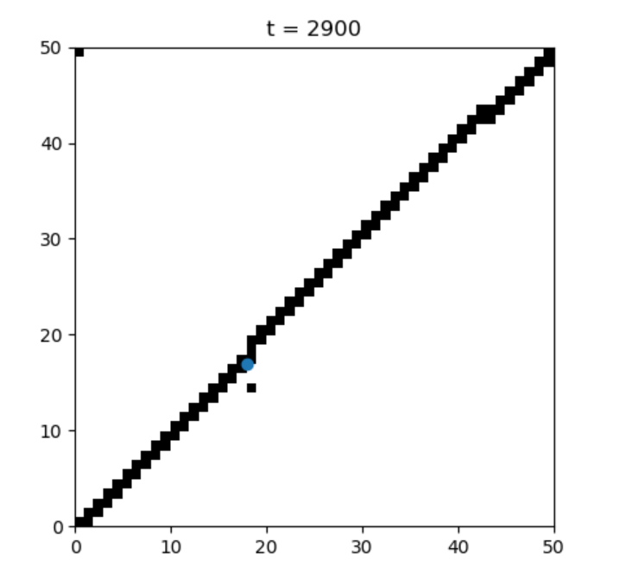

At a certain point, the highway exhibited three distinct sections. At the location of the gap in the line, the agent would change directions. As the upper and middle section increased the width of the highway by one cell, the lower section would decrease its width and vice versa, creating a picture like the one below.

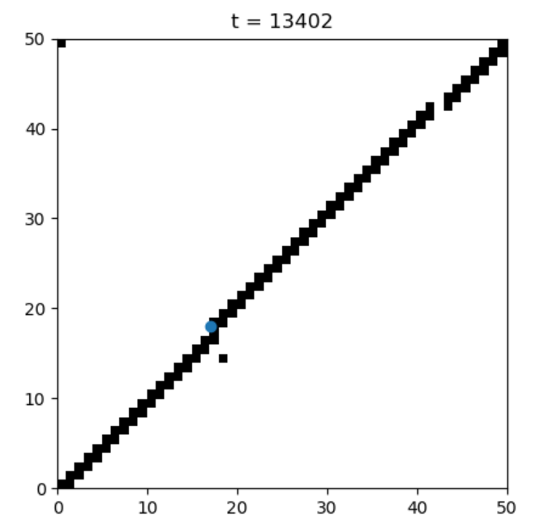

this point, the line started to resemble three distinct sections (upper, middle, lower). As the agent started moving up and down the line, it would increase the width of the lower and upper section, while decreasing the width of the middle section.

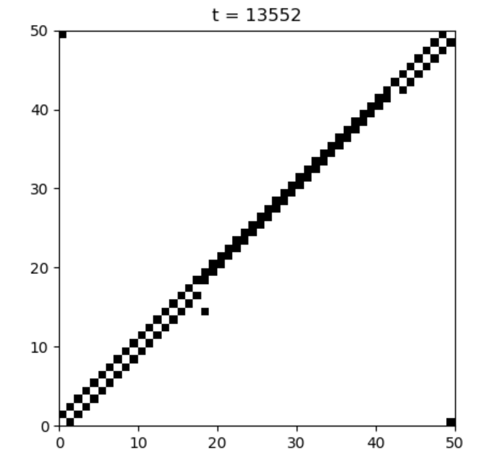

This phenomenon occurred when the environment allowed wrapping. When the environment was set to fixed, eventually one end of the line would reach the maximum width or height, depending on the start location, and the simulation would stop running. I initialized the ant to a random location and a random heading.