Relationship Manager Portal
Product Requirements Document
Small Business Banking | Financial Services
Status: Draft | March 2026

Table of Contents
1. Executive Summary
2. Background & Strategic Context
3. Goals & Success Metrics
4. User Personas & Stakeholders
5. Scope
6. User Journeys & Use Cases
7. Functional Requirements
8. Non-Functional Requirements
9. Data & Integrations
10. UX & Design Principles
11. Technical Architecture Considerations
12. Appendix

1. Executive Summary
Small Business Banking is a strategic growth engine for Truist — delivering low-cost, sticky deposits, diversified revenue, and serving as the primary feeder segment into Premier, Wealth, and Commercial as clients mature. Despite maintaining scale, recent performance reflects slowing deposit production, inconsistent banker productivity, and uneven client engagement across Small Business tiers.
The Relationship Manager Portal is a purpose-built digital workspace designed to address these gaps directly — embedding AI-driven insights, a GenAI Banker Co-Pilot, and guided workflows into a single interface that puts relationship managers back in control of their most important work.

What It Delivers
- Banker effectiveness & consistency — Standardized workflows, AI-assisted client briefings, and guided next-best-action recommendations ensure every RM operates at the level of top performers.
- Funnel throughput & conversion — AI-prioritized outreach and reduced administrative burden allow RMs to move opportunities forward across deposits, lending, cash management, cards, and referrals.
- Measurable revenue lift — Transparent, defensible KPIs tied to funnel performance and PPNR uplift.
- A reusable blueprint for scale — Initial focus on Small Business Banking (Tier I, Tier II, and Business Connect) with a clear path to Premier, Wealth, and Commercial.

2. Background & Strategic Context
Small Business Banking generates low-cost deposits, diversified revenue across lending, cards, and cash management, and serves as Truist's primary feeder segment into Premier, Wealth, and Commercial. The segment's performance is directly tied to long-term franchise value.

Current State Challenges
- Slowing deposit production — Insufficient precision in how bankers identify, prioritize, and engage the right clients at the right time.
- Inconsistent banker productivity — Significant performance variance across the RM population represents a recoverable opportunity that better tooling can close.
- Uneven client engagement — Touchpoint frequency and quality are inconsistent across tiers, leaving revenue on the table.

Strategic Direction
Project Thunderbolt was established to concentrate Truist's data and AI investment within Small Business Banking — improving banker effectiveness through productivity, precision, and scale. The RM Portal is the primary delivery vehicle for frontline impact, designed as a reusable blueprint that can extend to Premier, Wealth, and Commercial as value is proven.

Why a Dedicated Portal
Salesforce remains Truist's CRM of record. The portal complements it by:
- Surfacing AI-generated insights and Next Best Solution (NBS) recommendations in a banker-friendly interface.
- Providing a GenAI Banker Co-Pilot for client research, call preparation, and compliant email drafting.
- Aggregating signals from the Snowflake data layer into a unified Small Business client view optimized for lead lists and pre-call preparation.
- Enabling referral pathways into Premier, Wealth, and Commercial.

3. Goals & Success Metrics
Success will be measured across three categories. All numeric targets are directional estimates pending baseline validation against Truist data (*). Metrics are tracked at the individual RM level and aggregated by tier.

Banker Productivity & Activity
Portal adoption rate
- ≥ 70% weekly active users within 90 days (Tier I) *
Client touchpoints per RM per week
- +15% increase from baseline (Tier I); +10% (Tier II) *
Co-Pilot usage rate
- ≥ 50% of RMs using Co-Pilot for call prep within 90 days *
NBS action rate
- ≥ 30% of surfaced NBS recommendations acted on (Tier II/BC) *

Pipeline & Conversion
Opportunity creation rate
- +20% increase in logged opportunities per RM (Tier I) *
NBS-to-opportunity conversion
- ≥ 20% of acted-on NBS recommendations convert to tracked opportunities (Tier II/BC) *
Referral handoff rate
- Baseline established; referral pathway to Premier/Wealth/Commercial live *

Revenue & PPNR Lift
Deposit production
- A/B test cohort established; early lift signal visible within 90 days *
PPNR uplift
- Demonstrated payback aligned to Truist investment discipline *
Measurement approach
- A/B testing with control cohorts; leading indicators (activity, pipeline) tracked within 30–90 days; lagging indicators (revenue, PPNR) evaluated on rolling 6–12 month basis

4. User Personas & Stakeholders
Note: Tier criteria (book size, revenue thresholds, coverage model) are not yet confirmed. Persona descriptions reflect the most likely model and should be validated with Truist business line leadership.
Tier I RM
Manages a smaller, higher-value book. Responsible for deep relationship cultivation, multi-product penetration, and identifying clients for graduation to Premier or Commercial. Proactively drives outreach and opportunity creation. Key needs: unified client profile, AI-generated pre-call briefings, Co-Pilot for complex communications, expansion and referral signals.
Tier II RM
Manages a broader book at moderate complexity. Relies more heavily on system-generated prioritization. Key needs: AI-prioritized client lists with 'why now' context, NBS recommendations embedded in the client view, streamlined interaction logging.
Business Connect RM
Manages the highest volume of accounts. Engagement is primarily trigger-driven. Key needs: automated trigger alerts, one-click templated outreach, auto-logging, signals of upward segment mobility.
RM Team Lead / Manager
Oversees RM team performance. Key needs: team-level dashboards showing activity rates, pipeline health, and NBS action rates; ability to drill into individual RM performance; early warning signals for at-risk relationships.
Business Line Executive
Accountable for Small Business Banking performance. Key needs: portfolio KPI tracking, A/B test results, PPNR attribution, evidence that the blueprint is on track for segment expansion.

Key Stakeholders
Data & Analytics
Owns the Snowflake data layer and NBS model outputs. Primary dependency for portal data feeds.
IT / Engineering
Accountable for portal build, Salesforce integration, and infrastructure.
Model Risk Management
Must validate all AI and propensity models before production deployment.
Compliance & Legal
Reviews Co-Pilot-generated content; enforces fair lending and regulatory guardrails.
Change Management & Enablement
Delivers RM training, playbooks, and adoption telemetry.

5. Scope

5.1 In Scope — MVP (v1)
Unified Client View
Centralized banker-facing profile aggregating product holdings, relationship history, interaction logs, behavioral signals, and lifecycle indicators from the Snowflake data layer.
Next Best Solution (NBS)
AI- and propensity model-driven recommendations surfaced within the client view, prioritizing opportunities across deposits, lending, cash management, cards, and referrals — each with explicit 'why now' context.
GenAI Banker Co-Pilot
Secure, chat-based GenAI assistant for client research, call preparation, talking points, and compliant email drafting. Operates within Truist's technology stack with audit trails, hallucination mitigation, and fair-lending guardrails.
Salesforce Integration
Bi-directional integration ensuring portal activity syncs to Salesforce as the CRM of record without requiring duplicate RM entry.
Snowflake Data Layer
Unified Small Business client data layer with enriched attributes and signals powering the client view and NBS. Includes ML trigger models that fire downstream workflows to Salesforce.

5.2 Out of Scope — v1
- External client-facing features — Internal banker tool only. No client-facing functionality in scope.
- Premier, Wealth & Commercial segments — Initial build is Small Business only. Segment expansion is a future phase.
- Native mobile app — Mobile-responsive web confirmed for v1. Native app is a future phase.
- Automated interaction capture — Interaction logging is manual in v1. Automated call recording and AI summarization are future phase.

6. User Journeys & Use Cases
Three core RM journeys are mapped below. Where the experience differs meaningfully by tier, separate paths are shown. Journeys represent the intended end-state workflow once the portal is fully adopted.

Journey 1 — Pre-Call Preparation
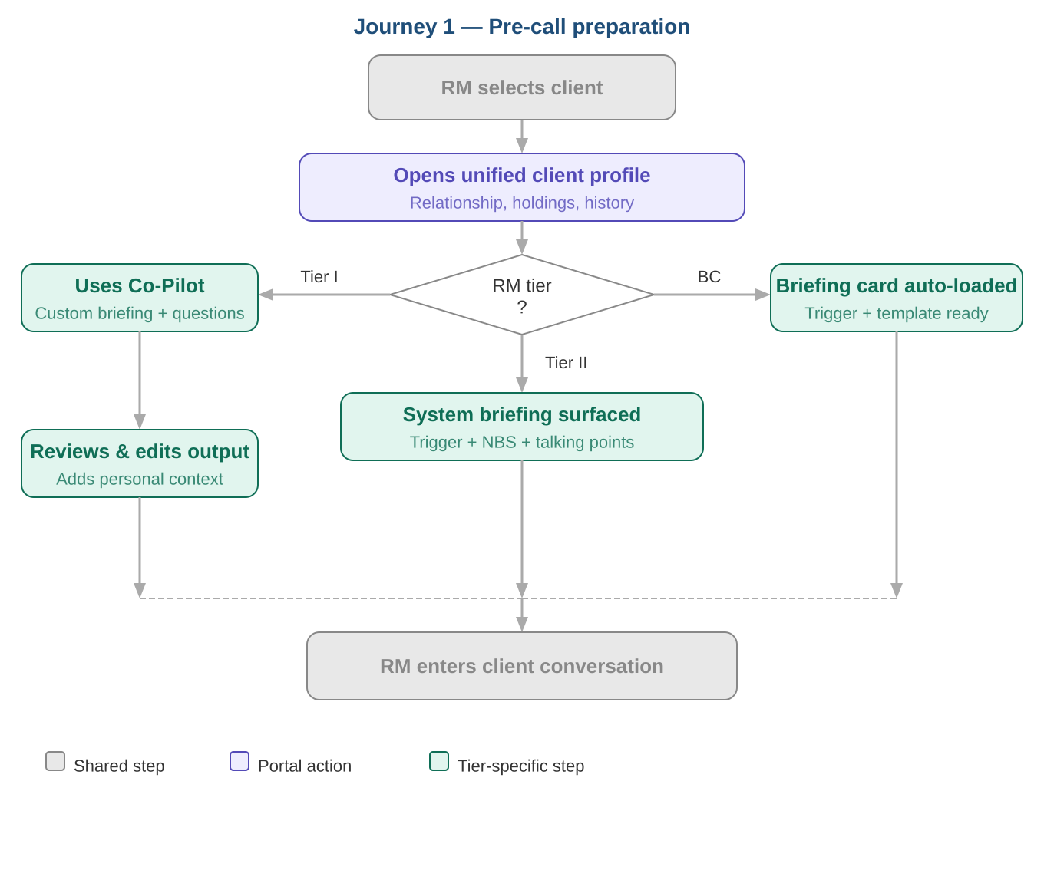
The RM opens the unified client profile before any client conversation. Tier I RMs use the Co-Pilot to generate a custom briefing with tailored probing questions. Tier II RMs work from a system-generated briefing surfaced by a portfolio trigger. Business Connect RMs receive a pre-populated briefing card with a ready-to-use outreach template. All tiers arrive at the client conversation informed — preparation time scales down as tier volume scales up.

Journey 2 — Client Outreach & Follow-Up
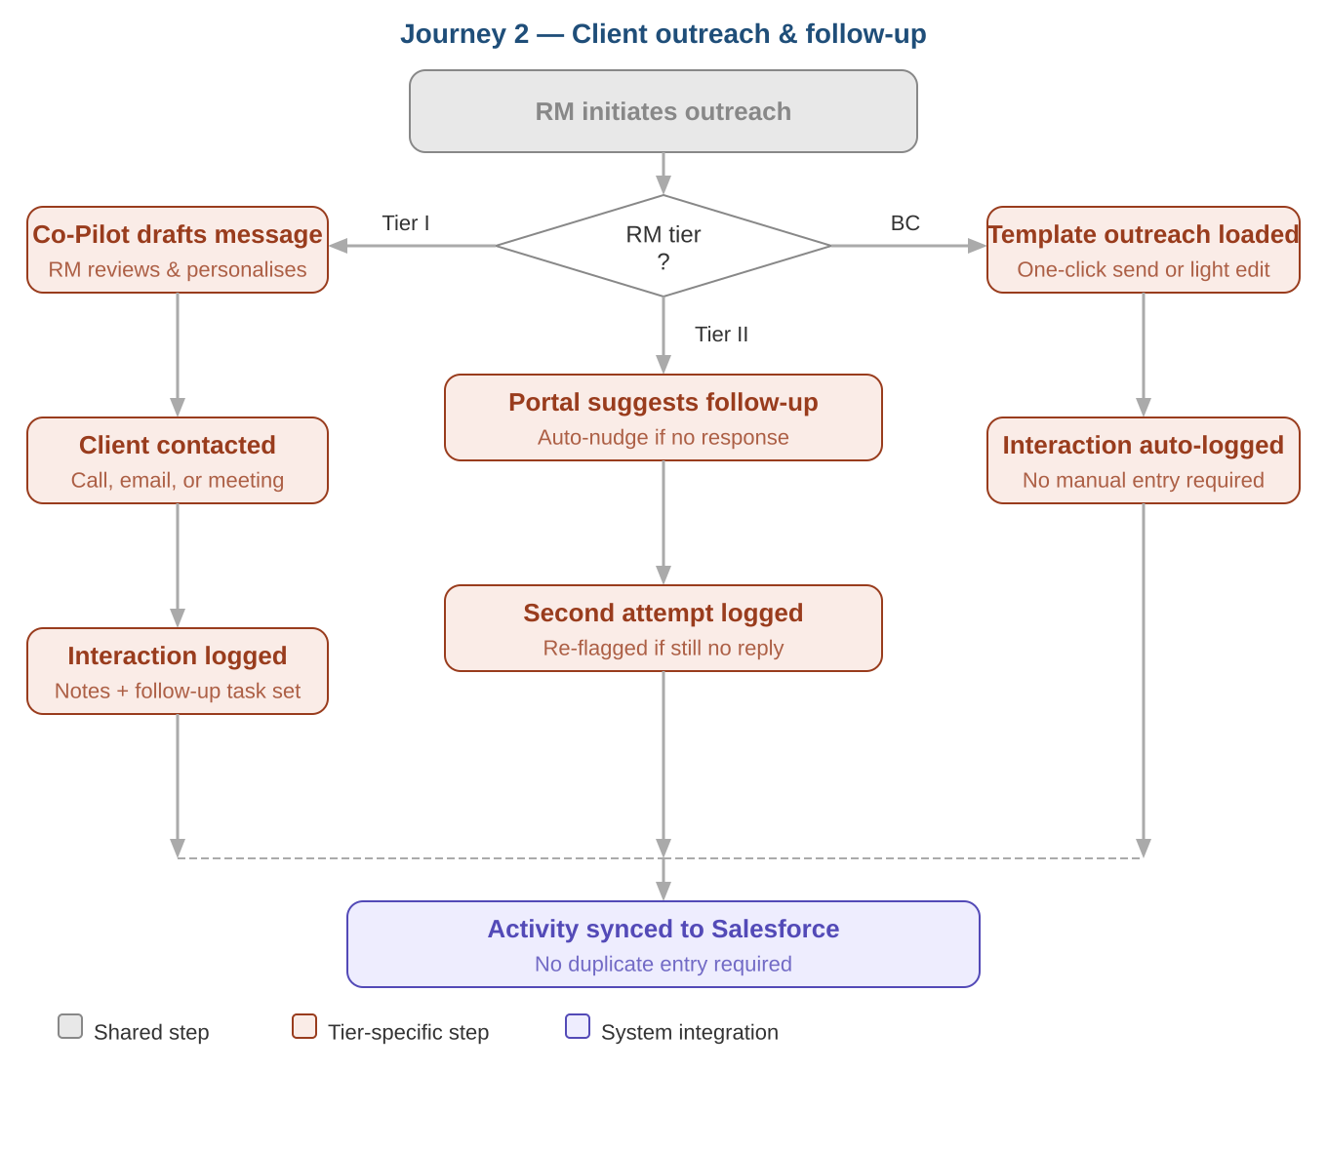
The RM initiates outreach and logs the interaction without leaving the portal. The Co-Pilot drafts follow-up communications for Tier I; Tier II receives automated nudges for non-responses; Business Connect uses one-click templated outreach with auto-logging. All activity syncs to Salesforce automatically — no duplicate entry required.

Journey 3 — Opportunity Management
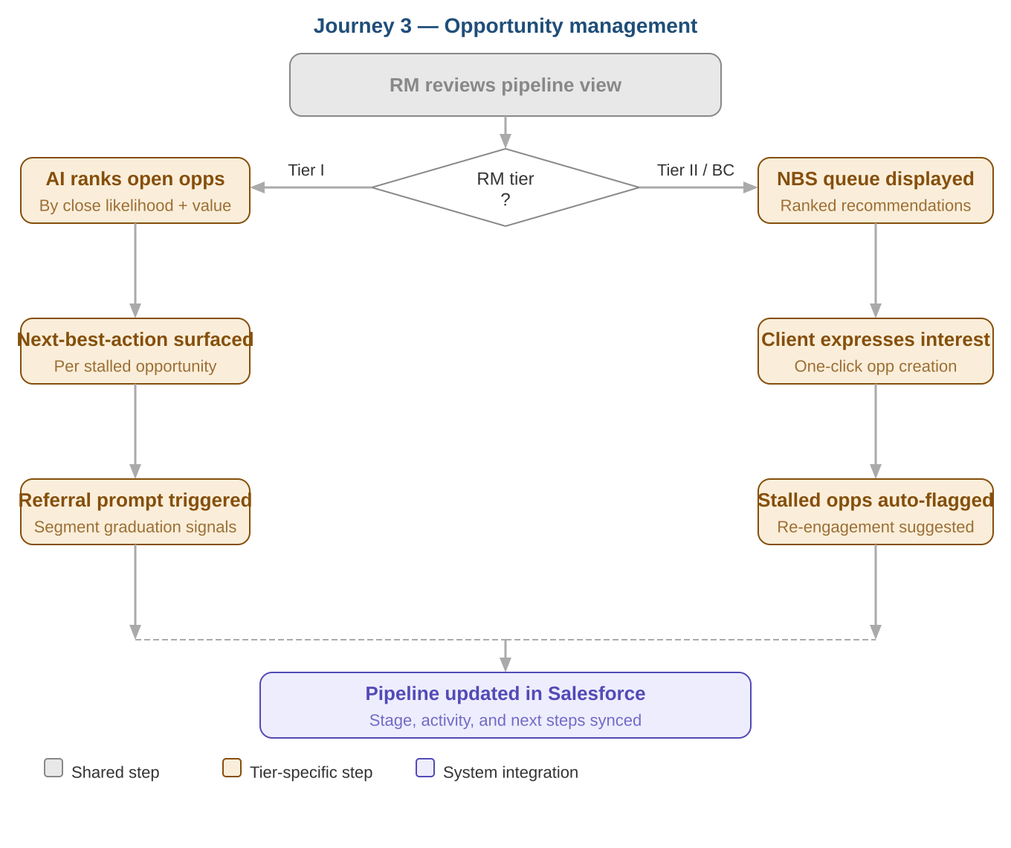
Tier I RMs work from an AI-ranked pipeline with next-best-action per stalled opportunity and referral prompts for graduating clients. Tier II and Business Connect RMs work from their NBS queue — converting acted-on recommendations to tracked opportunities with one click. Stalled opportunities are auto-flagged with re-engagement suggestions. Pipeline updates sync to Salesforce.

7. Functional Requirements
Must-have requirements for MVP launch, organized by capability module. Requirements marked [P2] are Phase 2.

7.1 Unified Client View
- FR-01 The portal must display a unified client profile aggregating product holdings, relationship history, interaction logs, and behavioral signals from the Snowflake data layer.
- FR-02 The portal must surface the client's current tier classification and flag signals of segment mobility.
- FR-03 The portal must display the date and summary of the last logged interaction for each client.
- FR-04 The portal must allow RMs to search for clients by name, business name, or account number.
- FR-05 The portal must display open NBS recommendations on the client profile with associated 'why now' context.
- FR-06 The portal must provide a prioritized daily client list ranked by AI-generated engagement urgency.

7.2 Next Best Solution (NBS)
- FR-07 The portal must surface NBS recommendations per client across deposits, lending, cash management, cards, and referrals, ranked by propensity model output.
- FR-08 Each NBS recommendation must include a 'why now' rationale derived from behavioral signals, lifecycle triggers, or portfolio events.
- FR-09 NBS recommendations must be embedded natively within the client profile for Tier II and Business Connect RMs.
- FR-10 The portal must allow RMs to mark an NBS recommendation as acted on, dismissed, or deferred.
- FR-11 NBS models must be validated through Truist's Model Risk Management (MRM) process before production deployment.
- FR-12 The portal must support referral pathway recommendations flagging clients showing signals of graduation to Premier, Wealth, or Commercial.

7.3 GenAI Banker Co-Pilot
- FR-13 The Co-Pilot must support natural language queries against the client's full relationship history, product holdings, and interaction log.
- FR-14 The Co-Pilot must generate pre-call briefings, probing questions, and talking points tailored to the specific client context.
- FR-15 The Co-Pilot must support drafting of client-facing email communications, subject to RM review before sending.
- FR-16 The Co-Pilot must operate within Truist's approved technology stack with no vendor-owned client data interactions.
- FR-17 The Co-Pilot must implement brand guardrails and fair-lending compliance controls on all generated outputs.
- FR-18 The Co-Pilot must maintain a full audit trail of queries and generated outputs.
- FR-19 The Co-Pilot must include hallucination mitigation controls and surface confidence caveats where appropriate.

7.4 Interaction Logging
- FR-20 The portal must allow RMs to manually log interactions capturing type (call, email, meeting), date, and notes.
- FR-21 Logged interactions must sync to Salesforce automatically without requiring duplicate RM entry.
- FR-22 The portal must allow RMs to set follow-up tasks with due dates directly from the interaction log.
- FR-23 Interaction logs must be visible to the RM's team lead.

7.5 Salesforce Integration
- FR-24 The portal must support bi-directional sync with Salesforce for interaction logs, opportunity stages, and follow-up tasks.
- FR-25 Opportunity records created or updated in the portal must be reflected in Salesforce without manual re-entry.
- FR-26 The portal must read existing client and opportunity data from Salesforce to populate the unified client view.
- FR-27 Sync failures must surface a clear error state to the RM and log the failure for IT resolution.

7.6 Snowflake Data Layer
- FR-28 The data layer must integrate data across Truist systems, products, and client relationships into a unified Small Business client view.
- FR-29 The data layer must support enriched client attributes including behavioral, lifecycle, risk, and engagement indicators.
- FR-30 The data layer must provide banker-facing logical views optimized for lead lists, NBS triggers, and pre-call preparation.
- FR-31 The data layer must expose APIs and integration patterns compatible with Salesforce and portal workflows.
- FR-32 The data layer must support MRM model monitoring, validation, and fairness testing.

8. Non-Functional Requirements
Note: All performance and availability targets below are placeholders pending validation against Truist's internal SLA standards and engineering constraints.

Performance & Availability
- NFR-01 Client profile view must load within 3 seconds for 95% of requests under normal operating conditions.
- NFR-02 NBS recommendations must load within 2 seconds of the client profile being opened.
- NFR-03 Co-Pilot responses must begin streaming within 5 seconds of submission for 90% of requests.
- NFR-04 Portal must achieve 99.5% uptime during core business hours (placeholder — to be validated).
- NFR-05 The portal must degrade gracefully on downstream dependency failure, surfacing a clear error state rather than a broken interface.

Scalability
- NFR-06 The portal must support concurrent usage by all active Small Business RMs without degradation below performance thresholds.
- NFR-07 The architecture must support a 3x increase in concurrent user load to accommodate future segment expansion without core infrastructure changes.
- NFR-08 Integration patterns — Salesforce sync and Snowflake data feeds — must be built as reusable, configurable components extendable to Premier, Wealth, and Commercial with minimal re-engineering.

9. Data & Integrations
The portal sits at the center of a three-platform architecture — consuming enriched client data from Snowflake, integrating bi-directionally with Salesforce, and serving as the primary workspace for RMs across all three tiers. All components operate within the Truist technology boundary.
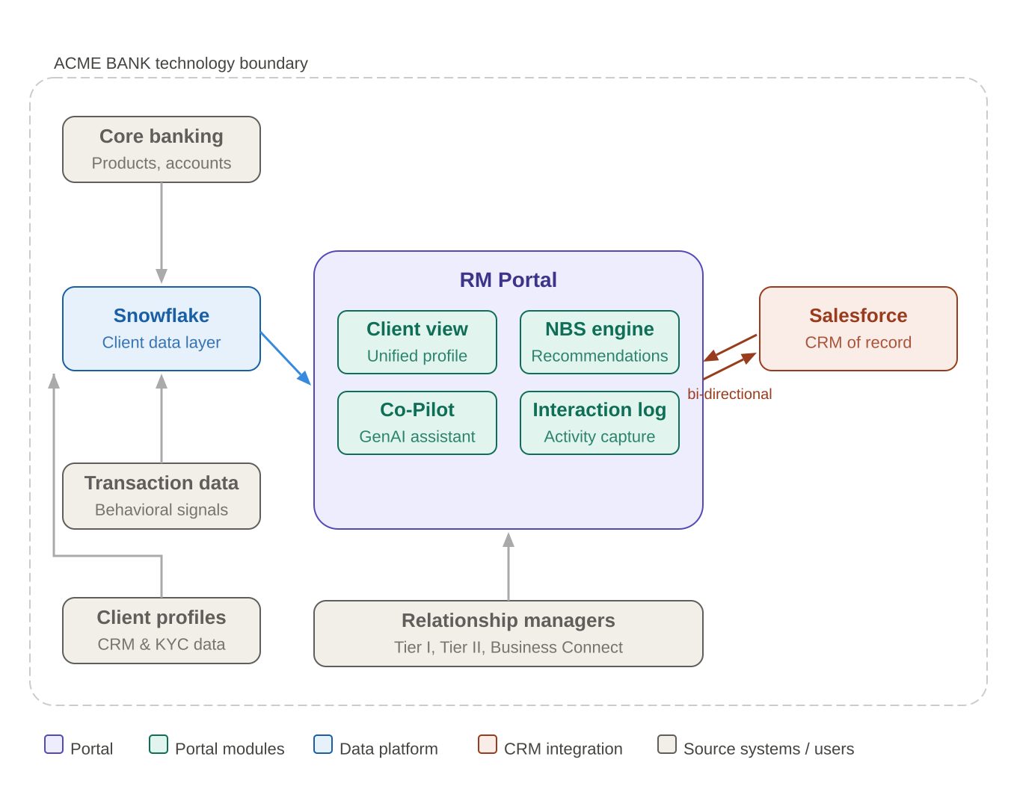
- Snowflake — Houses the enriched Small Business client data layer and NBS model outputs. Also runs ML trigger models that fire downstream workflows to Salesforce when defined signal conditions are met (e.g. deposit balance decline, lifecycle event). Read-only from the portal's perspective — RM-generated data flows through Salesforce.
- Salesforce — CRM of record. Bi-directional integration: portal reads client and opportunity data from Salesforce on load; interaction logs, opportunity updates, and follow-up tasks sync back automatically. Receives ML trigger-generated task and alert records from Snowflake.
- Core banking, transaction & profile systems — Upstream sources feeding Snowflake. Not directly integrated with the portal — all data accessed via Snowflake, insulating the portal from core system dependencies.

10. UX & Design Principles
These principles are the decision-making framework for all design and engineering trade-offs. Gong.io has been identified as the primary UX reference — see Appendix A1 for full analysis.
- Single pane of glass — All client context in one place. If an RM needs a second system to complete a workflow, the portal has failed that workflow.
- Progressive disclosure — Summary view first, detail on demand. The daily list surfaces top actions; the Co-Pilot leads with a concise briefing; NBS shows the recommendation before the rationale.
- AI as assistant, not authority — AI outputs inform and accelerate RM judgment. Every AI-generated output must be clearly marked as such. RMs must always be able to override without friction.
- Minimal administrative burden — Every workflow is evaluated against whether it adds or removes overhead. Logging must be fast. Pipeline updates happen as a byproduct of natural workflow actions.
- Action over information — The most prominent elements on any screen are the actions the RM needs to take, not the data supporting them.
- Tier-appropriate defaults — Information density and default views should be calibrated to the RM's tier. Tier I benefits from richer context; Business Connect benefits from a stripped-back trigger-and-action view.
- Mobile-responsive by default — The portal must render correctly on tablet and mobile browsers. Interaction logging and client lookup must be explicitly optimized for mobile viewports.

11. Technical Architecture Considerations

11.1 The Three-Platform Framework
Three platforms sit at the heart of the portal architecture, each with a distinct role:
- Snowflake — Data platform and ML trigger engine. Houses the enriched client data layer, NBS model outputs, and trigger models that fire downstream workflows into Salesforce. Not an interaction surface — RMs do not interact with Snowflake directly.
- Salesforce — CRM of record and MVP interaction anchor. The most pragmatic candidate for hosting portal interaction surfaces given existing RM adoption, data residency, and integration maturity. Receives trigger-generated task and alert records from Snowflake.
- Microsoft 365 Copilot — Desired long-term interaction layer. Truist's stated direction toward M365 Copilot as the enterprise AI surface has direct implications for the Co-Pilot architecture — it should be built as a capability that can be surfaced within M365 Copilot in a future phase without a rebuild.

11.2 Snowflake ML Trigger Architecture
Snowflake runs a library of ML trigger models that monitor enriched client signals on a defined cadence. When a threshold condition is met — a deposit balance decline, a lifecycle event, a propensity score crossing a confidence threshold — Snowflake fires a trigger event record that is pushed downstream into Salesforce as a task or alert assigned to the relevant RM. This is the mechanism by which NBS 'why now' context is generated and surfaced to bankers.
- Batch cadence for MVP — Triggers fire on a nightly batch cadence for v1. Real-time trigger firing is a future phase consideration.
- MRM governance required — All trigger models require MRM validation before production deployment.
- Suppression windows — Each trigger type must have a suppression window to prevent alert fatigue. Specific durations to be defined with Data & Analytics and validated with RM Team Leads.
- Data flow is unidirectional — Salesforce receives trigger-generated records from Snowflake but does not write back to the trigger model or its output tables.

11.3 Co-Pilot Architecture Constraints
- ACME BANK-hosted LLM — The Co-Pilot must operate on Truist's approved LLM infrastructure. No client data may be sent to externally hosted model endpoints.
- RAG architecture — Co-Pilot responses should be grounded in Truist client data from Snowflake and Salesforce via a Retrieval-Augmented Generation architecture, reducing hallucination risk on factual client queries.
- M365 Copilot compatible by design — The Co-Pilot service must expose a clean, documented API consumable by a Microsoft Copilot plugin in a future phase. Tight coupling to the portal front-end must be avoided.
- Audit and content governance at service layer — All Co-Pilot queries and outputs must be logged. Brand, fair-lending, and regulatory guardrails must be enforced at the service layer, not the UI, so they apply regardless of interaction surface.

12. Appendix

A1. Competitive Reference — Gong.io
Gong.io has been identified as the primary UX reference for the portal — a revenue intelligence platform that centralizes all revenue workflows with purpose-built AI. Relevant feature sets and UX principles are summarized below.
- Unified account view — All client context aggregated in one place. Maps to the portal's unified client profile.
- AI-powered account summaries & Ask Anything — Natural language account interrogation and time-period summaries. Maps to the Co-Pilot briefing generation flow.
- Pipeline & forecasting dashboard — At-risk account surfacing and opportunity health. Maps to the portal's opportunity management view.
- Alerts & smart notifications — Prioritized, actionable alerts over information overload. Maps to the NBS and trigger alert design.
- Integrations ecosystem — 250+ integrations including Salesforce, Teams, Zoom, Slack. Salesforce is the primary integration anchor for the RM Portal.

A2. Consolidated Assumptions Log
Assumptions embedded in this PRD requiring validation before finalization. Status: Confirmed | Updated | Pending.
A-01 [Confirmed] Slowing deposit production
Directly quoted from Project Thunderbolt. No further validation required.
A-02 [Updated] Foundational investments still in flux
Corrected from 'stabilized' to reflect that investments are ongoing. Validator: Business Line Executive.
A-03 [Updated] Strategic framing: improved productivity
'Productivity over headcount' replaced with 'improved productivity'. Validator: Business Line Executive.
A-04 [Updated] Business Connect is a distinct third tier
Terminology updated throughout. Not 'Tier III' — separately named tier. Validator: Business Line Executive.
A-05 [Pending] Tier criteria not yet confirmed
Tier definitions (book size, thresholds, coverage model) unconfirmed. All tier-specific metrics and personas should be reviewed once locked. Validator: Business Line Executive / RM Team Leads.
A-06 [Pending] Tier I vs. Tier II/BC metric distinction
Tier I measured on proactive creation and close rates; Tier II/BC on NBS action and conversion efficiency. Requires explicit confirmation. Validator: Business Line Executive / RM Team Leads.
A-07 [Updated] Manager-facing views required at MVP launch
Originally scoped Phase 2. Updated to MVP scope. Validator: Business Line Executive.
A-08 [Confirmed] Mobile-responsive web sufficient for v1
Confirmed. Native app remains a future phase.
A-09 [Pending] All 3-month and 3-year metric targets
All numeric targets are directional estimates. Require validation against Truist baseline data. Validator: Data & Analytics.
A-10 [Pending] NFR performance targets are placeholders
Uptime and response time targets require validation against Truist SLA standards. Validator: IT / Engineering.
A-11 [Pending] Salesforce bi-directional sync feasibility
Auto-sync without duplicate RM entry requires technical confirmation within MVP scope. Validator: IT / Engineering.
A-12 [Pending] Microsoft 365 Copilot as long-term surface
Needs confirmation whether formally committed or aspirational. Affects Co-Pilot API design. Validator: IT / Engineering / CTO office.
A-13 [Pending] Snowflake trigger cadence (nightly batch)
Feasibility and appropriate cadence per trigger type need confirmation. Validator: Data & Analytics.
A-14 [Pending] Trigger suppression window durations
Concept introduced but durations undefined. To be defined with Data & Analytics and validated with RM Team Leads.

