Properties of the angular-momentum and site basis, with plane waves.

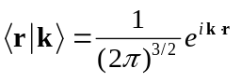

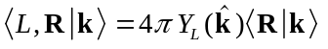

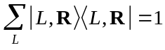

The wave function of the incident electron wave at the absorber is

Insert complete sets:

The operator t has the matrix elements 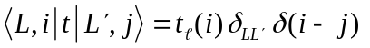, and so the sum over L” is removed.

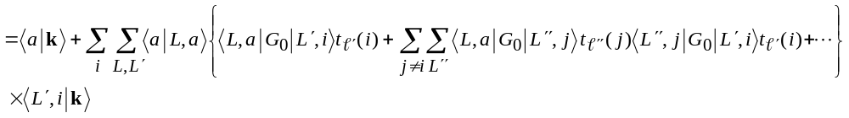
if we choose the origin to be at the absorber position R_{a}, then L = 0 and

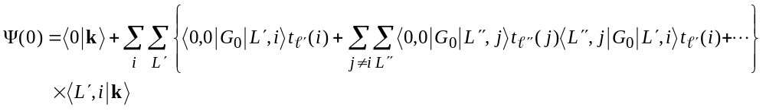

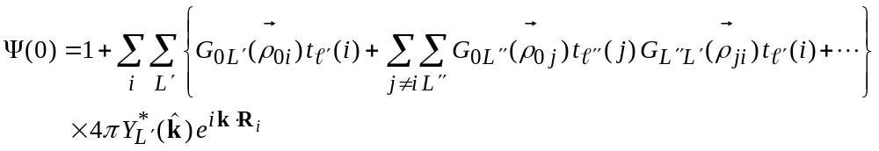

where 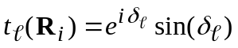, the scattering t-matrix for the atom located at R_{i}. All that remains is to calculate G, for which we use the separable expansion of Rehr and Albers:

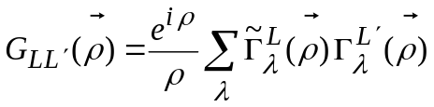

Examining just the single-scattering term,

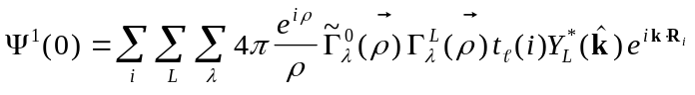

which, when compared to the plane-wave single scattering scattering formula:

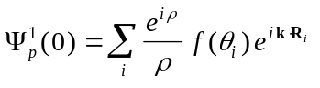

yields an expression for the effective scattering amplitude f_{eff}

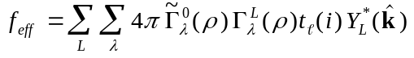

APPENDIX A: Calculation of 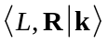

First, insert a complete set of states:

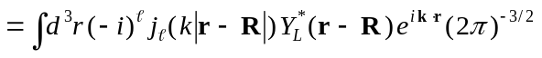

Change variables: p = (r - R), r = p + R, dr = dp

Expand the exponential under the integral in spherical harmonics:

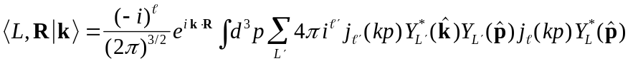

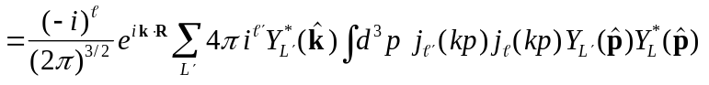

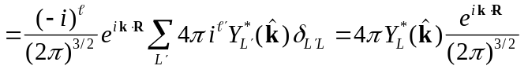

and we have the result that

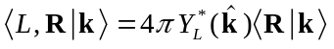

We can check this result by applying a complete set of states to 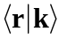:

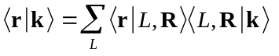

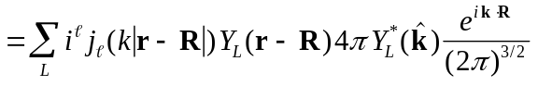

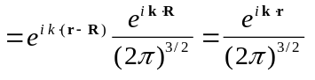 3

