A Multiple-Scattering Theory of Standing Electron-Wave Stimulated Desorption

M. T. Sieger, G. K. Schenter, J. J. Rehr, and T. M. Orlando

Some definitions:

Plane wave basis set: 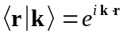

Spherical wave basis set: 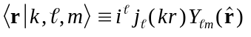

Orthonormality of the spherical wave basis:
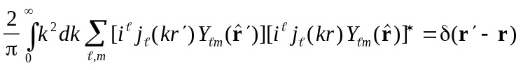
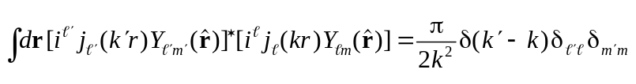
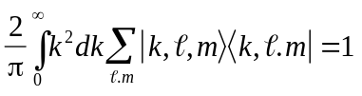

Projection of a plane wave onto the spherical wave basis:
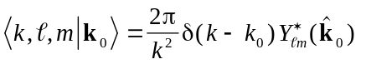

Displaced spherical wave basis set: 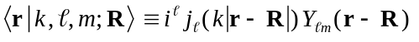

Representation of a plane wave:
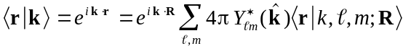

Projection of a plane wave onto the displaced spherical wave basis:
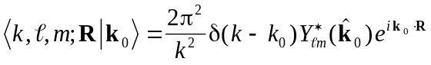

Orthonormality of the displaced spherical wave basis:
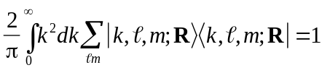
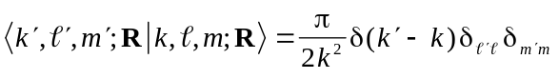

Special cases:
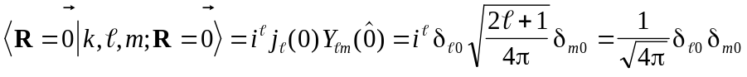

Matrix elements of the free-space propagator:

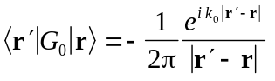

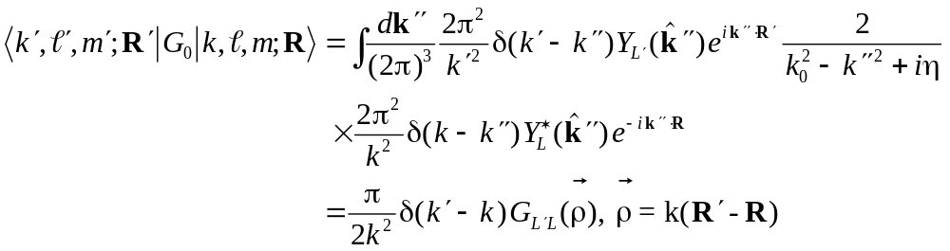

t-matrix elements?

Postulate that 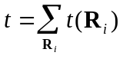,

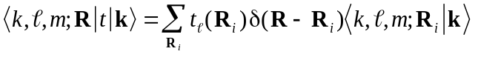

With these definitions, we are ready to consider the surface scattering problem:

Insert complete sets (examine only first two terms in the MS expansion):

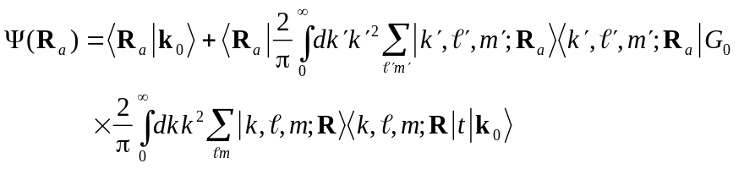

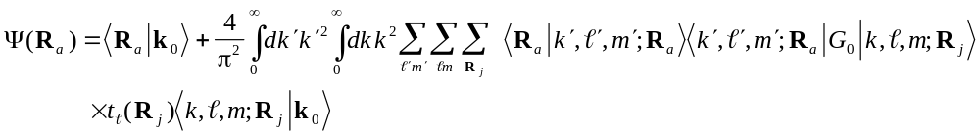

Substituting,

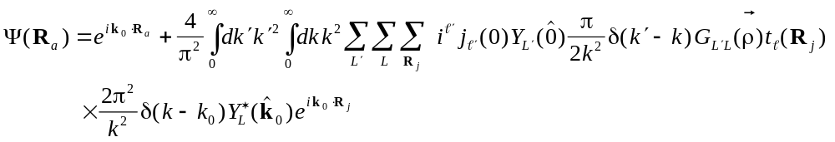

where is defined above, and 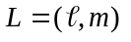. Reducing,

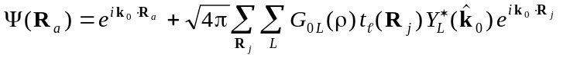

For G, we use the separable expansion of Rehr and Albers:

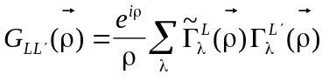

Substituting for G,

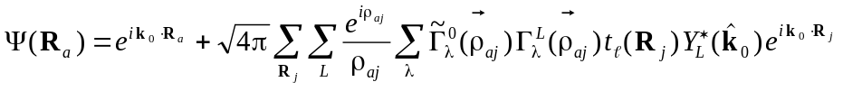

which, when compared to the plane-wave single-scattering formula:

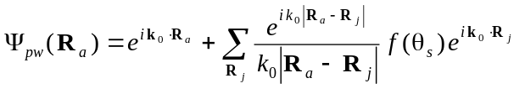

yields an expression for f_{eff}:

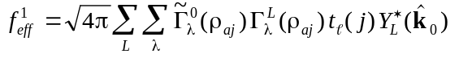

Define

“Initiation matrix” 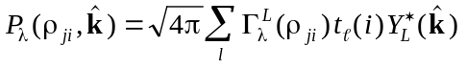
“Termination matrix” 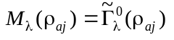

“Scattering matrix” 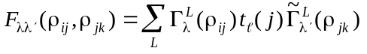

With these definitions, we can express f_{eff} as

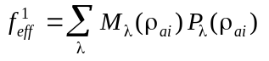

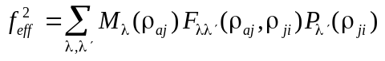

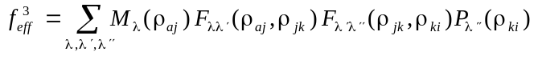

The superscript denotes the order of multiple scattering. The electron wave function can then be constructed by adding successive terms in scattering in a manner reminiscent of the plane wave formula:

