**CLIENT NAME**

## Engagement Title

Version: x

Date: December 21, 2017

# Overview

## Background

This Statement of Work (“SOW”) is entered into by and between Fishtech Group, LLC (hereinafter, “Fishtech”) and CLIENT NAME (hereinafter, “Client”) as is effective as of the last date this SOW is signed. This SOW outlines and describes the services to be provided by Fishtech (the, “Services”).

INSERT TEXT HERE

## Goals & Objectives

INSERT TEXT HERE

## Approach

Fishtech has developed an approach that XXX

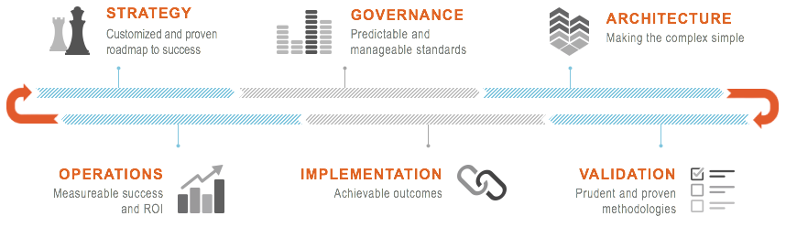

Figure 1: Fishtech Approach

## Methodology

Fishtech has developed a project method that highlights involvement level for both our consultants and Client  
The project will follow these stages: ADD ADDITIONAL INFORMATION IF APPLICABLE

|  |  |  |  |  |
| --- | --- | --- | --- | --- |
|  |  | **SERVICE DEFINITION** |  | * Problem Statement * Services Description * Business Requirements * Target Capabilities |
|  |  | **DISCOVERY** |  | * Sponsorship * Identify Stakeholders * Compliance Objectives * Maturity Assessment | |
|  |  | **GAP ANALYSIS** |  | * People * Process * Technology | |
|  |  | **PRIORITIZE GAPS  & FINDINGS** |  | * Current State vs.  Desired State * Document & Prioritize Findings | |
|  |  | **FEASIBILITY STUDY** |  | * Recommendations  Based on Gap &  Cost Analysis * Due Diligence * Capabilities Enhancement | |
|  |  | **EXECUTION  STRATEGY** |  | * Develop Deliverable * Prioritized & Phased Roadmap * Develop Target State | |

Figure 2: Fishtech Methodology

## Building Blocks

This section is optional. Building Blocks are located in Share Point in Projects, SOW, Building Bloks, insert the applicable image.

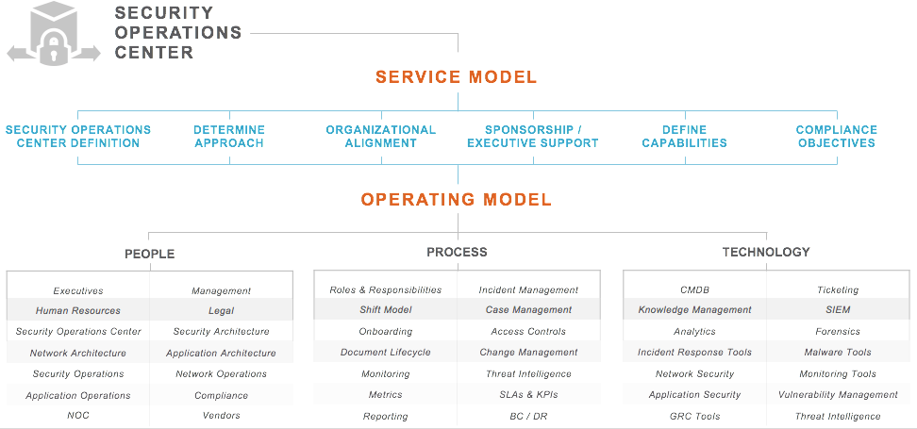

Figure 3: Fishtech Building Blocks

# Our Approach

## I. Customer Success

This phase consists of planning and coordination of the project and helps to identify the following items:

* Client and Fishtech resources and roles
* Final agreement on project scope
* Agreement on project timeline and resource availability
* Initial opportunity for project change order (if scope change from this document)

## II. Review

This phase consists of data gathering and review

* X
* Y
* Z

## III. Gap Analysis

This phase consists of

* X
* Y
* Z

## IV. Documentation

This phase consists of

* X
* Y
* Z

# Deliverables

Fishtech will provide Client with the following deliverable documents in electronic (Adobe PDF) format.

## Weekly Status Reports

Get a weekly snapshot of the project status, schedule, deliverables, project quality, and team interaction.

## Data Gathering and Review Document

This document will include:

* Executive Summary
* Detailed Gap Analysis
* Findings and Recommendations
* High Level Roadmap

## Deliverable Acceptance

All deliverables defined in this SOW are subject to inspection and acceptance by the Client. Client will agree to and document any specific acceptance criteria during the kickoff call. Any special requests not stated within this SOW (such as additional content or non-standard templates) will require a change order.

There will be one (1) round of draft report review, during which Client will be given an opportunity to ensure the report is complete, accurate, and meets expectations. Client is responsible for providing the deliverables to the appropriate stakeholders, obtaining feedback, and consolidating that feedback into a single view for Fishtech consultants to update appropriately.

Fishtech will provide a finalized deliverable for Client acceptance or rejection. In the event that the deliverable does not conform to the agreed-upon acceptance requirements, Client shall so notify Fishtech in writing, setting forth Client rejection and the basis of the nonconformity. Fishtech shall correct such nonconformity within a mutually agreeable timeframe.

Client will accept or reject the deliverable within five (5) business days of completing each iteration. If Client does not accept or reject the deliverable within this period, the deliverable(s) shall be considered accepted.

# Project Management

The goal of Project Management is to ensure that all aspects of the project are planned and executed in a manner that will lead to meeting the goals of the engagement to a high degree of Client satisfaction. Maintaining clear channels of communication will be necessary to ensure project success. Fishtech will provide immediate notification of issues requiring Client involvement and Fishtech expects that any issues identified will be resolved promptly to avoid impacting the project timelines.

## Fishtech responsibilities:

The following list details Fishtech project management responsibilities for this engagement:

* Facilitation of the engagement kick-off meeting
* Management of project budget and Change Order process
* Coordination of Fishtech personnel and logistics
* Creation and management of the formal project plan (if needed)
* Status report preparation and delivery on weekly intervals
* Facilitation of weekly status meetings to discuss project status and any issues that need to be addressed
* Ensure deliverables meet the Client sponsor’s approval within the boundaries of the scope of the engagement
* Ensure engagement work is completed as agreed upon in the SOW

## Client responsibilities:

The following list details Client’s responsibilities for this engagement:

* Client will designate one (1) employee to serve as a primary Point of Contact (“Client POC”) for the project.  The Client POC will be responsible for scheduling Client resources for required meetings, interviews, and other needs deemed necessary to complete the project work as scoped.  The Client POC will participate in weekly status meetings and will serve as the first point of escalation for any project-related requests or issues.
* Client is responsible for notifying impacted personnel of the project activities as needed, and said activities will be conducted with the expressed authority of management.
* Client will provide access to all proprietary information, applications, and systems necessary to the success of this project
* Fishtech assumes that all client data gathering activities will be executed in an efficient manner and data promptly submitted to Fishtech consultants within a reasonable response time.  Any delays incurred in acquiring this information may result in the need for a Change Order and rescheduling of the project, at the discretion of Fishtech.

## Changes

In the process of an engagement, additional work may be required based upon on-site discovery or changes requested by Client. If variations from the original SOW are deemed necessary, a mutually agreed upon Change Order will be created. Fishtech will provide a Change Order for Client to review and sign before any work outside the original scope is performed or additional expenses are invoiced.

The Change Order will specifically address the work, software, or other items added to the SOW and the associated costs. A brief explanation of the requirements for the changes will also be included.

## Timelines

Our consultants can typically be available within two to four weeks of signature of the SOW for scoped services. Fishtech is committed to completing the project within a timeframe that is agreed upon with Client. Fishtech will not begin to provide the Services as described herein until Client has returned the signed SOW.

## Rescheduling or Cancellation

Two (2) weeks written notice in advance of the engagement start date is required for cancelling or rescheduling any Services. If cancellation or rescheduling occurs with less than two (2) weeks advance notice of the scheduled start date, Client agrees to pay a fee of $3,500. Nonrefundable and/or nontransferable travel expenses will be billed to and paid by Client at actual cost.

## Security and Privacy

We pledge to ensure the security and privacy of your information. Fishtech employees are guided by strict information security handling procedures to maintain a high level of security.

* All employees are subjected to criminal history background investigation as a condition of hire.
* All employees have agreed to and signed non-disclosure agreements.
* Data files maintained on portable computers (laptops) will be encrypted.
* Communications of sensitive “Client Confidential” data will be encrypted.
* Physical (paper) files and reports will be secured in locked offices and/or file cabinets.
* Client data files are destroyed after one year unless agreed to differently via client contract or industry/regulatory requirement.

# Dependencies and Assumptions

The following assumptions have been made in this SOW. Any variations may result in scope changes and additional charges:

* Any special conditions not stipulated in this SOW may result in additional fees. Work performed outside normal business hours (Monday to Friday, 8:00AM to 5:00PM) will be billed at a one-and-a-half hour increments).
* No Fishtech employee is expected to work more than ten (10) consecutive hours.
* The following minimum billing will apply for all projects: eight (8) hour minimum for any on-site billable work and two (2) hour minimum for any remote consulting assistance.
* Any flight segment exceeding six (6) hours will be booked at Business Class.

# terms and conditions

These Statement of Work Terms and Conditions (the “Terms and Conditions”) sets forth the terms and conditions that shall govern the Services Fishtech shall perform and provide to Client pursuant to the SOW to which these Terms and Conditions are attached. These Terms and Conditions are incorporated by this reference into the SOW and shall govern the same. For the purposes of these Terms and Conditions, “party” or “parties” means, individually, Client or Fishtech, as the context requires, and, collectively, Client and Fishtech. Any terms not defined in these Terms and Conditions shall having the meaning set forth in the SOW.

1. **Scope of Services.** Fishtech will provide Client with the Services as set forth in the SOW. The SOW should include, at a minimum: (i) a description of the Services and any work product or other deliverables to be provided to Client; (ii) the scope of Services; and (iii) the applicable fees and payment terms for such Services. All functional specifications, technical documents and/or project plans related to the SOW are part of and subject to these Terms and Conditions.
2. **Restrictions on the Use of Services.** Except as otherwise provided in the SOW, Client agrees not to (a) rent, lease, or loan the Services, or any part thereof, or provide or use the Services on its own behalf, or on a third party’s behalf; (b) permit third parties to benefit from the use of the Services via timesharing, service bureau arrangements, or otherwise; (c) reverse engineer, recompile, or disassemble any software that provides the Services, or otherwise attempt to derive the source code of such software; or (d) download, export, or re-export any software or technical data received hereunder, regardless of the manner in which received, without all required United States and foreign government licenses.
3. **Fees.** In consideration of the Services performed, Fishtech shall be entitled to compensation in the amount, and payable at the times and in the manner, set forth in the SOW and these Terms and Conditions.
4. **Ownership.** As between the parties, the Services and the intellectual property that led to or produced the results of the Services (excluding individual factual data gathered from Client’s network or report(s) communicating the results of the Services to Client and any Client systems or Client-owned intellectual property) and all intellectual property rights, including any ideas, know-how or techniques relating thereto, are exclusively owned by Fishtech or its service providers, and Client acknowledges and agrees that it has no rights or interests thereto and will not obtain any rights or interests thereto, except as expressly granted in these Terms and Conditions or the SOW. Client acknowledges that Fishtech has extensive experience, expertise, and proprietary products and tools in the line of business in which it operates, and that Fishtech intends to utilize such expertise, experience, products, and tools in providing professional services to other companies.
5. **Confidentiality Obligations.** Either party may from time to time disclose (the “Disclosing Party”) Confidential Information (as defined below) to the other party (the “Recipient”). As used herein, “Confidential Information” shall mean: (i) all nonpublic information concerning the business, finances, technology, products, services, internal structure and strategies of the Disclosing Party, specifically including, but not limited to, any designs, concepts, methodologies, inventions, source code, know-how, plans, records, files, layouts, documentation, data developments or procedures, and (ii) all such information clearly labeled by the Disclosing Party in writing as “confidential” prior to its disclosure. Recipient shall keep in confidence and trust and will not disclose or disseminate, or permit any employee, agent or other person working under Recipient’s direction to disclose or disseminate, the existence, source, content or substance of any Confidential Information to any other person. The following information will not be considered Confidential Information: (i) information which was in the public domain prior to its disclosure; (ii) information which becomes part of the public domain by any means other than through violation of this SOW Agreement; or (iii) information which was independently developed by either party.
6. **Warranties.** Fishtech represents and warrants that (i) it will perform the Services as described in the SOW using personnel of required skill, experience and qualifications and (ii) it will perform such Services in a professional and workmanlike manner with commercially reasonable industry standards for similar services. In the event such Client believes the Services do not meet the warranties in this Section 6, Client shall provide Fishtech with written notice and details of such non-complying Services within ten (10) days after completion of the Services involved. After determination by Fishtech that such Services were not in conformance, Fishtech shall re-perform such non-complying Services at no additional cost to Client.
7. **Warranty Disclaimer.** EXCEPT FOR SECTION 6 HEREIN, THERE ARE NO WARRANTIES, AND FISHTECH EXPRESSLY DISCLAIMS ALL WARRANTIES, WHETHER EXPRESS, IMPLIED OR STATUTORY, INCLUDING BUT NOT LIMITED TO THE WARRANTIES OF MERCHANTABILITY, FITNESS FOR A PARTICULAR PURPOSE, TITLE, AND NONINFRINGEMENT OF THIRD PARTY RIGHTS. FISHTECH’S AGENTS HAVE NO AUTHORITY TO GIVE SUCH WARRANTIES ON BEHALF OF FISHTECH. WITHOUT LIMITING THE FOREGOING, FISHTECH MAKES NO WARRANTY THAT THE SERVICE WILL BE ERROR-FREE, FREE FROM INTERRUPTION OR FAILURE, OR SECURE FROM UNAUTHORIZED ACCESS, OR THAT IT WILL DETECT EVERY VULNERABILITY TO CLIENT’S NETWORK, OR THAT THE RESULTS GENERATED BY THE SERVICES, WILL BE ERROR-FREE, ACCURATE, OR COMPLETE. THE SERVICES MAY BECOME UNAVAILABLE DUE TO ANY NUMBER OF FACTORS INCLUDING SCHEDULED OR UNSCHEDULED MAINTENANCE, TECHNICAL FAILURE OF THE SOFTWARE, TELECOMMUNICATIONS INFRASTRUCTURE, OR THE INTERNET.
8. **Limitation of Liability.** Under no circumstances shall Fishtech be liable to Client, or to customers of Client, for any loss of profits, loss of data, equipment downtime, or for any indirect, incidental, exemplary, consequential, or special damages relating to or arising out of these Terms and Conditions or the SOW, even if advised of the possibility of such damages. In no event, except for confidentiality and indemnification obligations under these Terms and Conditions or the SOW, shall Fishtech total cumulative liability in connection with these Terms and Conditions and the Services, whether in contract, tort or otherwise, exceed the total amount of Client’s payment(s) hereunder. The foregoing provisions shall be enforceable to the maximum extent permitted by applicable law. This Section shall survive any termination or expiration of the SOW.
9. IN NO EVENT SHALL FISHTECH BE LIABLE TO CLIENT OR TO CUSTOMERS OF CLIENT FOR ANY DAMAGES RESULTING FROM OR RELATED TO ANY FAILURE OR DELAY OF FISHTECH IN THE DELIVERY OF THE SERVICES UNDER THE SOW, INCLUDING WITHOUT LIMITATION, DELAYS CAUSED BY ACTS OF GOD, FIRE, WAR, RIOTS, STRIKES, QUARANTINES OR EMBARGOES.
10. **Indemnification.** Each party (each an “Indemnifying Party”) shall indemnify and hold harmless the other party, its subcontractors and their respective partners, officers, directors, agents, advisors and employees (each an "Indemnified Party") from and against all claims, demands, losses, liabilities, costs, expenses and reasonable attorneys’ fees, arising out of a claim by a third party against the Indemnified Party (i) resulting from any negligent or willful act or omission of the Indemnifying Party under or related to these Terms and Conditions, including but not limited to causes of action for death or bodily injury or the physical damage to or loss or destruction of any real or tangible personal property; (ii) a breach of any confidentiality obligations hereunder; and (iii) when Client is the Indemnified Party, that the Services and any resulting use of the Services constitute an infringement of any intellectual property right of third party. Notwithstanding the foregoing, Fishtech shall have no obligation to indemnify, defend or hold harmless Client for any claim of infringement caused by (a) use of the Services by Client in combination with any other products or services in a way not authorized by Fishtech, if the infringement would not have occurred but for such combination, or (b) any alteration, change or modification of the Services by Client not authorized by Fishtech, if the infringement would not have occurred but for such alteration, change or modification.
11. **Method of Performing Services.** Fishtech is an independent contractor, and as such, shall have the right to determine the method, details, and means of performing the Services. Nothing in these Terms and Conditions or the SOW shall operate to create any employment relationship between Client and Fishtech.
12. **Personnel and Rates.** Fishtech shall have the sole right to designate the appropriate personnel necessary to accomplish the Services to be performed under the SOW. Fishtech reserves the right to substitute personnel for any reason and in its own discretion, provided that, the rates charged for the substituted personnel may not exceed the rates agreed in the SOW.
13. **No Publicity.** Neither party shall issue any announcement, news release, denial, or confirmation of the SOW, or in any other manner advertise or publish, including any terms and conditions of, these Terms and Conditions or the SOW, without the prior written consent of the other party. A party may, in its sole discretion, withhold consent to any publicity. Nothing in these Terms and Conditions or the SOW grants a party the right to use any trademarks, trade names, or logos proprietary to the other party.
14. **Term and Survival.** These Terms and Conditions are effective as of the date the SOW is last signed and expires upon completion of the Services as set forth in the SOW, or as otherwise set forth in the SOW. Sections 5, 6, 7, 8, 9, 11 and 12 of these Terms and Conditions survive termination or expiration of the SOW.
15. **Entire Agreement.** These Terms and Conditions and the SOW shall be the entire agreement among the parties with respect to the transactions contemplated among them and supersede all previous negotiations, commitments, and writings.

# Pricing and Signature

**Invoices.** Fishtech shall issue invoices monthly for Services provided to Client or upon completion of Services rendered if completed in less than one month. Invoices will list all expenses, charges, costs, service descriptions, and all state, federal, sales, or other applicable taxes separately, if any.

**Reimbursement of Expenses.** Client shall be obligated to reimburse Fishtech for all out-of-pocket expenses incurred by Fishtech in performing its obligations hereunder, including reasonable travel expense.

**Payments and Late Payment Charge.** All invoices shall be paid within thirty (30) days of invoice. Client shall pay a late charge of 1.5% per month, or the maximum rate permitted by applicable law, whichever is less, on any unpaid amount for each calendar month or fraction thereof that any payments are in arrears to Fishtech.

|  |  |  |
| --- | --- | --- |
| **SERVICE SKU** | **DESCRIPTION** | **ESTIMATED FEES** |
|  |  | $xx,xxx.xx |
| Travel & Expenses | | TBD |
| Total | | $xx,xxx.xx |

IN WITNESS WHEREOF, the parties have read, agree to, and have caused their duly authorized representatives to execute this SOW Agreement and the pricing as set forth within the accompanying Sales Proposal.

|  |  |  |  |
| --- | --- | --- | --- |
| Fishtech Group, LLC | | Client | |
| By: |  | By: |  |
| [ Authorized Signature ] [ Date] | | [ Authorized Signature ] [ Date] | |
| Name: |  | Name: |  |
| [ Print Name ] | | [ Print Name ] | |
| Title: |  | Title: |  |
|  | |  | |
| Opportunity #: | | Project Order (PO) #: | |