CSCE-312 Quiz 7 [20 points]

**csce-312 | DUE: tuesday Nov 29, 2016 11:59pm on e-campus**

**NAME: UIN**:

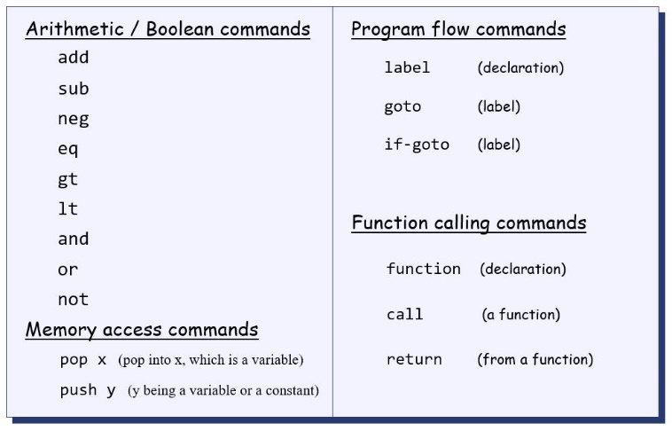

**Question 1. [3 points] Write pseudo VM code for the expression z = x+y using stack arithmetic. You may assume x, y, z are stored in consecutive memory locations. Pseudo VM code follows VM syntax as shown above but does not list specific memory segments like static, temp, argument, etc.**

**push x**

**push y**

**add**

**pop z**

**Question 2. [4 points] For the picture below, draw the final picture of the stack and static segments after execution of the following command sequence:**

**push static 3  
 push static 0  
 add  
 pop static 1**

**Stack**  **Static**

|  |  |  |
| --- | --- | --- |
| **121** |  | **5** |
| **5** |  | **-527** |
| **17** |  | **3** |
| **Stack pointer** |  | **-532** |

**Question 3. [5 points] Write pseudo VM code (stack arithmetic, memory, control, and functions) for the following high-level code. Assume that divide rounds down to an integer (for e.g. 8/3 returns 2). In your VM code you will need to write divide and multiply functions and call them from the main program.**

**if (~ (a = 0))   
 x = b/c  
else  
 x = b*c**

**push a**

**push 0**

**eq**

**not**

**if-goto divide**

**push b**

**push c**

**mult**

**goto end**

**(divide)**

**push b**

**push c**

**div**

**(end)**

**pop x**

**Here is a reference for HACK assembly language syntax that we practiced in this course. All details are given below for references and then the questions follow.**

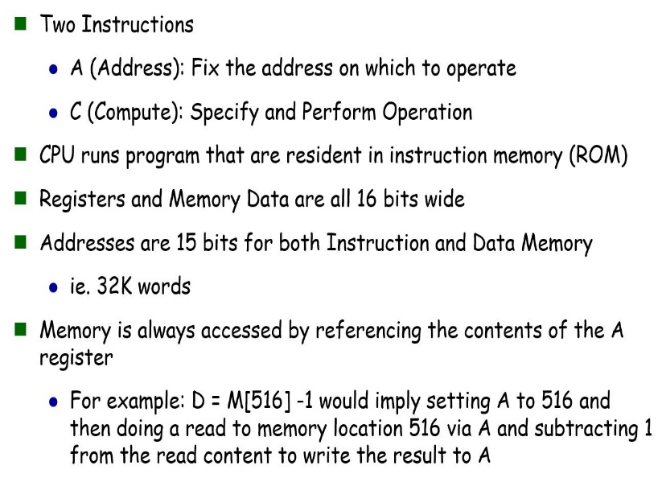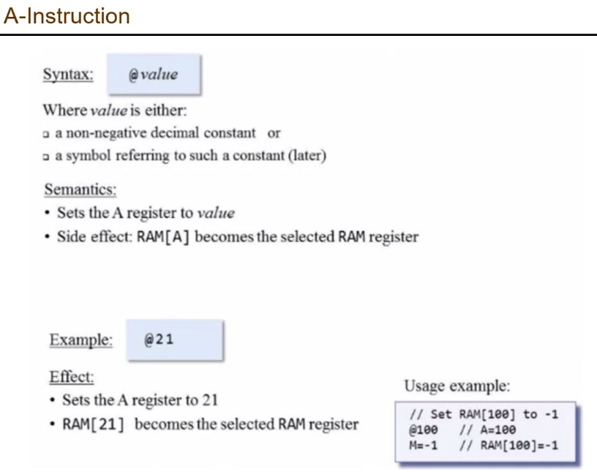

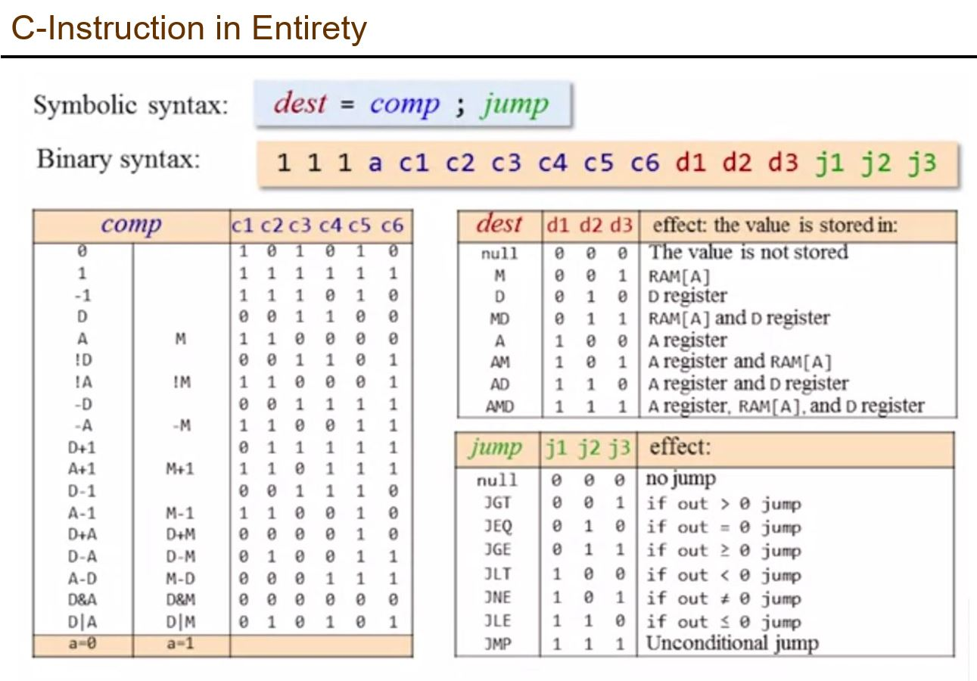

**Question 4. [8 points] Write HACK assembly code for the following VM commands:**

* **push constant 5**
* **sub**
* **pop local 2**
* **if-goto label (assume label is at ROM location 58)**

**//push constant 5:**

**@5**

**D = A;**

**//sub**

**@0**

**//pop local 2**

**//if-goto label**

@58