Document No.




Product name
LEC Serial Communication Information

Model/ Series
LEC□6 Series

SMC Corporation

Contents

1. Safety instructions
2
2. Outline 5
3. What is LEC serial communication? 6
4. Operation example : Editing step data 9
5. Communication specification 10
6. Function details 18
7. Memory map 26
8. CRC calculation method 29

LEC□6 Series/ Serial Communication


1. Safety Instructions

These safety instructions are intended to prevent hazardous situations and/or equipment damage. These instructions indicate the level of potential hazard with the labels of "Caution", "Warning" or "Danger". They are all important notes for safety and must be followed in addition to International standards (ISO/IEC), Japan Industrial Standards (JIS)^{*1)} and other safety regulations^{*2)}.

*1) ISO 4414: Pneumatic fluid power -- General rules relating to systems
ISO 4413: Hydraulic fluid power -- General rules relating to systems
IEC 60204-1: Safety of machinery -- Electrical equipment of machines (Part 1: General requirements)
ISO 10218-1992: Manipulating industrial robots -- Safety
JIS B 8370: General rules for pneumatic equipment
JIS B 8361: General rules for hydraulic equipment
JIS B 9960-1: Safety of machinery - Electrical equipment of machines. (Part 1: General requirements)
JIS B 8433-1993: Manipulating industrial robots - Safety.
*2) Labor Safety and Sanitation Law, etc.
 | Caution | indicates a hazard with a low level of risk which, if not avoided, could result in minor or moderate injury.
 | Warning | indicates a hazard with a medium level of risk which, if not avoided, could result in death or serious injury
 | Danger | indicates a hazard with a high level of risk which, if not avoided, will result in death or serious injury.
Warning
1. The compatibility of the product is the responsibility of the person who designs the equipment or decides its specifications.
Since the product specified here is used under various operating conditions, its compatibility with specific equipment must be decided by the person who designs the equipment or decides its specifications based on necessary analysis and test results. The expected performance and safety assurance of the equipment will be the responsibility of the person who has determined its compatibility with the product. This person should also continuously review all specifications of the product referring to its latest catalog information, with a view to giving due consideration to any possibility of equipment failure when configuring the equipment.
2. Only personnel with appropriate training should operate machinery and equipment.
The product specified here may become unsafe if handled incorrectly. The assembly, operation and maintenance of machines or equipment including our products must be performed by an operator who is appropriately trained and experienced.
3. Do not service or attempt to remove product and machinery/equipment until safety is confirmed.
1. The inspection and maintenance of machinery/equipment should only be performed after measures to prevent falling or runaway of the driven objects have been confirmed.
2. When the product is to be removed, confirm that the safety measures as mentioned above are implemented and the power from any appropriate source is cut, and read and understand the specific product precautions of all relevant products carefully.
3. Before machinery/equipment is restarted, take measures to prevent unexpected operation and malfunction.
4. Contact SMC beforehand and take special consideration of safety measures if the product is to be used in any of the following conditions.
1. Conditions and environments outside of the given specifications, or use outdoors or in a place exposed to direct sunlight.
2. Installation on equipment in conjunction with atomic energy, railways, air navigation, space, shipping, vehicles, military, medical treatment, combustion and recreation, or equipment in contact with food and beverages, emergency stop circuits, clutch and brake circuits in press applications, safety equipment or other applications unsuitable for the standard specifications described in the product catalog.
3. An application which could have negative effects on people, property, or animals requiring special safety analysis.
4. Use in an interlock circuit, which requires the provision of double interlock for possible failure by using a mechanical protective function, and periodical checks to confirm proper operation.
LEC□6 Series/ Serial Communication
1. Safety Instructions


Caution
Our products are provided for use in manufacturing industries.
The product herein described is basically provided for peaceful use in manufacturing industries. If considering using the product in other industries, consult SMC beforehand and exchange specifications or a contract if necessary. If anything is unclear, contact your nearest sales branch.

Limited warranty and Disclaimer/Compliance Requirements
The product used is subject to the following "Limited warranty and Disclaimer" and "Compliance Requirements".
Read and accept them before using the product.

Limited warranty and Disclaimer
1. The warranty period of the product is 1 year in service or 1.5 years after the product is delivered. ^{*3)}
Also, the product may have specified durability, running distance or replacement parts. Please consult your nearest sales branch.

2. For any failure or damage reported within the warranty period which is clearly our responsibility, a replacement product or necessary parts will be provided. This limited warranty applies only to our product independently, and not to any other damage incurred due to the failure of the product.

3. Prior to using SMC products, please read and understand the warranty terms and disclaimers noted in the specified catalog for the particular products.

*3) Vacuum pads are excluded from this 1 year warranty.
A vacuum pad is a consumable part, so it is warranted for a year after it is delivered.
Also, even within the warranty period, the wear of a product due to the use of the vacuum pad or failure due to the deterioration of rubber material are not covered by the limited warranty.

Compliance Requirements
When the product is exported, strictly follow the laws required by the Ministry of Economy, Trade and Industry (Foreign Exchange and Foreign Trade Control Law).

2. Outline
The electrical actuator controller LEC□6 series has a serial communication port with transmission line (physical layer) corresponding to RS485.
With this serial communication, the following operations can be performed using the controller LEC□6
(1) Movement instruction of registered step data.
(2) Editing of step data.
(3) Reading of position and speed data.

This document explains the use of LEC serial communication.
Please use it together with the operation manual of the electrical actuator LEC□6 series.

電動アクチュエータ用コントローラ（以下コントローラ） LEC□6シリーズには、RS485相当の伝送路（物理層）を持ったLECシリアル通信ポートを搭載しております。
このシリアル通信にて、ステップデータの編集をすることができます。
本書は、このLECシリアル通信の使用方法を説明した資料になります。
電動アクチュエータ LEC□6シリーズの取扱説明書と合わせてご確認ください。

3. What is LEC serial communication?
It is serial communication performed by a protocol equivalent to Modbus RTU with a transmission line corresponding to RS485.
With serial communication, internal relays, data memory and so on can be operated.
Within the controller there are internal relay’s and data memory that can change and check the data inside controller, operate actuator by accessing these.
The table below shows an outline of the memory that can be accessed by this serial communication.

Name | Address | Contents
Step data area | D0400～D043F | Memory area where contents of step data are saved. If data is written here, the contents of the step data will be changed.

Caution
・Settings inherent to the controller are saved in the addresses other than the ranges above. Please do not access this area.
・The step data area (D0400～D043F) is EEPROM. The guideline for the number of times it is possible to write to EEPROM is 100,000 times, please avoid frequent writing to EEPROM.
・The internal relay area and status data area are RAM access. When the control power supply is turned off, the set values will be reset.

The serial communication frame is shown below. Reading and writing of data is specified by “Function”, address and data are specified by “Data”. Please refer to Chapter 9 onwards for details of “Function”.
ID | Function | Data | CRC Check
1 byte | 1 byte | N bytes | 2 bytes

ID specifies the controller for communication. The initial default setting of the controller is 1.
CRC Check is a 16 bit CRC Check code for the communication data. The receiving device confirms the received data and CRC Check code, if communication is normal (error free), initiates the processing. For details please refer to the communication specification in Chapter 7.

4. Operation example 2: Editing step data
Step data is saved in D0400 onwards. To edit step data, please write data to these addresses.
【Sent data example】 Set step data No.1 “position” to 150.00 【CRC calculation example】
01 10 04 12 00 02 04 00 00 3A 98 52 B0 B0 52
↑(1) ↑(2)

(1) Destination address for writing: 0400h + 10h x 1【Step data No】 + 02h = 0412h
(2) Writing data: 150.00 x 100＝15000＝3A98h

5. Communication specifications
Serial communication with higher-level equipment is by Modbus Protocol compatible single master/ multi slave method. The higher-level equipment is the master and this controller is the slave.
When a query is issued from the master (higher-level equipment), the slave (controller) receives the query and returns a response. (The slave does not issue queries.)
But if a query is issued with broadcast specification, there is no response from the slave.

Item | Method/ condition
Interface | RS485
Communication method | Half duplex communication
Synchronization method | Start stop synchronization
Transmission mode | Modbus Protocol RTU mode
Communication speed (bps) | Can be selected from the speeds below, by parameter setting of the controller  9600 / 19200 / 38400 / 57600 / 115200 / 230400  (Initial value 38400)
Bit length | 8 bit
Stop bit | 1 bit
Parity | None

Caution
If using a Teaching Box (LEC-T1), set the communication speed to 115200 (bps) or less. If it is set to a value over 115200 (bps), the Teaching Box will not be able to communicate with the controller.

5.1 Communication frame
The communication frame is shown below.
Address | Function | Data | CRC Check
1Byte | 1Byte | N Bytes | 2 Bytes

5.1.1 Address
Sets the address of the slave.
When this value corresponds to the "Controller ID" in the "basic parameters", the comunication data is judged to be sent to itself.
But if the value is 0 (zero), it becomes broadcast specification (sent to all stations).
(In this case, no response is returned.)
The “Address” values and meanings are as follows.
0(00) : Broadcast specification (no response from slave)
1(01h) to 255(FFh) : Controller ID

5.1.2 Function
The table below shows the function codes and functions that can be used with this controller.
(For details of each code, refer to “8. Function details”.)
Code  (Hex) | Name | Function | Broadcast specification
01h | Read output signal (Y) | Read Y contact | Not possible
02h | Read input signal (X) | Read X contact | Not possible
03h | Read data (D) | Read parameters and other data | Cannot read X, Y contacts
05h | Forced signal output (Y) | Write one Y contact | Possible (*1)
08h | Echo back | Communication test by echo back | Not possible
0Fh | Output signal batch write | Write all Y contacts | Possible (*1)
10h | Write data (D) | Write parameters and other data | Cannot write Y contact
(*1) When in broadcast specification, the motor controller does not return a response.

5.1.3 Data
Data corresponding to each function code. Maximum 256 Bytes.

5.1.4 CRC Check
16 bit CRC Check code for communication data. The motor controller communication specification is “Modbus Protocol compatible”, so the CRC check method also conforms to the RTU mode of the Modbus Protocol. (The CRC check of the RTU mode is CRC-16 (polynomial data = A001h).
When sending, CRC data is calculated and added to the transmission frame.
When receiving, the CRC of the received data is calculated and compared with the CRC data attached to the received frame. If the CRC does not match, there will be no response.

5.2 Silent interval
In RTU mode of the Modbus Protocol, delimiter judgment of the communication frame is done by time (silent interval).
In other words, the interval between characters in the communication frame (T) is compared to the silent interval (Ts) and judged as follows.
When T ≧ Ts : Delimiter (end of communication frame)
When T ＜ Ts : Part of communication frame

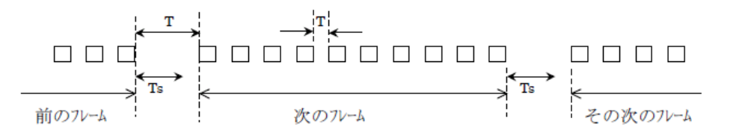
Previous frame
Next frame
Next frame

The silent interval (Ts) is specified in “Motor parameters”. Note that the unit of the parameter is a multiple of the basic interval (=3.5 Char). 1 Char is 10 bits.
The initial value of "Motor parameters" "Silent interval” is 1.

5.3 Communication delay time
It is possible to set a delay time after receiving a query (transmission frame from the master) before starting to send the response. This time is specified in “Motor parameters” “Minimum communication delay time”.
The initial value of "Motor parameters" “Minimum communication delay time” is “5ms”.

5.4 Response time
The time Tx from when the master sends the query to when this controller finishes sending the response is as follows. If the master re-sends the query, please wait for at least time Tx from the previous transmission before resending. (Tx does not include the query communication time)

Tx ＝ Ts + T0 + Td + (10 x Br / Kbr) ［ms］
Ts : Silent interval time
(1 / communication speed bps x (silent interval set value x 3.5 Char x 10 bit) )
T0 : Internal processing time (4ms) x 1.5 (safety factor)
Td : Communication delay time
Br : Number of Bytes of response messages
Kbr : Communication speed [kbps]

5.5 Wiring of serial IO connector (CN4) for LEC
A controller wiring example when one controller is connected to the higher-level communication device is shown below.
Communication device
Communication method: RS485

Name
SD+ (Transmission data +)
SD- (Transmission data -)
SG (Signal ground)

LEC controller
Plug for CN4 (modular connector 8P)
Recommended plug: TM21-88P(04) [Hirose Electric]
Name | Pin No.
EMG+ | 1
EMG- | 2
SD+ | 3
SD- | 4
EN_SW+ | 5
CON | 6
DC24V | 7
GND | 8

Shield
Caution
・If CON(6) and DC24V(7) are short circuited, movement instruction from serial IO becomes possible.
Also, stop signal "EMG+(1), EMG-(2)" becomes effective at this time. If necessary, connect a stop switch to EMG+(1), EMG-(2).
・EN_SW+ is a signal for the teaching box (LEC-T1). Do not connect it.
・For details of the connection with the higher-level equipment, please refer to the operation manual of the higher-level communication equipment.

Warning
・Enquire to SMC separately if connecting multiple controllers to the higher-level equipment.
・Power supply 0V of all controllers for communication and power supply 0V of the higher-level equipment should have the same potential.
・Be sure to turn power “off” before removing connectors, otherwise the controller may be damaged.
5.6 How to change parameters (example)
The procedure for changing “Communication speed”, “Silent interval” and “Minimum delay time” is shown below. Please follow steps 1 to 9.
(Example)
Communication speed | 38400 | ⇒ | 57600
Silent interval | 1 | ⇒ | 10
Minimum delay time | 5 | ⇒ | 50

① Start up the controller setting software in normal mode, click on “Help” (circled in red below) and select “Password”.
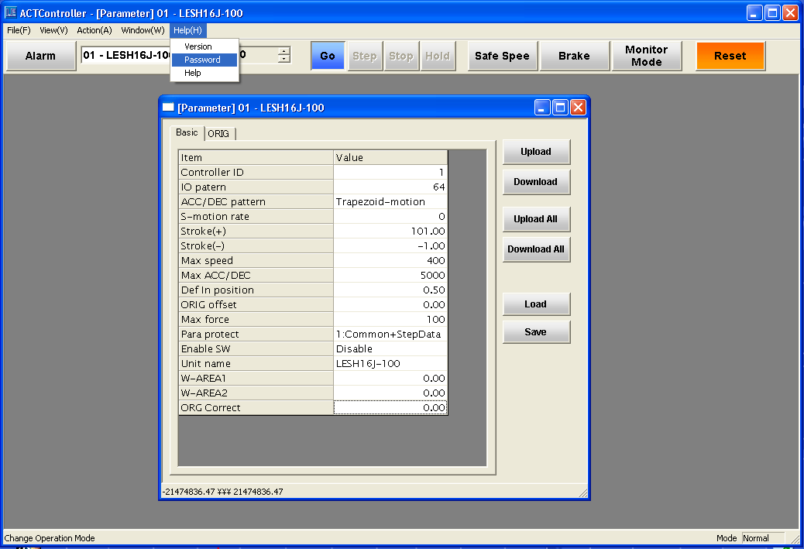

② The password input screen is displayed. Input
password
and click on “OK”.
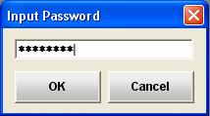

If the input is successful, “Manager” is displayed on the lower right of the screen.

③ “3: Basic + extended + step” is added to the Parameter Protect of the basic parameters. Select “3: Basic + extended + step” and click on “Download”.
④
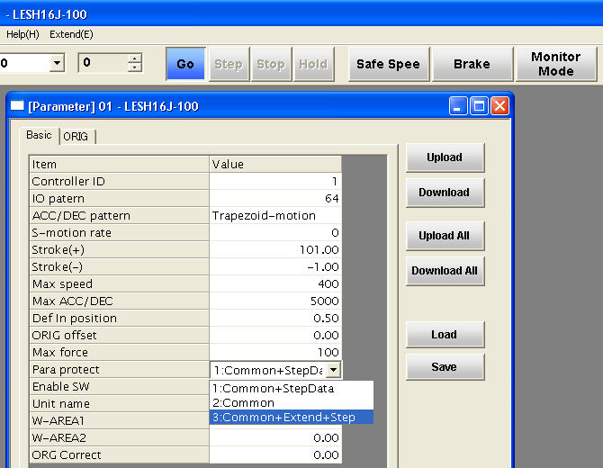

② Download
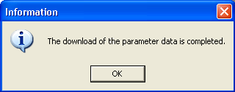

(Download complete)

① Select

- The extended parameters are displayed. Select the motor parameter.
(It is possible to change “Communication speed”, “Silent interval” and “Minimum delay time”.)
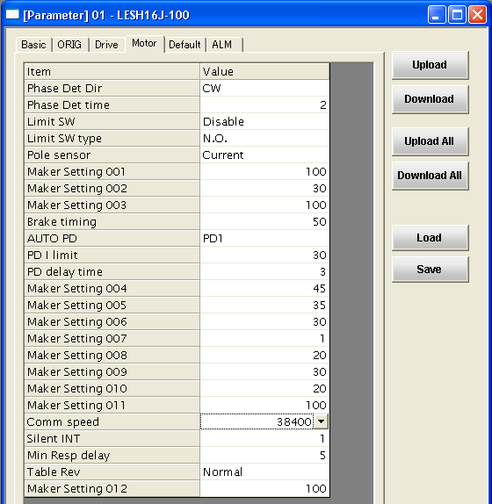

⑤ Change the “Communication speed”, “Silent interval” and “Minimum delay time” values and click on “Download”. The values will be reflected by the controller.
(*When the values are changed the text changes to blue. When downloaded, the changed values turn black.)
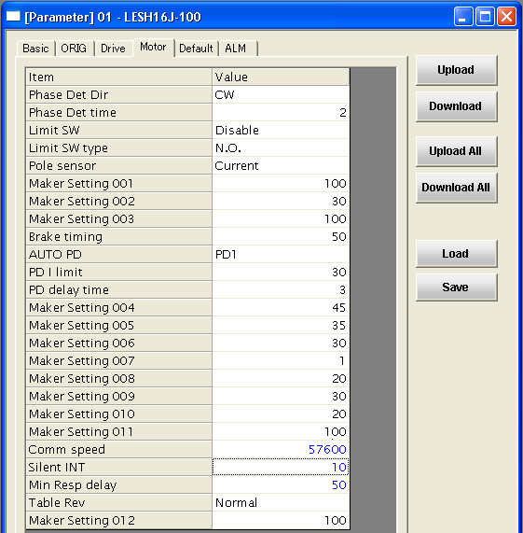
② Download

(Download complete)

① Input values (text changes to blue)

⑥ To confirm, after “download” click on “upload”.
Confirm that the values you set have been recorded.
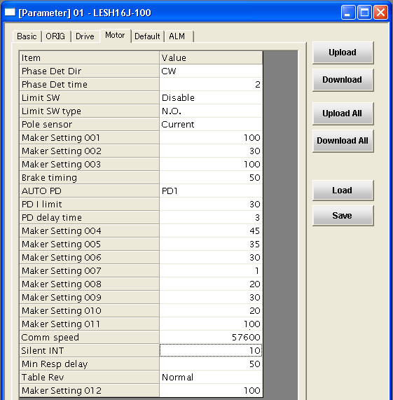
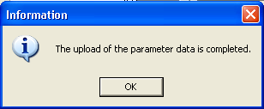

(Upload complete)

* After downloading, text turns black

⑦ If the set values are recorded, select [1: Basic + step data] of the Parameter Protect of basic parameters, and click on “Download”.
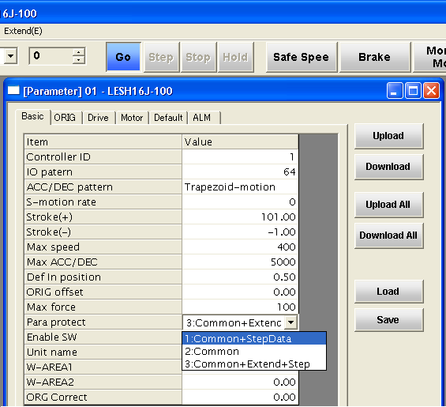

② Download

(Download complete)

① Select

- To confirm, after “download” click on “upload”.
If [1: Basic + step data] of the Parameter Protect of basic parameters is registered, the parameter change work is completed.
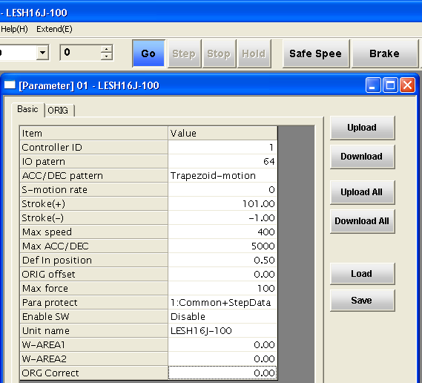

(Upload complete)

Warning
・This change involves changing extended parameters. Do not change parameters that are not mentioned in the procedure.
・Do not click on [Download All]. Other parameters will be changed as a batch, so parameters that cannot be changed may be changed, causing ignition, malfunction and damage to the actuator and controller.

6. Function details

6.1 Read output signal (01h) * Broadcast not possible
Performs reading of Y contact.
(Example) Read 16 bits of Y10(h)～Y1F(h) from controller with ID=3.
●Query
 |  |  | Example
1 | Address |  | 03
2 | Function |  | 01
3 | DATA | Read start number (H) | 00
4 | DATA | Read start number (L) | 10
5 | DATA | Read points (H) | 00
6 | DATA | Read points (L) | 10
7 | CRC16 (L) |  | Calculated value
8 | CRC16 (H) |  | Calculated value

●Normal response
 |  |  | Example | →
1 | Address |  | 03
2 | Function |  | 01
3 | DATA | Data bytes | 02 | → | bit7 |  |  |  |  |  |  | bit0
4 | DATA | Data 1 | 00 | → | Y17 | Y16 | Y15 | Y14 | Y13 | Y12 | Y11 | Y10
5 | DATA | Data 2 | 12 | → | Y1F | Y1E | Y1D | Y1C | Y1B | Y1A | Y19 | Y18
7 | CRC16 (L) |  | Calculated value | →
8 | CRC16 (H) |  | Calculated value | →
The examples of data 1 to 3 above are when Y1F～Y10 = 0001 0010 0000 0000.

●Abnormal response
 |  | Example
1 | Address | 03
2 | Function (*1) | 81
3 | Error code (*2) | 01
7 | CRC16 (L) | Calculated value
8 | CRC16 (H) | Calculated value
(*1) The function code of the abnormal response is the value when MSB(Most Significant Bit) of the function code of the query is 1.
(*2) Refer to “8.8 Error Codes” for details of error codes.
6.2 Read input signal (02h) * Broadcast not possible
Performs reading of X contact. (Format is the same as reading output signal (01h)).
(Example) Read 16 bits of X40～X4F(h) from controller with ID=3.
●Query
 |  |  | Example
1 | Address |  | 03
2 | Function |  | 02
3 | DATA | Read start number (H) | 00
4 | DATA | Read start number (L) | 40
5 | DATA | Read points (H) | 00
6 | DATA | Read points (L) | 10
7 | CRC16 (L) |  | Calculated value
8 | CRC16 (H) |  | Calculated value

●Normal response
 |  |  | Example | →
1 | Address |  | 03
2 | Function |  | 02
3 | DATA | Data bytes | 02 | → | bit7 |  |  |  |  |  |  | bit0
4 | DATA | Data 1 | 04 | → | X47 | X46 | X45 | X44 | X43 | X42 | X41 | X40
5 | DATA | Data 2 | 8E | → | X4F | X4E | X4D | X4C | X4B | X4A | X49 | X48
7 | CRC16 (L) |  | Calculated value | →
8 | CRC16 (H) |  | Calculated value | →
The examples of data 1 to 2 above are when X4F～X40 = 1000 1110 0000 0100.

●Abnormal response
 |  | Example
1 | Address | 03
2 | Function | 82
3 | Error code | 01
7 | CRC16 (L) | Calculated value
8 | CRC16 (H) | Calculated value
6.3 Read data (03h) * Broadcast not possible
Performs reading of parameters and other data.
(Example) Read 4 words of D0400～D0403 from controller with ID=3. (2 bytes = 1 word)
●Query
 |  |  | Example
1 | Address |  | 03
2 | Function |  | 03
3 | DATA | Read start number (H) | 04
4 | DATA | Read start number (L) | 00
5 | DATA | Read words (H) | 00
6 | DATA | Read words (L) | 04
7 | CRC16 (L) |  | Calculated value
8 | CRC16 (H) |  | Calculated value

●Normal response
 |  |  | Example
1 | Address |  | 03
2 | Function |  | 03
3 | DATA | Data bytes | 08
4 | DATA | word1 (H) | 00 | D0400 | Operation method  (For 1h)
5 | DATA | word1 (L) | 01 | D0400
6 | DATA | word2 (H) | 00 | D0401 | Speed  (For 28h)
7 | DATA | word2 (L) | 28 | D0401
8 | DATA | word3 (H) | 00 | D0402 | Position  (For 640h)
9 | DATA | word3 (L) | 00 | D0402
10 | DATA | word4 (H) | 06 | D0403
11 | DATA | word4 (L) | 40 | D0403
12 | CRC16 (L) |  | Calculated value
13 | CRC16 (H) |  | Calculated value

●Abnormal response
 |  | Example
1 | Address | 03
2 | Function | 83
3 | Error code | 01
7 | CRC16 (L) | Calculated value
8 | CRC16 (H) | Calculated value
6.4 Forced signal output (05h) * Broadcast possible
Performs writing of 1 point of Y contact.
(Example) Turn ON Y19 (SVON) of controller with ID=3.
●Query
 |  |  | Example
1 | Address |  | 03
2 | Function |  | 05
3 | DATA | Contact number (H) | 00
4 | DATA | Contact number (L) | 19
5 | DATA | Contact state (H) | FF | ON : FF00h  OFF: 0000h
6 | DATA | Contact state (L) | 00 | ON : FF00h  OFF: 0000h
7 | CRC16 (L) |  | Calculated value | ON : FF00h  OFF: 0000h
8 | CRC16 (H) |  | Calculated value | ON : FF00h  OFF: 0000h

●Normal response
 |  |  | Example
1 | Address |  | 03
2 | Function |  | 05
3 | DATA | Contact number (H) | 00
4 | DATA | Contact number (L) | 19
5 | DATA | Contact state (H) | FF
6 | DATA | Contact state (L) | 00
7 | CRC16 (L) |  | Calculated value
8 | CRC16 (H) |  | Calculated value

●Abnormal response
 |  | Example
1 | Address | 03
2 | Function | 85
3 | Error code | 01
7 | CRC16 (L) | Calculated value
8 | CRC16 (H) | Calculated value

6.5 Echo back (08h) * Broadcast not possible
Performs communication test by echo back.
(Example) Perform echo back test for controller with ID=3.
●Query
 |  |  | Example
1 | Address |  | 03
2 | Function |  | 08
3 | DATA | Test code (H) | 00 | Specify 0000h
4 | DATA | Test code (L) | 00 | Specify 0000h
5 | DATA | Data (H) | 12 | Arbitrary
6 | DATA | Data (L) | 34 | Arbitrary
7 | CRC16 (L) |  | Calculated value | Arbitrary
8 | CRC16 (H) |  | Calculated value | Arbitrary

●Normal response
 |  |  | Example
1 | Address |  | 03
2 | Function |  | 08
3 | DATA | Test code (H) | 00
4 | DATA | Test code (L) | 00
5 | DATA | Data (H) | 12 | Received data is returned
6 | DATA | Data (L) | 34 | Received data is returned
7 | CRC16 (L) |  | Calculated value
8 | CRC16 (H) |  | Calculated value

●Abnormal response
 |  | Example
1 | Address | 03
2 | Function | 88
3 | Error code | 01
7 | CRC16 (L) | Calculated value
8 | CRC16 (H) | Calculated value
6.6 Output signals batch writing (0Fh) * Broadcast possible
Performs batch writing of Y contacts. (Writing data format is the same as the reading data format of output signal (01h).
(Example) Batch write to Y10～Y1F of controller with ID=3.
●Query
 |  |  | Example | →  * Set contacts Y16, Y17, Y1D, Y1E, Y1F to “0”.
1 | Address |  | 03
2 | Function |  | 0F
2 | DATA | Write start number (H) | 00
3 | DATA | Write start number (L) | 10
4 | DATA | Write points (H) | 00
5 | DATA | Write points (L) | 10
6 | DATA | Number of data | 02 | →  * Set contacts Y16, Y17, Y1D, Y1E, Y1F to “0”. | bit7 |  |  |  |  |  |  | bit0
7 | DATA | Set data 1 | 0F | →  * Set contacts Y16, Y17, Y1D, Y1E, Y1F to “0”. | Y17 | Y16 | Y15 | Y14 | Y13 | Y12 | Y11 | Y10
8 | DATA | Set data 2 | 12 | →  * Set contacts Y16, Y17, Y1D, Y1E, Y1F to “0”. | Y1F | Y1E | Y1D | Y1C | Y1B | Y1A | Y19 | Y18
9 | CRC16 (L) |  | Calculated value | →  * Set contacts Y16, Y17, Y1D, Y1E, Y1F to “0”.
10 | CRC16 (H) |  | Calculated value | →  * Set contacts Y16, Y17, Y1D, Y1E, Y1F to “0”.
The examples of data 1 to 2 above are when Y1F～Y10 = 0001 0010 0000 1111.

●Normal response
 |  |  | Example
1 | Address |  | 03
2 | Function |  | 0F
3 | DATA | Write start number (H) | 00
4 | DATA | Write start number (L) | 00
5 | DATA | Write points (H) | 00
6 | DATA | Write points (L) | 0E
7 | CRC16 (L) |  | Calculated value
8 | CRC16 (H) |  | Calculated value

●Abnormal response
 |  | Example
1 | Address | 03
2 | Function | 8F
3 | Error code | 01
7 | CRC16 (L) | Calculated value
8 | CRC16 (H) | Calculated value

6.7 Write data (10h) * Broadcast possible
Performs writing of data.
(Format of writing data is the same as reading data format of data reading (03h).)
(Example) Write 4 words of D0410～D0413 to controller with ID=3. (2 Bytes = 1 word)
●Query
 |  |  | Example
1 | Address |  | 03
2 | Function |  | 10
3 | DATA | Write start number (H) | 04
4 | DATA | Write start number (L) | 10
5 | DATA | Words written (H) | 00
6 | DATA | Words written (L) | 04
7 | DATA | Number of data | 08
8 | DATA | word1 (H) | 00 | D0410 | Operation method  (For 1h)
9 | DATA | word1 (L) | 01 | D0410 | Operation method  (For 1h)
10 | DATA | word2 (H) | 00 | D0411 | Speed  (For 28h)
11 | DATA | word2 (L) | 28 | D0411 | Speed  (For 28h)
 | DATA | word3 (H) | 00 | D0412 | Position  (For 640h)
 | DATA | word3 (L) | 00 | D0412 | Position  (For 640h)
12 | DATA | word4 (H) | 06 | D0413 | Position  (For 640h)
13 | DATA | word4 (L) | 40 | D0413 | Position  (For 640h)
14 | CRC16 (L) |  | Calculated value
15 | CRC16 (H) |  | Calculated value

●Normal response
 |  |  | Example
1 | Address |  | 03
2 | Function |  | 10
3 | DATA | Write start number (H) | 04
4 | DATA | Write start number (L) | 10
5 | DATA | Words written (H) | 00
6 | DATA | Words written (L) | 04
7 | CRC16 (L) |  | Calculated value
8 | CRC16 (H) |  | Calculated value

●Abnormal response
 |  | Example
1 | Address | 03
2 | Function | 90
3 | Error code | 01
7 | CRC16 (L) | Calculated value
8 | CRC16 (H) | Calculated value

6.8 Error codes
Error codes and the factors causing them to be generated are shown below.
Error code | Name | Factors
01 | Illegal function | An undefined function code was specified.
02 | Outside address range | 1) An address outside the range was set in the read or write start address.  2) In echo back, the test code was not 0000h.  ・ Writing was attempted to a number (address) not permitted for writing.  ・ Writing was attempted of a parameter not permitted in the Parameter Protect setting.  ・ Writing was attempted of a parameter not permitted due to the operation mode (parallel/ serial).
  Warning
  Use only the range whose use is permitted in this document. Other addresses are in the manufacturer’s setting range. If the manufacturer’s setting range is changed, it could cause damage to the controller and actuator.
03 | Outside access point range | 1) The number of points set meant that the read or write last number was outside the range.  2) There was an instruction meaning that the size of “Data” in the communication frame exceeded 256 Bytes.  3) In Function 05 (Forced signal output), the data of the specified “terminal state” was not FF00h(ON) or 0000h (OFF).  4) In Function 0F (Output signals batch writing), the specified “Write points” exceeded 256.  5) The read or write specified size was 0.

7. Memory map
The memory map of the LEC controller is shown below.
Only use the valid addresses and flags. Do not use any others (including undefined and unused).

7.1 State data
The state of the electrical actuator (current location, current speed, and current thrust) is located in address D9000-D9006.

Address | Parameter name | Byte | Setting range | Data type | Contents
D9000 | Current position | 4 | ±2147483647 | Integer | Displays the current position (Units: 0.01mm)
D9002 | Current speed | 2 | 0～65535 | Integer | Displays the current speed (Units: mm/sec)
D9003 | Current thrust | 2 | 0～300 | Integer | Displays the current thrust (Units: %)
D9004 | Target position | 4 | ±2147483647 | Integer | Displays the target position (Units: 0.01mm)
D9006 | Driving data No. | 2 | 0～63 | Integer | Displays the step data no. that is completed or driving

② “Equipment name”(basic parameter ”Equipment name”) is stored in Address D000e.
Address | Parameter name | Byte | Setting range | Data type | Contents
D000e | Equipment name | 16 | 14 letters | Letter | Registered by ASCII code
7.2 Internal flags
The status information of the motor controller can be confirmed by using address D9084 (X40 to X4F). The internal flags of the electrical actuator are operated using address D90c1 (Y10～Y1F) and D90c2 (Y30～Y3F).

● Internal flags (status flags)
Flag name |  | Read | Write | Contents
X40 | OUT0 | ○ | × | As internal processing of controller (regardless of parallel/ serial), ON when the functions on the left are output
X41 | OUT1 | ○ | ×
X42 | OUT2 | ○ | ×
X43 | OUT3 | ○ | ×
X44 | OUT4 | ○ | ×
X45 | OUT5 | ○ | ×
X46 | ― | ○ | × | Cannot be used
X47
X48 | BUSY | ○ | × | As internal processing of controller (regardless of parallel/ serial), ON when the functions on the left are output  But unlike parallel I/O driving, ESTOP and ALARM signals have positive logic.  E-STOP: ON when EMG stops.  ALARM: ON when alarm is generated.
X49 | SVRE | ○ | ×
X4A | SETON | ○ | ×
X4B | INP | ○ | ×
X4C | AREA | ○ | ×
X4D | WAREA | ○ | ×
X4E | ESTOP | ○ | ×
X4F | ALARM | ○ | ×

● Internal flags (state change flags)
Flag name |  | Read | Write | Contents
Y10 | IN0 | ○ | ○ | ●When Read  Displays the instruction state when in serial driving mode.  (ON: 1, OFF: 0)  ●When Write  Gives instructions to controller.  Only valid when in serial driving mode.  (ON: 1, OFF: 0)
Y11 | IN1 | ○ | ○
Y12 | IN2 | ○ | ○
Y13 | IN3 | ○ | ○
Y14 | IN4 | ○ | ○
Y15 | IN5 | ○ | ○
Y16 | ― | ○ | ○ | Cannot be used
Y17 | ― | ○ | ○ | Cannot be used
Y18 | HOLD | ○ | ○ | ●When Read  Displays the instruction state when in serial driving mode.  (ON: 1, OFF: 0)  ●When Write  Gives instructions to controller.  Only valid when in serial driving mode.  (ON: 1, OFF: 0)
Y19 | SVON | ○ | ○
Y1A | DRIVE | ○ | ○
Y1B | RESET | ○ | ○
Y1C | SETUP | ○ | ○
Y1D | JOG- | ○ | ○ | Move to – direction by JOG operation. (1: move, 2: stop)
Y1E | JOG+ | ○ | ○ | Move to + direction by JOG operation. (1: move, 2: stop)
Y1F | ― | ○ | ○ | Cannot be used
Ｙ30 | Input invalid flag  (*1) (*2) | ○ | ○ | 0: Parallel input driving mode (parallel output end normal operation)  1: Serial input driving mode (parallel output end output prohibited)
Y31  ～Y3F | ― | ○ | × | Cannot be used (cannot be changed)
(*1) The driving input mode (parallel/ serial) is switched in Y30.
(*2) When Y30 is specified from 0 to 1, the parallel input state before the instruction is continued. Conversely, when Y30 is specified from 1 to 0, the state of the parallel input terminal is reflected immediately.

7.3 Step data
Address |  | Parameter name | Byte | Input range | Data type | Contents
D0400 to  D07FF |  | Step data (No.0～63)  32byte x 64 | 2048 | - | - | -
(Example)
When address is Step data No.0
Address | Parameter name |  | Byte | Input range | Data type | Contents
D0400 | Movement mode |  | 2 | 0～255 | Integer | 1: Absolute co-ordinate movement (ABS)  2: Relative co-ordinate movement (INC)
D0401 | Speed |  | 2 | 1～65535 | Integer | Sets the speed of movement to the target position or pushing start position.  (Units: mm/s)
D0402 | Position |  | 4 | ±21474  83647 | Integer | Sets the target position or pushing start position. (Units: 0.01mm)
D0404 | Acceleration |  | 2 | 1～65535 | Integer | Sets the acceleration to the movement speed. (Units: mm/s²)
D0405 | Deceleration |  | 2 | 1～65535 | Integer | Sets the deceleration to the movement speed. (Units: mm/s²)
D0406 | Pushing force |  | 2 | 0～100 | Integer | Selects pushing operation or positioning operation from the set value.  0: Positioning operation  １ to 100: Pushing operation torque setting (unit 1%)
D0407 | Trigger LV |  | 2 | 0～100 | Integer | When in pushing operation, if thrust above this value is generated, INP output becomes ON.  This parameter is set to a value below the pushing thrust. (Units: %)
D0408 | Pushing speed |  | 2 | 1～65535 | Integer | Movement speed when pushing. (Units: mm/s)
D0409 | Moving force |  | 2 | 0～300 | Integer | Maximum thrust when positioning. (Units: %)
D040a | Area output end 1 (Area 1) |  | 4 | ±21474  83647 | Integer | Condition for AREA output to be ON. (Units: 0.01mm)  If the position is in the range between Area output end 1 (Area 1) and Area output end 2 (Area 2), the AREA output turns ON.
D040c | Area output end 2 (Area 2) |  | 4 | ±21474  83647 | Integer
D040e | In position |  | 4 | 1～21474  83647 | Integer | The functions are different for pushing driving and positioning driving.  ●Positioning driving:  Positioning width (Units: 0.01mm)  ●Pushing driving:  Pushing width (Units: 0.01mm)

7.4 Alarm data
Alarm history is controlled on a group basis classifying 8 generated alarms （8byte） as one group and stores 16 groups of alarms from Group 0 to Group 15.
Address | Parameter name | Byte | Input range | Data type | Contents
D0380  to  D03BF | Alarm history  Group 0 to 15  Group15 | 128 | 0 to 255 | Integer | Stores alarm history (＊1)
（＊1） Group 0 of alarm history shows the latest alarm (being generated) and as the group No. increases, the generated alarm history goes back.

7.5 Data format for alarm history
Generated alarm 6
Generated alarm 5
Generated alarm 3
Generated alarm 4
Generated alarm 2
Generated alarm 1
Generated alarm 7
Adress
D0380
Latest
Latest
D0383
D0384
Earliest
D0387
・
・
・
D03BC
D03BF
Earliest
Group 0
Group 1
Group 15
Parameter
Generated alarm 8
No. of the bytes in one group
～
Omitted
～
～
～
～
～

8. CRC calculation method
Data for calculation is all message data. Data is calculated in units of 2 Bytes (16 bits).
Step | Calculation method
【I】 | Preload ”FFFFh”.
【II】 | ExOR the 1 Byte value from the start of the message data (1st value) and the value of 【I】.
【III】 | Shift the result of 【II】 by 1 bit in the lowest bit direction, and set 0 to the highest bit.
【IV】 | As a result of 【III】, if the bit obtained is 1, then ExOR ”A001h” to the value of 【III】. (If the bit obtained is 0, do not ExOR.)
【V】 | Repeat the contents of 【III】 to 【IV】 above until 8 bit shift.
【VI】 | ExOR the result of 【V】 and the value of the next 1 Byte of the message data (2nd value).
【VII】 | Repeat the contents of 【III】 to 【VI】 for the remainder of the message (3rd value to last value).
【VIII】 | The 2 Byte data of the result of 【VII】 becomes the CRC data.
Caution
When adding CRC to the message, be careful of the order of High Byte “CRC16(H)” and Low Byte ”CRC16(L)” of the result of ⑧.

【Calculation example】
Calculate the CRC check data when communication test is done by echo back (Function 08: test code 0000h, test data 5AA5h) for Address 20.

Address | 20 | → | 1st value
Function | 08 | → | 2nd value
Data | 00 | → | 3rd value
 | 00 | → | 4th value
 | 5A | → | 5th value
 | A5 | → | 6th value (final value)

 |  | High Byte “CRC16(H)” |  |  |  |  |  |  |  | Low Byte “CRC16(L)” |  |  |  |  |  |  |  |  | Step
 |  | 15 | 14 | 13 | 12 | 11 | 10 | 9 | 8 | 7 | 6 | 5 | 4 | 3 | 2 | 1 | 0 | flag | Step
1 | FFFFh load | 1 | 1 | 1 | 1 | 1 | 1 | 1 | 1 | 1 | 1 | 1 | 1 | 1 | 1 | 1 | 1 |  | 【I】
2 | 1st value(20h) | 0 | 0 | 0 | 0 | 0 | 0 | 0 | 0 | 0 | 0 | 1 | 0 | 0 | 0 | 0 | 0 |  | 【II】
3 | No.1 xor No.2 | 1 | 1 | 1 | 1 | 1 | 1 | 1 | 1 | 1 | 1 | 0 | 1 | 1 | 1 | 1 | 1 |  | 【II】
4 | Shift>>1 | 0 | 1 | 1 | 1 | 1 | 1 | 1 | 1 | 1 | 1 | 1 | 0 | 1 | 1 | 1 | 1 | 1 | 【III】
5 | No.4 xor a001h | 1 | 1 | 0 | 1 | 1 | 1 | 1 | 1 | 1 | 1 | 1 | 0 | 1 | 1 | 1 | 0 |  | 【IV】
6 | Shift>>2 | 0 | 0 | 1 | 1 | 0 | 1 | 1 | 1 | 1 | 1 | 1 | 1 | 1 | 0 | 1 | 1 | 1 | 【V】
7 | No.6 xor a001h | 1 | 0 | 0 | 1 | 0 | 1 | 1 | 1 | 1 | 1 | 1 | 1 | 1 | 0 | 1 | 0 |  | 【V】
8 | Shift>>2 | 0 | 0 | 1 | 0 | 0 | 1 | 0 | 1 | 1 | 1 | 1 | 1 | 1 | 1 | 1 | 0 | 1 | 【V】
9 | No.8 xor a001h | 1 | 0 | 0 | 0 | 0 | 1 | 0 | 1 | 1 | 1 | 1 | 1 | 1 | 1 | 1 | 1 |  | 【V】
10 | shift>>1 | 0 | 1 | 0 | 0 | 0 | 0 | 1 | 0 | 1 | 1 | 1 | 1 | 1 | 1 | 1 | 1 | 1 | 【V】
11 | No.10 xor a001h | 1 | 1 | 1 | 0 | 0 | 0 | 1 | 0 | 1 | 1 | 1 | 1 | 1 | 1 | 1 | 0 |  | 【V】
12 | shift>>2 | 0 | 0 | 1 | 1 | 1 | 0 | 0 | 0 | 1 | 0 | 1 | 1 | 1 | 1 | 1 | 1 | 1 | 【V】
13 | No.12 xor a001h | 1 | 0 | 0 | 1 | 1 | 0 | 0 | 0 | 1 | 0 | 1 | 1 | 1 | 1 | 1 | 0 |  | 【V】
14 | 2nd value(08h) | 0 | 0 | 0 | 0 | 0 | 0 | 0 | 0 | 0 | 0 | 0 | 0 | 1 | 0 | 0 | 0 |  | 【VI】
15 | No.13 xor No.15 | 1 | 0 | 0 | 1 | 1 | 0 | 0 | 0 | 1 | 0 | 1 | 1 | 0 | 1 | 1 | 0 |  | 【VI】
16 | shift>>2 | 0 | 0 | 1 | 0 | 0 | 1 | 1 | 0 | 0 | 0 | 1 | 0 | 1 | 1 | 0 | 1 | 1 | 【VI】
17 | No.16 xor a001h | 1 | 0 | 0 | 0 | 0 | 1 | 1 | 0 | 0 | 0 | 1 | 0 | 1 | 1 | 0 | 0 |  | 【VI】
18 | shift>>3 | 0 | 0 | 0 | 1 | 0 | 0 | 0 | 0 | 1 | 1 | 0 | 0 | 0 | 1 | 0 | 1 | 1 | 【VI】
19 | No.18 xor a001h | 1 | 0 | 1 | 1 | 0 | 0 | 0 | 0 | 1 | 1 | 0 | 0 | 0 | 1 | 0 | 0 |  | 【VI】
20 | shift>>3 | 0 | 0 | 0 | 1 | 0 | 1 | 1 | 0 | 0 | 0 | 0 | 1 | 1 | 0 | 0 | 0 | 1 | 【VI】
21 | No.20 xor a001h | 1 | 0 | 1 | 1 | 0 | 1 | 1 | 0 | 0 | 0 | 0 | 1 | 1 | 0 | 0 | 1 |  | 【VI】
22 | 3rd value(00h) | 0 | 0 | 0 | 0 | 0 | 0 | 0 | 0 | 0 | 0 | 0 | 0 | 0 | 0 | 0 | 0 |  | 【VII】
23 | No.21 xor No.22 | 1 | 0 | 1 | 1 | 0 | 1 | 1 | 0 | 0 | 0 | 0 | 1 | 1 | 0 | 0 | 1 |  | 【VII】
24 | shift>>1 | 0 | 1 | 0 | 1 | 1 | 0 | 1 | 1 | 0 | 0 | 0 | 0 | 1 | 1 | 0 | 0 | 1 | 【VII】
25 | No.24 xor a001h | 1 | 1 | 1 | 1 | 1 | 0 | 1 | 1 | 0 | 0 | 0 | 0 | 1 | 1 | 0 | 1 |  | 【VII】
26 | shift>>1 | 0 | 1 | 1 | 1 | 1 | 1 | 0 | 1 | 1 | 0 | 0 | 0 | 0 | 1 | 1 | 0 | 1 | 【VII】
27 | No.26 xor a001h | 1 | 1 | 0 | 1 | 1 | 1 | 0 | 1 | 1 | 0 | 0 | 0 | 0 | 1 | 1 | 1 |  | 【VII】
28 | shift>>1 | 0 | 1 | 1 | 0 | 1 | 1 | 1 | 0 | 1 | 1 | 0 | 0 | 0 | 0 | 1 | 1 | 1 | 【VII】
29 | No.28 xor a001h | 1 | 1 | 0 | 0 | 1 | 1 | 1 | 0 | 1 | 1 | 0 | 0 | 0 | 0 | 1 | 0 |  | 【VII】
30 | shift>>2 | 0 | 0 | 1 | 1 | 0 | 0 | 1 | 1 | 1 | 0 | 1 | 1 | 0 | 0 | 0 | 0 | 1 | 【VII】
31 | No.30 xor a001h | 1 | 0 | 0 | 1 | 0 | 0 | 1 | 1 | 1 | 0 | 1 | 1 | 0 | 0 | 0 | 1 |  | 【VII】
32 | shift>>1 | 0 | 1 | 0 | 0 | 1 | 0 | 0 | 1 | 1 | 1 | 0 | 1 | 1 | 0 | 0 | 0 | 1 | 【VII】
33 | No.32 xor a001h | 1 | 1 | 1 | 0 | 1 | 0 | 0 | 1 | 1 | 1 | 0 | 1 | 1 | 0 | 0 | 1 |  | 【VII】
34 | shift>>1 | 0 | 1 | 1 | 1 | 0 | 1 | 0 | 0 | 1 | 1 | 1 | 0 | 1 | 1 | 0 | 0 | 1 | 【VII】
35 | No.34 xor a001h | 1 | 1 | 0 | 1 | 0 | 1 | 0 | 0 | 1 | 1 | 1 | 0 | 1 | 1 | 0 | 1 |  | 【VII】
36 | shift>>1 | 0 | 1 | 1 | 0 | 1 | 0 | 1 | 0 | 0 | 1 | 1 | 1 | 0 | 1 | 1 | 0 | 1 | 【VII】
37 | No.36 xor a001h | 1 | 1 | 0 | 0 | 1 | 0 | 1 | 0 | 0 | 1 | 1 | 1 | 0 | 1 | 1 | 1 |  | 【VII】
38 | 4th value(00h) | 0 | 0 | 0 | 0 | 0 | 0 | 0 | 0 | 0 | 0 | 0 | 0 | 0 | 0 | 0 | 0 |  | 【VII】
39 | No.37 xor No.38 | 1 | 1 | 0 | 0 | 1 | 0 | 1 | 0 | 0 | 1 | 1 | 1 | 0 | 1 | 1 | 1 |  | 【VII】
40 | shift>>1 | 0 | 1 | 1 | 0 | 0 | 1 | 0 | 1 | 0 | 0 | 1 | 1 | 1 | 0 | 1 | 1 | 1 | 【VII】
41 | No.40 xor a001h | 1 | 1 | 0 | 0 | 0 | 1 | 0 | 1 | 0 | 0 | 1 | 1 | 1 | 0 | 1 | 0 |  | 【VII】
42 | shift>>2 | 0 | 0 | 1 | 1 | 0 | 0 | 0 | 1 | 0 | 1 | 0 | 0 | 1 | 1 | 1 | 0 | 1 | 【VII】
43 | No.42 xor a001h | 1 | 0 | 0 | 1 | 0 | 0 | 0 | 1 | 0 | 1 | 0 | 0 | 1 | 1 | 1 | 1 |  | 【VII】
44 | shift>>1 | 0 | 1 | 0 | 0 | 1 | 0 | 0 | 0 | 1 | 0 | 1 | 0 | 0 | 1 | 1 | 1 | 1 | 【VII】
45 | No.44 xor a001h | 1 | 1 | 1 | 0 | 1 | 0 | 0 | 0 | 1 | 0 | 1 | 0 | 0 | 1 | 1 | 0 |  | 【VII】
46 | shift >>2 | 0 | 0 | 1 | 1 | 1 | 0 | 1 | 0 | 0 | 0 | 1 | 0 | 1 | 0 | 0 | 1 | 1 | 【VII】
47 | No.46 xor a001h | 1 | 0 | 0 | 1 | 1 | 0 | 1 | 0 | 0 | 0 | 1 | 0 | 1 | 0 | 0 | 0 |  | 【VII】
48 | shift>>2 | 0 | 0 | 1 | 0 | 0 | 1 | 1 | 0 | 1 | 0 | 0 | 0 | 1 | 0 | 1 | 0 |  | 【VII】
49 | 5th value(5Ah) | 0 | 0 | 0 | 0 | 0 | 0 | 0 | 0 | 0 | 1 | 0 | 1 | 1 | 0 | 1 | 0 |  | 【VII】
50 | No.48 xor No.49 | 0 | 0 | 1 | 0 | 0 | 1 | 1 | 0 | 1 | 1 | 0 | 1 | 0 | 0 | 0 | 0 |  | 【VII】
51 | shift>>5 | 0 | 0 | 0 | 0 | 0 | 0 | 0 | 1 | 0 | 0 | 1 | 1 | 0 | 1 | 1 | 0 | 1 | 【VII】
52 | No.51 xor a001h | 1 | 0 | 1 | 0 | 0 | 0 | 0 | 1 | 0 | 0 | 1 | 1 | 0 | 1 | 1 | 1 |  | 【VII】
53 | shift>>1 | 0 | 1 | 0 | 1 | 0 | 0 | 0 | 0 | 1 | 0 | 0 | 1 | 1 | 0 | 1 | 1 | 1 | 【VII】
54 | No.53 xor a001h | 1 | 1 | 1 | 1 | 0 | 0 | 0 | 0 | 1 | 0 | 0 | 1 | 1 | 0 | 1 | 0 |  | 【VII】
55 | shift>>2 | 0 | 0 | 1 | 1 | 1 | 1 | 0 | 0 | 0 | 0 | 1 | 0 | 0 | 1 | 1 | 0 | 1 | 【VII】
56 | No.55 xor a001h | 1 | 0 | 0 | 1 | 1 | 1 | 0 | 0 | 0 | 0 | 1 | 0 | 0 | 1 | 1 | 1 |  | 【VII】
57 | 6th value(A5h) | 0 | 0 | 0 | 0 | 0 | 0 | 0 | 0 | 1 | 0 | 1 | 0 | 0 | 1 | 0 | 1 |  | 【VII】
58 | No.56 xor No.57 | 1 | 0 | 0 | 1 | 1 | 1 | 0 | 0 | 1 | 0 | 0 | 0 | 0 | 0 | 1 | 0 |  | 【VII】
59 | shift>>2 | 0 | 0 | 1 | 0 | 0 | 1 | 1 | 1 | 0 | 0 | 1 | 0 | 0 | 0 | 0 | 0 | 1 | 【VII】
60 | No.59 xor a001h | 1 | 0 | 0 | 0 | 0 | 1 | 1 | 1 | 0 | 0 | 1 | 0 | 0 | 0 | 0 | 1 |  | 【VII】
61 | shift>>1 | 0 | 1 | 0 | 0 | 0 | 0 | 1 | 1 | 1 | 0 | 0 | 1 | 0 | 0 | 0 | 0 | 1 | 【VII】
62 | No.61 xor a001h | 1 | 1 | 1 | 0 | 0 | 0 | 1 | 1 | 1 | 0 | 0 | 1 | 0 | 0 | 0 | 1 |  | 【VII】
63 | shift>>1 | 0 | 1 | 1 | 1 | 0 | 0 | 0 | 1 | 1 | 1 | 0 | 0 | 1 | 0 | 0 | 0 | 1 | 【VII】
64 | No.63 xor a001h | 1 | 1 | 0 | 1 | 0 | 0 | 0 | 1 | 1 | 1 | 0 | 0 | 1 | 0 | 0 | 1 |  | 【VII】
65 | shift>>1 | 0 | 1 | 1 | 0 | 1 | 0 | 0 | 0 | 1 | 1 | 1 | 0 | 0 | 1 | 0 | 0 | 1 | 【VII】
66 | No.65 xor a001h | 1 | 1 | 0 | 0 | 1 | 0 | 0 | 0 | 1 | 1 | 1 | 0 | 0 | 1 | 0 | 1 |  | 【VII】
67 | shift>>1 | 0 | 1 | 1 | 0 | 0 | 1 | 0 | 0 | 0 | 1 | 1 | 1 | 0 | 0 | 1 | 0 | 1 | 【VII】
68 | No.67 xor a001h | 1 | 1 | 0 | 0 | 0 | 1 | 0 | 0 | 0 | 1 | 1 | 1 | 0 | 0 | 1 | 1 |  | 【VII】
69 | shift>>1 | 0 | 1 | 1 | 0 | 0 | 0 | 1 | 0 | 0 | 0 | 1 | 1 | 1 | 0 | 0 | 1 | 1 | 【VII】
70 | No.69 xor a001h | 1 | 1 | 0 | 0 | 0 | 0 | 1 | 0 | 0 | 0 | 1 | 1 | 1 | 0 | 0 | 0 |  | 【VII】
71 | shift>>1 | 0 | 1 | 1 | 0 | 0 | 0 | 0 | 1 | 0 | 0 | 0 | 1 | 1 | 1 | 0 | 0 |  | 【VII】
 | Convert to hexadecimal | 6 |  |  |  | 1 |  |  |  | 1 |  |  |  | C |  |  |  |  | 【VIII】

Revision history

SMC Corporation URL http://www.smcworld.com
(Note) The contents are subject to change without prior notification.
© 2009 SMC Corporation All Rights Reserved

