STAA 567: HW 2

Matthew Stoebe

# Q1

## Q1A

Write the Log likelyhood Function

## Q1B

Find the First Derrivative

## Q1C

Find the Fomula for Lambda hat

## Q1D

## [1] 4.607375

## Q1E

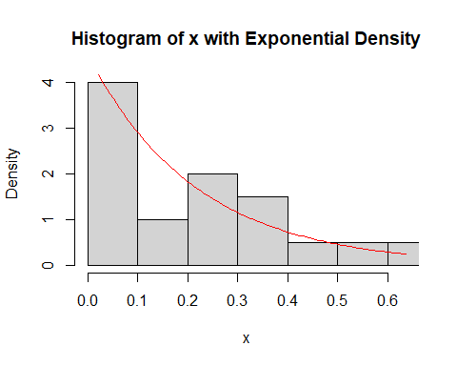

## Q1f

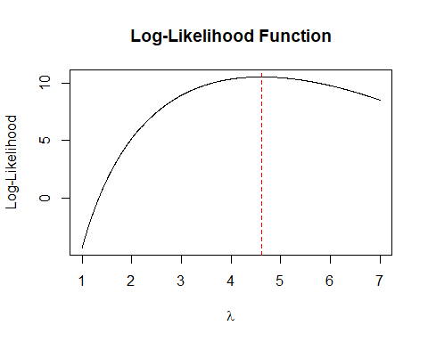

## [1] 4.607375

## Q1I

## Iteration 1 : lambda = 4.04661   
## Iteration 2 : lambda = 4.539124   
## Iteration 3 : lambda = 4.606364   
## Iteration 4 : lambda = 4.607375   
## Iteration 5 : lambda = 4.607375

## [1] 4.607375

# Q2

## Q2A

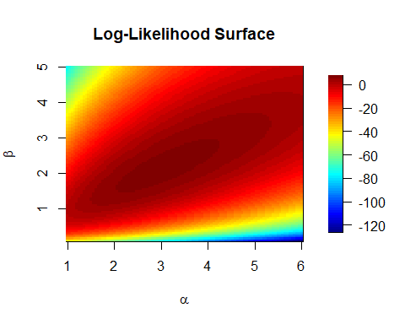

## Q2B

## alpha beta   
## 3.014761 2.115292

## function gradient   
## 55 NA

## Q2C

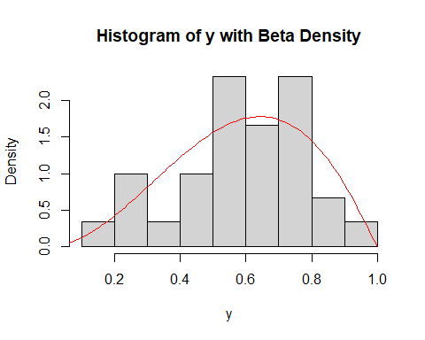

## Q2D

## alpha beta   
## 3.015065 2.115614

## function gradient   
## 23 9

# Appendix

#Retain this code chunk!!!  
library(knitr)  
knitr::opts_chunk$set(echo = FALSE)  
knitr::opts_chunk$set(message = FALSE)  
knitr::opts_chunk$set(warning = FALSE)  
  
#install.packages("field")  
  
#install.packages("tinytex")  
  
#Q1D  
load("./Data/expData.RData")  
  
lambda_hat <- 1 / mean(x)  
lambda_hat  
hist(x, freq = FALSE, xlim = c(0, max(x)), main = "Histogram of x with Exponential Density", xlab = "x")  
  
x_vals <- seq(0, max(x), length.out = 100)  
dens_vals <- dexp(x_vals, rate = lambda_hat)  
lines(x_vals, dens_vals, col = "red")  
lambda_seq <- seq(1, 7, length.out = 1000)  
  
logLik_vals <- sapply(lambda_seq, function(lambda) {  
 n <- length(x)  
 n * log(lambda) - lambda * sum(x)  
})  
  
plot(lambda_seq, logLik_vals, type = 'l', xlab = expression(lambda), ylab = "Log-Likelihood", main = "Log-Likelihood Function")  
  
abline(v = lambda_hat, col = 'red', lty = 2)  
  
neg_logLik <- function(lambda) {  
 if (lambda <= 0) return(Inf)  
 n <- length(x)  
 - (n * log(lambda) - lambda * sum(x))  
}  
  
opt_result <- optimize(neg_logLik, interval = c(1, 7))  
lambda_hat_opt <- opt_result$minimum  
lambda_hat_opt  
newton_raphson <- function(x, lambda_init = 3, tol = 1e-6, max_iter = 100) {  
 n <- length(x)  
 S <- sum(x)  
 lambda_old <- lambda_init  
 for (i in 1:max_iter) {  
 dL <- n / lambda_old - S  
 d2L <- - n / lambda_old^2  
 lambda_new <- lambda_old - dL / d2L  
 cat("Iteration", i, ": lambda =", lambda_new, "\n")  
 if (abs(lambda_new - lambda_old) < tol) {  
 break  
 }  
 lambda_old <- lambda_new  
 }  
 return(lambda_new)  
}  
  
lambda_hat_nr <- newton_raphson(x)  
lambda_hat_nr  
#Q2A  
load("./Data/betaData.RData")  
  
logLik_beta <- function(alpha, beta, y) {  
 if (alpha <= 0 || beta <= 0) {  
 return(NA)  
 }  
 sum(dbeta(y, shape1 = alpha, shape2 = beta, log = TRUE))  
}  
  
alpha_seq <- seq(1, 6, length.out = 100)  
beta_seq <- seq(0.1, 5, length.out = 100)  
  
logLik_vals <- matrix(NA, nrow = length(alpha_seq), ncol = length(beta_seq))  
  
for (i in 1:length(alpha_seq)) {  
 for (j in 1:length(beta_seq)) {  
 logLik_vals[i, j] <- logLik_beta(alpha_seq[i], beta_seq[j], y)  
 }  
}  
  
library(fields)  
image.plot(alpha_seq, beta_seq, logLik_vals, xlab = expression(alpha), ylab = expression(beta), main = "Log-Likelihood Surface")  
#Q2B  
neg_logLik_beta <- function(params, y) {  
 alpha <- params[1]  
 beta <- params[2]  
 if (alpha <= 0 || beta <= 0) {  
 return(Inf)  
 }  
 -sum(dbeta(y, shape1 = alpha, shape2 = beta, log = TRUE))  
}  
  
start_params <- c(alpha = 3, beta = 3)  
  
result_nelder <- optim(start_params, neg_logLik_beta, y = y, method = "Nelder-Mead")  
result_nelder$par # Estimated parameters  
result_nelder$counts # Number of iterations  
  
#Q2C  
hist(y, freq = FALSE, main = "Histogram of y with Beta Density", xlab = "y")  
  
y_vals <- seq(0, 1, length.out = 100)  
dens_vals <- dbeta(y_vals, shape1 = result_nelder$par[1], shape2 = result_nelder$par[2])  
lines(y_vals, dens_vals, col = 'red')  
#Q2D  
result_bfgs <- optim(start_params, neg_logLik_beta, y = y, method = "BFGS")  
result_bfgs$par # Estimated parameters  
result_bfgs$counts # Number of iterations