HW4

Matthew Stoebe

2024-11-10

set.seed(123)  
  
n <- 100  
phi <- 0.6   
theta <- 0.9   
  
arma11_series <- arima.sim(n = n, list(ar = phi, ma = theta), sd = 1)  
arma10_series <- arima.sim(n = n, list(ar = phi), sd = 1)  
arma01_series <- arima.sim(n = n, list(ma = theta), sd = 1)  
  
# Plot the time series  
ts.plot(arma11_series, main = "ARMA(1,1) Time Series", ylab = "Value")

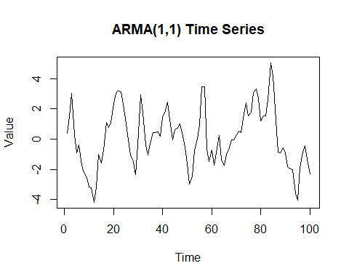

ts.plot(arma10_series, main = "AR(1) Time Series", ylab = "Value")

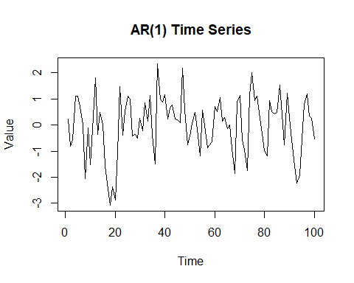

ts.plot(arma01_series, main = "MA(1) Time Series", ylab = "Value")

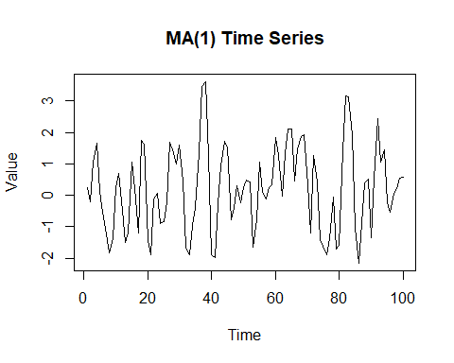

acf_arma11 <- acf(arma11_series, plot = FALSE)  
acf_arma10 <- acf(arma10_series, plot = FALSE)  
acf_arma01 <- acf(arma01_series, plot = FALSE)  
  
pacf_arma11 <- pacf(arma11_series, plot = FALSE)  
pacf_arma10 <- pacf(arma10_series, plot = FALSE)  
pacf_arma01 <- pacf(arma01_series, plot = FALSE)  
  
theoretical_acf_arma11 <- ARMAacf(ar = phi, ma = theta, lag.max = 20)  
theoretical_acf_arma10 <- ARMAacf(ar = phi, lag.max = 20)  
theoretical_acf_arma01 <- ARMAacf(ma = theta, lag.max = 20)  
  
plot(acf_arma11, main = "Sample ACF vs Theoretical ACF for ARMA(1,1)")  
lines(0:20, theoretical_acf_arma11, col = "red", lty = 2)  
legend("topright", legend = c("Sample ACF", "Theoretical ACF"), col = c("black", "red"), lty = c(1, 2))

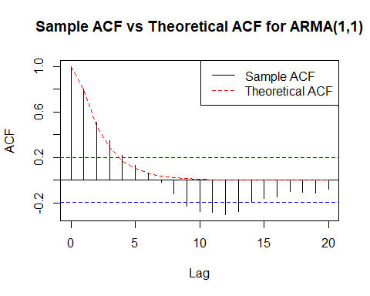

plot(acf_arma10, main = "Sample ACF vs Theoretical ACF for AR(1)")  
lines(0:20, theoretical_acf_arma10, col = "red", lty = 2)  
legend("topright", legend = c("Sample ACF", "Theoretical ACF"), col = c("black", "red"), lty = c(1, 2))

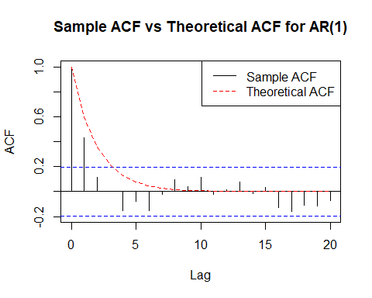

plot(acf_arma01, main = "Sample ACF vs Theoretical ACF for MA(1)")  
lines(0:20, theoretical_acf_arma01, col = "red", lty = 2)  
legend("topright", legend = c("Sample ACF", "Theoretical ACF"), col = c("black", "red"), lty = c(1, 2))

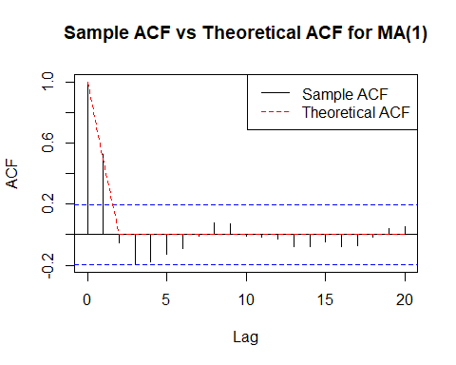

plot(pacf_arma11, main = "Sample PACF for ARMA(1,1)",   
 ylim = c(min(pacf_arma11$acf), max(pacf_arma11$acf)))  
abline(h = 0, col = "black")

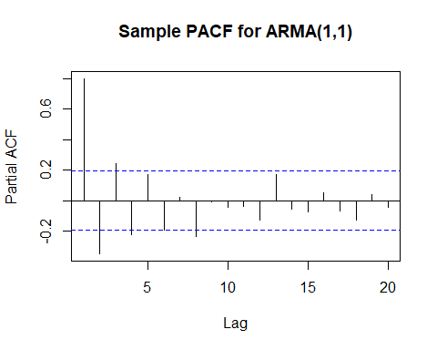

plot(pacf_arma10, main = "Sample PACF for AR(1)",   
 ylim = c(min(pacf_arma10$acf), max(pacf_arma10$acf)))  
abline(h = 0, col = "black")

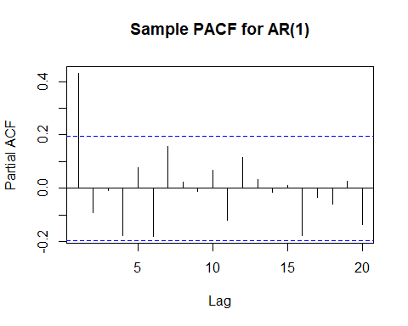

plot(pacf_arma01, main = "Sample PACF for MA(1)",   
 ylim = c(min(pacf_arma01$acf), max(pacf_arma01$acf)))  
abline(h = 0, col = "black")

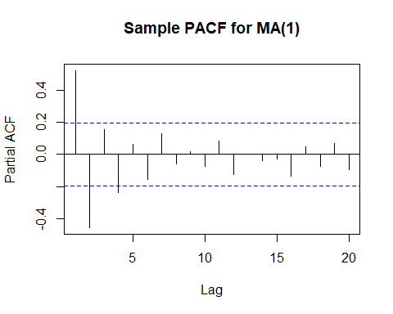

These results align with what is expected from table 3.1 in the textbook