566 Assignment 1

Matthew Stoebe

2024-08-29

# Load necessary library  
library(ggplot2)  
  
  
# Create the plot  
ggplot(mpg, aes(x = displ, y = hwy)) +  
 geom_point(aes(color = factor(cyl))) + # Scatter plot colored by number of cylinders  
 geom_smooth(method = "loess", se = TRUE, color = "black", size = 1) + # Curvy line with confidence interval for all data  
 geom_smooth(aes(color = factor(cyl)), method = "lm", se = FALSE, linetype = "dashed") + # Straight lines fit to each group  
 geom_smooth(method = "loess", se = FALSE, color = "black", linetype = "solid", size = 1) + # Curvy line for all data (without CI)  
 scale_color_manual(values = c("4" = "red", "6" = "green", "8" = "blue")) + # Set colors for cylinders  
 labs(title = "Exploration of MPG Dataset",   
 x = "Displacement (liters)",   
 y = "Highway mileage",  
 color = "Number of cylinders") +  
 theme_minimal() +  
 theme(  
 panel.background = element_rect(fill = "grey85", color = NA),   
 plot.background = element_rect(fill = "grey85", color = NA),   
 panel.grid.major = element_line(color = "white"),   
 panel.grid.minor = element_line(color = "white"),  
 axis.ticks = element_blank(),   
 axis.text = element_text(color = "black", face = "bold")   
 )

## Warning: Using `size` aesthetic for lines was deprecated in ggplot2 3.4.0.  
## ℹ Please use `linewidth` instead.  
## This warning is displayed once every 8 hours.  
## Call `lifecycle::last_lifecycle_warnings()` to see where this warning was  
## generated.

## `geom_smooth()` using formula = 'y ~ x'  
## `geom_smooth()` using formula = 'y ~ x'  
## `geom_smooth()` using formula = 'y ~ x'

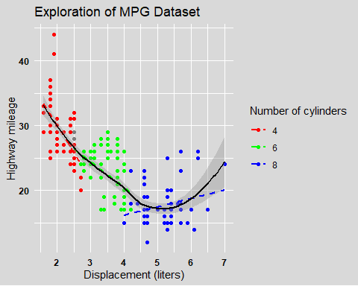

# Create the plot  
ggplot(mpg, aes(x = factor(cyl), fill = factor(cyl))) +  
 geom_bar() + # Bar plot  
 facet_wrap(~ drv) + # Facet by drive type  
 labs(title = "Exploration of MPG Dataset",   
 subtitle = "Comparison across drive types",  
 x = "Number of cylinders",   
 y = "Number of cars",  
 fill = "Number of cylinders") +  
 scale_fill_manual(values = c("4" = "red", "6" = "cyan", "8" = "purple")) + # Set colors  
 theme_minimal() +  
 theme(  
 panel.background = element_rect(fill = "grey85", color = NA),   
 plot.background = element_rect(fill = "grey85", color = NA),   
 strip.background = element_rect(fill = "grey85", color = NA),   
 panel.grid.major = element_line(color = "white"),   
 panel.grid.minor = element_line(color = "white"),  
 axis.ticks = element_blank(),   
 axis.text = element_text(color = "black", face = "bold")  
 )

