562_HW_2

Matthew Stoebe

2024-10-25

#3 b:

x = qchisq(.01, 8)  
print(x)

## [1] 1.646497

xadj <- x*225 / 100  
print(xadj)

## [1] 3.704619

pchisq(xadj, df=8, lower.tail=TRUE)

## [1] 0.1172577

#3 c:

# Define parameters  
threshold <- 0.8 # Desired power  
alpha <- 0.01 # Significance level  
sigma0_sq <- 225 # Variance under H0  
sigma_a_sq <- 100 # Variance under H1  
  
# Starting sample size  
n <- 9 # Corresponds to df = 8  
  
# Initialize variables  
df <- n - 1 # Degrees of freedom  
power <- 0 # Initial power  
  
# Loop to find the required sample size  
while(power < threshold && df < 200){  
   
 # Calculate the critical chi-square value for the given alpha  
 x <- qchisq(alpha, df = df)  
   
 xscaled <- x * sigma0_sq / sigma_a_sq  
 power <- pchisq(xscaled, df = df)  
  
 if(power < threshold){  
 n <- n + 1  
 df <- df + 1  
 }  
}  
  
# Output the required sample size  
if(power >= threshold){  
 cat("Required sample size (n):", n, "\n")  
} else {  
 cat("Sample size did not reach required power within n=100.\n")  
}

## Required sample size (n): 37

x = qchisq(.01, 36)  
print(x)

## [1] 19.23268

xadj <- x*225 / 100  
print(xadj)

## [1] 43.27352

power <- pchisq(xadj, df=36, lower.tail=TRUE)  
  
print(power)

## [1] 0.8113461

Note that the echo = FALSE parameter was added to the code chunk to prevent printing of the R code that generated the plot.

#4a:

1-pt(5.316, 19)

## [1] 1.972177e-05

#4b

n = 20  
sd = 45  
true_mean <- 1180  
  
nloop = 10000  
  
tstat <- numeric(nloop)  
  
for(iloop in 1:nloop){  
 y=rnorm(n, true_mean, sd)  
 samp_mean = mean(y)  
 samp_sd = sd(y)  
 tstat[iloop] = (samp_mean - 1160)/(samp_sd /sqrt(n))  
}  
  
hist(tstat, br=50)

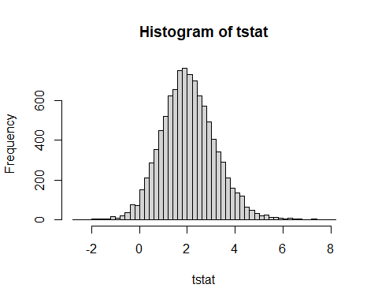

sum(tstat > qt(1-.05,n-1))/nloop

## [1] 0.6042

#5b

2*(1-pt(.978, df=24))

## [1] 0.3378304

#5c

2* (1-pf(2.1199, df1=11, df2=13))

## [1] 0.1987924