HW5_567

Matthew Stoebe

2024-11-20

library(ggplot2)

#Question 1

earthquakes <- read.csv("Data/earthquakes.csv")  
head(earthquakes)

## year quakes  
## 1 1901 14  
## 2 1902 8  
## 3 1903 10  
## 4 1904 16  
## 5 1905 26  
## 6 1906 32

##a Create summary plots of the data. Specifically, create a (line) plot of number of earthquakes per year. Also use acf() to create an autocorrelation plot.

ggplot(data = earthquakes, aes(x = year, y = quakes)) +  
 geom_line(color = "blue") +  
 labs(title = "Number of Earthquakes per Year (Magnitude > 7.0)",  
 x = "Year",  
 y = "Number of Earthquakes") +  
 theme_minimal()

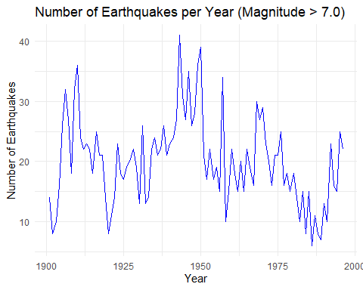

acf(earthquakes$quakes, main = "Autocorrelation of Earthquake Counts")

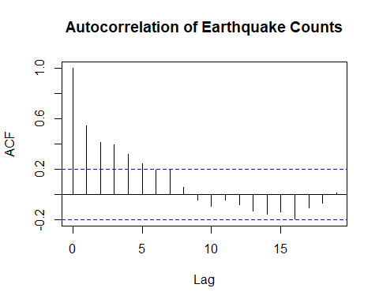

##b Provide the estimated mean and simple t-based confidence interval for the mean. We will use this naive approach for purposes of comparison only!

n <- nrow(earthquakes)  
mean_eq <- mean(earthquakes$quakes)  
sd_eq <- sd(earthquakes$quakes)  
  
df <- n - 1  
  
  
se_eq <- sd_eq / sqrt(n)  
  
# t-value for 95% confidence interval  
alpha <- 0.05  
t_value <- qt(1 - alpha/2, df)  
  
lower_bound <- mean_eq - t_value * se_eq  
upper_bound <- mean_eq + t_value * se_eq  
  
cat("Estimated Mean:", mean_eq, "\n")

## Estimated Mean: 20.13542

cat("95% t-based Confidence Interval: [", lower_bound, ",", upper_bound, "]\n")

## 95% t-based Confidence Interval: [ 18.65037 , 21.62047 ]

##c Now perform a non-moving block bootstrap with a block length of 8 and R = 5000. Write a function to do this. Show the 12 blocks and the histogram of the resulting bootstrap means

set.seed(420) # For reproducibility  
  
block_length <- 8  
num_blocks <- floor(n / block_length)  
  
# Create blocks  
blocks <- split(earthquakes$quakes, rep(1:num_blocks, each = block_length))  
  
  
non_moving_block_bootstrap <- function(data, block_length, R) {  
 n <- length(data)  
 num_blocks <- floor(n / block_length)  
 blocks <- split(data, rep(1:num_blocks, each = block_length))  
   
 bootstrap_means <- numeric(R)  
   
 for (i in 1:R) {  
 # Sample blocks with replacement  
 sampled_blocks <- sample(blocks, size = num_blocks, replace = TRUE)  
 # Concatenate sampled blocks  
 sampled_data <- unlist(sampled_blocks)  
 # Calculate mean  
 bootstrap_means[i] <- mean(sampled_data)  
 }  
 return(bootstrap_means)  
}  
  
# Perform bootstrap  
R <- 5000  
bootstrap_means <- non_moving_block_bootstrap(earthquakes$quakes, block_length, R)  
hist(bootstrap_means, breaks = 30, main = "Histogram of Bootstrap Means",  
 xlab = "Bootstrap Means", col = "grey", border = "black")

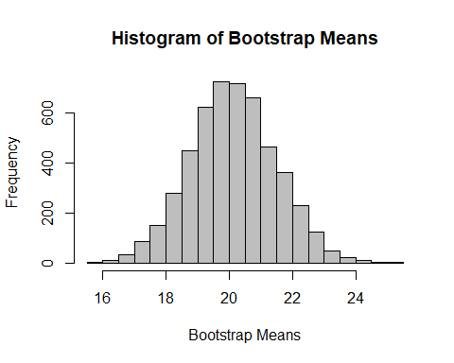 ##d Using your boostrap results, construct a 95% confidence interval using the percentile method.

# Calculate the 2.5th and 97.5th percentiles  
ci_lower <- quantile(bootstrap_means, 0.025)  
ci_upper <- quantile(bootstrap_means, 0.975)  
  
# Output the bootstrap confidence interval  
cat("95% Bootstrap Confidence Interval (Percentile Method): [", ci_lower, ",", ci_upper, "]\n")

## 95% Bootstrap Confidence Interval (Percentile Method): [ 17.46875 , 22.80208 ]

##e Compare your bootstrap confidence interval to the simple t-based confidence interval.Which is wider? Briefly explain why this is the case. Our bootstrap Confidence interval is wider because it accounts for the autocorrelation in the data.The t based method assumes independent samples which is often not the case with time series data.

#Question 2

##a Create a scatterplot of Unemployed (y) vs GNP (x).

data(longley)  
plot(longley$GNP, longley$Unemployed,  
 main = "Scatterplot of Unemployed vs GNP",  
 xlab = "GNP",  
 ylab = "Unemployed",  
 pch = 19, col = "blue")

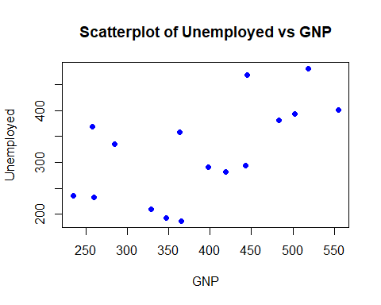

##b Use cor.test() to calculate (default) Pearson correlation, p-value and 95% confidence interval. You can just print the output

pearson_result <- cor.test(longley$Unemployed, longley$GNP)  
print(pearson_result)

##   
## Pearson's product-moment correlation  
##   
## data: longley$Unemployed and longley$GNP  
## t = 2.8376, df = 14, p-value = 0.01317  
## alternative hypothesis: true correlation is not equal to 0  
## 95 percent confidence interval:  
## 0.1549766 0.8464304  
## sample estimates:  
## cor   
## 0.6042609

##c Use cor.test() again but this time with method = ”spearman” and print the result. Note that a confidence interval is NOT provided.

spearman_result <- cor.test(longley$Unemployed, longley$GNP, method = "spearman")  
print(spearman_result)

##   
## Spearman's rank correlation rho  
##   
## data: longley$Unemployed and longley$GNP  
## S = 246, p-value = 0.009375  
## alternative hypothesis: true rho is not equal to 0  
## sample estimates:  
## rho   
## 0.6382353

##d Use bootstrap() to perform case resampling bootrap for correlation with R = 5000.Provide a 95% confidence interval using the percentile method.

# I was having issues with the bootstrap() function so i swapped to this one.   
library(boot)

## Warning: package 'boot' was built under R version 4.4.2

data_longley <- longley[, c("Unemployed", "GNP")]  
correlation_stat <- function(data, indices) {  
 resampled_data <- data[indices, ]  
 return(cor(resampled_data$Unemployed, resampled_data$GNP))  
}  
  
# Perform bootstrapping  
R <- 5000  
boot_results <- boot(data_longley, statistic = correlation_stat, R = R)  
bootstrap_estimates <- boot_results$t  
  
  
# Calculate the 95% confidence interval using the percentile method  
ci_lower <- quantile(bootstrap_estimates, 0.025)  
ci_upper <- quantile(bootstrap_estimates, 0.975)  
  
  
cat("95% Bootstrap Confidence Interval: [", ci_lower, ",", ci_upper, "]\n")

## 95% Bootstrap Confidence Interval: [ 0.2564638 , 0.8303361 ]

##e Finally, implement a permutation test of H0 : ρ = 0 where ρ is the population correlation. Perform 5000 permutations and report your permutation based p-value (twosided).

obs_cor <- cor(longley$Unemployed, longley$GNP, method='spearman')  
  
n_perm <- 5000  
perm_cor <- numeric(n_perm)  
  
for (i in 1:n_perm) {  
 permuted_gnp <- sample(longley$GNP)  
 perm_cor[i] <- cor(longley$Unemployed, permuted_gnp, method='spearman')  
}  
  
# two-sided p-value  
p_value <- (sum(abs(perm_cor) >= abs(obs_cor)) + 1) / (n_perm + 1)  
cat("Permutation p-value:", p_value)

## Permutation p-value: 0.00859828