HW6_567

Matthew Stoebe

2024-12-05

#Question 1 ##a Start by visualizing the Cauchy density using a red curve for −10 ≤ x ≤ +10. One option is to use dcauchy(). For comparison, also overlay a normal density curve in blue.

x <- seq(-10, 10, length.out = 1000)  
  
  
cauchy_density <- dcauchy(x, location = 0, scale = 1)  
normal_density <- dnorm(x, mean = 0, sd = 1)  
  
  
plot(x, cauchy_density, type = "l", col = "red", lwd = 2,  
 ylab = "Density", main = "Standard Cauchy and Normal Densities",  
 xlab = "x")  
lines(x, normal_density, col = "blue", lwd = 2)  
legend("topright", legend = c("Cauchy", "Normal"),  
 col = c("red", "blue"), lwd = 2)

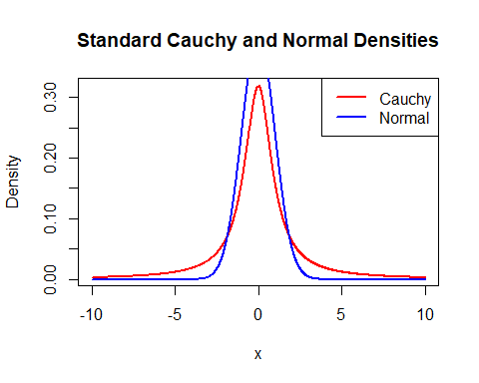 ##b To prepare to use the inverse transform method, find F −1(u).

set.seed(490)  
n <- 100000  
  
u <- runif(n, min = 0, max = 1)  
x_cauchy <- tan(pi * (u - 0.5))

##c (4 pts) Use the inverse transform method to generate a random sample of 10,000 observa- tions from the standard Cauchy distribution. Show a histogram of your sample using a large number of bins for your histogram (e.g., 100). In order to show all the data, do NOT restrict your x axis. What striking features do you notice about your histogram?

set.seed(123)  
  
u <- runif(n, min = 0, max = 1)  
x_cauchy <- tan(pi * (u - 0.5))  
  
hist(x_cauchy, breaks = 100, main = "Histogram of Second Standard Cauchy Sample", xlab = "x")

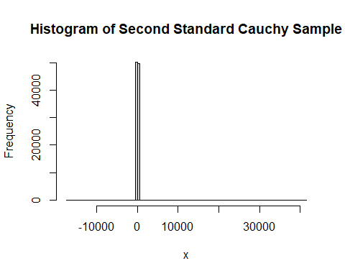 There are some insane outliers every time this is run

##d

# Set a different seed  
set.seed(999)  
  
u2 <- runif(n, min = 0, max = 1)  
x_cauchy2 <- tan(pi * (u2 - 0.5))  
  
  
hist(x_cauchy2, breaks = 100, main = "Histogram of Second Standard Cauchy Sample", xlab = "x")

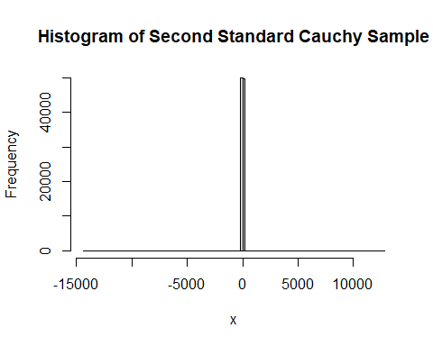 More insane outliers which wont even show up on a plot

##e The ratio of two independent standard normal (mean = 0, sd = 1) random variables is distributed standard Cauchy. Use this information and rnorm() to generate a random sample of 10,000 observations. Show the histogram.

set.seed(789)  
  
n <- 10000  
Z1 <- rnorm(n, mean = 0, sd = 1)  
Z2 <- rnorm(n, mean = 0, sd = 1)  
  
# Compute the ratio  
x_cauchy_ratio <- Z1 / Z2  
  
# Plot histogram  
hist(x_cauchy_ratio, breaks = 100, main = "Histogram of Standard Cauchy Sample (Ratio Method)", xlab = "x")

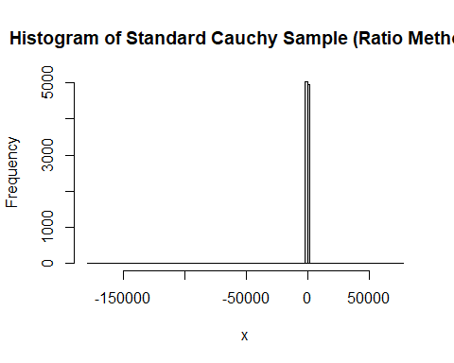 Again, Because of the outliers this distribution is totally shifted from the one above.

#Question 2

##a

x_vals <- seq(-10, 10, length.out = 1000)  
  
  
f_x <- exp(-x_vals) / (1 + exp(-x_vals))^2  
g_x <- ifelse(x_vals >= 0, exp(-x_vals), exp(x_vals))  
  
  
plot(x_vals, f_x, type = "l", col = "black", lwd = 2,  
 xlab = "x", ylab = "Density",  
 main = "Logistic Density f(x) and Exponential Density g(x)")  
  
lines(x_vals, g_x, col = "blue", lwd = 2)  
  
  
legend("topright", legend = c("Logistic Density f(x)", "Exponential Density g(x)"),  
 col = c("black", "blue"), lwd = 2, bty = "n")

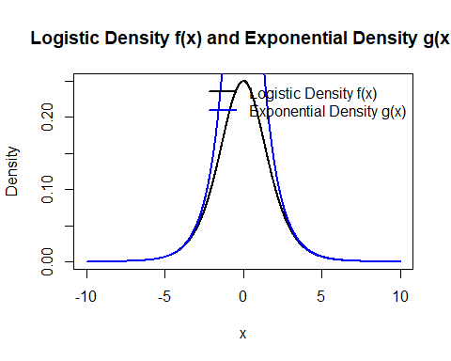

# PARAMS  
set.seed(420)  
N <- 10000  
samples <- numeric(N)  
accepted <- 0   
total_trials <- 0  
  
while (accepted < N) {  
 x <- rexp(1, rate = 1)  
 alpha <- (1 / (1 + exp(-x)))^2  
   
 u <- runif(1)  
   
 if (u <= alpha) {  
 # Assign random sign  
 s <- sample(c(-1, 1), 1)  
 samples[accepted + 1] <- s * x  
 accepted <- accepted + 1  
 }  
 total_trials <- total_trials + 1  
}  
  
  
acceptance_rate <- (N / total_trials) * 100  
cat("Acceptance Rate:", round(acceptance_rate, 2), "%\n")

## Acceptance Rate: 50.08 %

hist(samples, breaks = 50, probability = TRUE,  
 main = "Histogram of Samples from Logistic Distribution",  
 xlab = "Value", xlim = c(-10, 10), col = "lightblue", border = "white")  
  
x_vals <- seq(-10, 10, length.out = 1000)  
logistic_density <- exp(-x_vals) / (1 + exp(-x_vals))^2  
lines(x_vals, logistic_density, col = "red", lwd = 2)  
  
legend("topright", legend = c("Sample Histogram", "Logistic Density"),  
 col = c("lightblue", "red"), lwd = c(10, 2), bty = "n")

