Futureproof Financial
Lenders Mortgage Insurance (LMI) & Portfolio Risk Reinsurance Program:
Recommended Structure and Interaction

Based on the Equity Preservation Mortgage (EPM) v14c Stochastic GBM + Mean Reverting Model
50,000-path Monte Carlo Simulation | April 2025

Purpose: This paper sets out the recommended structure for the Futureproof Lenders Mortgage Insurance (LMI) program and its interaction with the Portfolio Risk Reinsurance program. It provides reinsurers with a comprehensive framework for structuring individual mortgage risk and tail risk coverage for portfolio of EPM loans (by Funder).

Contents
- Executive Summary
- EPM Insurance Architecture Overview
- Part A: LMI Program — Structure and Settings
- Part B: Portfolio Risk Reinsurance — Structure and Settings
- Part C: Interaction Between Individual LMI and Loan Book Portfolio Reinsurance
- Part D: Reinsurer Structuring Recommendations
- Quantitative Analysis — v14c Model Results
- Premium Pricing Framework
- Risk Transfer Summary
- Appendix: Model Parameters

Executive Summary
Futureproof’s Equity Preservation Mortgage® (EPM) employs a two-layer insurance architecture designed to protect both the lender and wholesale mortgage funder from credit losses. This paper addresses two key questions:
- Part A: How should the individual mortgage LMI program settings interact with the loan book portfolio risk reinsurance program settings?
- Part B: How should a reinsurer structure the Portfolio Risk Reinsurance Program?

Key Findings

Metric | LMI Layer | Tail Risk Reinsurance | Combined
Coverage scope | 80% of deficit paths | 20% of deficit paths (worst) | 100% of deficit paths
Probability of Claim
Fair Premium (PV)
Loaded Premium (50%)
% of Max Loan
Top cover boundary
Critical distinction
The EPM is a mortgage, not an investment product r managed investment scheme. Claims can only be made upon expiry of the mortgage loan (at the end-of-term), not intra-term at any intermediate point.
This fundamentally changes the risk profile compared to traditional mortgage insurance.

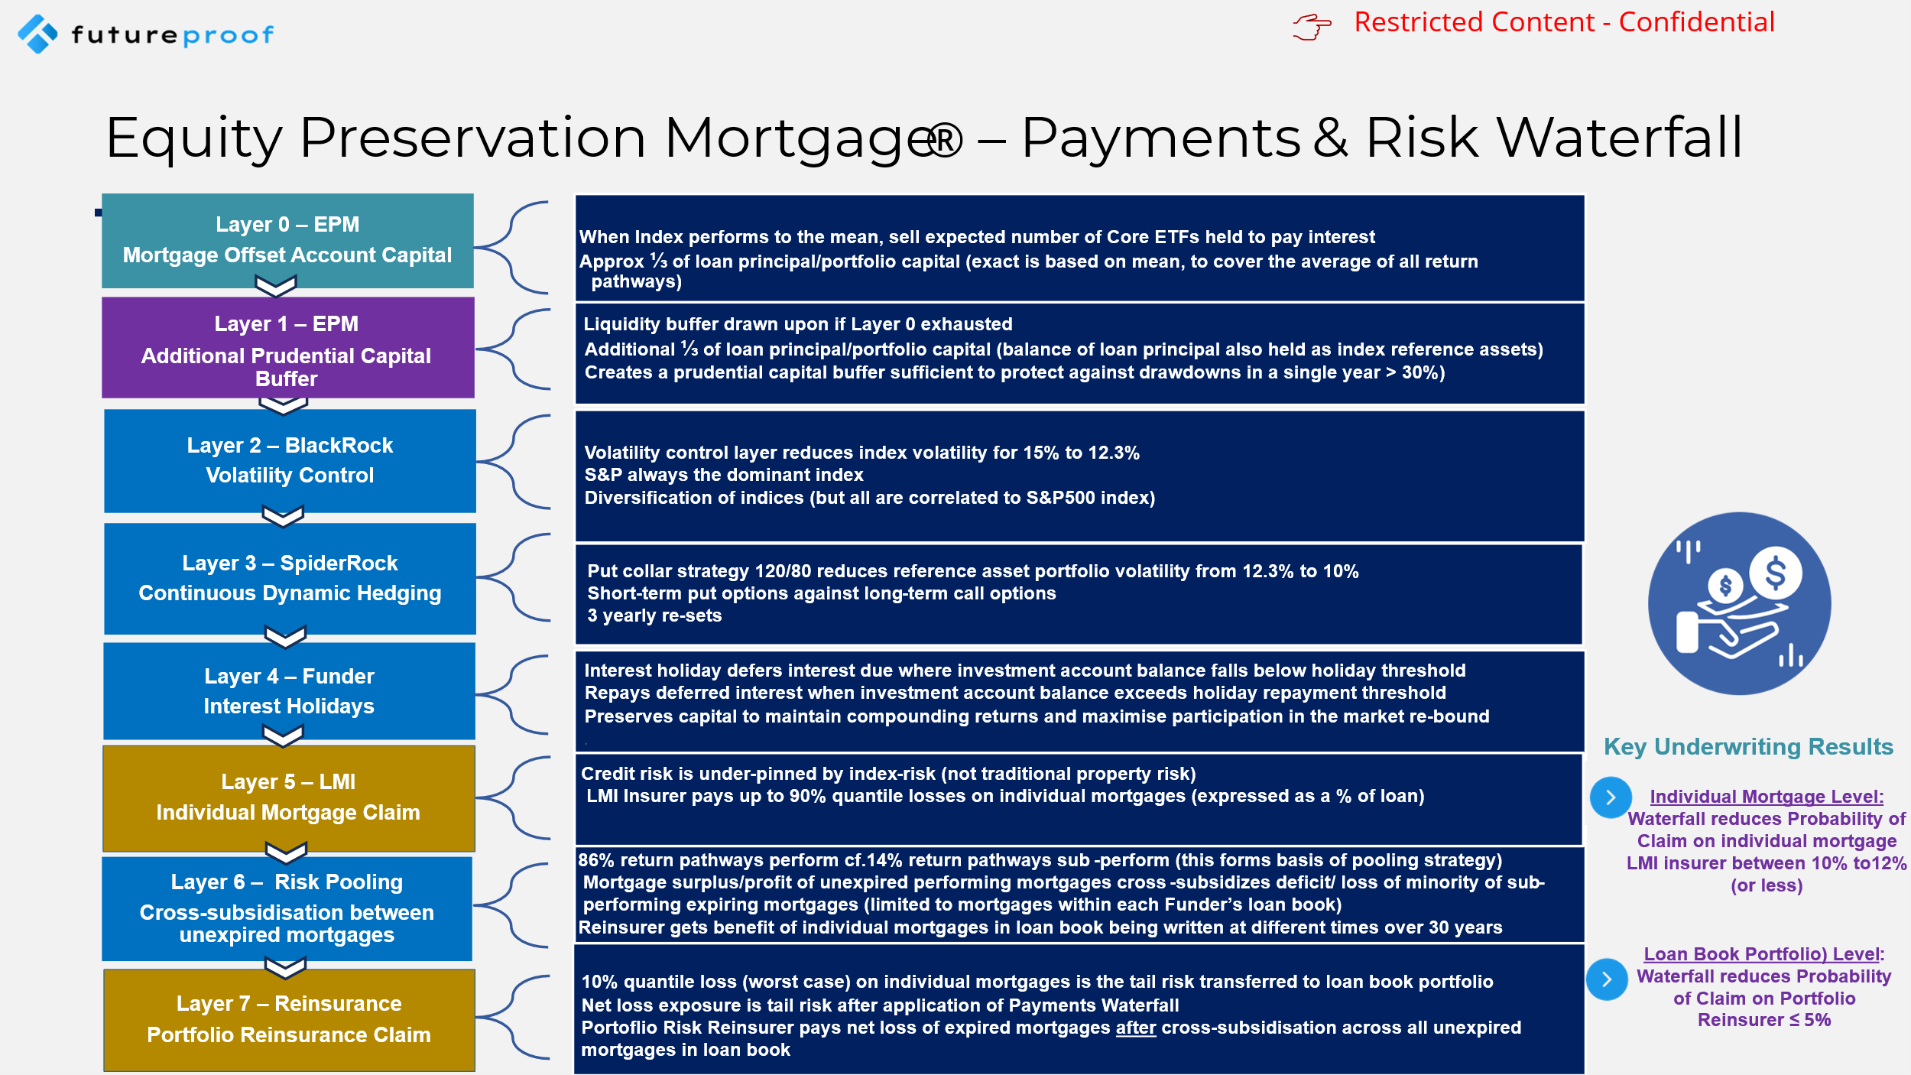
EPM Insurance Architecture Overview
The EPM insurance structure consists of two distinct layers with a clear boundary between them. This architecture is designed to provide both lenders and wholesale mortgage funders with full credit protection through a blend of capital market risk solutions and risk transfer to the reinsurance market of residual risk.

The Payments Waterfall
Before any insurance claim is triggered, a multi-step Payments and Risk Waterfall applies. This waterfall dramatically reduces the actual claim frequency for the individual mortgage PoC to the loan book portfolio PoC:
- Step 1 — Passive Index-linked ETF Reference Assets:
- (a) ETF Selldown - The individual mortgage's offset account (holding S&P 500 index-linked ETFs as reference assets) is progressively liquidated to pay loan interest and part-principal each quarter. The amount of mortgage loan principal held by the lender for this purpose is calculated from the average of all return pathways (mean) of the monte carlo simulation of S&P500 index performance over equivalent duration as the loan term. Unsold ETFs continue to enjoy compounding returns as the index appreciates over the loan term.
- (b) Capital Buffer: An additional portion of the mortgage loan principal is held in the individual’s mortgage offset account as a capital buffer. The amount generally equates to approximately 30% of the loan principal. This capital buffer is also held by the lender as S&P 500 index-linked ETFs as reference assets. These references assets may also be called upon and sold to pay loan interest and part-principal is there is a deficit following Step 1 as a result of the index sub-performing the mean return pathway . The capital buffer over-collaterializes the mortgage offset account, with the size of the capital buffer calculated to be sufficient to cover large drawdowns where index sub-performs the long-term mean total return by 20%-30% in any year.
- Step 2 – Volatility Control: The lender mandates Futureproof’s platform partner, BlackRock to manage the reference assets for each EPM borrower as a single managed account (SMA). BlackRock’ constructed volatility layer achieves a reduction in index volatility from 17% down to 12% largely using a diversification strategy involving other index-linked ETFs (although S&P500 always remains the predominate index linked to the EPM). The correlation between S&P500 return and other selected index returns is strong and always approaches 1 in a downturn.
- Step 3 – The lender also mandates Futureproof’s platform partner, SpiderRock to run and manage a continuous dynamic hedging program for each SMA. This is a collar strategy deploying a short-terms puts against long-term calls. The hedging parameters are 130/80 with hedges re-set every three years for the duration of the mortgage loan. Continuous dynamic hedging has the effect of reducing the net index volatility further, from 12% down to 10%.
- Step 4 — Interest-holidays: The Wholesale Mortgage Funder agrees to a program of interest-holidays in circumstances where the index sub-performs the mean total return. The Funder sets interest-entry and interest-exit thresholds, in consultation with Futureproof. The maximum number of quarterly interest-holidays is capped at between 15% of total loan quarters. Interest-holidays are designed to preserve the loan capital in the individual’s mortgage offset account, so as to avoid the need to “chase losses”. This has the effect of maximizing returns on the any market re-bound. Whilst in interest-holiday, the loan interest and part-principal due is simply deferred (not accrued or compounded).The Wholesale Mortgage Funder is compensated for this cashflow risk by sharing in the end-of-terms surplus of every EPM which is derived from the appreciation in value of unsold reference assets held of 30 year loan terms. The average of all return pathways (mean) or expected result is that the number of interest-holidays is zero. The 99% loss quantile results in less than the interest-holiday cap number.
- Step 5 – Lenders Mortgage Insurance: If, by end-of-term, there remains an interest deficit or capital loss (calculated as the delta between the opening balance at start-of-term and closing balance at end-of-term, of the mortgage offset account), then this would be a claim on the LMI cover for each individual EPM. LMI has a top cover limit which is equivalent to 80% of total loss. The average return of all return pathways (mean) produces a probability of claim (PoC) for the LMI reinsurer of 10.8%.
- Step 6 -Cross-Subsidization: The 20% tail risk associated with any individual EPM is then transferred to the loan book portfolio level. Within a Wholesale Mortgage Funder’s book of EPMs, not all loans are affected identically by a downturn. The loan book consists of EPM of various vintages and size with each having its own specific profit/loss. At a portfolio level surpluses from performing mortgages are used to offset deficits from underperforming mortgages. The monte carlo analysis shows that at the end-of-term the majority of return pathways (89% ) are positive being in sufficient to pay all loan costs or in surplus and only a minority (11%) are negative and in deficit. This result supports this program architecture by introducing the concept of pooling of mortgage and resulting tail risk.
- Step 3 — Net Deficit: Only the residual deficit after Steps 1 and 6 triggers a loan book portfolio reinsurance claim. The true Probability (PoC) of the portfolio risk reinsurer attaching to the tail risk is 2%.

The Payments Waterfall reduces portfolio PoC from 14.2% (individual) to approximately 0.55% (portfolio of 10,000+ EPMs) — a ~25x reduction.

Two-Layer Insurance Structure
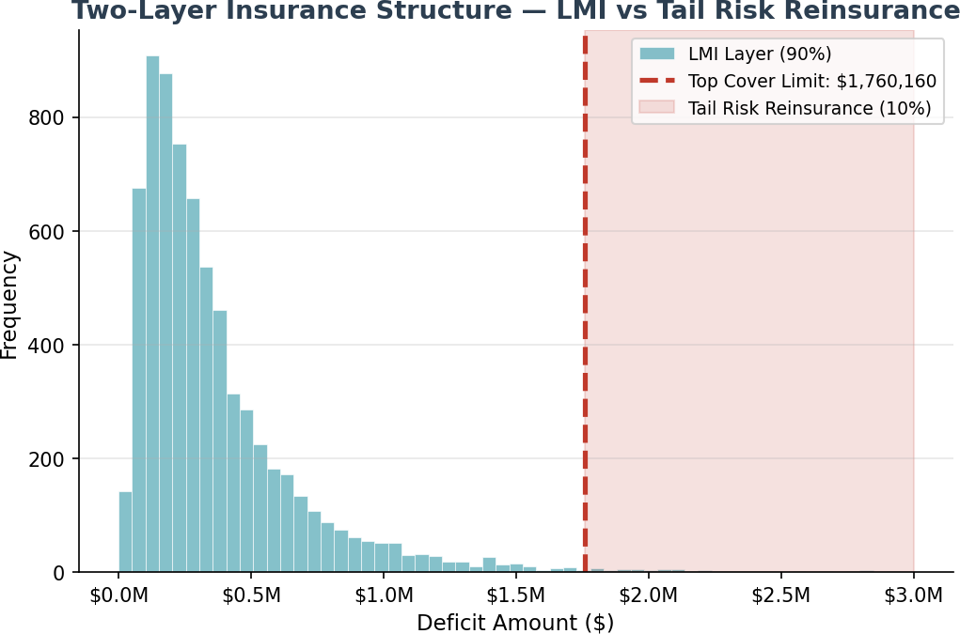
The top cover boundary is set at the 20th percentile of the conditional deficit distribution ($1,760,160). This means:
- LMI Layer: Covers 80% of all deficit outcomes (those below the top cover limit). These are "mild-to-moderate" deficits. The LMI reinsurer pays the full deficit for paths within this layer.
- Tail Risk Reinsurance: Covers the worst 20% of deficit outcomes (those exceeding the top cover limit). The reinsurer pays only the excess above the top cover boundary. The LMI reinsurer pays up to the top cover limit on these paths, and the reinsurer covers the remainder.

Part A: LMI Program — Structure and Settings

LMI Program Scope
The LMI program provides first-loss credit protection to the lender on every EPM originated. Unlike traditional LMI (which covers shortfalls from foreclosure sales), EPM LMI covers the deficit between the investment account value and the outstanding mortgage balance at mortgage expiry. The underlying credit risk has been replaced by long-term index risk.

LMI Program Settings

Setting | Value | Rationale
Coverage trigger | Mortgage expiry only | No intermediate claims; run-off mechanism prevents early exit
Top cover limit | $ | 20th percentile of conditional deficit distribution
Coverage scope | 80% of deficit paths | Mild-to-moderate deficits within top cover limit
PoC (individual) | 11.2% | Probability any individual mortgage results in a deficit
Conditional expected deficit | $ | Mean deficit given a deficit occurs
Fair premium (PV) | $ | Discounted expected loss at 4.4% (cash rate mean)
Loaded premium (50%) | $ | Industry-standard loading for expenses + profit
Premium as % of max loan | % | Competitive with traditional LMI at 80% LVR
Payment timing | Upfront at origination | Funded from mortgage drawdown
Claim timing | At mortgage expiry (Year 15-30) | Deferred claims benefit insurer float

  - LMI Insurer Advantages
    - Deferred claims: Claims only arise at mortgage expiry (earliest Year 15 for a 15-year mortgage, up to Year 30 for a 30-year or lifetime mortgage). This provides significant investment float benefit — the insurer collects premiums upfront and invests for 15-30 years before any claim liability crystallises.
    - Bounded exposure: The top cover limit caps the maximum claim per mortgage at $. Tail risk beyond this is transferred to the reinsurer.
    - No moral hazard: The homeowner cannot default — they retain full ownership of their property. The run-off mechanism allows strategic early exit (with discharge of mortgage) but retains loan capital in the individual’s mortgage offset account until such time as any interest deficit or capital loss is paid or end-of-term (whereupon it is covered by reinsurances), whichever occurs first.
    - Transparent pricing: Monte Carlo simulation provides precise, auditable premium calculations with quantified standard errors.

Part B: Portfolio Risk Reinsurance Program — Structure and Settings

Reinsurance Program Scope
The Portfolio Risk Reinsurance Program provides excess-of-loss protection for tail risk events — specifically, deficit outcomes that exceed the LMI top cover limit. This covers the worst 20% of deficit paths where individual mortgage losses are severe.

Reinsurance Program Settings

Setting | Value | Rationale
Attachment point | $ | 20th percentile of conditional deficit distribution
Coverage | Unlimited excess above attachment | Full tail protection for the mortgage funder
Probability of claim (individual) | % | Only 1 in ~70 mortgages triggers a reinsurance claim
Fair premium (PV) | $ | Discounted expected excess loss
Loaded premium (50%) | $ | Standard risk loading
Premium as % of max loan | % | Very small relative to mortgage size
Payment timing | Annual premium (paid from mortgage margin) | Ongoing cost rather than upfront
Claim timing | At mortgage expiry only | Same deferred-claim benefit as LMI
Portfolio aggregation | Per-mortgage excess-of-loss | Each mortgage independently assessed

  - Why the Top Cover Boundary Works
The 20th percentile of the conditional deficit distribution is the optimal boundary because:
    - It is represents a fair apportionment of risk between LMI and Portfolio Reinsurance
    - A significant tail risk is transferred from each individual EPMs to a 15-30 year portfolio (on a rolling basis) of EPMs to derive the benefit of pooling and cross-subsidization to minimize insured losses
    - It isolates truly extreme outcomes (severe market downturns sustained over the full mortgage term) from moderate cyclical underperformance.
    - xxx% of deficit paths result in claims that are manageable for a primary LMI insurer (up to
$xxx per mortgage).
    - The 20% tail is small enough in probability (xxx% of all paths) to be efficiently transferred to reinsurance markets that specialize in low-frequency, high-severity events.
    - The premium for tail risk coverage is economically efficient — only $xxx fair premium per mortgage (xxx% of max loan) because the probability of claim is very low.

Part C: Interaction Between LMI and Portfolio Reinsurance

Claim Flow Mechanics
The two programs interact through a clear, sequential claim process:

Step | Action | Responsible Party
1 | Mortgage expires — investment account liquidated | Futureproof (servicer)
2 | Payments Waterfall applied (ETF selldown, cross-subsidisation) | Futureproof (servicer)
3 | Net deficit determined after waterfall | Futureproof (servicer)
4a | If deficit ≤ $1,760,160: LMI pays full deficit | LMI Reinsurer
4b | If deficit > $1,760,160: LMI pays $1,760,160, portoflio reinsurer pays excess | LMI Reinsurer + Portoflio Reinsurer
5 | Mortgage funder made whole — zero credit loss | N/A

Key Interaction Principles
Principle 1: No gap in coverage. The LMI layer and reinsurance layer together provide 100% coverage of all deficit outcomes. There is no deductible, no co-insurance, and no coverage gap. All credit risk has been mitigated for the Lender and Wholesale Mortgage Funder.
Principle 2: Clear allocation of risk. Every deficit path is allocated entirely to either the LMI layer (80% of paths, mild deficits) or split between LMI and reinsurance (20% of paths, severe deficits). The LMI reinsurer always pays up to the top cover limit; the Portfolio reinsurer only pays excess.
Principle 3: Independent pricing. Each layer is priced independently based on its own loss distribution. The LMI premium reflects the expected value of losses up to the top cover limit. The reinsurance premium reflects only the excess-of-loss component.
Principle 4: Aligned incentives. The LMI reinsurer retains 80% of deficit frequency risk, ensuring active underwriting engagement. The Portfolio reinsurer takes severity risk at a very low probability (2%), which is their natural specialty.

Sensitivity of Boundary to Model Parameters
The top cover boundary is calibrated to the 20th percentile of the conditional deficit distribution. If model parameters change (e.g., higher equity volatility, different mortgage LVR), the boundary should be recalibrated. The 80/20 split is recommended as a stable default, but the specific dollar boundary will shift with the underlying risk profile.

Parameter Change | Effect on Top Cover Limit | Effect on Reinsurance Premium
Higher equity volatility | Increases (wider deficit distribution) | Increases (more tail risk)
Lower equity return | Increases (more deficits, wider tails) | Increases moderately
Higher LVR | Increases proportionally | Increases roughly proportionally
Shorter mortgage term | Decreases (less time for compounding) | Decreases significantly

Parameter Change | Effect on Top Cover Limit | Effect on Reinsurance Premium
Higher buffer cap | May increase or decrease (trade-off) | Marginal effect
Portfolio diversification | No direct effect (individual boundary) | Reduces aggregate exposure

Part D: Reinsurer Structuring Recommendations

Recommended Treaty Structure
The recommended structure for the Portfolio Risk Reinsurance Program is a per-risk excess-of-loss (XOL) treaty with the following key features:

Feature | Recommendation | Rationale
Treaty type | Per-risk excess-of-loss (XOL) | Clean separation from primary LMI layer
Attachment point | $xxx per mortgage | Matches LMI top cover limit exactly
Limit | Unlimited (or $3M per risk) | Tail events can produce large individual deficits
Term | 15-30 years (matching max mortgage term) | Claims deferred until mortgage expiry
Premium basis | Annual per in-force mortgage | Predictable cash flow for reinsurer
Estimated annual rate | 0.05% of outstanding balance | Very competitive given PoC of 2%
Aggregate limit (annual) | Optional — 10x expected annual claims | Catastrophe protection for extreme scenarios
Reinstatement | Automatic, unlimited | Continuous coverage essential for mortgage funder
Claims basis | Losses discovered | Triggered at mortgage expiry

Portfolio-Level Considerations
The reinsurer should consider the following portfolio dynamics when structuring coverage:
    - Vintage diversification: A portfolio of 1,000+ EPMs per year across multiple vintages means claims are spread over decades. A "bad" vintage (originated during a market peak) will have its claims offset by "good" vintages.
    - Tenure diversification: Mixed 15/20/25/30-year mortgage terms mean claims emerge gradually, not in a single spike. The reinsurer's exposure is smoothed over time.
    - Deferred claims benefit: The reinsurer collects premiums for 15-30 years before any claim liability emerges. The investment income on accumulated premiums is substantial.

Alternative Treaty Structures
While per-risk XOL is the recommended primary structure, reinsurers may also consider:

Structure | Pros | Cons | Suitability
Per-risk XOL (recommended) | Clean, transparent, simple pricing | Individual risk assessment needed | PRIMARY — best fit
Aggregate XOL | Protects against correlated losses | More complex pricing | COMPLEMENTARY — for  catastrophe layer

Structure | Pros | Cons | Suitability
Quota share | Proportional risk sharing | Less efficient for tail risk | NOT RECOMMENDED —  wrong risk profile
Stop loss | Caps total loss ratio | Expensive for  low-frequency risk | OPTIONAL — aggregate cap
ILW (Industry Loss Warranty) | Triggered by market index | Basis risk | INNOVATIVE — for  systematic risk

Recommended Layered Structure for Larger Portfolios
For portfolios exceeding 5,000 EPMs, a layered reinsurance structure is recommended:

Layer | Type | Attachment | Limit | Estimated Rate
Layer 1: Working Layer | Per-risk XOL | $xxx | $1M xs attachment | xxx% of  outstanding
Layer 2: Buffer Layer | Per-risk XOL | $1M + $xxx | $2M xs Layer 1 | xxx% of  outstanding
Layer 3: Cat Layer | Aggregate XOL | 150% of expected annual claims | $10M xs attachment | xxx% of  outstanding
This layered approach provides efficient risk transfer at each severity level and allows specialised reinsurers to participate in the layers that best match their risk appetite.

Quantitative Analysis — v14c Model Results

PoC Trajectory
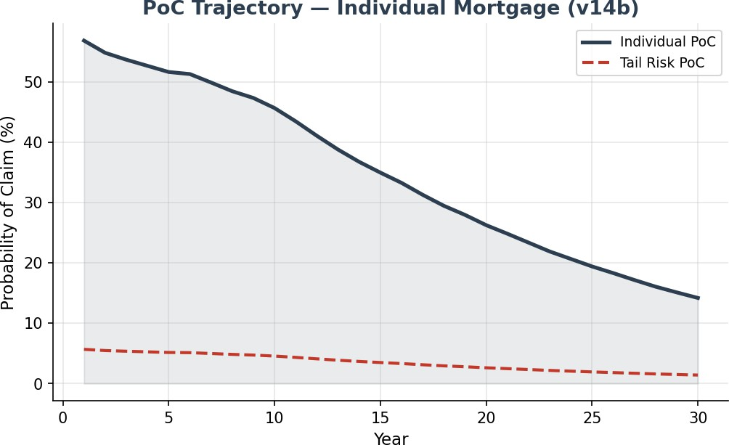
Individual PoC declines from xxx% in Year 1 to xxx% in Year 30 as the PI amortization progressively reduces the mortgage balance. The tail risk PoC follows the same trajectory at approximately 1/10th of the individual PoC.

Portfolio Diversification
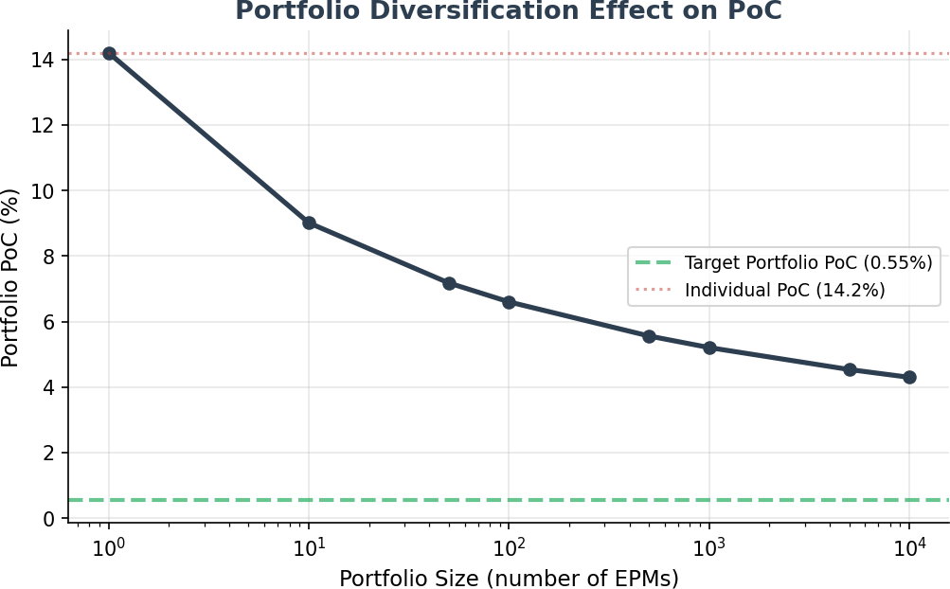
At portfolio scale (10,000+ EPMs), the Payments Waterfall reduces PoC from xxx% to approximately xxx%. This is the actual claim probability the insurance structure needs to cover — not the individual PoC.

Premium AllocationR

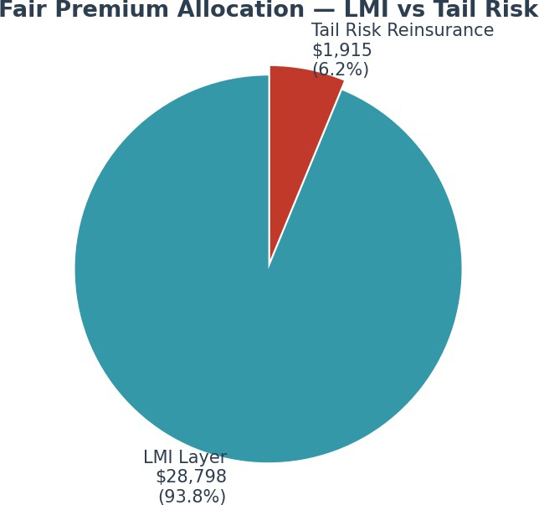

The total fair premium of $xxx is split xx% / xx% between LMI and tail risk reinsurance. This reflects the dramatically lower frequency and expected loss of the tail risk layer.

  - Surplus Distribution at Year 30

Percentile | Surplus ($) | Interpretation
P1 (worst 1%) | $xxx | Extreme downside — reinsurance claim likely
P5 | $xxx | Significant deficit — within LMI/reinsurance coverage
P10 | $xxx | Near boundary — may trigger reinsurance
P25 | $xxx | Moderate surplus — no claim
Median | $xxx | Typical outcome — healthy surplus
Mean | $xxx | Average outcome — strong surplus
P75 | $xxx | Good outcome
P90 | $xxx | Strong outcome
P99 | $xxx | Exceptional outcome

Premium Pricing Framework

LMI Premium Calculation
The LMI premium is calculated using the Discounted Expected Deficit methodology:
    - Step 1: Run 50,000-path Monte Carlo simulation to generate surplus/deficit distribution at mortgage expiry.
    - Step 2: Identify deficit paths (investment account < outstanding mortgage balance). Result: 14.2% of paths are in deficit.
    - Step 3: Calculate the 10th percentile of the conditional deficit distribution to establish the top cover boundary ($1,760,160).
    - Step 4: For each deficit path within the LMI layer: claim = min(deficit, top cover limit). Discount each claim to present value at 4.4% (cash rate mean).
    - Step 5: Fair premium = mean of discounted claims = $28,798. Apply 50% loading for expenses and profit = $43,197.

Reinsurance Premium Calculation
The reinsurance premium follows the same methodology for the excess layer:
    - For each deficit path exceeding the top cover limit: reinsurance claim = deficit - top cover limit.
    - Discount each excess claim to present value at 4.4%.
    - Fair premium = mean of discounted excess claims = $1,915. Apply 50% loading = $2,872.

Annual Premium Conversion (for Reinsurance)
While LMI is paid upfront at mortgage origination, the reinsurance premium can be converted to an annual basis for treaty pricing purposes:

Metric | Value | Notes
Loaded premium (PV, upfront) | $2,872 | Single premium equivalent
Annual equivalent rate | 0.05% of outstanding | Spread over mortgage term
Annual premium (Year 1) | $680 | On initial loan of $1,360,000
Annual premium (Year 15) | $600 | On amortised balance of ~$1.2M

Risk Transfer Summary
The complete risk transfer architecture ensures the wholesale mortgage funder bears zero credit risk:

Risk Layer | Coverage | Risk Bearer | Premium Basis
First loss (investment underperformance) | ETF selldown from individual account | Homeowner (via investment account) | None (embedded in product)
Second loss (portfolio cross-subsidy) | Surplus loans offset deficit loans | FutureProof (portfolio manager) | None (portfolio structure)
Third loss (mild deficit) | Up to $1,760,160 | LMI Insurer | $43,197 upfront per mortgage
Fourth loss (severe deficit) | Excess above  $1,760,160 | Reinsurer | Annual treaty premium
Residual risk | None — full coverage | N/A | N/A
Key takeaway for reinsurers: The EPM reinsurance opportunity offers a low-frequency, high-attachment-point risk with substantial investment float benefit (15-30 year claim deferral), predictable premium income, and natural portfolio diversification across vintages, tenures, and geographies.
  - Advantages for Each Participant

Participant | Key Advantage | Risk Retained
Mortgage Funder | Zero credit risk — full insurance coverage | None (fully transferred)
LMI Insurer | High-premium, deferred-claim product with bounded severity | Up to $1,760,160 per mortgage
Reinsurer | Low-frequency tail risk with long investment float | Excess above $1,760,160
FutureProof | Origination fees + margin + profit share | Portfolio management (cross-subsidy)
Homeowner | Access to home equity while retaining ownership | Investment account performance

Appendix: v14c Model Parameters

Parameter | Value | Notes
Home value | $2,000,000 | Representative Australian metropolitan property
Initial mortgage | $1,360,000 | Effective LVR: 68.0%
Max LVR | 80% | Max loan: $1,600,000
Mortgage type | Principal + Interest | Builds to peak at Year 10, then amortises
Mortgage term | 30 years | Longest available term
Annuity | $24,000/year | For first 10 years
Equity return (mu) | 9.4% | Adjusted S&P 500 long-term expected return (10%), after volatility control
Equity volatility (sigma) | 16.6% | Annual volatility
Buffer cap | 130% | Maximum quarterly return
Buffer floor | 80% | Minimum quarterly return
Cash rate (initial/mean) | 4.4% | Stochastic OU process
Cash rate speed (kappa) | 0.24 | Mean-reversion speed
Cash rate vol (sigma) | 1.22% | Interest rate volatility
Equity-rate correlation | 0.30 | Appropriate for 30yr horizon
Wholesale margin | 2.0% | Funder borrowing margin
Retail margin | 0.75% | Lender margin
FP margin | 0.50% | Futureproof loan margin (ARR)
Hedging fee | 0.25% | SpiderRock continuous dynamic hedging program fee
Collar price | -0.81% | Net cost of cap/floor
LMI upfront | 2.0% | Of max loan at origination
Profit share | 10% every 5 years | Surplus drawn periodically with balance re-invested in reference assets. Remaining surplus balance fully drawn at end-of-term
Simulation paths | 50,000 | SE on PoC: xxx%
Holiday entry level | 0.9 | Interest-Holiday entry trigger
Holiday exit level | 1.458 | Interest-Holiday exit trigger
Source: FutureProofCalculator_Pavel_v14b (Fixed).xlsm | monte_carlo_v14c_results.json

