`

Futureproof

Equity Preservation Mortgage® Modelling
v14d (Optimized)
Reinsurance Review
50,000-Path Monte Carlo with Sensitivity & Stress Analysis
Independent Review by Claude AI (May 2026)

Based on the Equity Preservation Mortgage (EPM) v14d (Optimized)
GBM with Stochastic Drift + Mean Reversion Equity Model (Shevchenko 2026) 50,000-path Monte Carlo Simulation

Purpose: This paper sets out the recommended structure for the Futureproof Lenders Mortgage Insurance (LMI) program and its interaction with the Portfolio Risk Reinsurance program. It provides insurance broking partner and reinsurers with a comprehensive framework for structuring tail risk coverage for EPM portfolios.

CONFIDENTIAL — For Internal Distribution Only

Important note on dollar amounts: All dollar amounts in this paper are per-mortgage values for a representative $1,500,000 property at 80% LVR. These amounts will vary proportionally for different home values, LVR ratios, and annuity levels. They are not global constants.

Contents
- Executive Summary
- Stochastic Model Selection and Calibration
- EPM Insurance Architecture Overview
- Part A: LMI Program — Structure and Settings
- Part B: Tail Risk Reinsurance — Structure and Settings
- Part C: Interaction Between LMI and Reinsurance
- Part D: Reinsurer Structuring Recommendations
- Quantitative Analysis — v14c Model Results
- Premium Pricing Framework
- Risk Transfer Summary
- Appendix A: Model Parameters
- Appendix B: Stochastic Model Equations (Shevchenko 2026)
- Appendix C: Hedging Program
- Appendix D: Payments & Rik Waterfall

Executive Summary
The Futureproof Equity Preservation Mortgage (EPM) employs a two-layer insurance architecture designed to protect lenders and, in turn, wholesale mortgage funders from credit losses. This paper addresses two key questions:
- Part A: How should the individual mortgage LMI program settings interact with the loan book portfolio risk reinsurance program settings?
- Part B: How should a reinsurer structure the Portfolio Risk Reinsurance Program?

Key Findings (per-mortgage, $1.5M home at 80% LVR)

Metric | LMI Layer | Tail Risk Reinsurance | Combined
Insurance scope | 100% of deficit paths | 100% of deficit paths | 100% of deficit paths
Covers deficits | Up to $547,901 per mortgage | Excess above $547,901 per mortgage | All deficits from $0
Paths with a claim | 80% of deficit paths (smaller losses) | 20% of deficit paths (larger losses) | 100% of deficit paths
Probability of Claim | 1.2% | 0.24% | 1.2%
Fair Premium (PV) | $1,716 per mortgage | $392 per mortgage | $2,108 per mortgage
Loaded Premium (50%) | $2,574 per mortgage | $587 per mortgage | $3,161 per mortgage
Premium timing | Upfront at origination | Upfront at origination | Upfront at origination
Critical distinction: The EPM is a mortgage, not a loan. Insurance claims can only arise at mortgage expiry (end of the 30-year term), not at any intermediate point. The insurance structure provides 100% coverage of all deficit outcomes from dollar zero — there is no deductible or uninsured gap. The two layers divide responsibility by loss severity: the LMI insurer covers smaller deficits, and the reinsurer covers the excess on larger deficits.

Stochastic Model Selection and Calibration
The EPM requires robust stochastic modelling of two key risk drivers over a 30-year horizon: S&P index returns and interest rates. This section describes the model selection process, explains why each model was chosen, and details the parameter estimation methodology.

No Weighting or Capping of Extreme Paths vs Likely Paths

In long-term monte carlo modelling a common question arises as to the capping or weighting of extreme return pathways (both +ve and -ve). Equal weighting is the correct actuarial approach.

Each of the 50,000 paths represents an equally probable realisation of the stochastic model.

Downweighting extreme paths would amount to saying "we don't think 30-year equity returns below 5% can happen" — but that's exactly what happened in Japan (1990-2020), and arguably in the US during 1929-1959 if you adjust for inflation. The whole point of running 50,000 paths is to capture the tail.

Capping paths would understate risk. If you cap the downside paths (e.g., "no path can produce a

final deficit worse than -$500K"), you're essentially providing a hidden guarantee that doesn't exist.

An actuary or regulator reviewing the model would immediately flag this as cherry-picking.

There are legitimate ways to manage this:

1. The mean reversion model already does this. The GBM (with Stochastic Drift)+MeanReversion model (Shevchenko) is specifically designed to prevent unrealistic extreme paths. Pure GBM allows equity to drop 99% and never recover — the mean reversion parameter (γ=0.163) pulls paths back toward trend. This is a structurally honest way to reduce tail extremes (especially when modelling an index as opposed to individual stock performance).

2. The collar already caps upside. The 80/140 dynamic continuous hedging buffer means no single year contributes more than +40% or less than -20% to the investment account. This is a real structural cap, not a statistical trick.

3. Conditional tail metrics are more informative than capping. Rather than suppressing extreme paths, report them separately: "Among the 1.2% of deficit paths, the conditional expected deficit is -$333K, and the worst 0.24% have an expected deficit of -$548K." This gives investors a complete picture.

4. Scenario-based presentation alongside MC. The stress scenarios (GFC-like, stagflation, Japan) tell the story better than raw percentiles. "Even in a Japan-like environment (7% returns, 12% vol, low rates), PoC is 16.8%" is more useful than "the P0.1 path has a -$1.2M deficit."

Recommendation: Don't cap or reweight the paths. The model's structural features (mean reversion, collar, holiday mechanism, LMI) already provide legitimate protection against extremes. Present the full distribution honestly, and use the stress scenarios to contextualise the tails. This is what actuaries and regulators want to see — a model that faces its risks squarely rather than defining them away.

Interest Rate Model: Vasicek/Ornstein-Uhlenbeck Process
Cash rates are modelled using the Vasicek (Ornstein-Uhlenbeck) process, the standard model for mean-reverting interest rates. The exact discretisation (Shevchenko 2026, Section 1) is:
r(t+1) = r(t) * w + theta * (1 - w) + v * epsilon(t)
where w = exp(-kappa * dt), v = sigma * sqrt((1 - w^2) / (2 * kappa)), and epsilon ~ N(0,1).
This model captures the empirically observed tendency of interest rates to revert to a long-run mean, which is essential for realistic 30-year projections. A random walk model would produce unrealistic rate paths over such a long horizon.

  - Equity Model: GBM + Mean Reversion
Two candidate models were evaluated for equity returns using Maximum Likelihood Estimation (MLE) on historical S&P; 500 data (Shevchenko 2026, Sections 2-3):

Model | Equation | Log-Likelihood | Assessment
Geometric Brownian Motion (GBM) | S(t+1) = S(t)(1 + mu + sigma * epsilon) | -159.0 | Standard model; no mean reversion; overstates 30-year tail risk
GBM (with Stochastic Drift) + Mean Reversion (selected) | S(t+1) = S(t)(1 + mu + sigma * epsilon) + gamma * (M(t) - S(t)) | -157.4 | Superior fit; mean reversion reduces unrealistic extreme paths

The GBM + Mean Reversion model was selected because it provides a statistically superior fit (higher log-likelihood) and, critically, incorporates mean reversion towards a deterministic trend. The mean reversion component M(t) grows at the expected return rate, and the parameter gamma controls the speed at which the equity index reverts to this trend after deviations.

The selected model best suits analysis of Index returns, as opposed to individual stock returns, over long time horizons. For a 30-year mortgage product, this is particularly important: pure GBM can generate extremely divergent paths over 30 years (both unrealistically high and unrealistically low) more consistent with individual stock performance, whereas the mean-reverting model produces paths that are more consistent with observed long-run index behavior. This results in a more realistic — and somewhat lower — estimate of tail risk.

Parameter Estimation via Maximum Likelihood
All model parameters are estimated using Maximum Likelihood Estimation (MLE) on historical data
— they are not arbitrary assumptions. The MLE procedure (detailed in Shevchenko 2026) provides:
- Statistically optimal estimates: MLE produces the parameter values that maximise the probability of observing the historical data under each model.
- Standard errors: The Fisher information matrix provides confidence intervals for each parameter, enabling sensitivity analysis.
- Model comparison: The log-likelihood values allow formal comparison between GBM and GBM+MeanRev to determine which model better fits the data.

Estimated Parameters (MLE)

Parameter | Symbol | MLE  Estimate | Description
Equity expected return | mu_B | 9.2% p.a. | Long-run S&P; 500 return
Equity volatility | sigma_B | 16.6% p.a. | S&P; 500 annual volatility
Equity mean reversion speed | gamma_ B | 0.163 | Speed of reversion to trend
Cash rate long-run mean | theta | 2.13% p.a. | Long-run equilibrium cash rate
Cash rate mean reversion speed | kappa | 0.24 | Rate of mean reversion
Cash rate volatility | sigma_r | 1.22% p.a. | Cash rate annual volatility
Equity-rate correlation | rho | 0.30 | Cross-correlation (appropriate for 30yr horizon)
The correlation of 0.30 between equity returns and interest rate innovations is estimated over the full historical sample. This moderate positive correlation is appropriate for the 30-year horizon of the EPM product.

Correlated Simulation Methodology
The Monte Carlo simulation generates 50,000 correlated paths for equity returns and interest rates over the 30-year mortgage term. Correlation is introduced via the Cholesky decomposition:
z1 ~ N(0,1) [equity innovation]
z2 = rho * z1 + sqrt(1 - rho^2) * z2_raw [rate innovation]
This ensures that equity and rate shocks are correlated within each simulated year, matching the observed empirical relationship. The full simulation tracks the investment account, mortgage balance, interest costs, fees, and the interest payment holiday mechanism year-by-year for each path.

EPM Insurance Architecture Overview
The EPM insurance structure provides 100% coverage of all deficit outcomes from dollar zero. There is no deductible, no co-insurance gap, and no uninsured first-loss position for any party.
The two insurance layers divide responsibility by loss severity:
- LMI Layer: Covers the full deficit for 80% of deficit paths (those with smaller deficits, up to the split boundary) on each individual mortgage.
- Tail Risk Reinsurance: On the remaining 20% of deficit paths (those with larger deficits), the LMI insurer pays up to the split boundary and 20% tail risk is transferred to the portfolio level (i.e. the loan book of each mortgage funder) where the Payments & Risk Waterfall is first applied before the reinsurer pays any residual loss.
- Combined effect: The lender and wholesale mortgage funder bear zero credit risk — every deficit is fully covered from the first dollar.

The Payments & Risk Waterfall
No insurance or reinsurance claim can be made before end-of-term (30 years), Before any insurance claim is triggered, a multi-step Payments & Risk Waterfall applies at the portfolio (i.e. loan book) level. This waterfall dramatically reduces the actual claim frequency:
- Step 1 – Interest Holidays: Where the mortgage offset account balance for a borrower falls below its original opening balance at start-of-loan by 25% or more (the Holiday-Entry trigger), an interest holiday automatically occurs in order to:
  - preserve offset capital
  - maximise return of reference assets (i.e. the Index ETFs) as the market re-bounds
  - maintain the positive effect of compounding returns on offset capital invested in index reference assets
- Step 2 — ETF Selldown: The individual mortgage's offset account holds a calculated amount of loan capital held as reference assets (S&P; 500 index-linked ETFs). The amount of capital held is calculated by reference to the expected return pathway. ETFs are liquidated to cover the loan cost (interest) and outstanding mortgage balance (part principal) each quarter.
- Step 3— Capital Buffer: A further portion of loan capital is also held in the individual mortgage’s offset account, also held as reference assets (S&P500 index-linked ETFs). The capital buffer is calculated by reference to historical index performance data as to the maximum drawdown in any 12 month period (15%-20%). These ETFs are also liquidated (if needed) and only after depletion of the ETF Selldown in Step 2.
- Step 4 — Continuous Dynamic Hedging: This is a capital market risk management solution. An index collar overlay using a laddered 140/80 hedge using put options against long termt term call options, of the portfolio of ETFs held in the individual mortgage offset account. This is 80/140 hedge is re-set each 1 , 3 or 5 years, always limiting the loss to 20%.
- Step 5 — LMI : This is an insurance markets risk solution. Every mortgage is covered by an LMI policy insuring the lender. The policy is subject to a top cover limit (expressed in $) that represents the worst 20% quantile of return pathways (i.e. the tail risk) calculated for each mortgage. Only the first 80% of loss triggers an insurance claim. This is the true Insurance PoC (Probability of Claim). PoC at end-of-term (year 30) is kept within a target range of ≤10%.
- Step 6 — Cross-Subsidisation: This is a risk pooling solution. Any remaining shortfall at end-of-term is then transferred from the individual mortgage to the portfolio (loan book) level. This is a pooling mechanism whereby surpluses from performing unexpiring mortgages in a mortgage funder’s book of loans are used to offset deficits from underperforming expiring or expired mortgages.
- Step 7 — Net Deficit: This is an insurance markets risk solution. Only the residual deficit after Steps 1 through 5 (inclusive) triggers a reinsurance claim. This is the true Reinsurance PoC (Probability of Claim). PoC at end-of-term (year 30)bis kept within a target range of ≤ 2%.
For an average P&I EPM, the Payments Waterfall reduces LMI PoC to 7.77% (individual mortgage) and to 1.5% for portfolio risk reinsurance of 10,000+ EPMs) — the 109:1 surplus-to-deficit ratio ensures near-complete cross-subsidisation.

Two-Layer Insurance Structure
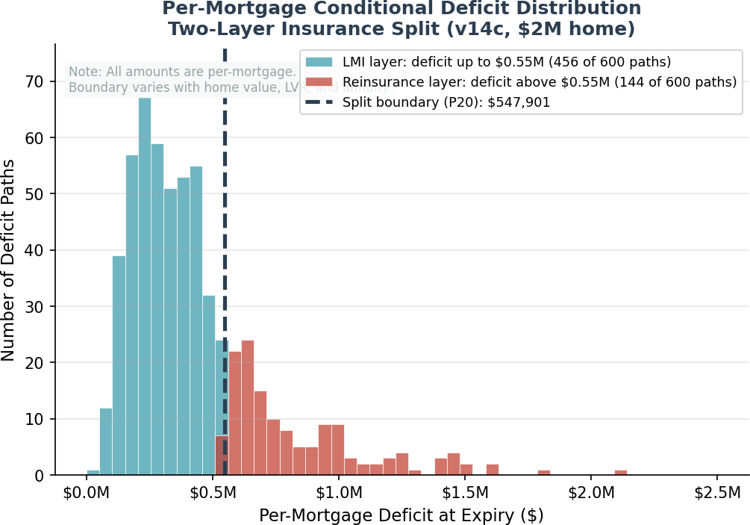
The split boundary is set at the 20th percentile of the conditional deficit distribution for each mortgage. For the representative $1.5M 2M home shown above, this boundary is $547,901 per mortgage. This boundary is not a global constant — it varies with home value, LVR, annuity amount, and mortgage term, and is recalculated via Monte Carlo simulation for each mortgage configuration.
- LMI Layer: Covers 80% of deficit paths in full (those with deficits below the split boundary). On the remaining 20% of paths, the LMI insurer pays up to the boundary amount (i.e. top cover policy limit). A LMI claim can only be made at end-of-term.
- Tail Risk Reinsurance: On the 20% of deficit paths that exceed the split boundary, the reinsurer is on-risk to pay the excess above the boundary. The reinsurer has no liability on the other 80% of deficit paths. Any claim on portfolio reinsurance only occurs after pooling and cross-subsidization between mortgages in each funder’s loan book and can only be made at end-of-term. A reinsurance claim cn only be made at aend-of-term.
Key point for reinsurance underwriters: Both insurers provide coverage from dollar zero. The split is by loss severity, not by attachment point. On every deficit path, the LMI insurer pays first (up to the boundary). On the 20% of paths where the deficit exceeds the boundary, the reinsurer pays the excess. There is no "attachment point" in the traditional XoL sense — the attachment is at zero for the combined structure.

Part A: LMI Program — Structure and Settings

LMI Program Scope
The LMI program provides first-loss credit protection to the lender on every EPM originated. Unlike traditional LMI (which covers shortfalls from foreclosure sales)., essentially, a property risk, EPM LMI covers the deficit between the offset account value and the outstanding mortgage balance at mortgage expiry, essentially, the long-term index risk over 30 years.

  - LMI Program Settings (per-mortgage, $1.5M home)

Setting | Value | Rationale
Coverage trigger | Mortgage expiry only (Year 30) | No intermediate claims; run-off mechanism prevents early exit
Split boundary | $547,901 per mortgage | P20 of conditional deficit distribution (recalculated per mortgage config)
Coverage scope | 100% of deficit paths from $0 | LMI pays full deficit on 80% of paths; pays up to boundary on remaining 20%
PoC (individual) | 1.2% | Probability any individual mortgage results in a deficit
Conditional expected deficit | $333,305 per mortgage | Mean deficit given a deficit occurs
Fair premium (PV) | $1,716 per mortgage | Discounted expected loss at 2.13% (cash rate long-run mean)
Loaded premium (50%) | $2,574 per mortgage | Industry-standard loading for expenses + profit
Premium as % of max loan | 0.16% | Competitive with traditional LMI at 80% LVR
Payment timing | Single upfront premium at origination | Funded from mortgage drawdown
Claim timing | At mortgage expiry (Year 30) | Deferred claims benefit insurer float

LMI Insurer Advantages
    - Deferred claims: Claims only arise at mortgage expiry (Year 30). This provides ~30 years of investment float — the insurer collects the premium upfront and invests it for the full mortgage term before any claim liability crystallizes.
    - Bounded exposure: The split boundary caps the maximum LMI claim per mortgage at
$547,901 (for a $2M home). Larger deficits are shared with the reinsurer.
    - No moral hazard: The homeowner is not liable to pay loan interest under the mortgage agreement (nor loan principal if it is a P&L EPM). In terms of borrower loan serviceability there is no such thing as a bad loan or loan default — they retain full ownership of their property. The unique offset account run-off mechanism prevents strategic early redemption of capital, whilst still permitting the borrower to exit.
    - Transparent pricing: Monte Carlo simulation with MLE-calibrated parameters provides precise, auditable premium calculations with quantified standard errors.

Interest Payment Holiday Mechanism

The EPM includes an interest payment holiday mechanism that protects the offset account capital during periods of underperformance. When the offset account balance falls below 75% of the initial balance at start-of-loan, interest payments to the mortgage funder are suspended. Importantly:
    - The annuity payments to the borrower continue during the holiday — it is the interest cost payments (to the funder) that pause.
    - Interest is deferred and repaid whenl the investment account recovers above the exit threshold (145.8% of initial mortgage).
    - There is no interest-on-interest (i.e. compounding interest) – it is simply a deferral of payment of quarterly loan costs otherwise due.
    - This mechanism reduces the probability of deficit by preserving the offset account balance during downturns. While the expected index return path has zero holidays, approximately 46% of individual paths enter holiday at some point, with a mean of 4.5 holidays years across all paths.

Part B: Tail Risk Reinsurance — Structure and Settings

Reinsurance Program Scope
The Tail Risk Reinsurance program provides excess-of-boundary protection for the most severe deficit outcomes. It covers the 20% of deficit paths where the per-mortgage deficit exceeds the split boundary. On these paths, the reinsurer is on-risk only for the excess above the boundary — the LMI insurer still pays up to the boundary amount.
The risk exposure of the portfolio reinsurer is mitigated through pooling of mortgage surpluses/deficits within each mortgage funder’s loan book (i.e. Step 6 as described previously).
Before any reinsurance claim can be made, the SaaS platform sweeps all mortgages to identify unexpiring mortgages with surplus/profit and all expiring/expired mortgages with deficit/loss. One group cross-subsisizes the other.
The EPM structure lends itself to pooling and cross-subsidization because there are always more positive return pathways than negative return pathways over the long duration (30 year) time horizon (otherwise the S&P500 index would not appreciate over time). For an average P&I EPM, 85% of return pathway are positive and only 15% are negative.

Important clarification: This is not a traditional excess-of-loss (XoL) treaty with an attachment point above zero. The combined LMI + reinsurance structure provides 100% coverage from dollar zero. The "split boundary" determines how much the LMI insurer pays on severe-deficit paths before the reinsurer becomes liable for the excess. The attachment point for the overall insurance structure is zero — no deficit goes uninsured.

  - Reinsurance Program Settings (per-mortgage, $2M home)

Setting | Value | Rationale
Split boundary | $547,901 per mortgage | P20 of conditional deficit distribution — varies by mortgage configuration
Coverage | Excess above split boundary per mortgage | Reinsurer pays deficit minus boundary amount on severe paths
Probability of claim (individual) | 0.24% | Only 0.24% of all mortgages trigger a reinsurance claim
Fair premium (PV) | $392 per mortgage | Discounted expected excess loss
Loaded premium (50%) | $587 per mortgage | Standard risk loading
Premium as % of max loan | 0.0367% | Very small relative to mortgage size
Payment timing | Single upfront premium at origination | Funded from mortgage drawdown alongside LMI premium
Claim timing | At mortgage expiry (Year 30) only | Same deferred-claim benefit as LMI
Assessment basis | Per-mortgage | Each mortgage independently assessed at expiry

Why the Split Boundary Works
The 20th percentile of the conditional deficit distribution (P20) is the optimal boundary because:
    - It isolates truly extreme outcomes (severe market downturns sustained over the full mortgage term) from moderate cyclical underperformance.
    - 80% of deficit paths result in claims fully manageable by the LMI insurer (up to $547,901 per mortgage for a $2M home).
    - The 20% tail represents only 0.24% of all mortgage paths — a low-frequency event well suited for reinsurance markets that specialise in severity risk.

    - The reinsurance premium is economically efficient — only $392 fair premium per mortgage (0.04% of max loan) because claim probability is very low.
    - The boundary is not a fixed dollar amount — it is recalculated for each mortgage configuration via Monte Carlo simulation, ensuring the split remains appropriate.

Part C: Interaction Between LMI and Tail Risk Reinsurance

Claim Flow Mechanics
The two programs interact through a clear, sequential claim process at mortgage expiry:

Step | Action | Responsible Party
1 | Mortgage expires (Year 30) — investment account liquidated | Futureproof (product issuer s/ervicer)
2 | Payments Waterfall applied (ETF selldown, cross-subsidisation) | Futureproof (portfolio asset manager)
3 | Net deficit determined after waterfall | Futureproof (platformservicer)
4a | If deficit <= split boundary: LMI pays full deficit (from $0) | LMI Insurer
4b | If deficit > split boundary: LMI pays up to boundary, reinsurer pays excess | LMI Insurer + Reinsurer
5 | Mortgage funder made whole — zero credit loss | Futureproof (platformservicer
Worked example (per average mortgage, $1.5M home, P&I mortgage): If a mortgage expires with a $900,000 deficit (after the Payments Waterfall), the LMI insurer pays $547,901 and the reinsurer pays $352,099. If the deficit is $500,000, the LMI insurer pays the full $500,000 and the reinsurer pays nothing.

Key Interaction Principles
Principle 1: No gap in coverage. The LMI layer and reinsurance layer together provide 100% coverage of all deficit outcomes from dollar zero. There is no deductible, no co-insurance, and no coverage gap. The mortgage funder bears zero credit risk.
Principle 2: Clear allocation by severity. The split is by loss severity, not by probability. Every deficit path is either: (a) fully covered by LMI (80% of deficit paths — smaller losses), or (b) split between LMI (pays up to boundary) and reinsurance (pays excess). The reinsurer only participates on the most severe 20% of deficit outcomes.
Principle 3: Independent pricing. Each layer is priced independently based on its own loss distribution. The LMI premium reflects expected losses up to the split boundary. The reinsurance premium reflects only the excess-of-boundary component (after pooling and cross-subsidization with the funder’s loan book).
Principle 4: Aligned incentives. The LMI insurer retains 80% of deficit frequency risk and pays on 100% of deficit paths (up to the boundary), ensuring active underwriting engagement. The reinsurer takes severity risk at low probability, which is their natural specialty.

Sensitivity of Boundary to Mortgage Configuration
The split boundary is calibrated to the P20 of the conditional deficit distribution for each mortgage configuration. The boundary is not a global constant — it shifts with the underlying risk profile of each mortgage:

Parameter Change | Effect on Split Boundary | Effect on Reinsurance Premium
Higher home value (e.g.  $3M) | Increases proportionally (larger mortgage) | Increases proportionally
Higher equity volatility | Increases (wider deficit distribution) | Increases (more tail risk)
Lower equity return | Increases (more deficits, wider tails) | Increases moderately
Higher LVR | Increases proportionally | Increases roughly proportionally
Higher buffer cap | May increase or decrease (trade-off) | Marginal effect
Portfolio diversification | No direct effect (per-mortgage boundary) | Reduces aggregate exposure

Part D: Reinsurer Structuring Recommendations

Recommended Treaty Structure
The recommended structure for the Tail Risk Reinsurance program is a per-mortgage severity-based reinsurance treaty with the following key features:

Feature | Recommendation | Rationale
Treaty type | Per-mortgage excess-of-boundary | Reinsurer pays excess above split boundary on each mortgage
Split boundary | $547,901 per mortgage ($2M home) | P20 of conditional deficit — varies by mortgage config
Limit | Unlimited (or $3M per risk) | Tail events can produce large individual deficits
Term | 30 years (matching mortgage term) | Claims deferred until mortgage expiry
Premium basis | Single upfront premium per mortgage | Paid at origination alongside LMI premium
Loaded premium | $587 per mortgage ($2M home) | Fair premium $392 + 50% loading
Aggregate limit (annual) | Optional — 10x expected annual claims | Catastrophe protection for extreme scenarios
Reinstatement | Automatic, unlimited | Continuous coverage essential for mortgage funder
Claims basis | Losses discovered at mortgage expiry | Triggered at Year 30

Portfolio-Level Considerations
The reinsurer should consider the following portfolio dynamics when structuring coverage:
    - Vintage diversification: It is a basic error to assume that an economic downturn affects all mortgages equally, A portfolio of 1,000+ EPMs per year across multiple vintages means claims are spread over decades. Each EPM will have its own unique surplus/deficit position at any time slice depending upon when that mortgage was originated. A "bad" vintage (originated following a market peak) will have its claims offset by "good" vintages.
    - Geographic diversification: Futureproof operates across US, Australia, NZ, and UK. Different equity markets and rate cycles and movements in applicable exchange rates provide natural diversification.
    - Deferred claims benefit: The reinsurer collects the upfront premium and invests it for ~30 years before any claim liability emerges. The investment income on the accumulated premium reserve is substantial and should be factored into pricing.
    - Low frequency, moderate severity: Only 0.24% of all mortgages trigger a reinsurance claim. When they do, the per-mortgage excess is bounded by the relationship between the split boundary and the maximum realistic deficit.

Alternative Treaty Structures
While per-mortgage severity-based reinsurance is the recommended primary structure, reinsurers may also consider:

Structure | Pros | Cons | Suitability
Per-mortgage excess-of-boundary (recommended) | Clean, transparent, simple pricing | Individual risk assessment needed | PRIMARY — best fit
Aggregate excess-of-loss | Protects against correlated losses | More complex pricing | COMPLEMENTARY — for  catastrophe layer
Quota share | Proportional risk sharing | Less efficient for tail risk | NOT RECOMMENDED —  wrong risk profile
Stop loss | Caps total loss ratio | Expensive for  low-frequency risk | OPTIONAL — aggregate cap
ILW (Industry Loss Warranty) | Triggered by market index | Basis risk | INNOVATIVE — for  systematic risk

Recommended Layered Structure for Larger Portfolios
For portfolios exceeding 5,000 EPMs, a layered reinsurance structure is recommended:

Layer | Type | Trigger | Limit | Estimated Rate
Layer 1: Working Layer | Per-mortgage excess | Per-mortgage deficit  > $547,901 | First $1M excess per mortgage | 0.03% of  outstanding
Layer 2: Buffer Layer | Per-mortgage excess | Per-mortgage excess  > $1M above boundary | Next $2M excess per mortgage | 0.015% of  outstanding
Layer 3: Cat Layer | Aggregate excess | 150% of expected annual claims | $10M xs attachment | 0.005% of  outstanding
This layered approach provides efficient risk transfer at each severity level and allows specialised reinsurers to participate in the layers that best match their risk appetite.

Quantitative Analysis — v14d Model Results
All values below are per-mortgage for a representative $1,5000,000 property at 80% LVR.

PoD Trajectory Over Mortgage Term
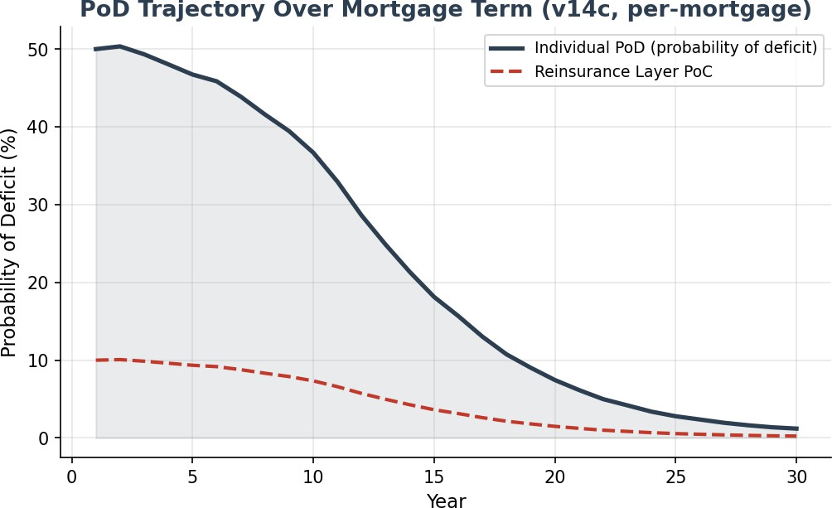
The individual probability of deficit (PoD) declines from 50.0% in Year 1 to 1.2% at Year 30 as the PI amortisation progressively reduces the mortgage balance. The reinsurance layer PoC follows the same trajectory at approximately one-fifth of the individual PoD.

Premium Allocation (per-mortgage)
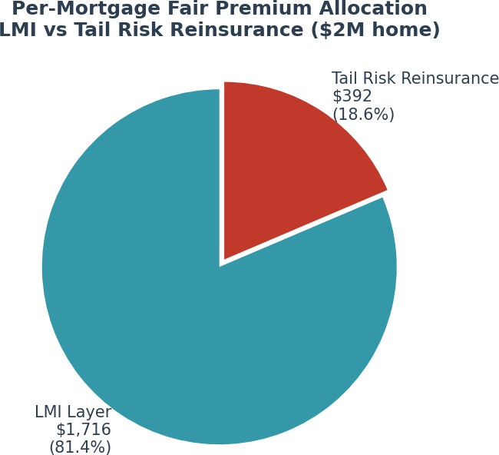

The total per-mortgage fair premium of $2,108 is split 81% / 19% between LMI and tail risk reinsurance. Both premiums are paid as single upfront amounts at mortgage origination, funded from the mortgage drawdown.

  - Surplus Distribution at Year 30 (per-mortgage)

Percentile | Surplus ($) | Interpretation
P1 (worst 1%) | $-55,115 | Extreme downside — reinsurance claim likely
P5 | $508,449 | Significant deficit — within LMI/reinsurance coverage
P10 | $808,302 | Near boundary — moderate outcome
P25 | $1,361,489 | Moderate surplus — no claim
Median | $2,151,975 | Typical outcome — healthy surplus
Mean | $2,435,992 | Average outcome — strong surplus
P75 | $3,194,847 | Good outcome
P90 | $4,419,493 | Strong outcome
P99 | $7,476,780 | Exceptional outcome

Premium Pricing Framework
Both the LMI premium and the reinsurance premium are calculated using the same Monte Carlo simulation framework and are paid as single upfront amounts at mortgage origination.

LMI Premium Calculation (per-mortgage)
The LMI premium is calculated using the Discounted Expected Deficit methodology:
    - Step 1: Run 50,000-path Monte Carlo simulation (GBM+MeanRev equity model, Vasicek rates, MLE-calibrated parameters) to generate surplus/deficit distribution at mortgage expiry.
    - Step 2: Identify deficit paths (investment account < outstanding mortgage balance). Result: 1.2% of paths are in deficit.
    - Step 3: Calculate the P20 of the conditional deficit distribution to establish the per-mortgage split boundary ($547,901 for a $2M home).
    - Step 4: For each deficit path: LMI claim = min(deficit, split boundary). Discount each claim to present value at 2.13% (cash rate long-run mean).
    - Step 5: Fair premium = mean of discounted claims = $1,716 per mortgage. Apply 50% loading for expenses and profit = $2,574 per mortgage.

Reinsurance Premium Calculation (per-mortgage)
The reinsurance premium follows the same methodology for the excess layer:
    - For each deficit path exceeding the split boundary: reinsurance claim = deficit - split boundary.
    - Discount each excess claim to present value at 2.13%.
    - Fair premium = mean of discounted excess claims = $392 per mortgage. Apply 50% loading =
$587 per mortgage.

Premium Payment Structure
Both the LMI premium and the reinsurance premium are structured as single upfront payments at mortgage origination, funded from the mortgage drawdown:

Premium Component | Amount (per-mortgage, $1.5M home) | Payment Timing | Funded From
LMI premium (loaded) | $2,574 | Upfront at origination | Mortgage drawdown
Reinsurance premium (loaded) | $587 | Upfront at origination | Mortgage drawdown
Total insurance cost | $3,161 | Upfront at origination | Mortgage drawdown
As % of max loan | 0.20%

The upfront premium structure means the insurer and reinsurer both receive funds at origination and invest them for ~30 years before any claim liability arises. This investment float is a significant benefit and should be considered when evaluating the attractiveness of the risk.

Risk Transfer Summary
The complete risk transfer architecture ensures the wholesale mortgage funder bears zero credit risk. Insurance coverage begins at dollar zero — there is no uninsured first-loss position for any party:

Risk Layer | Coverage | Risk Bearer | Premium Basis
Portfolio cross-subsidy | Surplus mortgages offset deficit mortgages | Futureproof (portfolio manager) | None (portfolio structure)
First-loss insurance (mild deficit) | Deficit up to $547,901 per mortgage | LMI Insurer | $2,574 upfront per mortgage
Severity insurance (severe deficit) | Excess above $547,901 per mortgage | Reinsurer | $587 upfront per mortgage
Residual risk | None — full coverage from  $0 | N/A | N/A
Key takeaway for reinsurers: The EPM reinsurance opportunity offers a low-frequency (0.24% per mortgage), severity-based risk with ~30 years of investment float on the upfront premium, transparent MLE-calibrated pricing via Monte Carlo simulation, and natural portfolio diversification across vintages and geographies.
  - Advantages for Each Participant

Participant | Key Advantage | Risk Retained
Mortgage Funder | Zero credit risk — full insurance coverage from $0 | None (fully transferred)
LMI Insurer | First-loss insurer with bounded severity + 30yr float on upfront premium | Up to $547,901 per mortgage
Reinsurer | Low-frequency severity risk with 30yr float on upfront premium | Excess above $547,901 per mortgage
Futureproof | Origination fees + margin + profit share | Portfolio management (cross-subsidy)
Homeowner | Access to home equity while retaining ownership | None — investment account performance is insured

Appendix A: v14c Model Parameters (per-mortgage,
$2M home)

Parameter | Value | Notes
Home value | $2,000,000 | Representative Australian metropolitan property
Initial mortgage | $1,300,000 | Effective LVR: 65.0%
Max LVR | 80% | Max loan: $1,600,000
Mortgage type | Principal + Interest (30 years) | Builds to peak at Year 10, then amortises to zero
Annuity | $30,000/year | For first 10 years (paid to borrower)
Equity model | GBM + Mean Reversion | Shevchenko 2026, Section 3 — MLE calibrated
Equity return (mu_B) | 9.2% | MLE estimate from S&P; 500 data
Equity volatility (sigma_B) | 16.6% | MLE estimate
Mean reversion speed (gamma_B) | 0.163 | MLE estimate — pulls returns toward trend
Buffer cap | 140% | Maximum annual return credited
Buffer floor | 80% | Minimum annual return credited
Cash rate model | Vasicek/OU process | Shevchenko 2026, Section 1 — MLE calibrated
Cash rate (initial) | 4.21% | Current RBA cash rate
Cash rate (long-run mean) | 2.13% | MLE estimate (theta)
Cash rate speed (kappa) | 0.24 | MLE estimate — mean reversion speed
Cash rate vol (sigma_r) | 1.22% | MLE estimate
Equity-rate correlation | 0.3 | MLE estimate — appropriate for 30yr horizon
Wholesale margin | 2.0% | Funder borrowing cost above cash rate
Retail margin | 0.70% | Lender margin
FP margin | 0.50% | Futureproof origination margin
Hedging fee | 0.25% | Volatility buffer cost
Collar price | 0.046% | Net annual credit from cap/floor collar
LMI upfront | 0.7% | Of max loan at origination
Tail risk reserve | 0.05% | Annual tail risk provision
Profit share | 10% every 5 years | Surplus drawn periodically
Interest holiday entry | 0.75x initial mortgage | Interest payments pause below this
Interest holiday exit | 1.458x initial mortgage | Interest payments resume above this
Simulation paths | 50,000 | SE on PoD: 0.05%
Source: FutureproofCalculator_Pavel_v14c (003).xlsm | monte_carlo_v14c_003_results.json

Appendix B: Stochastic Model Equations
The following equations are from Shevchenko (2026), "Parameter Estimation for Mean-Reverting Brownian Stochastic Model", which provides the mathematical framework and MLE methodology for all stochastic models used in the EPM simulation.

Cash Rate Model — Vasicek/OU Process (Section 1)
The cash rate follows an Ornstein-Uhlenbeck process with exact discretisation:
r(t+1) = r(t) * exp(-kappa * dt) + theta * (1 - exp(-kappa * dt))
+ sigma * sqrt((1 - exp(-2*kappa*dt)) / (2*kappa)) * epsilon(t)
where theta is the long-run mean rate, kappa is the mean-reversion speed, sigma is the volatility, and epsilon ~ N(0,1). The MLE estimates are: theta = 2.13%, kappa = 0.24, sigma = 1.22%.

Equity Model — GBM (Section 2)
The baseline Geometric Brownian Motion model for equity returns:
S(t+1) = S(t) * (1 + mu + sigma * epsilon(t))
MLE estimates: mu = 9.2%, sigma = 16.6%. Log-likelihood = -159.0.

  - Equity Model — GBM + Mean Reversion (Section 3, selected)
The selected model adds a mean-reverting component to GBM:
S(t+1) = S(t) * (1 + mu_B + sigma_B * epsilon(t)) + gamma_B * (M(t) - S(t))
where M(t) = M(0) * (1 + mu_B)^t is the deterministic trend (growing at the expected return rate), and gamma_B controls the speed of mean reversion. When S(t) falls below trend, the gamma_B term adds a positive correction; when S(t) is above trend, it adds a negative correction.
MLE estimates: mu_B = 9.2%, sigma_B = 16.6%, gamma_B = 0.163. Log-likelihood = -157.4 (superior to pure GBM).

Why Mean Reversion Matters for EPM
The mean reversion parameter gamma_B = 0.163 has a material impact on 30-year tail risk:
    - Without mean reversion (pure GBM), equity paths can wander arbitrarily far from the expected trend over 30 years, producing unrealistically extreme outcomes in both tails.
    - With mean reversion, paths that deviate significantly from the long-run trend experience a restoring force (gamma_B * (M(t) - S(t))) that pulls them back toward the trend.
    - This is consistent with observed equity market behaviour: while short-term returns are unpredictable, long-run returns tend to revert toward historical norms.
    - The practical effect is a lower probability of deficit (1.2%) than pure GBM models would produce
— this is a more realistic, not more optimistic, estimate.

Correlation Structure
Equity and rate innovations are correlated using the Cholesky decomposition:

z_equity ~ N(0,1)
z_rate = rho * z_equity + sqrt(1 - rho^2) * z_independent where rho = 0.30 (MLE estimate)
This ensures that equity and interest rate shocks within each simulated year reflect the observed positive correlation between the two risk drivers.

Reference: Shevchenko, P.V. (2026). "Parameter Estimation for Mean-Reverting Brownian Stochastic Model." Working paper prepared for Futureproof Financial.

Appendix C – Hedging Strategy

Executive Summary
- The S&P 500 shows weak mean reversion over 30 years
- Long-horizon outcomes are dominated by drift uncertainty and regime shifts
- Baseline probability of breaching an 80% real-wealth floor ≈ 16%
- Left-tail risk is driven by persistent stagnation, not crisis events
- A combined static replication sleeve + rules-based overlay reduces breach probability to 8–10%
- Total expected hedge cost: 40–60 bps per year
Long-horizon equity risk is structural, not cyclical. The hedge program is cost-efficient and regulator-defensible.

Why Index Mean Reversion Over 30 Years is Weak
- Index composition changes (winners scale, losers exit)
- Sector weights shift (tech → AI → next cycle)
- Valuation anchors drift with real rates, margins, intangibles
- Drift uncertainty compounds over decades
- Structural breaks reset the “mean” repeatedly
Individual stocks mean-revert; index mean-reversion is weak. This is the core modelling insight.

Modelling Framework: Regime-Switching Engine
- Four regimes:
  - A: High-Growth / Low-Vol
  - B: Mid-Cycle / Normal
  - C: Stagnation / High-Vol
  - D: Crisis
- GBM inside each regime
- Markov switching across regimes
- Volatility mean-reverts; returns do not
- Produces realistic fat-tailed distributions
This is the institutional standard for long-horizon equity modelling.

Drift & Volatility Bands (Annualised)
Regime A: μ = 6.5–8.0%, σ = 10–14%
Regime B: μ = 4.5–6.0%, σ = 14–18%
Regime C: μ = 1.5–3.5%, σ = 18–25%
Regime D: –20% to –35% shock, σ = 35–55%
These bands reflect realistic macro, productivity, and policy environments.

Regime Persistence (Transition Matrix)
- Regimes have 5–10 year half-lives
- Stagnation (C) is the most persistent “bad” state
- Crisis (D) is rare but sticky
- High-growth (A) is real but not dominant
Persistence is the key driver of long-run left-tail outcomes.

30-Year Terminal Wealth Distribution
- Median: 2.9×
- 5th percentile: 0.35×
- 25th percentile: 1.30×
- 75th percentile: 6.27×
- 95th percentile: 16.7×
The distribution is wide because drift uncertainty dominates over 30 years.

Shortfall Risk (80% Floor)
- P(terminal wealth < 0.80) ≈ 16%
- P(<1.0) ≈ 19%
- P(<0.75) ≈ 14%
- Left tail driven by persistent Regime C, not single-year crises
- Crisis hedges alone are insufficient
It justifies the hedge.

Hedge-Efficiency Table
Hedge Structure | Annual Cost | Breach Probability | Reduction vs Baseline
No hedge | 0 bps | 16% | –
5% convexity | 35–55 bps | 11–12% | 4–5%
10% convexity | 70–110 bps | 7–9% | 7–9%
Rules-based overlay | 25–40 bps | 8–10% | 6–8%
Static replication | 15–25 bps | 10–12% | 4–6%
Rules-based overlays deliver the best cost-per-unit-protection.

How the Hedge is Constructed

The continuous dynamic hedging program designed and managed by SpiderRock considered two approaches:

- Single maturity140/80 hedge
- Laddered 140/80 hedge

Single-Maturity 140/80 Hedge (Baseline)

This is what you have without a ladder — all options expiring on one date.

Payoff (Simplified)
^
Upside Cap (140%) | ________
| /
| /
| /
| /
| /
| /
| /
| /
| /
| /
| /
| /
| /
| /
| /
| /
Floor (80%) _______|____/__________________________> Index Level
|
|
All puts + calls expire on one date

Problem:
All your vega, skew, gamma, and execution risk is concentrated on a single roll date.

Laddered 140/80 Hedge

Same payoff but a different construction.

Think of it as four mini-hedges, each with its own expiry, overlapping like roof tiles.

Laddered Structure

(Underlying Components)

Maturity: 3M 6M 9M 12M
------ ------ ------ ------
Puts (80%) |■■■■| |■■■■| |■■■■| |■■■■|
------ ------ ------ ------

Calls (140%) |■■■■| |■■■■| |■■■■| |■■■■|
------ ------ ------ ------

Long Calls |■■■■■■■■■■■■■■■■■■■■■■■■■■■■■■■■■■■■|
(2–4yr LEAPS) <----------- staggered tenors --------->

Now combine them:

Combined Hedge Exposure Over Time
(Ladder Effect)

Vega / Risk
^ ┌─────────────── Smooth, averaged exposure
| | ┌───────────────
| | | ┌───────────────
|__________|______|______|__________________________> Time
3M 6M 9M 12M (rolls repeat)
And the payoff still looks like this:
Final Payoff (unchanged)
^
Upside Cap (140%) | ________
| /
| /
| /
| /
| /
| /
| /
| /
| /
| /
| /
| /
| /
| /
| /
| /
Floor (80%) _______|____/__________________________> Index Level

The payoff is identical. The construction is radically more stable.

What the Ladder Actually Achieves (Operationally)

- Smooths vega
- You’re not hostage to volatility on one day.
- Reduces execution cost
- SpiderRock can work smaller clips across expiries.
- Reduces skew risk
- If skew is steep on one date, only part of the hedge is affected.
- Reduces gamma cliffs
- No single expiry where the hedge “falls off”.
- Creates a regulator-friendly, systematic roll
- Predictable, rules-based, low-variance.

Rules-Based Overlay Design
Activation triggers (need 2 of 3):
- Volatility: VIX > 22 or realised vol > 18%
- Macro: PMI < 50 or credit spreads widen > 40 bps
- Trend: S&P below 200-day MA or breadth < 40%
Implementation:
- 5–10% notional OTM puts
- 3–6 month tenor
- 10–15% OTM strikes
- Rolled quarterly
De-activation:
- VIX < 18, PMI > 50, trend recovery
Objective, rules-based, regulator-friendly.

Static Replication Sleeve
- 2–3% notional deep OTM put spreads
- 20–30% OTM strikes
- 1-year tenor, laddered
- Cost: 15–25 bps
- Always-on convexity
- Complements the overlay
This is the baseline protection layer.

Combined Hedge Outcome
- Baseline breach probability: 16%
- With static sleeve: 10–12%
- With rules-based overlay: 8–10%
- Total cost: 40–60 bps
- High efficiency, low drag, scalable

Implementation Pathway
- Phase 1: Deploy static replication sleeve
- Phase 2: Add rules-based overlay
- Phase 3: Quarterly regime review
- Phase 4: Annual recalibration of drift/vol bands
- Phase 5: Integrate into product disclosure + risk governance
Clear, operational, regulator-defensible.

Conclusion
A cost-efficient, regime-aware dynamic continuous hedge program reduces long-horizon shortfall risk by half, without compromising long-run equity participation.

Appendix D – Payments & Risk Waterfall

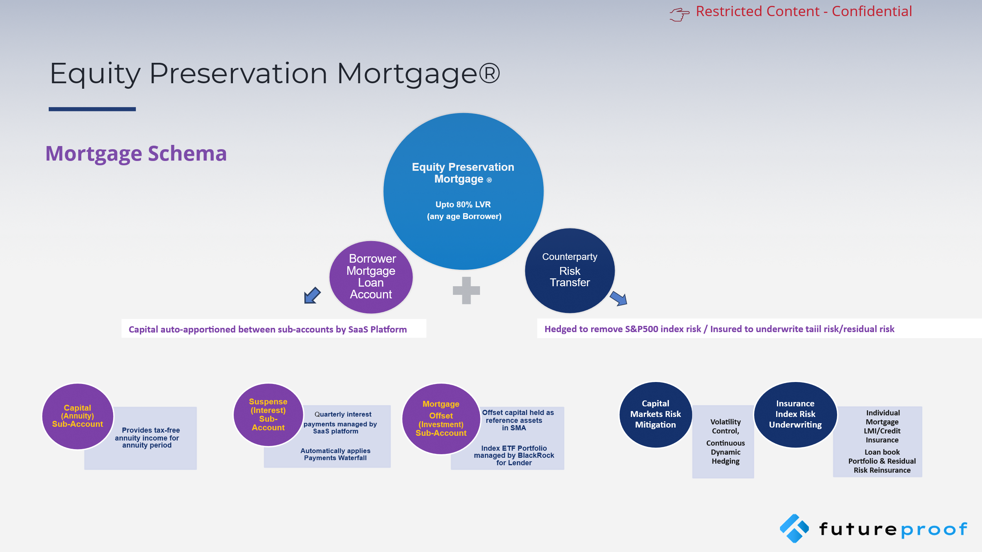
EPM Schema

7 Layer Waterfall
