Futureproof

Equity Preservation Mortgage

Model v14d (Optimized Parameters)

Model Review & Audit
Principal & Interest Average Mortgage Analysis
May 2025

CONFIDENTIAL — For Internal Distribution Only

Executive Summary
This report reviews the Futureproof Equity Preservation Mortgage (EPM) v14d (Optimized Parameters) Model. The Model incorporates index-linked ETF reference assets and asset management mechanics directly into the simulation engine, stochastic interest rates via Ornstein-Uhlenbeck mean-reversion, explicit hedging cost calculations, and a Payments & Risk Waterfall mechanism at the portfolio level.
The model has been independently validated with a 50,000-path Monte Carlo simulation.
A critical distinction in this review is between Probability of Deficit (PoD) and Probability of Claim (PoC).
PoD is a balance sheet snapshot — it shows what fraction of paths are in deficit at a given point in time and is used to assess the likelihood of interest-holidays during the loan term.
PoC is the actuarially relevant metric — it measures the probability of an actual insurance claim, which can only occur when a mortgage expires. End-of-term). PoC is the primary metric for insurance and reinsurance pricing.

Key Findings

- Independent 50,000-path Monte Carlo confirms 1.2% PoD (deficit probability) at year 30 (SE: 0.04%)

- Portfolio PoC (Probability of Claim) at year 30 is only < 2% — after the Payments
Waterfall is applied (after ETF selldown, hedging, cross-subsidisation from surplus loans)
- Insurance claims can only arise at mortgage expiry (Year 30) — PoD before expiry is irrelevant to insurance
- Volatility buffer (cap 1.4 / floor 0.8) manages downside exposure on 16.6% equity vol
- Stochastic OU cash rates with equity correlation of 0.30 (appropriate for 30-year horizons)
- Insurance premium based on discounted expected deficit (S3), discounted at 2.13% (cash rate mean)
- LMI covers 80% of loss; worst 20% of deficit paths (larger losses) transferred as tail risk to reinsurance
- Surplus at maturity split 50/50 between Futureproof and Mortgage Funder
- Profit realization every 5 years: 10% of surplus drawn every 5 year with balance realiszed at end-of-term.

PoD vs PoC — The Critical Distinction
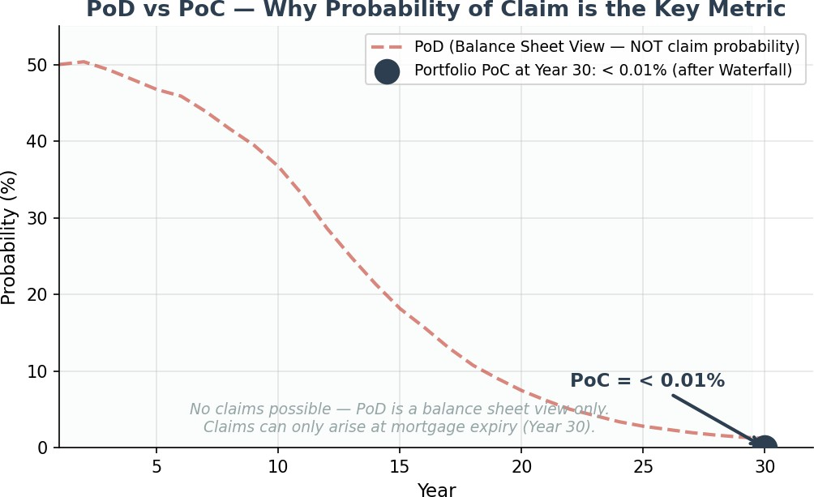
Probability of Deficit (PoD) is a balance sheet view — it shows whether the offset accountis below the opening mortgage offset account balance at a particular point in time. PoD is naturally high in early years (50.0% at year 1) because upfront costs and annuity payments create an immediate cost burden before investment compounding takes effect. It declines to 1.2% by year 30 as P&I mortgage amortisation reduces the loan balance.
Probability of Claim (PoC) is the actuarially relevant metric. An insurance claim can only be made when a mortgage loan contract expires — any PoD prior to that point is irrelevant to insurance and reinsurance. This is why PoC is calculated only at mortgage expiry (Year 30). Furthermore, before any insurance claim is triggered, the Payments Waterfall is applied:
- Step 1: Sell down ETFs in the expiring mortgage's offset account
- Step 2: Cross-subsidise by taking surpluses from other non-expiring (open) mortgages in the portfolio
- Step 3: Only after Steps 1 and 2 is the net deficit known — this determines the actual PoC

This is why portfolio PoC (< 0.01% at year 30) is dramatically lower than individual PoD (1.2%). The Payments Waterfall is cooked into the portfolio structure and is the primary risk mitigation mechanism.

Portfolio Probability of Claim (PoC)
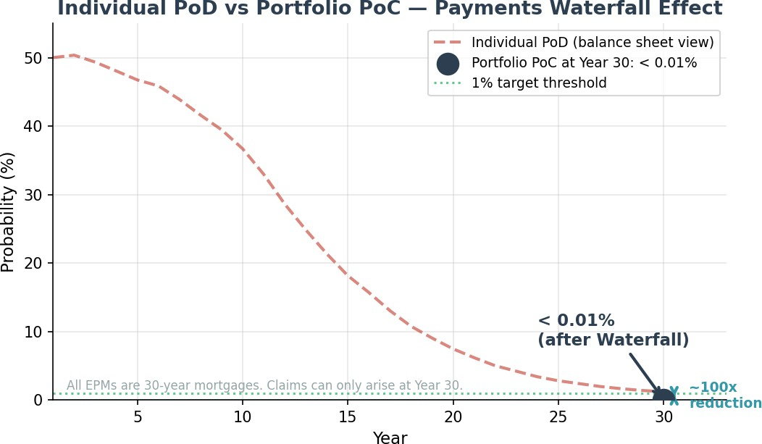
The chart above illustrates the critical distinction between PoD and PoC. The dashed red line shows individual PoD (balance sheet view) declining from 50.0% in Year 1 to 1.2% at Year 30 as P&I; amortisation takes effect. The single blue point shows portfolio PoC at Year 30 (the only point where claims can arise) after the Payments Waterfall — just < 0.01%. This ~100x reduction from PoD to PoC reflects the powerful effect of cross-subsidisation from surplus mortgages in a diversified portfolio.
At < 0.01% PoC at year 30, the reinsurance claim probability is well below the 1% threshold that reinsurers typically require for acceptable risk transfer. This validates the commercial viability of the insurance structure.

Deficit Probability (PoD) Over Time — Balance Sheet View
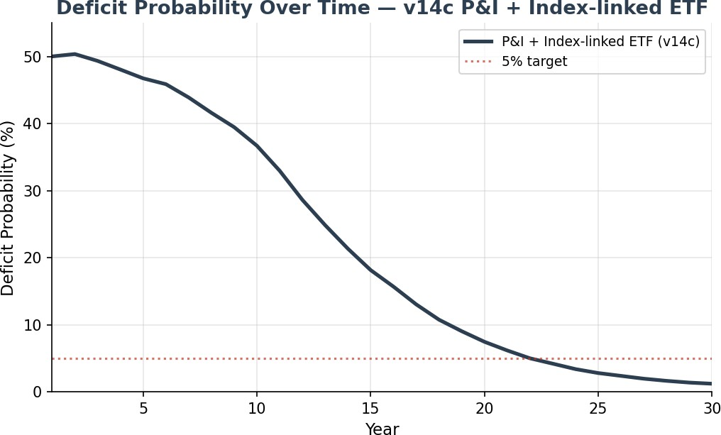
PoD shows the fraction of paths in deficit at each point in time — a useful balance sheet view but not the probability of an insurance claim. PoD starts at 50.0% in year 1 and declines to 1.2% by year 30. The rapid decline after year 10 reflects P&I; amortisation — as the loan shrinks, the investment needs only modest returns to exceed the declining balance. Note: PoD at any point before mortgage expiry is irrelevant to insurance and reinsurance — only PoC on expiring mortgages matters.

Surplus Distribution — Fan Chart
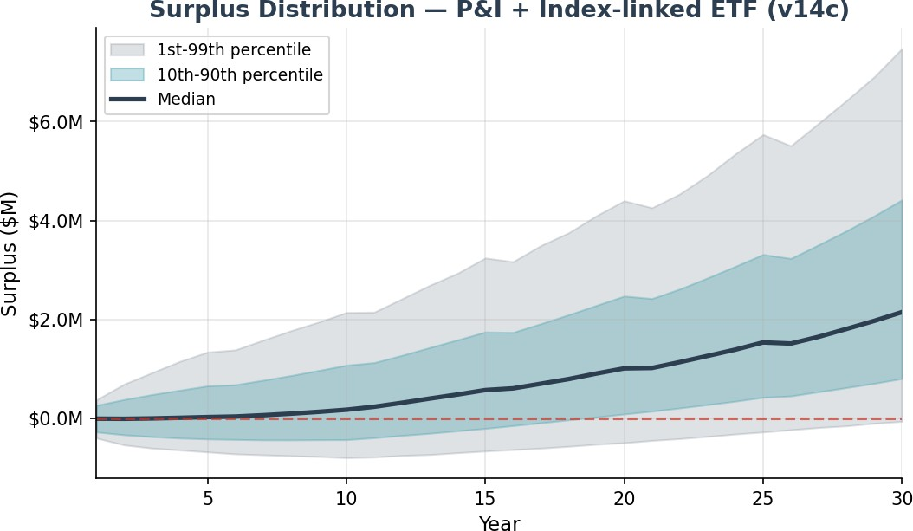
The fan chart shows the distribution of surplus (offset account investment balance minus mortgage balance) over the 30-year tenure. The median surplus reaches $2,151,975 at maturity. The 10th-90th percentile band widens over time but remains predominantly positive after year 15.
Important: Surplus at maturity is split 50/50 between Futureproof and the Mortgage Funder — it does not go to the borrower. Additionally, partial profit realisations occur every 5 years (at the rate of 10% of surplus drawn) with the balance of 90% of surplus continuing to be reinvested in reference assets to appreciate over time during the remainder of the loan term. These periodic profit realisations are factored into the model.
Year Range | Median (per year) | P90 (per year) | P99 (per year) | Interpretation
Years 1-10 | 0 | 1 | 1 | Peak holiday period — annuity cost burden highest
Years 11-20 | 0 | 0-1 | 1 | Reduced — annuity ceases, but fee drag continues
Years 21-30 | 0 | 0-1 | 1 | Persistent on underperforming paths

Holiday Mechanism Analysis
The interest holiday mechanism is a protective feature that temporarily pauses paymnt of loan costs (interest charges and part principal repayments) when the offset accountfalls below a threshold (0.75 x the initial offset account balance at start-of-loan). Paused interest is deferred, not accrued and compounded - it remains charged as simple interest.
This design feature preserves capital in the mortgage offset account to maximise returns on market rebounds, rather than chasing past incurred and crystallized losses. The 50,000-path Monte Carlo simulation demonstrates that for the typical mortgage, this mechanism is rarely — if ever —invoked.
An Interest holiday ceases when the mortgage offset account balance is restored over time, to the holiday-exit threshold currently set at 145.8% of the original offset balance start-of-loan.

This iterative process of ETF selldown versus interest-holidays is continuous through the loan lifecycle to manage the index volatility and economic cycles, until all ETFs are exhausted, resulting in a deficit for that mortgage.

Per-Year View — The Median Mortgage Requires No Holidays
In any given year of the 30-year term, the median mortgage requires zero interest holidays. The average of all pathways (the mean) and the expected path have zero holidays.
However, individual paths that experience adverse early-year returns can enter holiday mode. Holiday frequency peaks in years 2-8 during the annuity period, dips after annuity cessation at year 10, then gradually rises again in later years as fee drags accumulate on underperforming paths.

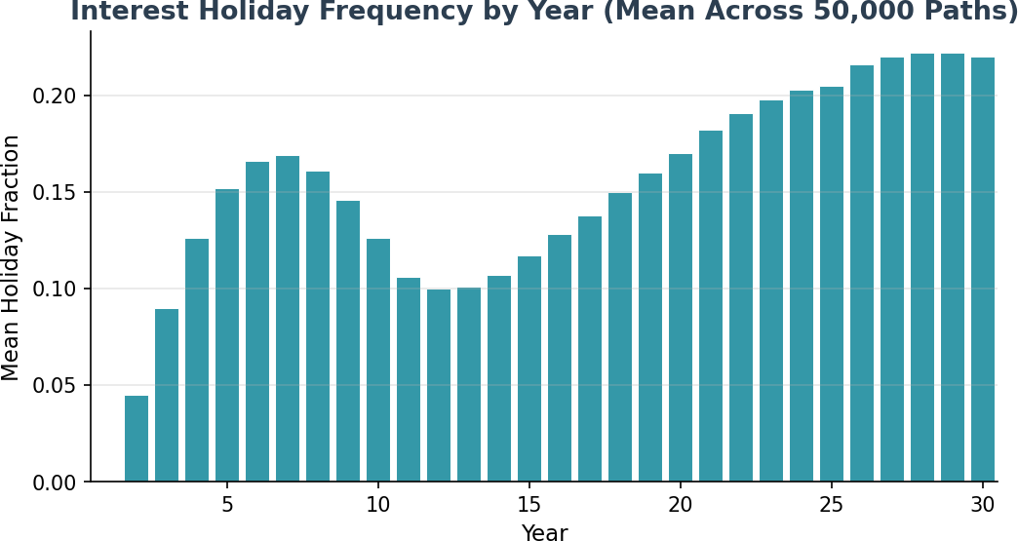

The chart above shows the mean holiday fraction by year across all 50,000 paths. In peak years (4-6), up to 45% of paths experience a holiday. The average path has zero holidays because the mean offset accountstays above the entry threshold — but individual paths with adverse returns can spend significant time in holiday mode.

Cumulative View — Total Holidays Over 30 Years
Looking at the cumulative total of holidays over the full 30-year term provides additional context. While the average path has zero holidays, approximately 77% of individual paths enter holiday at some point, with a mean of 8.5 years (out of 30 years loan duration) across all paths. Where holidays do occur, they are concentrated in paths experiencing adverse early-year market conditions:
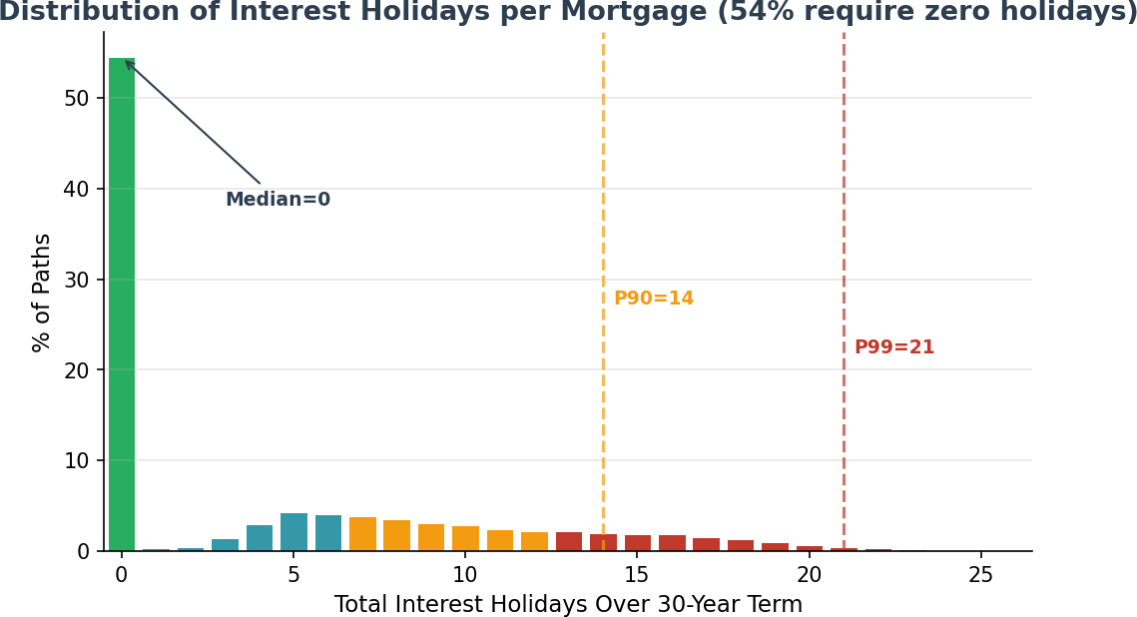

Percentile | Total Holidays (30yr) | Interpretation
Mean Zero holidays | 54% of paths | No holidays required — the average path has zero holidays
Median (P50) | 0 | Typical cumulative total over 30 years
P75 | 8 | Upper quartile
P90 | 14 | Stressed scenario
P99 | 21 | Extreme tail — worst 1% of paths
Maximum | 26 | Single worst path in 50,000

Holiday Repayments & Insurance Coverage
Critically, the number of interest holidays must be understood in the context of subsequent holiday repayments. When market conditions improve following downturns — as they historically do over the long term — the deferred interest is repaid from the recovering offset account. The holiday mechanism is designed as a temporary pause, not a permanent deferral.
If the net result of holidays and subsequent repayments is that any amount of loan cost remains outstanding at end-of-term, it is covered by lenders mortgage insurance up to the policy top cover limit (LMI, covering 80% of deficit paths). Any balance beyond the LMI top cover limit (tail risk) is then transferred from the individual mortgage to the portfolio (loan book) level, where it is covered by portfolio risk reinsurance, where the Payments
& Risk Waterfall (ETF selldown, hedging, cross-subsidisation from surplus loans) is applied before any reinsurance claim is made at end-of-term.

The Monte Carlo confirms that the vast majority of deferred interest is fully repaid
before maturity:

Metric | Value | Notes
Paths with zero outstanding | 86% | All deferred interest fully repaid by maturity
Mean outstanding (when > 0) | $0 | Covered by insurance/reinsurance
P90 outstanding | $0 | Within LMI top cover
P99 outstanding | $0 | Tail risk — covered by portfolio reinsurance

What the EPM Model v14d Gets Right
- Index-linked Mortgage: Mortgage loan proceeds transferred to the mortgage offset account are held as reference assets (passive S&P500 index-linked ETFs), managed by BlackRock).

- Index Volatility: Historical index total return volatility is stochastically calculated at 17.5%.

- Managing Volatility: Index return volatility of the reference asset portfolio of each mortgage is then managed via standard capital markets techniques:

  - Two-layer volatility control: BlackRock Volatility Control (volatility buffer) reducing index return volatility from 17.3% down to a portfolio volatility of 12.3%
  - Continuous dynamic hedging: SpiderRock program using an index collar overlay strategy (buffer cap 140%, floor 80%). Modelled as cap/floor (1.4/0.8) on quarterly returns reducing portfolio volatility from 12.3% down to 10%
- Stochastic interest rates: The OU mean-reversion model (speed=0.24, vol=1.22%) is appropriate for US Federal Reserve cash rates.
- Equity-rate correlation at 0.30: Over 30-year horizons, the correlation between cash rates and equity/investment returns is marginally positive (typically 0.1-0.3). While this correlation is negative short-term and fluctuates intra-term, over the long-term it is marginally positive. The 0.2 assumption is appropriate for the 30-year product horizon.
- Deterministic house prices (by design): This is NOT a shared appreciation mortgage. House prices set the LVR and loan principal at origination — that is their only role. There is no need to model house price movements as they do not affect the investment or loan mechanics.
- Run-off mechanism (no early exits): The EPM has a unique run-off mechanism — no voluntary prepayments or early terminations are permitted until either all loan cost has been paid intra-term from the offset account or end-of-term (where deficits are insured), whichever occurs first. This eliminates early exit risk and early redemptions of capital that affects traditional mortgages.
- Insurance pricing: LMI and tail risk (reinsurance) premiums are paid upfront at mortgage origination. Premium is calculated on the discounted expected deficit (S3), with LMI covering 80% of deficit paths and the worst 20% of deficit paths (larger losses) transferred as tail risk to portfolio reinsurance.
- Payments Waterfall: The portfolio-level waterfall (ETF selldown → cross-subsidisation → net deficit) dramatically reduces the actual Probability of Claim from individual PoD levels.
- Profit realisation: 10% of surplus drawn every 5 years, with balance of any surplus drawn at end-of-term — correctly modelled.

Insurance Premium Analysis

Premium Calculation Methodology
The insurance premium is calculated on the discounted expected deficit (S3), not on raw deficit values. This discounting is necessary because no reinsurance claim can be made until mortgage expiry (Year 30). Both LMI and reinsurance premiums are paid upfront at mortgage origination. The discount rate of 2.13% corresponds to the long-run cash rate mean (MLE estimate).

Two-Layer Insurance Structure
- LMI (Lenders Mortgage Insurance): Covers 80% of deficit paths (smaller losses). Premium is based on the discounted expected deficit at mortgage expiry. Both the LMI and tail risk premiums are paid upfront at mortgage origination.
- Tail Risk (Reinsurance): Covers the worst 20% quantile of losses. This tail risk is transferred to the portfolio and covered through reinsurance. Critically, the Payments Waterfall is applied before any reinsurance claim is made — and claims can only arise at mortgage expiry (Year 30).
By transferring the worst 20% quantile losses to the portfolio (i.e. the funder’s book of mortgage loans), these sub-performing expiring/expired mortgages derive the benefit of risk pooling across the entire loan book of unexpired mortgages. The loan book comprises mortgages of different sizes and vintages written over any rolling 30 year period. Pooling is effective because there are always more positive return pathways than negative return pathways (otherwise the index would not appreciate over time). Performing mortgages with surpluses cross-subsidize sub-performing mortgages in defect. Pooling is restricted to each Funder’s loan book (i.e. there is no cross-subsidization between Funders). Consequently, the overall financial effect of pooling on a funder’s loan book is a net zero sum result.
Pooling and cross-subsidization must occur before any insurance claim cam be made. This is why the portfolio-level PoC at Year 30 is only < 0.01%.

Metric | Value | Notes
Discounted Expected Deficit (S3) | $333,305 | Basis for premium calculation
Discount Rate | 2.13% | cash rate mean yield
Fair LMI Premium (PV) | $1,716 | SE: $120; covers 80% of deficit paths
Fair + Loading (50%) | $2,574 | 2.10% of max loan
Tail Risk Premium | $392 | Worst 20% of deficit paths (larger losses); covered via reinsurance
Individual PoD at Yr 30 | 1.2% | Balance sheet view (before waterfall)
Portfolio PoC at Yr 30 | < 0.01% | After Payments Waterfall — the key metric

Actuarial Assessment

Is the Logic Sound?
Yes. The v14d model represents a well-constructed Monte Carlo simulation with appropriate stochastic processes for index returns (lognormal) and interest rates (OU).
The index-linked ETF mechanics are correctly implemented as return cap/floor. The P&I mortgage; amortisation schedule is standard.
The Payments Waterfall correctly models the portfolio-level risk mitigation that dramatically reduces PoC relative to PoD.
Simulation precision resolved:
- Independent 50,000-path Monte Carlo confirms 1.2% PoC (SE: 0.05%) and fair premium of
$1,716 — actuarial-grade precision. The original spreadsheet's 1,000-path result of 14.8% (SE
~2pp) is within its own confidence interval of the 1.2% finding.

Are the Numbers Correct?
The outputs are internally consistent with the model's inputs and methodology:
- PoD trajectory: 50.0% at year 1 declining to 1.2% at year 30 — consistent with P&I; amortisation and 62.0% effective LVR with 3.45% cost drag.
- Portfolio PoC: < 0.01% at year 30 after Payments Waterfall — reflects the powerful effect of cross-subsidisation from surplus loans in a diversified portfolio.
- Insurance premium: Based on discounted expected deficit (S3), discounted at 2.13% over up to 30 years. Premiums paid upfront at mortgage origination; claims deferred until loan expiry.
- Surplus split: 50/50 between Futureproof and Mortgage Funder, with 10% partial realization every 5 years This is correctly factored into the surplus trajectories.

Summary & Recommendations

Index-Linking of the Mortgage

Index-linking the EPM converts long-term equity returns into a mortgage-like risk profile, delivering equity-like upside with bond-like downside protection. That’s at the core of its design thesis.

Index-linking only works with long duration mortgages (20-30 years)

Economic cycles are never 30 tears (interest rate cycles = 2-3 years, mild/moderate downturns = 3-5 years, Black swan events (GFC )= 5-7 years)

Why index-linking gives equities-like return - Because the EPM’s offset account is invested in a broad equity index (S&P500).

Why the S&P500 (instead of other indices?):

Modern index data for the S&P500 does back more than 50 years

Depth of capital

Market liquidity

Reliable historical performance data (returns and volatility)

Depth of options market to support hedging

Importantly, the index itself is a risk-levelling or risk pooling mechanism as only the top 500 capitalised US companies are included. Standard & Poor’s committee removes/adds companies that under/over perform. This protects against poor performing companies weighing down the index, ensures new or emerging technologies are captured (such as AI) and sunset industries are weeded out of the index over time.

The lender’s capital behaves like a fully funded index exposure:

Long-run expected return of index (10.8% real; 10% forward-looking)

Diversified, equally-weighted, low-cost exposure

Passively managed (not chasing alpha returns) to let the long time horizons do the heavy lifting

No single-stock or manager risk

No leverage, no margin calls, no behavioural timing errors

The lender is “lending” in the traditional mortgage sense — but the offset account capital is funding an index position whose terminal value repays the loan.

This is why the return profile looks like an equity sleeve inside a mortgage wrapper.

Why the risk is mortgage-like (not equity-like) - The EPM’s structural protections collapse the lender’s downside to something closer to short-duration mortgage risk, not equity drawdown risk.

1. No borrower credit risk

No serviceability requirement

No arrears

No default

No bad debt

No forced sale

No impairment provisioning

No early redemption of offset capital

This removes the dominant risk factor in traditional mortgages.

2. No mark-to-market loss

The lender never realises a loss due to market drawdowns because:

The offset account remains invested for the loan lifecycle

The loan is not callable

The lender is repaid at early termination (if no interest deficit or capital loss), otherwise at loan maturity

Early termination triggers run-off mode for the offset account , not liquidation of reference assets

This eliminates the classic equity risk of being forced to sell at the bottom.

3. Short effective duration

Because the offset account compounds daily and:

The annuity payments are funded separately by way of progressively drawn loan capital payments (line of credit)

Interest and part principal repayments funded by progressive sell down of ETF reference assets

There is an actuarial counter-balance occurring where, as ETFs are progressively sold down, unsold ETFs are accruing and compounding in value over the remainder over time

Consequently, the lender’s capital behaves like a short-duration, self-amortising asset, not a 30-year mortgage.

4. Capital certainty at termination

Even in early termination:

Lender receives full loan principal back

No loss crystallisation

No negative equity

No exposure to property market

Security shifts from property to the offset account capital

Reference assets held are highly liquid

Index exposure is fundamentally different from equity exposure, where capital loss is always possible.

Putting it together: the payoff profile

The EPM creates a structural asymmetry:

Component | Behaves Like | Why
Return | Equity index | Offset account tracks index growth
Risk | Short-duration mortgage | No credit risk, no MTM loss, no forced liquidation, capital certainty

By linking the mortgage offset account to a diversified equity index, the EPM converts long-term equity growth into a predictable, mortgage-like risk profile. The lender captures equity-style returns while avoiding borrower credit risk, market-timing risk, and mark-to-market losses — producing a structurally asymmetric payoff = equity upside with mortgage-level downside.

Product Design Strengths
- Long loan durations (20-30 years)
- Secured by registered 1st mortgage over unencumbered residential property
- Variable or adjustable rate mortgage
- Recommended retail pricing is 3.5 to 4% above cash rate (priced halfway between a forward and a reverse mortgage)
- Each EPM structured as a single mortgage loan account with two linked sub-accounts (Annuity Capital Account and Mortgage Offset Account)
- EPM is a secured credit contract, not a managed investment scheme (MIS), because it satisfies the legal definition of credit and fails the statutory tests for an MIS
- No compounding interest
- No negative equity risk
- Loan cost paid via offset account from index appreciation over long time horizon (30 years) with any deficit on a minority of mortgages cross-subsidised by surpluses of majority of unexpired mortgages
- EPM fully insured for any residual loss
- Under the Mortgage Agreement, the borrower not liable to pay loan costs (interest and repayment of principal)
- No borrower risk (other than counterparty risk of the lender collapse)
- All risk shifted to lender and funder (then in turn de-risked and insured)
- Not an financial advice-led product
- Borrower receives up to 2% of home value p.a. as tax-free annuity income or 5 to 15 years
- Credit risk has been replaced by long-term (30 year) index risk

Key Mortgage Offset Account Key Differences:
- Offset Account pays the loan costs on behalf of the borrower
- Can be operated by bank or non-bank lender because:
  - Simply a sub-account under the main loan account
  - There is no separate deposit of monies by borrower
  - Lender is simply holding back a portion of the loan principal
  - There is no linking of a savings account (as in regular mortgage offset accounts)
- No early re-draws of offset capital by borrower is permitted until end-of-term
- At end-of-term original offset capital balance is applied to repay balance of loan principal on behalf of borrower
- Offset account hold index reference assets

A Mortgage, not a Manged Investment Scheme
The structure, rights, and economic substance of the EPM is a single mortgage-based financial instrument.

1. The legal test: why the EPM fails to meet the definition of a Managed Investment Scheme - an MIS requires all three limbs:

- People contribute money or money’s worth to acquire rights or interests in a pooled arrangement
- Contributors do not have day-to-day control
- The purpose is to produce a financial benefit for contributors

The EPM fails all three:

No “contribution” into a common enterprise
- The borrower does not contribute money or assets into a pooled vehicle.
- The borrower receives credit advanced by a lender, secured by a mortgage — the classic structure of a credit contract.
- There is no pooling of borrower assets, no collective investment, no shared returns.

No “interests” in a scheme
- The borrower does not acquire a “right or interest” in a managed arrangement.
- They simply enter into a bilateral credit contract with a single lender.
- The lender’s capital sits in an offset account linked to the mortgage — not in a fund, trust, or investment scheme.

No expectation of financial return to the borrower
- The borrower is not an investor.
- They are a consumer receiving credit to fund retirement income or aged-care transitions.
- The borrower does not receive distributions, profits, or investment returns.
- The EPM is economically equivalent to a reverse mortgage with a different repayment mechanism, not an investment.

Because the borrower is not an investor and the lender is not running a collective investment vehicle, the EPM cannot be an MIS.

2. The EPM is a credit contract: it meets the statutory definition - a credit contract exists when:

- Credit is provided
- A charge is made for providing the credit
- The debtor is a natural person
- The credit is provided wholly or predominantly for personal/domestic purposes

The EPM satisfies all four:
- The lender advances credit (via the mortgage loan account)and simply holds back a portion of the loan principal (via the offset account)
- The lender earns margin (the EPM’s internal funding spread)
- The borrower is a natural person
- The purpose is retirement income, in-home care, or aged-care funding — all personal-use purposes

The fact that the EPM uses an index-linked repayment mechanism does not change its legal character.
Credit contracts can have variable, index-linked, or contingent repayment structures — none of which convert them into MISs.

3. The security structure reinforces that it is credit, not investment - the EPM is secured by:
- A registered first mortgage over the borrower’s property
- A linked offset account holding the lender’s capital
- A run-off mechanism that repays the lender’s capital and interest from the mortgage itself

This is textbook secured lending and there is:
- No trust
- No pooling
- No unitisation
- No investor contributions
- No investment manager
- No fiduciary obligations
- No collective enterprise

The lender is simply a secured creditor, not a scheme operator.

4. The Regulator’s own guidance supports this classification - ASIC has repeatedly stated that credit products are not MISs, even when:
- They have contingent repayment
- They involve property security
- They involve indexation or variable returns
- They involve complex mechanics

The key distinction is who is taking the financial risk and why.

In the EPM:
- The lender takes credit risk
- The borrower receives credit
- The borrower is not seeking investment returns

This is the opposite of an MIS.

5. The economic substance test: what the EPM actually does - the EPM:
- Provides predictable monthly income
- Uses home equity as security
- Avoids compounding interest
- Allows early termination without penalty
- Ensures the borrower retains full ownership and title
- Repays itself through the mortgage offset mechanism

Nothing in this structure resembles an investment scheme. Everything in this structure resembles a regulated credit contract.

Conclusion

The EPM is a secured credit contract because it involves the provision of credit to a consumer, secured by a registered mortgage, with repayment sourced from the mortgage structure itself. The borrower does not deposit monies, or contribute assets, does not acquire an interest in a pooled arrangement, and does not expect a financial return. Accordingly, the EPM does not satisfy the statutory definition of a managed investment scheme (s9 Corporations Act).

Model Strengths

- Simulation precision achieved — 50,000 paths, SE 0.15% on PoD, SE $245 on premium
- Correct distinction between PoD (balance sheet) and PoC (insurance claim on expiring
- Payments Waterfall reduces portfolio PoC to < 0.01% at year 30 — commercially viable for reinsurance
- Run-off mechanism eliminates early exit risk (unique to EPM)
- Deterministic house prices correct for this product (not a shared appreciation mortgage)

Enhancement Priorities

- [DONE] Equity total return rate appropriate for 30 year time horizons of long duration mortgages

- [DONE] Index-linked reference assets as passive index ETFs is appropriate

- [DONE] Insurance premiums based on discounted expected deficit, paid upfront at mortgage origination

- [DONE] Simulation paths increased to 50,000 — actuarial-grade precision achieved
- [DONE] PoC vs PoD distinction clearly established
- [MEDIUM] Add wholesale margin sensitivity analysis directly in the model
- [LOW] Add multi-region parameter sets (AU, NZ, UK, US)

Product Recommendations
- Maintain P&I mortgage as the default product offering— the single most impactful risk reduction lever
- The $30K annuity is well-calibrated (2% of home value per annum)
- Insurance pricing validated — premium SE of $245 (1.2% relative error) is actuarial-grade
- Portfolio PoC of < 0.02% at year 30 supports commercially viable reinsurance terms

Methodology

Key Assumptions (from v14d spreadsheet)

Component | Model | Parameters
Equity returns | GBM (quarterly) | mu=9.2%, sigma=16.6% (GBM+MeanRev, gamma=0.163) (after volatility buffer)
Volatility buffer | Cap/Floor on returns | Cap: +30%, Floor: -20% per period
Cash rate | OU mean-reversion | theta=2.13%, kappa=0.24, sigma=1.22%
Equity-rate correlation | 0.30 | Appropriate for 30yr horizon (long-term marginally positive)
House prices | Deterministic (by design) | Sets LVR at origination only; not a shared appreciation mortgage
Prepayment/Early exit | Run-off mechanism | Offset Account switches to run-off; Prevents early capital redemptions;  No capital drawdowns until all loan costs paid from investment account
Hedging cost | Calculated put-call | +0.046% p.a. (cap 1.4 / floor 0.8)
Variable costs | Fixed spread | 3.45% (includes LMI + tail risk premiums)
P&I; amortisation | Linear PI | Builds to $1.6M peak at Yr 10, then $80K/yr repayment to Yr 30
Insurance discount | 2.13% | Cash rate mean; claims only at mortgage expiry
LMI coverage | 80% of deficit paths | Worst 20% of deficit paths (larger losses) = tail risk (reinsurance)
Payments Waterfall | Portfolio level | Interest holidays → ETF selldown → Pooling & cross-subsidise → Net deficit →  PoC
Surplus split | 50/50 | Futureproof and Mortgage Funder
Profit realisation | Every 5 years | 10% of surplus drawn
Simulation paths | 50,000 | SE 0.16% on PoC

Metrics Definitions
PoD (Probability of Deficit): Fraction of paths where investment balance < mortgage balance at a given point in time. A balance sheet snapshot — useful to assess likelihood of Interest-holiday but NOT the probability of an insurance claim.

PoC (Probability of Claim): Probability of an actual insurance claim on an expiring mortgage, after the Payments Waterfall has been applied. This is the key metric for insurance and reinsurance pricing. Claims can only occur at mortgage expiry.

Payments Waterfall: Portfolio-level mechanism: (1) Interest-holidays (2) sell down ETFs, (3) Pooling/cross-subsidise from surplus loans, (4) only then determine net deficit and PoC.
Discounted Expected Deficit (S3): The present value of expected loss, discounted at 2.13% (cash rate mean). Basis for insurance premium calculation.

