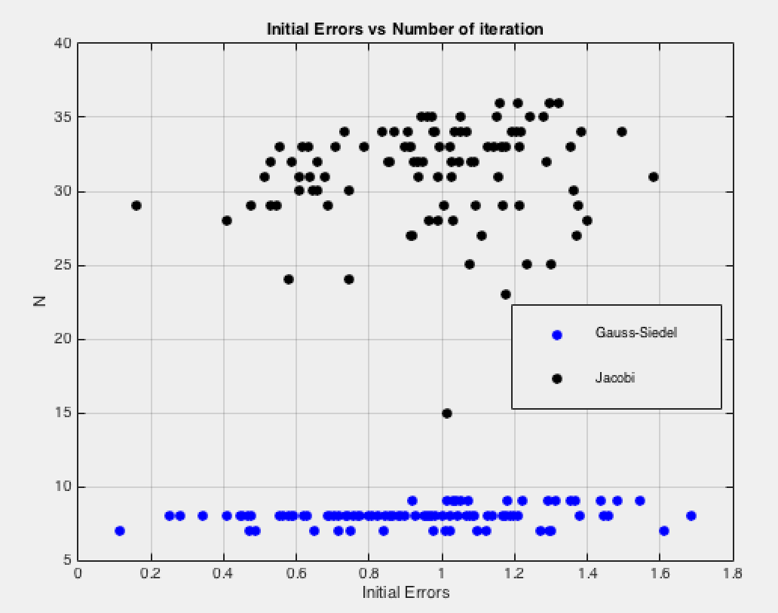

As we can see from the graph, Gauss-Seidel can compute the approximate solution with less number of iteration than Jacobi. On the graph, Gauss-Seidel’s number of iteration does not exceed 10. On the other hand, Jacobi’s number of iteration is much larger. 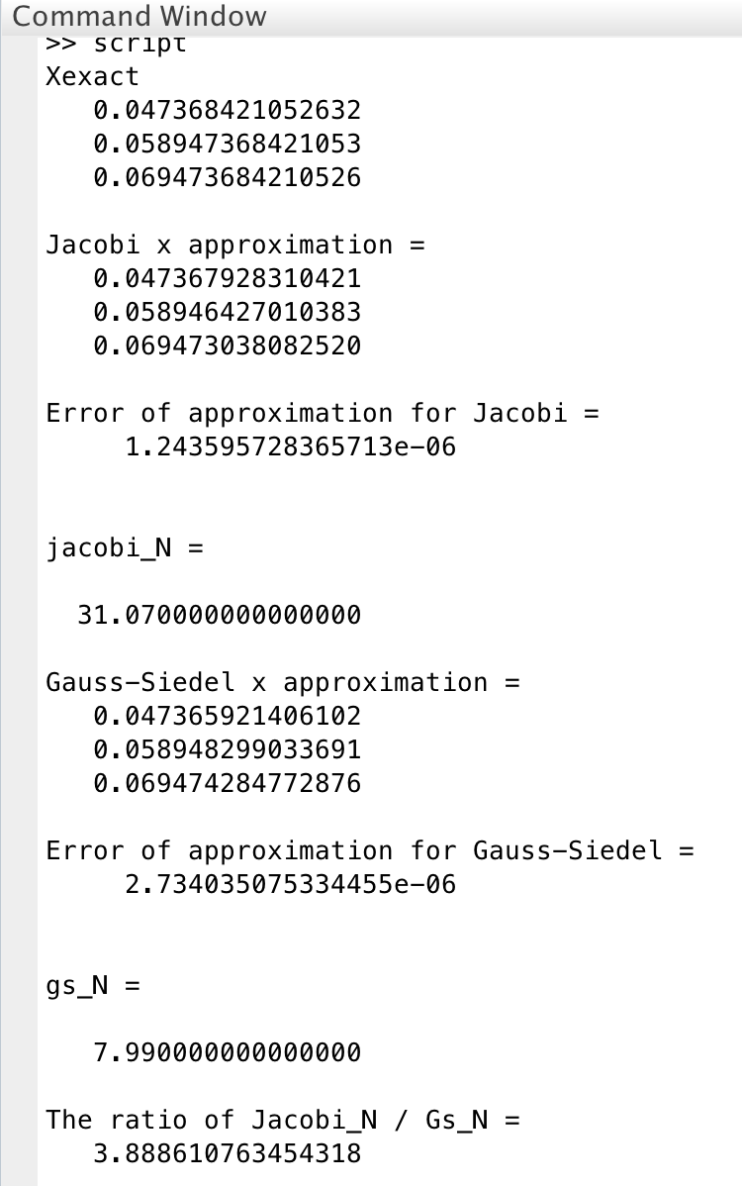

As we can see from the result we got, Jacobi method iterates more than approximately 4 times more than Gauss-Seidel method. We can also see that the number of iteration varies depends on value of initial vector position, x0. N, number of iteration, tends to be smaller when the initial error, ||x0-xexact||, is close to 0. Therefore, when initial vector position is closer to the exact vector, it shortens the number of iteration.