NAME: MATTUVARKUZHALI L

REG NO: 727721EUIT087

QUESTION 1:

Create an EC2 Instance in the us-east-1 region with the following requirements.

Give the Name tag of both EC2 instance & keypair as "ec2usecase1"(Name).

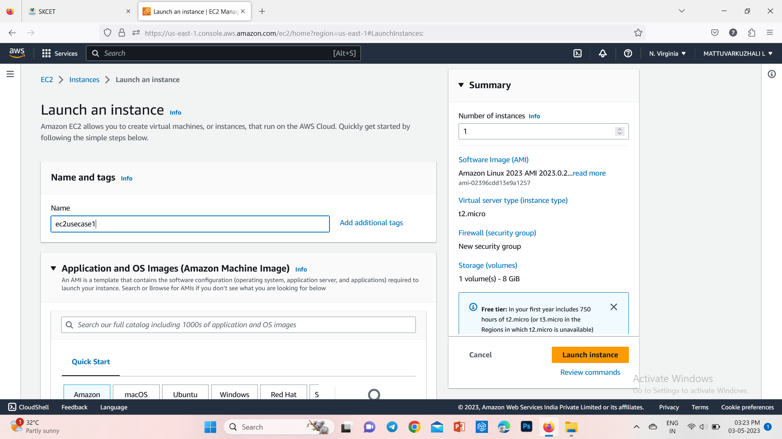

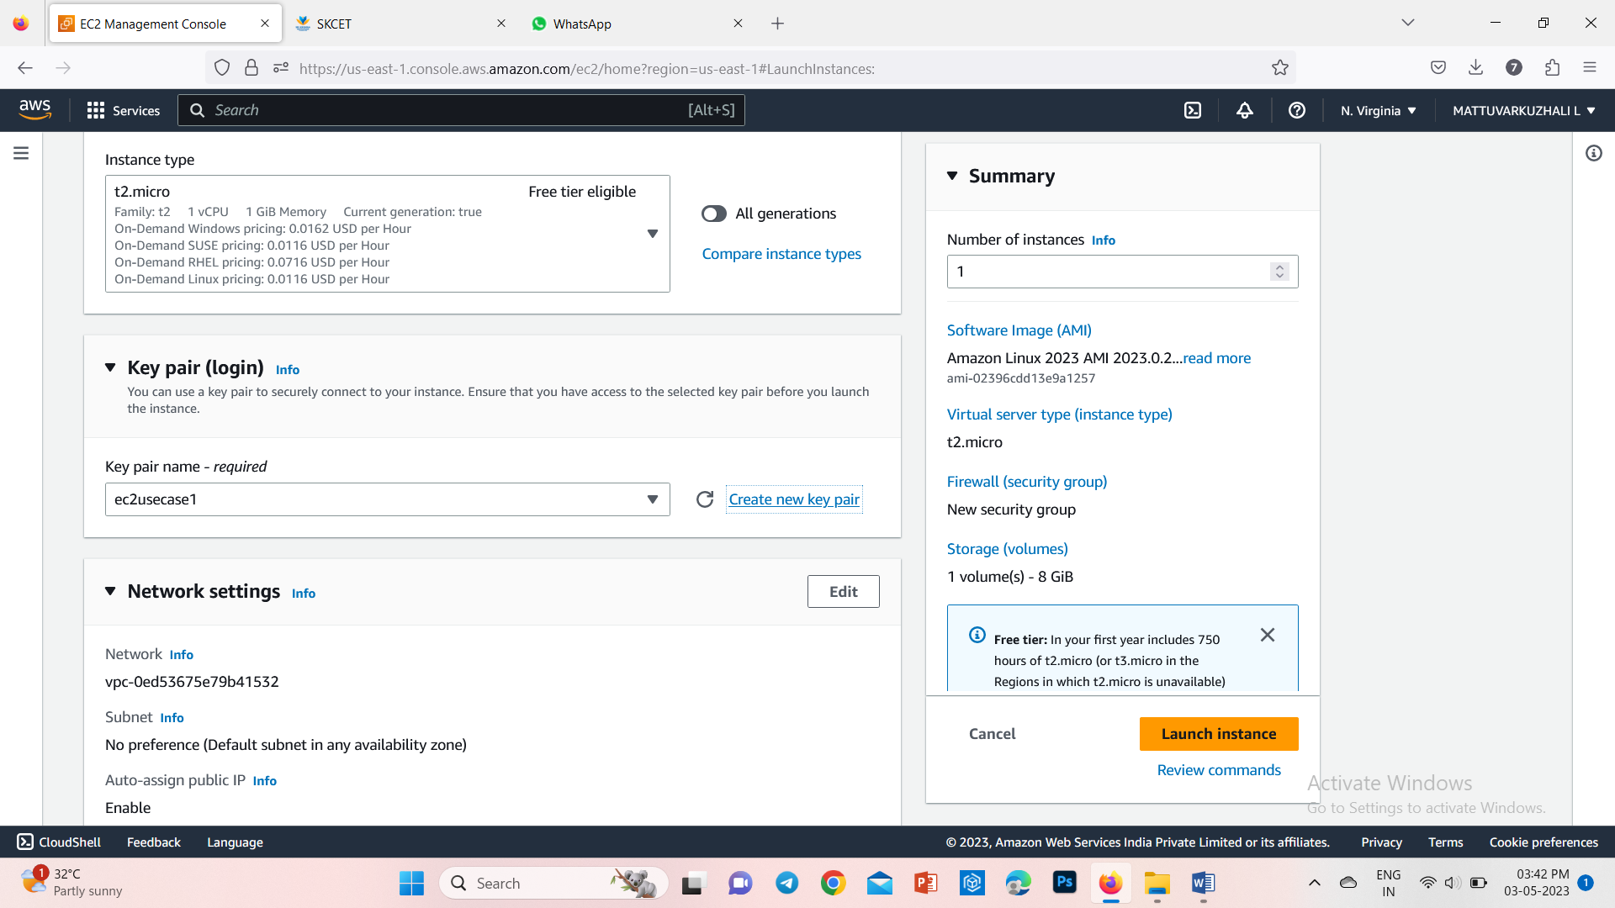

EC2 instance AMI should be "Amazon Linux 2"

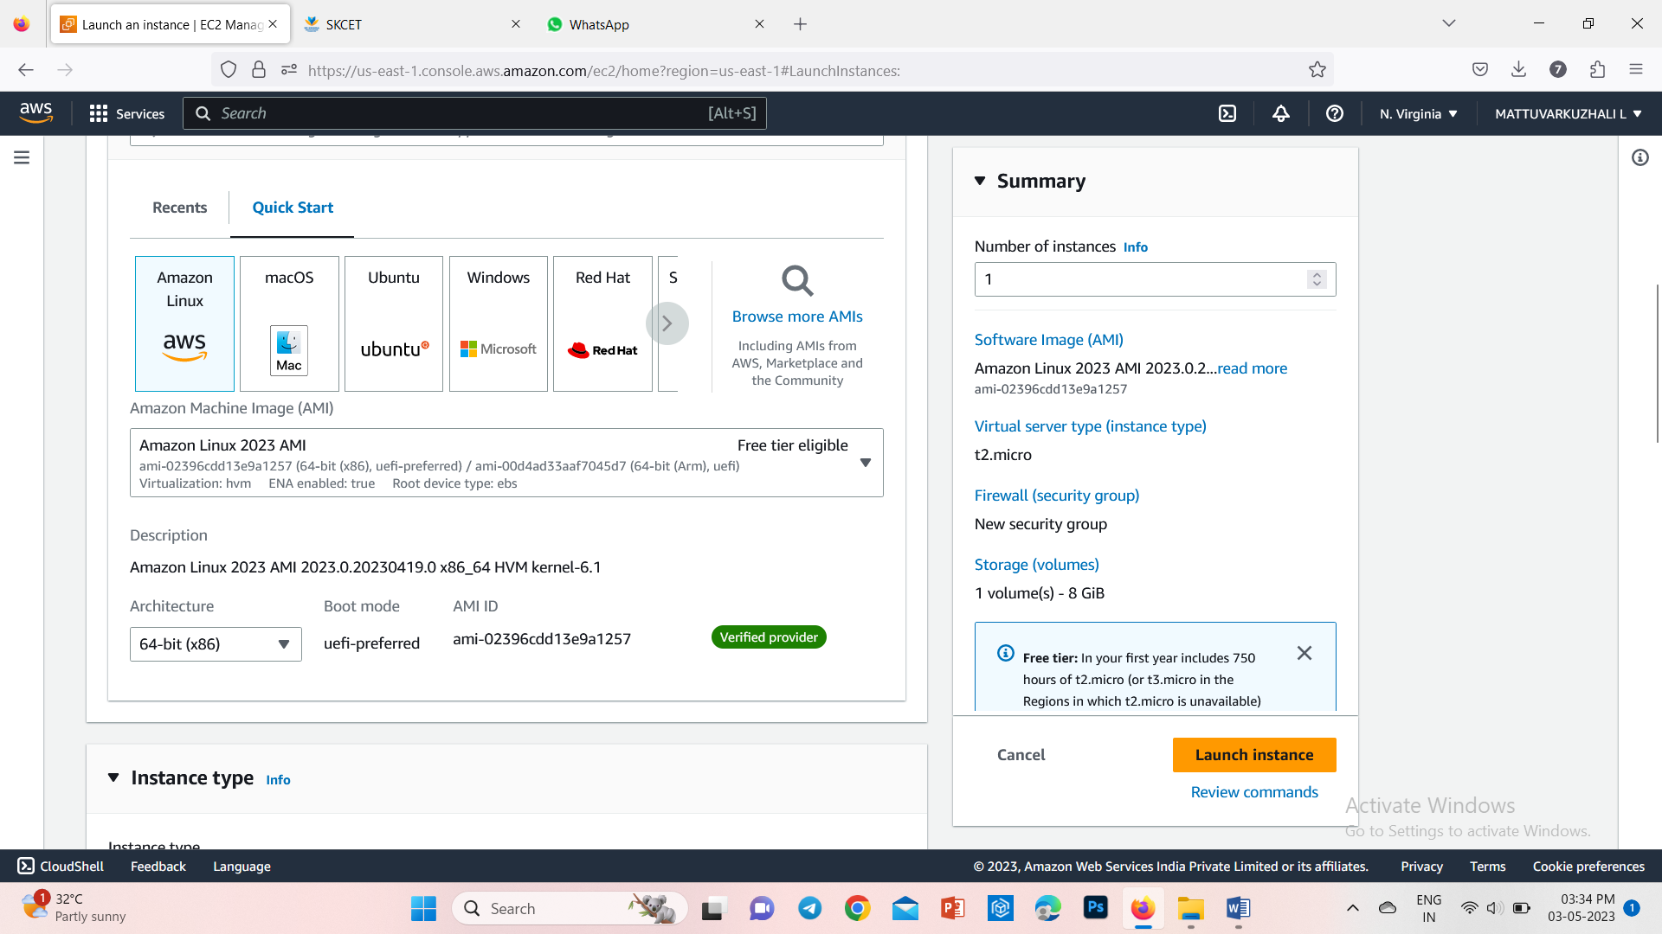

Allow SSH traffic for taking puttyremote connection.

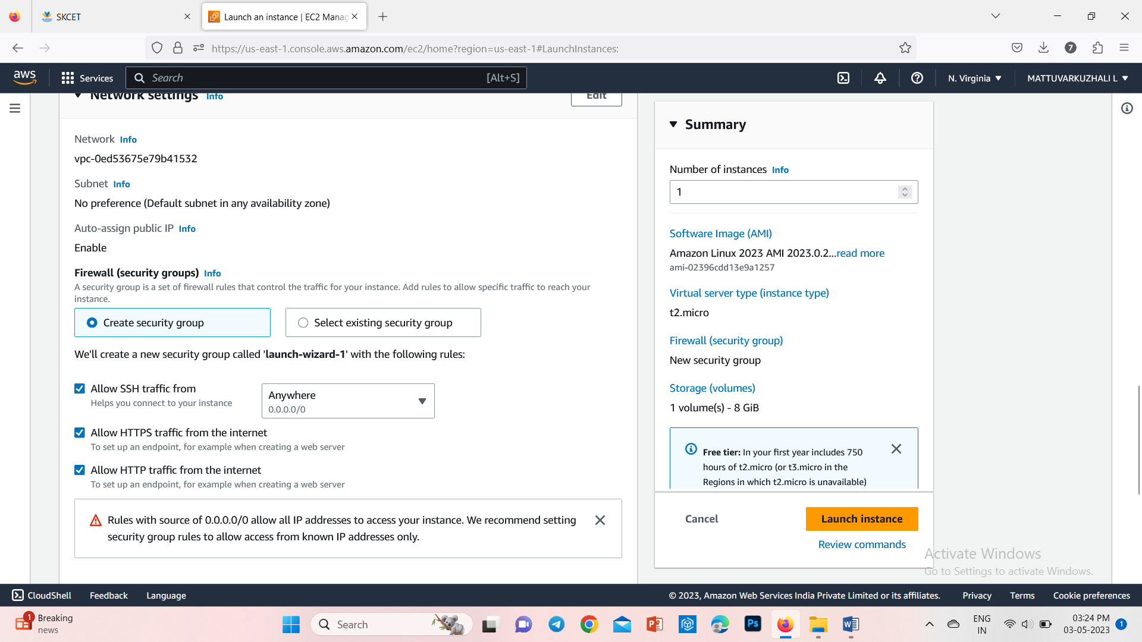

Allow HTTP traffic from the internet for reaching website requests.

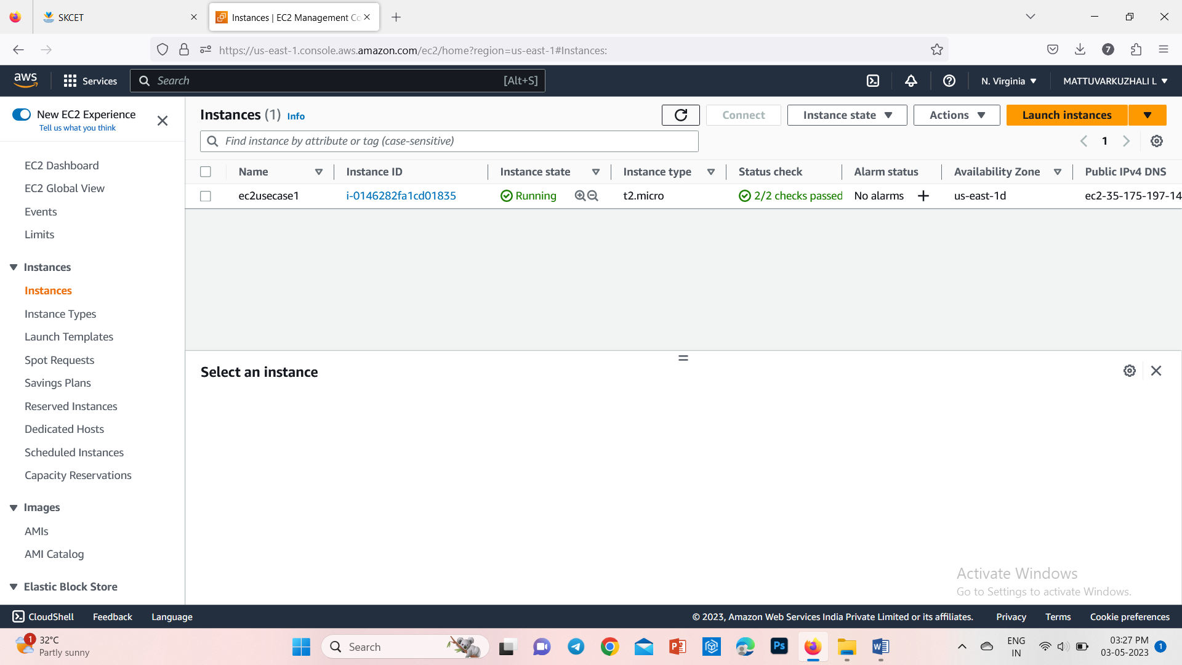

QUESTION 2:

Create an IAM group called 'Network-L1-Team' with'AmazonVPCReadOnlyAccess'and ‘AWSNetworkManagerReadOnlyAccess' policies, then add an IAM user called 'Network-L1-User1' to the group.

The name of the IAM group should be 'Network-L1-Team'.

The 'AmazonVPCReadOnlyAccess' policy should be attached.

The 'AWSNetworkManagerReadOnlyAccess' policy should be attached.

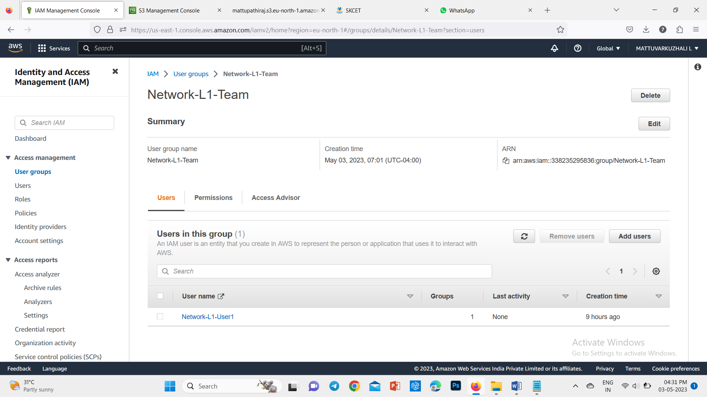

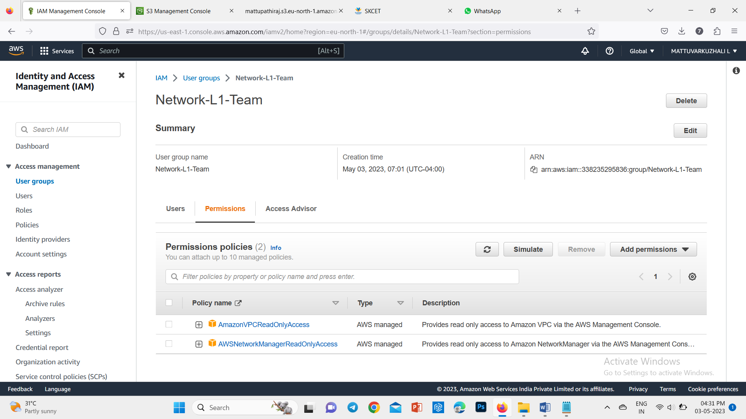

QUESTION 3:

Create a S3 bucket for the following requirements

Create a new S3 bucket in the region of "Stockholm".

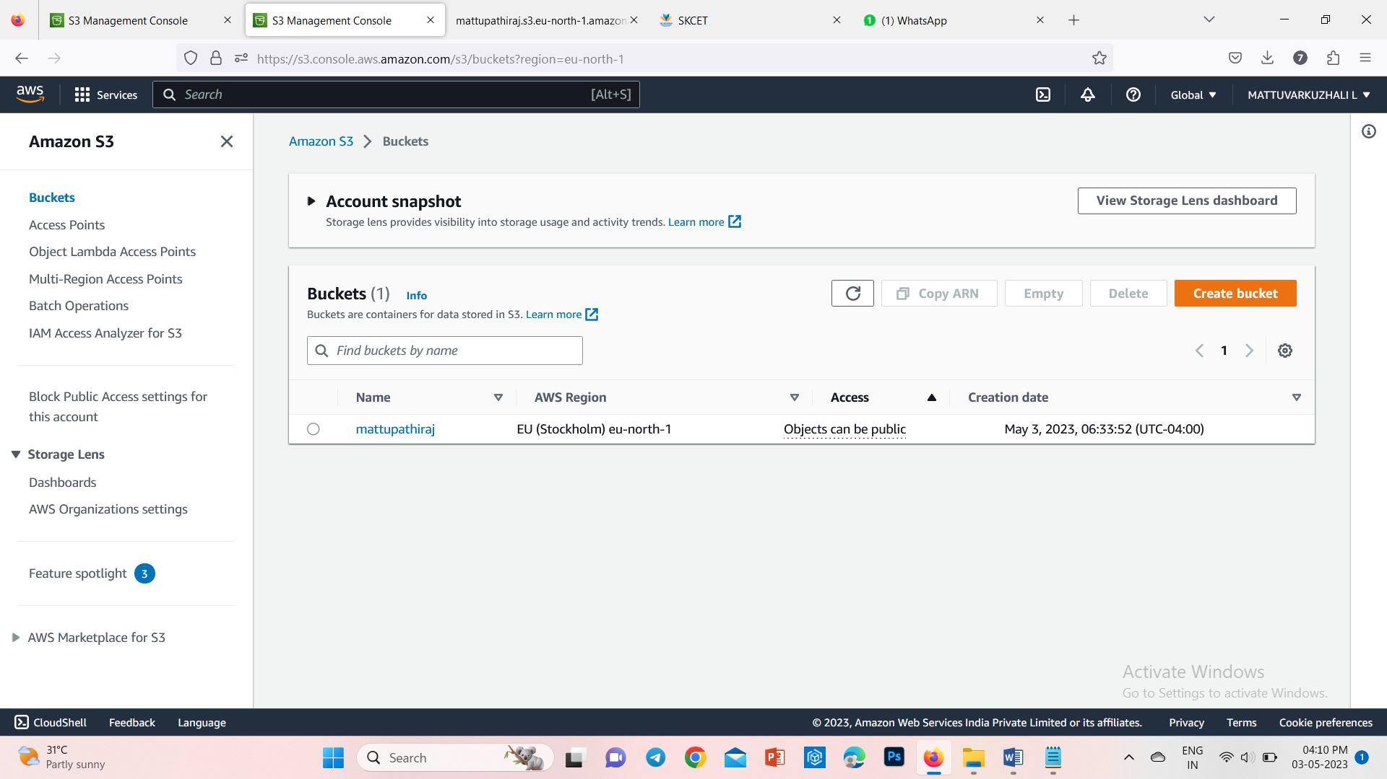

Make the bucket accessible to everyone(publicly) via Bucket ACL.

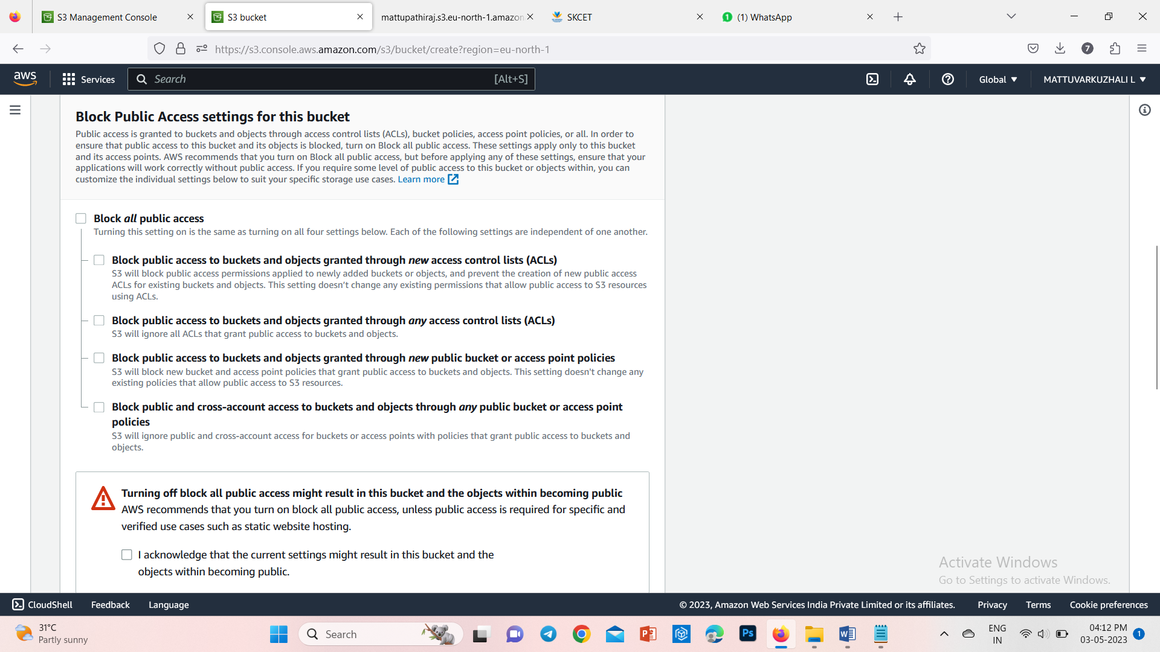

Upload a text file in the name of 'accounts.txt'.

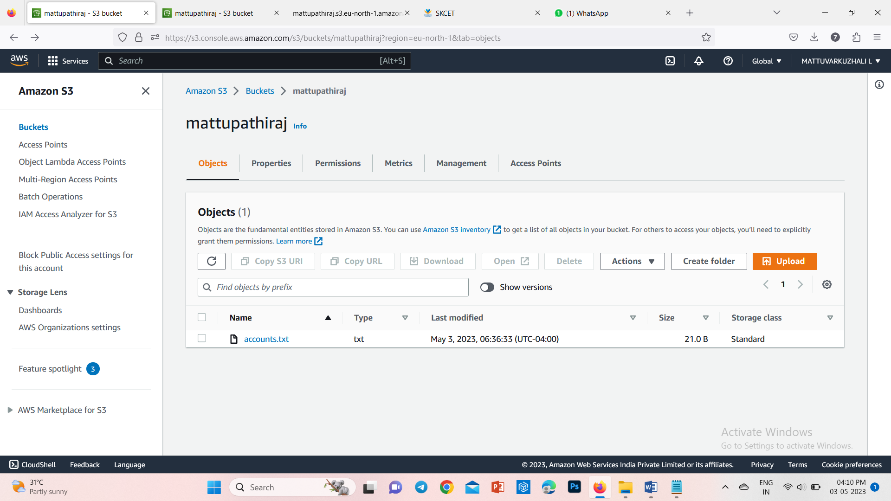

Make the object 'accounts.txt' file accessible to everyone(publicly)

