Asymmetric Key Cryptography
Let us demonstrate asymmetric key cryptography with two prime numbers p=7, q=11, to do a quick refresher on how it works and see why prime factors are important.
(Obviously the below was ALL created with the help of ChatGPT – buyer beware!)
The modulus now is 7x11 = 77. This is the numeric space within which the arithmetic works. So let us define a character set with 0-76 codes
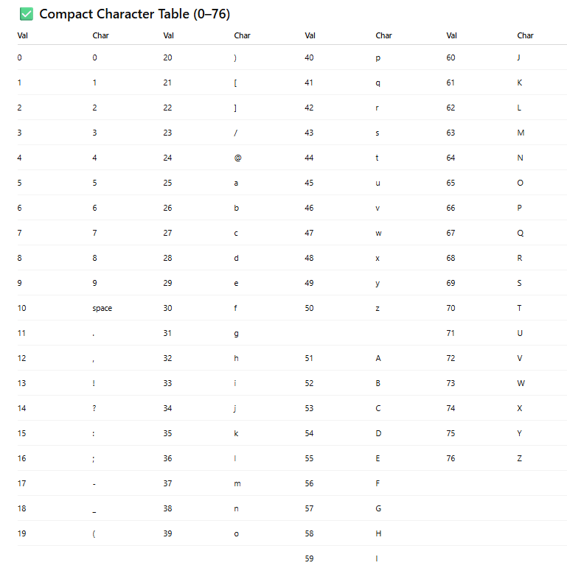

Computing the keys
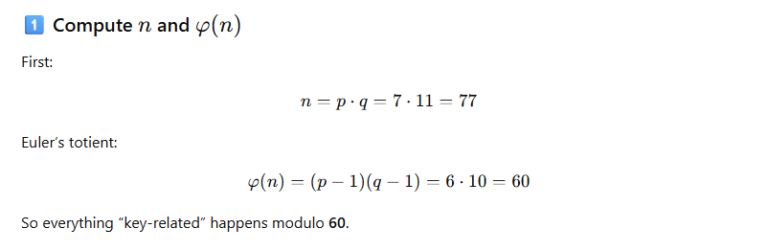
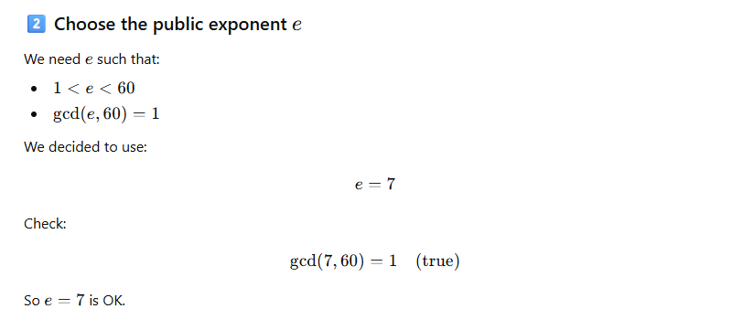

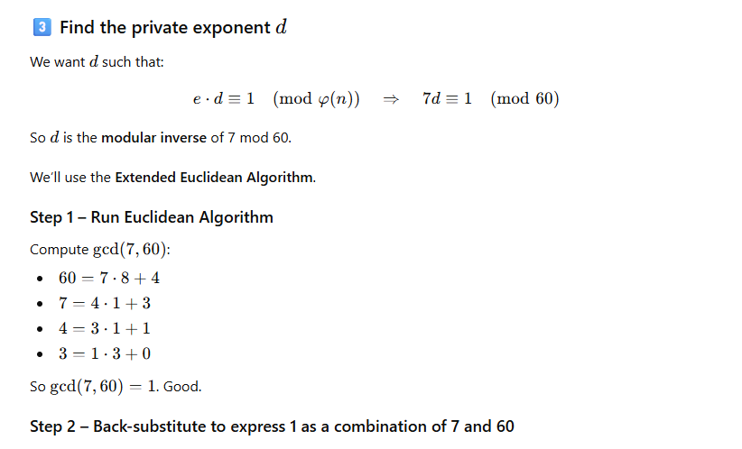
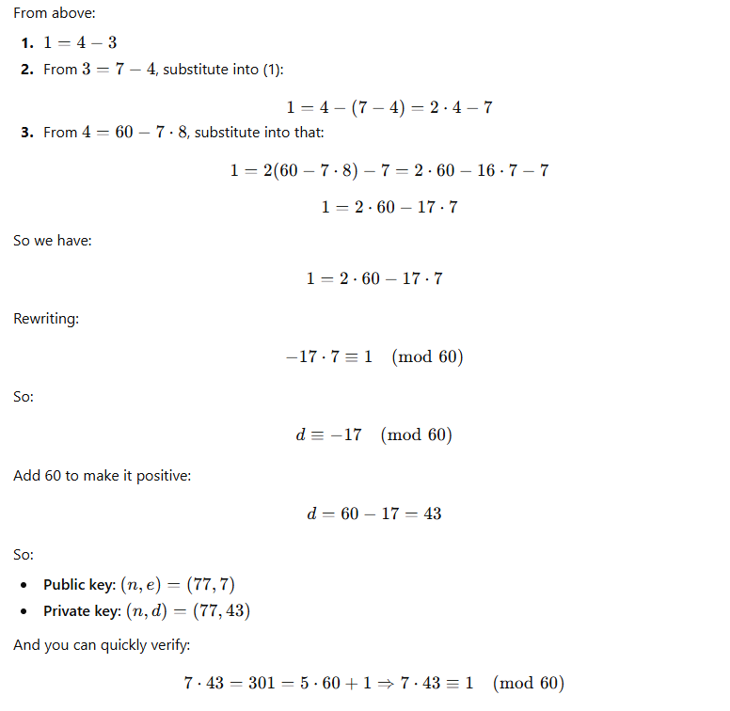

Encrypt “Matt Varghese”
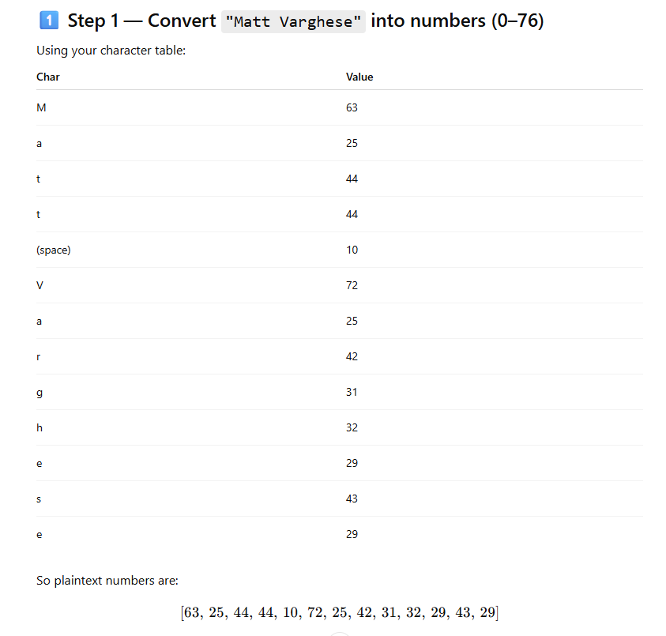

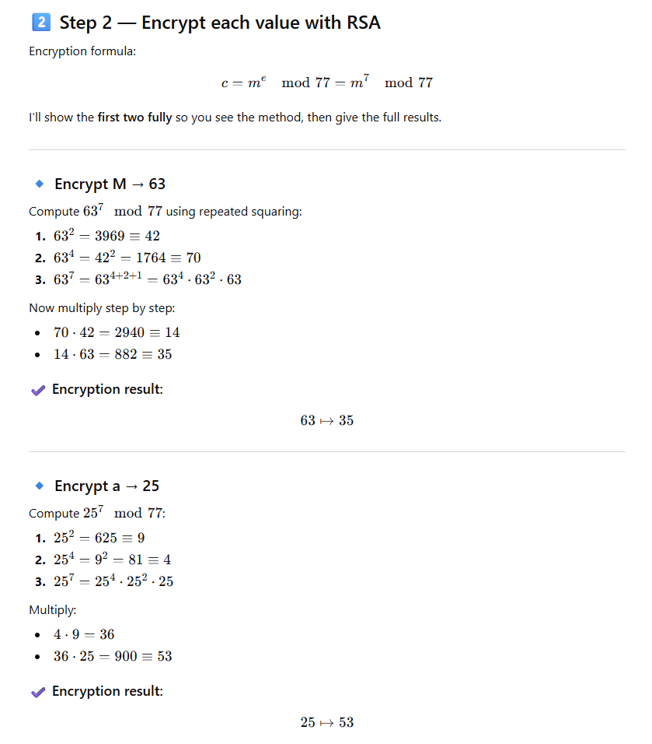

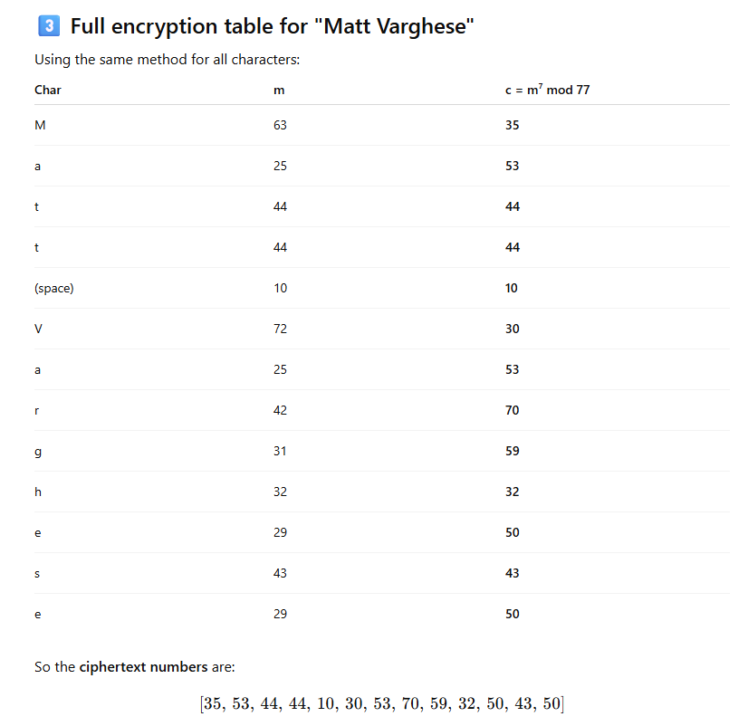
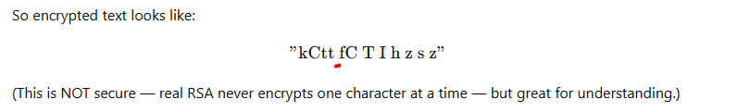
Note that “h”,”s”,“t” and space encrypted to the same characters. With large prime numbers, such won’t happen either.

Decrypt [35,53,44,44,10,30,53,70,59,32,50,43,50]
