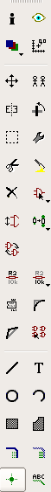
Layers
Move |  | Copy
Select
Delete |  | Add part
Set name |  | Set value
Split name
 |  | Text
 |  | Draw net
 |  | Name
Layers
Move
Select
Split name
Draw net |  | Ripup net
 |  | Text
 |  | Polygon
Hole
Ratsnest
Workshop documentation
http://bit.ly/shrimp-links

Table on the left is for schematic, table on the right is for the board.

See over for the schematic.
