There are plenty of great players in the history of the NBA. Who produced well beyond their draft position? Let’s find out.

Measuring the “best” basketball players presents a few challenges. Which statistics are relevant? Which are not? For my analysis, I decided to avoid complication and simplify, simplify, simplify. The most basic pinnacle of basketball success is winning an NBA Championship. How do you win an NBA Championship? You win games consistently. How do you win games consistently? Score points consistently. Therefore, my measurement of the top 51 (only because I didn’t want to leave out Tim Duncan) players in NBA history is by their points per game over their career (PPG/Career).

Here are the rankings:

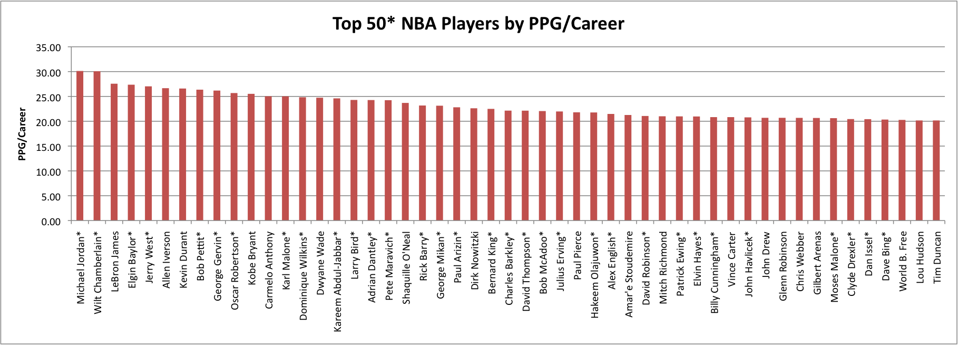

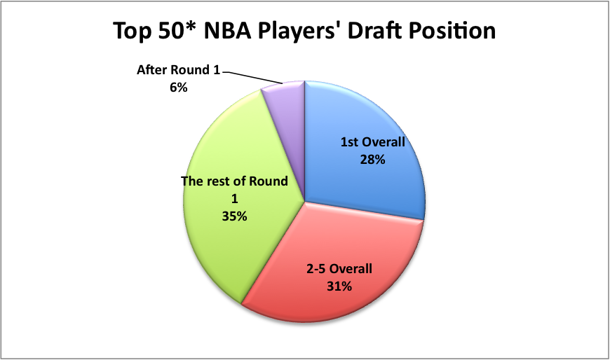To measure the value of each of these players, I compiled their draft positions. Everyone on this list is a stud, but I am looking for players that weren’t drafted to be stars. I’m looking for players that made contributions above and beyond the duty expected of the typical player from their draft position. First pick overall? You had better be stinking great. Top five? No slack. In fact, I would argue anyone taken in the first round has extreme expectations on them. This isn’t to say that second round picks have it easy, but they probably weren’t their teams first choice of draftable players, and so there is a little bit of wiggle room when measuring their performance. (There is a slight problem with the “Round 1” and “Round 2” argument, as those numbers change with the addition of teams in the league. I decided to set “Round 2” in my analysis start at pick 30. Alex English was taken as the 23rd pick overall, which was in the second round in 1976. Congratulations, Mr. English, you’re a first rounder by my analysis.)

Of the 51 players that I analyzed, there are a lot of tremendous names. (And, interestingly, beside Billy Cunningham and David Robinson, they are all right handed shooters.)Jordan. Kobe. Kareem. Dirk. Many more. Great players. An argument for their value could be made, as they are arguably the best players in NBA history. Spending the 3rd overall pick on Michael Jordan or the 13th pick on Kobe Bryant certainly comes with incredible and immeasurable value. Even though they greatly exceeded expectations, they *were* expected to do great things. The early-pick-high-value argument is valid, but this isn’t what I’m looking for.

Here is the players’ draft positions, from highest PPG/Career on the left to lowest on the right:

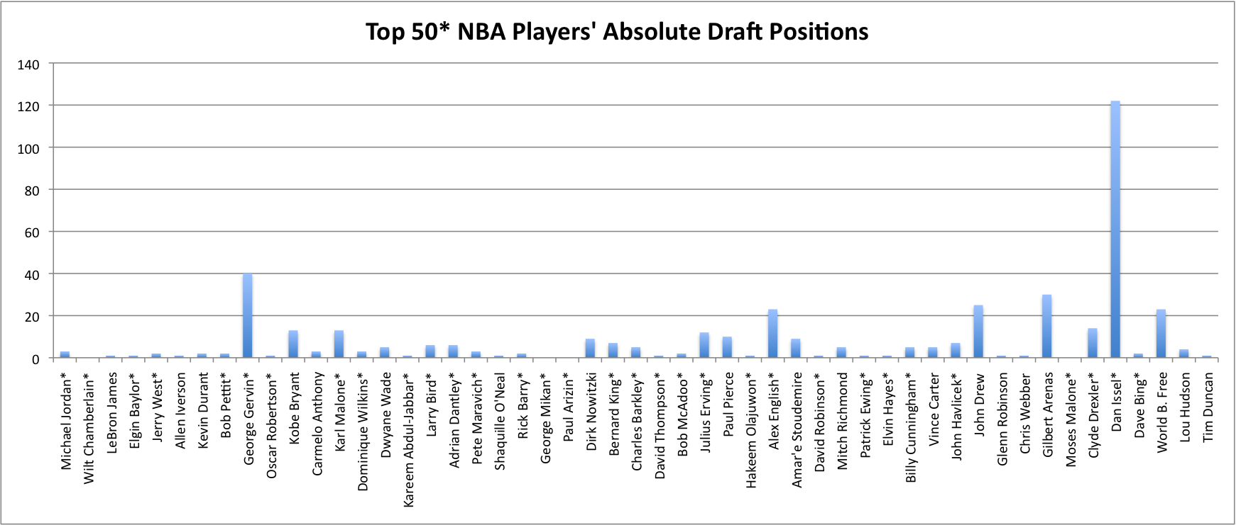

Only three players in the Top 50\* were drafted outside of the first round (Set above to end at pick 29).

They are: Gilbert Arenas in 2001(pick 30), George Gervin in 1974(pick 40), and Dan Issel in 1970(pick 122).   
 Good for Gilbert. His value is the lowest of the three by far, as his average PPG/Career has him ranked 44th, and he was drafted in the highest eligible position to be considered a 2nd rounder. George Gervin is, by this measure, the 9th best player in NBA history, with an PPG/Career of 26.18. The only other member of Gervin’s draft class to be inducted into the Hall of Fame was first overall pick Bill Walton. Very impressive for a 40th overall pick.

But Dan Issel. Holy crap.

Issel was drafted in the 8th round by the Detroit Pistons. With the first overall pick, they had drafted Bob Lanier, who played Issel’s position of center. Issel just didn’t care about any of this. He said, “Screw the system, I’m the best player on this team” and then showed everyone why it was true. Issel is ranked the 47th best player by the PPG/Career system, but who cares, because he was taken in the *freaking 8th round.* He’s in the HOF and deserves every bit of it. What a stud.

\*\*\*\*  
Notes:

I had trouble deciding how to display these large graphics effectively. I hate the draft position chart. It’s so hard to see where the bars end, because freaking Dan Issel’s value of 122 makes everything so tiny. Also, in hindsight I could have put a line at 30 that would make the players above that line more visible. This was tougher than I expected it to be.  
Sorry for using a pie chart, but I think it was the best medium for that type of data. *Be thankful it wasn’t a word cloud…*

-Travis