marxan.io user guide

A web app for systematic conservation planning

Matthew E. Watts

m.watts@uq.edu.au

15th April 2016

For marxan.io revision 39

Table of contents
What is marxan.io? 3
Get an account 3
The open source project 6
Preparing your data 6
Introduction to Marxan course materials 6
Qmarxan plugin for Quantum GIS 6
Marxan workflow in R 7
Other ways to create a Marxan dataset 7
Creating a zip file 7
Sample datasets 7
Login to marxan.io 7
Upload a dataset 9
Choose File 9
Database Name 11
Accept Database 11
Run Marxan 12
Database 12
BLM 13
Run 13
Display: Map 13
Best solution 14
Solution M 14
Selection frequency 15
Display Table: Conservation Features 15
Edit “prop” and “spf” 16
Save 17
Display Table: Summary 17
Display Table: Missing values 17
Display: Cluster 18
NMDS of solutions 18
Bray-Curtis dissimilarity of solutions 19
Parameter Testing 20
Database 21
Display 22
Parameter to test 23
BLM Calibration 23
SPF Calibration 24
Target Sensitivity 25
Run 26
Output table 27
Output graph 28
Output map 28
Value to display 29
Map to display 30
Plot Parameter Values 30
Run MarZone 30
Database 31
Run 32
Display: Map 32
Best solution 32
Solution M 33
Selection frequency zone N 33
Display Table: Inputs 35
Edit “prop” and “spf” 35
Save features 35
Display Table: Outputs 36
Display: Cluster 36
NMDS of solutions 36
Bray-Curtis dissimilarity of solutions 37
Download a dataset 38
Acknowledgements 39
References 40

What is marxan.io?

Marxan is the most widely used decision support software for conservation planning globally. It’s used in over 180 countries to build marine and terrestrial conservation systems. It’s the global leader in conservation land and sea use planning software and new extensions are making it even more popular.

The marxan.io web app is a graphical user interface for Marxan users that runs on the Nectar research cloud. You can upload your own Marxan datasets, edit targets, SPF and BLM, conduct parameter testing and analysis, visualise output maps, figures, and tables, and download the completed analysis in an easy to use web interface.

The instructions relate to revision 39 of the marxan.io web app.

Get an account

Visit http://marxan.net and click the “register marxan.io account” link.

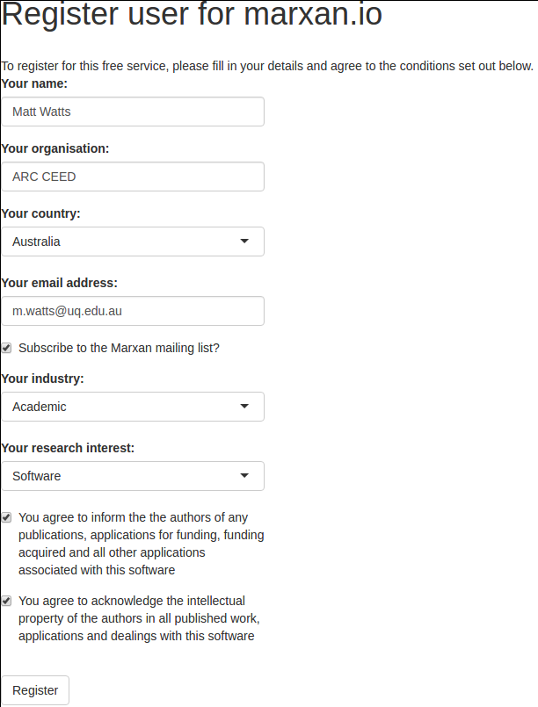

Enter your registration details, and click the “Register” button.

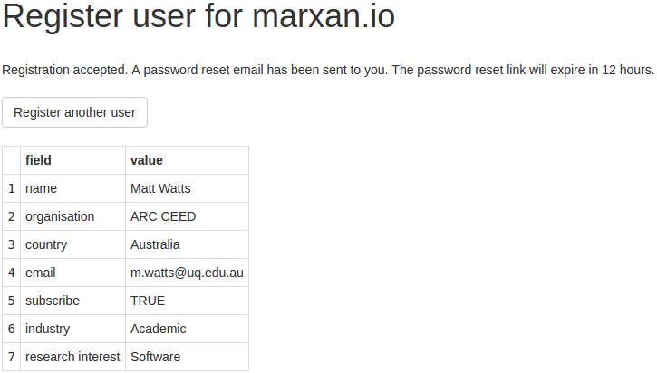
An email will then be sent you with a password reset link. When you click the link, you will be able to enter a password for your new account:

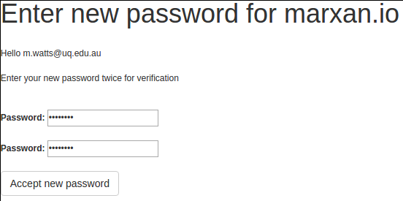
Enter the password twice so an to not make a mistake typing it, then click the “Accept new password” button.

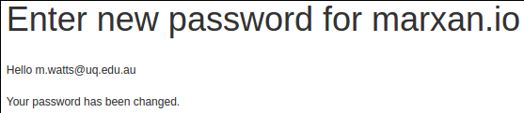
Make sure to write your password down in a safe place so you don't forget it.

The open source project

The apps are written in R. It’s open source software that you can freely use and modify subject to the conditions of the AGPLv3 open source software license.

You can access the source code on Github here:

https://github.com/mattwatts/marxan.io

You’re welcome to participate in the evolution of the software by contributing changes to the Github repository. Lots more changes and improvements are planned.

Preparing your data

To use your own data with marxan.io, you first need to prepare your dataset and ensure Marxan is running ok on your local computer. If Marxan doesn’t run ok, there is likely something wrong with your data. That is, one or more files malformed and not in compliance with the specification as detailed in the Marxan user manuals and course manuals.

There are functions in marxan.io that check for common mistakes in data creation and attempt to fix them, although some mistakes might stop your data from importing. More improvements to the error checking and correction code are planned.

Introduction to Marxan course materials

Day 1 of the Introduction to Marxan course materials describes in detail how to create a Marxan dataset from your own GIS layers. Handbooks are provided with the materials explaining this procedure using an open source GIS (Quantum GIS) and a commercial GIS (ESRI ArcMap). URL http://marxan.net , click “Teaching and Learning”, “Course Materials”.

Qmarxan plugin for Quantum GIS

An easy way to create a Marxan dataset is to use the Qmarxan plugin for Quantum GIS, described in the introduction to Marxan day 1 course materials.

Marxan workflow in R

We’ve created an entire workflow in R to create Marxan datasets that is available here:

https://github.com/mattwatts/CoESRA-Marxan

Other ways to create a Marxan dataset

There are many ways users create Marxan datasets and the methods multiply as time goes by. GRASS is a great way to intersect raster layers to create input files. Similarly PostGIS is a great way to intersect vector layers to create input files. You should choose the method that works best for you.

Creating a zip file

Once you have a Marxan dataset, assemble all the required files to prepare them for upload. You need these files:
- The input.dat input parameter file,
- The input folder with all the input files,
- The planning unit layer shapefile files.

The planning unit shapefile must have a planning unit id field called either: PUID, PU_ID, puid, or pu_id.

Put all the files in a directory with the name you want for your Marxan database then zip up the directory. This zip file is your Marxan dataset.

Sample datasets

A sample Marxan dataset “Tasmania” and a sample MarZone dataset “Rottnest Island scenario 4” are included in your account by default. Several additional sample datasets are provided for download from http://marxan.net

Login to marxan.io

We recommend Google Chrome web browser if other browsers don’t work as expected with the apps. Using your browser, visit http://marxan.net and click “marxan.io login”

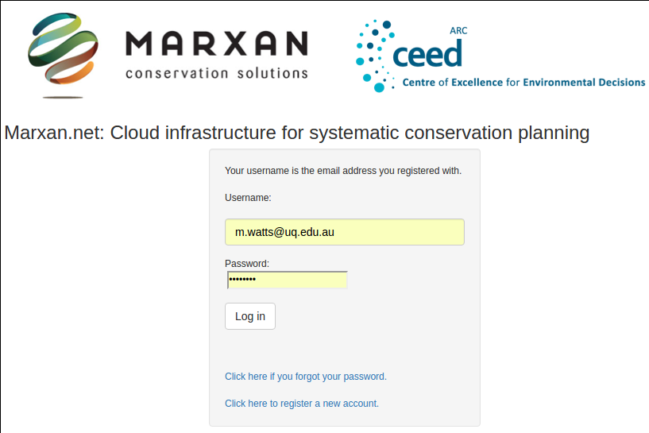
Enter your username and password. Your username is the email address you registered with and your password is the one you entered in the “reset password” form. If you've forgotten your password, click the blue “Click here if you forgot your password” link to reset your password again.

Click the “Log in” button to be authenticated on the system. Once you’re authenticated, you’ll see this screen:
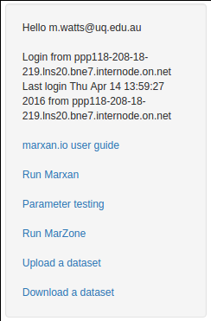
Click the blue “Run Marxan” link to run Marxan.

Click the blue “Parameter testing” link to do parameter testing.

Click the blue “Run MarZone” link to run Marxan with Zones.

Click the blue “Upload a dataset” link to upload your datasets.

Click the blue “Download a dataset” link to download your datasets.

A new tab will open in your browser for each app, leaving the authentication tab open where you can launch other apps.

Upload a dataset

The “Upload a dataset” screen looks like this:

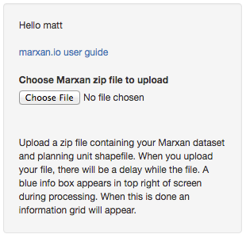

Choose File

Click the “Choose File” button to select and upload the zip file containing your dataset. When you upload your file, there will be a delay while the file is processed and your data is extracted and ingested.

While processing occurs, blue progress messages are displayed in the top right corner of the screen like this one:

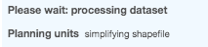

For large datasets, the delay might be a minute or even several minutes while the files are analysed. Large and complex datasets take a while to process.

The progress messages displayed are:

Please wait: processing dataset
Reading zip
Copying
Unzipping
Input files
converting Marxan files
converting MarZone files
reading Marxan files
reading MarZone files
writing Marxan files
converting matrix file
Planning units
reading shapefile
writing shapefile
reading dbf table
querying dbf table
writing dbf table
simplifying shapefile
dissolving shapefile
creating shapefile outlines
converting shapefile
saving pulayer.Rdata

When this is done, an information grid is presented to you like the screen below:

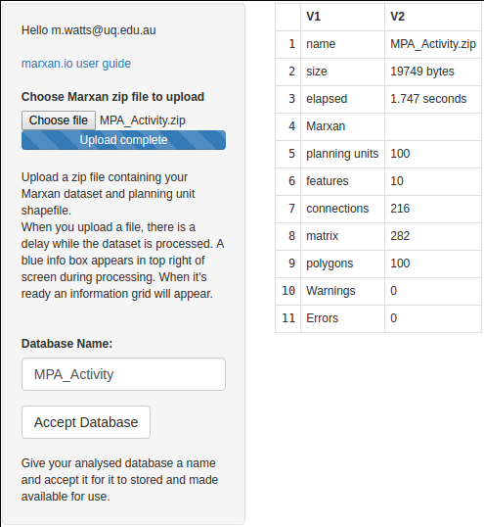

If the blue progress messages disappear and the information grid does not appear, an error might have occurred in the processing of your dataset. You can email m.watts@uq.edu.au to check your data that is logged in the system.

If an error is listed in the “Errors” box, it will contain diagnostic information that might help you correct the error and upload a corrected zip file. If you get stuck you can email m.watts@uq.edu.au to check your data that is logged in the system.

Diagnosis of errors will allow us to improve the service over time for all users, so your patience and help is appreciated.

Database Name

If the information grid is displayed with summary information on the examination of your dataset, and no errors are displayed, then you can specify a name for your dataset.

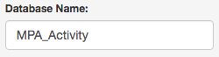

Please only use alphabetic and numeric characters with underscores and no spaces, as this becomes the directory name for your dataset.

Accept Database

To accept a dataset that has been successfully analysed, click the “Accept Database” button.

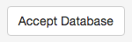

Your dataset will then be imported into your account for use. A blue message will briefly appear on the top right corner of the screen screen saying “Dataset accepted”.

If you already have a dataset with the same name, a blue message will briefly appear on the top right corner of the screen saying “Duplicate dataset name”. In this case, enter a new unique name before pressing “Accept Database”.

Run Marxan

The “Run Marxan” app allows users to run Marxan, display maps, tables and graphs, and edit key parameters. It has a control panel on the left, and an output panel on the right.

The “Run Marxan” screen looks like this:

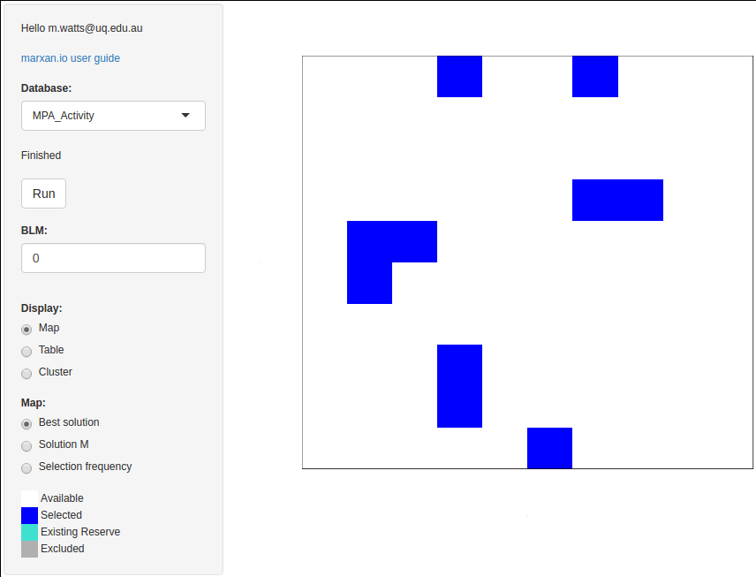

Database

The app has a “Database” control:

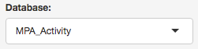

Click the drop down arrow on the right of the control to select the dataset you want to work with.

The first time you select a dataset you have uploaded, there will be a delay while the Marxan outputs are rendered. Blue progress messages appear in the top right corner of the screen while processing occurs.

This delay is a minute or so for small datasets and several minutes for large and complex datasets.

Please be patient after selecting a dataset while the output renders. The blue progress messages disappear and the display refreshes with output from your dataset once it’s rendered.

BLM

The app has a “BLM” control:

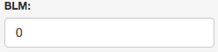

To edit the boundary length modifier (BLM), enter a new value in this control.

Run

The app has a run button:

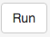

When you’ve changed BLM, SPF, or targets, click this button to run Marxan with the new parameters.

A delay of a few seconds for small datasets and longer for larger datasets occurs. During processing, progress messages appear in the top right corner of the screen and the “Finished” label greys out. After the results are rendered, the blue progress messages disappear, the “Finished” label appears black again and the display refreshes with new output.

Display: Map

The app has a “Display” control. Select “Map” to display output maps.
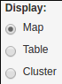

When “Map” is selected, a “Map” control appears:

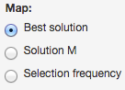

Best solution

Selecting “Best solution” displays the Marxan solution with the lowest objective function score. A map and map legend appears:

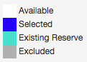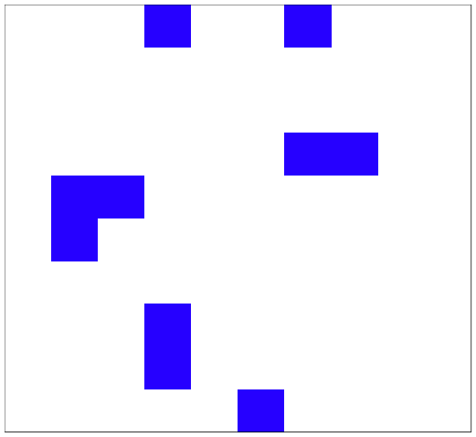

Solution M

Selecting “Solution M” displays a slider to select any of the 100 solutions:

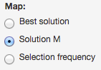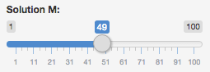

When you drag the slider, the map display is refreshed with the solution selected in the slider.

Selection frequency

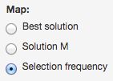

Selecting “Selection frequency” displays a selection frequency map of 100 solutions and a map legend:

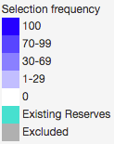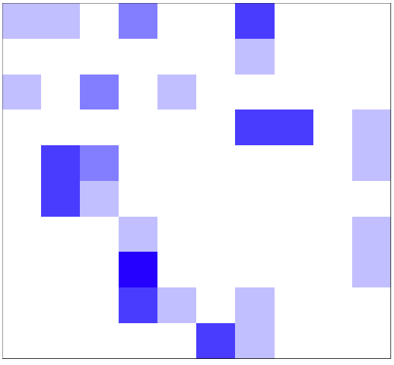

Display Table: Conservation Features

Selecting “Table” with the “Display” control causes the “Table” control to appear. Selecting “Conservation Features” with “Table” allows you to view the feature table and edit prop and spf.

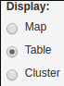
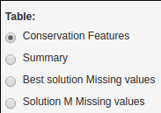

Edit “prop” and “spf”

Here you can edit prop (proportional target) and SPF (species penalty factor) for each species.

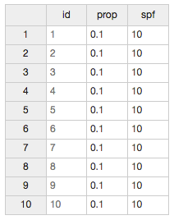

To edit prop or SPF for a species, click the cell you want to edit and type in a new value. Here we have changed the prop for species 2 from 0.1 to 0.4:

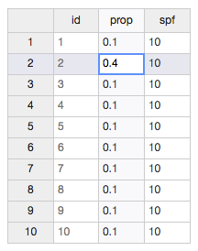

Save

When you have entered the prop and SPF values for the species you want to change, click the “Save” button to save the changes to your dataset:

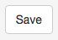

Display Table: Summary

Selecting “Summary” with “Table” allows you to display the “Summary” table:

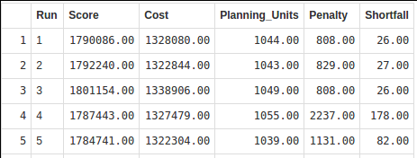

Display Table: Missing values

Selecting “Best solution Missing values” or “Solution M missing values” with “Table” allows you to display the missing values tables.

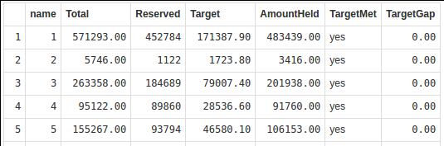
When you select “Solution M missing values”, a slider appears where you can select any of the 100 missing values tables to display.

When you drag the slider, the table display is refreshed with the missing values table selected in the slider.

Display: Cluster

Selecting “Cluster” with the “Display” control causes the “Cluster” control to appear:

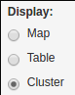
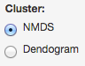

NMDS of solutions

Selecting “NMDS” with the “Cluster” control displays the 2 dimensional scaling of the dissimilarity of the 100 solutions:
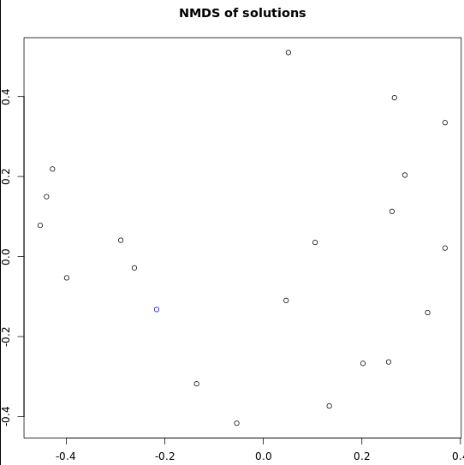

Unique solutions are displayed on the graph, and the solution with the lowest objective function score is displayed in blue.

Bray-Curtis dissimilarity of solutions

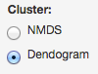

Selecting “Dendogram” with the “Cluster” control displays a dendogram of the 100 solutions:

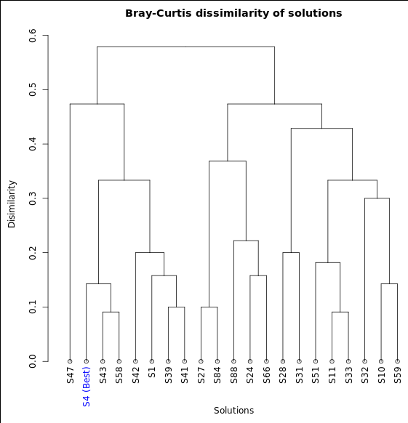
Only unique solutions are displayed. Each solution is labeled and the solution with the lowest objective function score is labeled in blue.

Parameter Testing

The “Parameter testing” app allows users to do parameter testing, and display maps, tables and graphs:

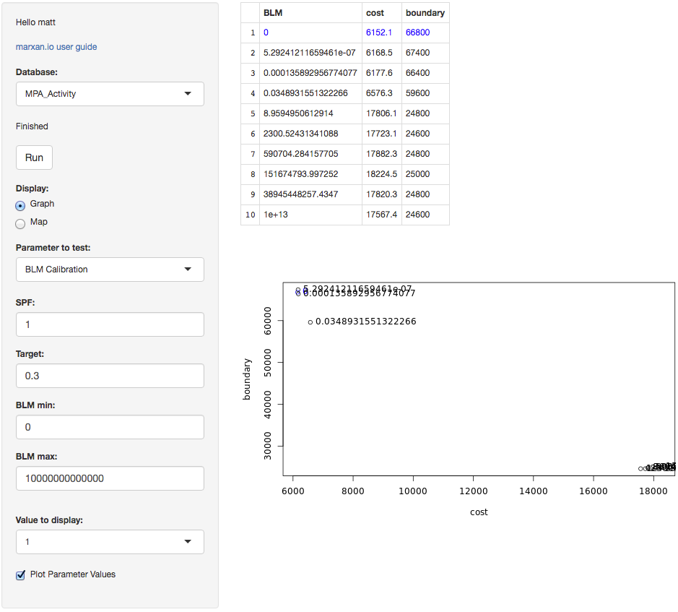

Here you can do calibration and sensitivity analysis of key parameters.
You can iteratively run tests for parameters of interest, changing parameters each time, to interactively explore the response of variables of interest. This allows the dynamics of a problem to be systematically explored in a structured way.

Appropriate values for the key parameters can thus be rapidly and efficiently determined.

Database

The app has a “Database” control:

Click the drop down arrow on the right of the control to select the dataset you want to work with.

The first time you select a dataset you have uploaded, there will be a delay while the parameter testing outputs for the selected test are rendered. Blue progress messages appear in the top right corner of the screen while processing occurs.

This delay is a minute or so for small datasets and several minutes for large and complex datasets.

Please be patient after selecting a dataset while the output renders. The blue progress messages disappear and the display refreshes with output from your dataset once it’s rendered.

Display

Click the “Display” control to switch the display between “Graph” and “Map”:

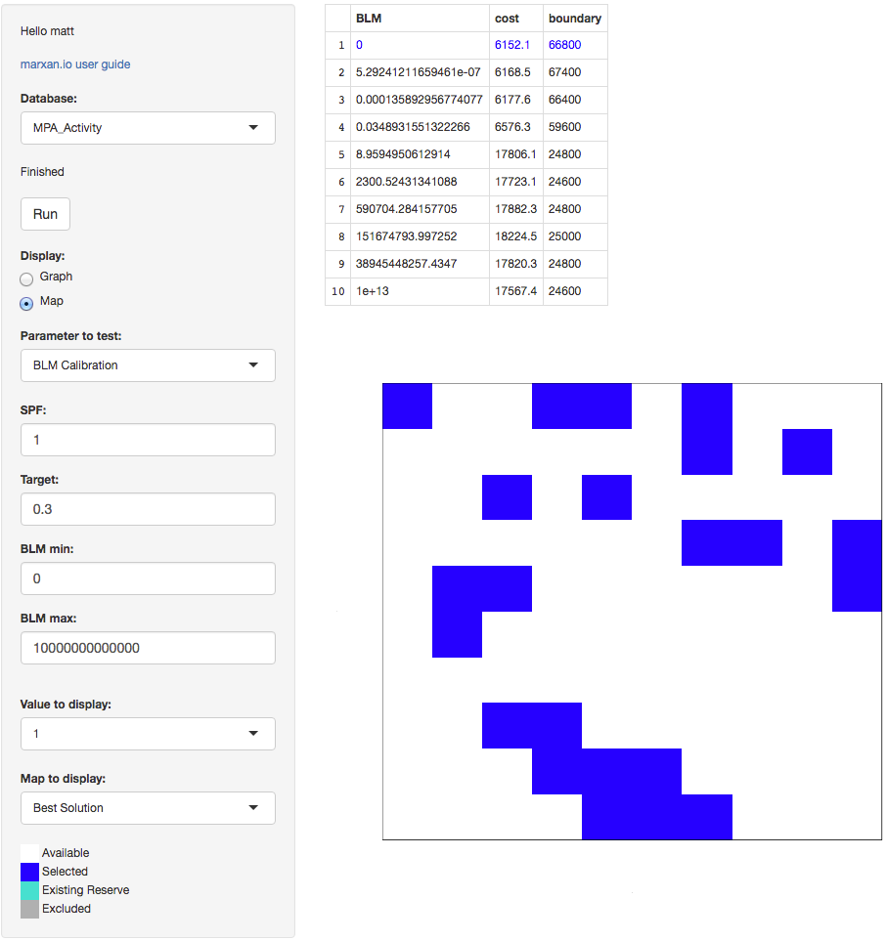

Parameter to test

The “Parameter to test” control selects the test you want to run: “BLM Calibration”, “SPF Calibration”, or “Target Sensitivity”:

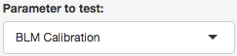

The first time you select a parameter to test for a dataset you have uploaded, there will be a delay while the parameter testing outputs for the selected test are rendered. Blue progress messages appear in the top right corner of the screen while processing occurs.

This delay is a minute or so for small datasets and several minutes for large and complex datasets.

Please be patient after selecting a parameter while the output renders. The blue progress messages disappear and the display refreshes with output from your dataset once it’s rendered.

BLM Calibration

Click the drop down arrow on the right of the “Parameter to test” control and select “BLM Calibration” to calibrate the boundary length modifier (BLM):

These controls appear to enter parameter values for the calibration:

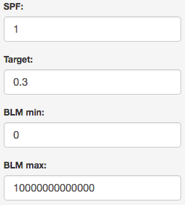

In the “SPF” control, enter the SPF value to use.

In the “Target” control, enter the proportional target value to use.

In the “BLM min” control, enter the minimum BLM value to use.

In the “BLM max” control, enter the maximum BLM value to use.

SPF Calibration

Click the drop down arrow on the right of the “Parameter to test” control and select “SPF Calibration” to calibrate the species penalty factor (SPF):

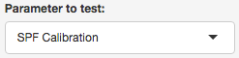

These controls appear to enter parameter values for the calibration:
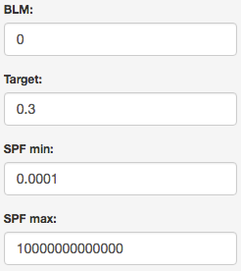

In the “BLM” control, enter the BLM value to use.

In the “Target” control, enter the proportional target value to use.

In the “SPF min” control, enter the minimum SPF value to use.

In the “SPF max” control, enter the maximum SPF value to use.

Target Sensitivity

Click the drop down arrow on the right of the “Parameter to test” control and select “Target Sensitivity” to analyse the sensitivity of the species targets:

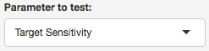

These controls appear to enter parameter values for the sensitivity test:

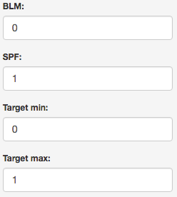

In the “BLM” control, enter the BLM value to use.

In the “SPF” control, enter the proportional SPF value to use.

In the “Target min” control, enter the minimum Target value to use.

In the “Target max” control, enter the maximum Target value to use.

Run

Click the run button to execute the selected parameter test with the parameters you have entered:

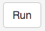

A delay of a few seconds for small datasets and several minutes for larger datasets occurs during which the “Finished” label greys out. Blue progress messages appear in the top right corner of the screen while processing occurs.

When processing is finished, the blue progress messages disappear, the “Finished” label appears black again, and the display refreshes with new output.

A set of 10 values is tried for the parameter you are testing.

A set of 10 solutions are generated for each value you are testing for a total of 100 solutions.

For BLM and SPF calibration, the values are ramped exponentially between the min and max entered.

For Target sensitivity analysis, the values are ramped linearly between the min and max entered.

Output table

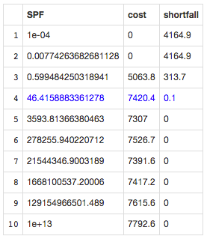

The output table displays the parameter values tried, the average cost of solutions, and the average value for the response variable of the solutions.

For SPF, the response variable is “shortfall” (the total amount by which our features miss meeting their targets).

For BLM, the response variable is “boundary” (the total boundary length of the reserve network configuration).

For target, the response variable is simply “target” (the target level we are testing).

Our aim with SPF and BLM calibration is to discover a parameter value that gives an appropriate response in the response variable.

Our aim with target sensitivity analysis is to discover how much it costs to protect different proportions of our species.

Output graph

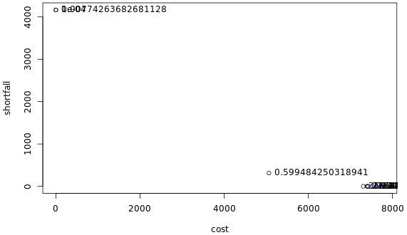

The output graph for BLM and SPF displays the response variable on the Y axis, and the cost on the X axis.

The output graph for target displays target on the Y axis and cost on the X axis.

As a test is rerun with different values of “min” and “max”, results are cumulatively added to the graph so the problem dynamics can gradually be revealed.

This iterative process allows rapid and efficient determination of appropriate values for the key parameters.

Output map

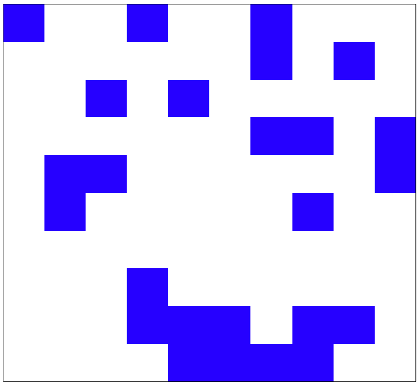

The output map displays selected areas or selection frequency for the value selected in the “Values to display” control (see below).

The “Map to display” control also determines which map is displayed (see below).

Value to display

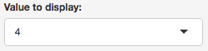

The “values to display” control allows you to select which input parameter value to interrogate.

Choosing “1” selects the “min” value specified. Choosing “10” selects the “max” value specified. Choosing a value between 1 and 10 selects one of the values ramped between the “min” and “max” values.

The selected value is highlighted in blue on the output table and graph, and results from testing the selected value are displayed on the output map.

Map to display

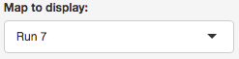

The “Map to display” control allows you to select which map to display.

10 solutions are generated for each input parameter value tried, and selecting “Run 1” to “Run 10” displays that solution on the map.

Selecting “Best Solution” displays the solution with the lowest objective function score on the map.

Selecting “Selection Frequency” displays selection frequency on the map.

Plot Parameter Values

The “Plot Parameter Values” control selects if parameter values will or will not be displayed next to their relevant points on the graph.

Run MarZone

The “Run MarZone” app allows users to run Marxan with Zones, display maps, tables and graphs, and edit key parameters. It has a control panel on the left, and an output panel on the right.

The “Run MarZone” screen looks like this:

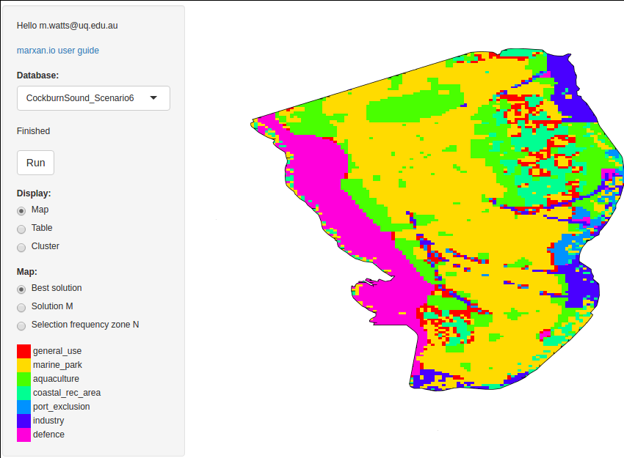

Database

The app has a “Database” control:

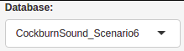

Click the drop down arrow on the right of the control to select the dataset you want to work with.

The first time you select a dataset you have uploaded, there will be a delay while the MarZone outputs are rendered. Blue progress messages appear in the top right corner of the screen while processing occurs.

This delay is a minute or so for small datasets and several minutes for large and complex datasets.

Please be patient after selecting a dataset while the output renders. The blue progress messages disappear and the display refreshes with output from your dataset once it’s rendered.

Run

The app has a run button:

When you’ve changed SPF, or targets, click this button to run MarZone with the new parameters.

A delay of a few seconds for small datasets and longer for larger datasets occurs. During processing, progress messages appear in the top right corner of the screen and the “Finished” label greys out. After the results are rendered, the blue progress messages disappear, the “Finished” label appears black again and the display refreshes with new output.

Display: Map

The app has a “Display” control. Select “Map” to display output maps.

When “Map” is selected, a “Map” control appears:

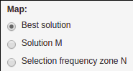

Best solution

Selecting “Best solution” displays the MarZone solution with the lowest objective function score. A map and map legend appears:

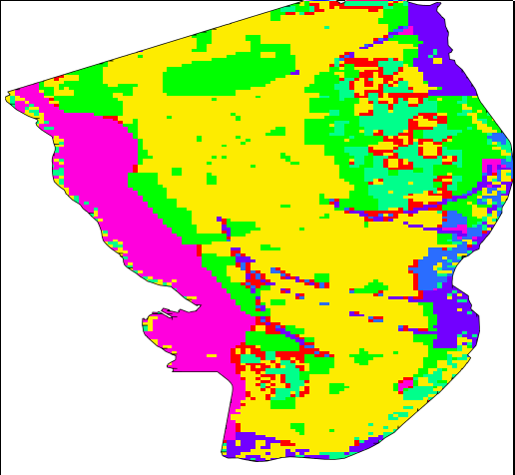
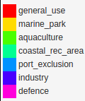

Solution M

Selecting “Solution M” displays a slider to select any of the 100 solutions:

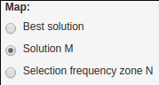

When you drag the slider, the map display is refreshed with the solution selected in the slider.

Selection frequency zone N

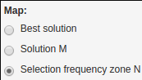
Selecting “Selection frequency zone N” displays a “Zone N” slider, a selection frequency map of 100 solutions, and a map legend:

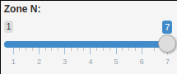
When you drag the slider, the map is refreshed with the selection frequency for the zone selected in the slider.

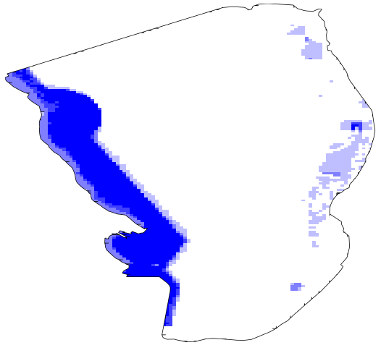
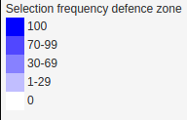

Display Table: Inputs

Selecting “Table” with the “Display” control causes the “Table type” control to appear. Selecting “Inputs” cause the “Table” control to appear for input tables. Selecting “spec” with “Table” allows you to view the Conservation Features table and edit prop and spf.

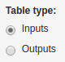
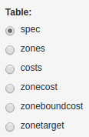

Selecting the other input tables in the “Table” control allows you to view them also. e.g. Click “zones” to view the zones table.

Edit “prop” and “spf”

When displaying “spec”, you can edit prop (proportional target) and SPF (species penalty factor) for each species.

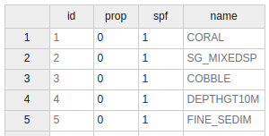

To edit prop or SPF for a species, click the cell you want to edit and type in a new value.

Save features

When you have entered the prop and SPF values for the features you want to change, click the “Save features” button to save the changes to your dataset:

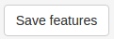

Display Table: Outputs

Selecting “Ouputs” with “Table type” causes the “Table” control to appear for output tables.

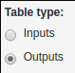
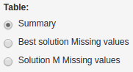

The display of output tables for MarZone works exactly as it does for Marxan: simply choose the output table you want to be displayed.

Display: Cluster

Selecting “Cluster” with the “Display” control causes the “Cluster” control to appear:

NMDS of solutions

Selecting “NMDS” with the “Cluster” control displays the 2 dimensional scaling of the dissimilarity of each zone for the 100 solutions. A legend shows the colour of each zone.

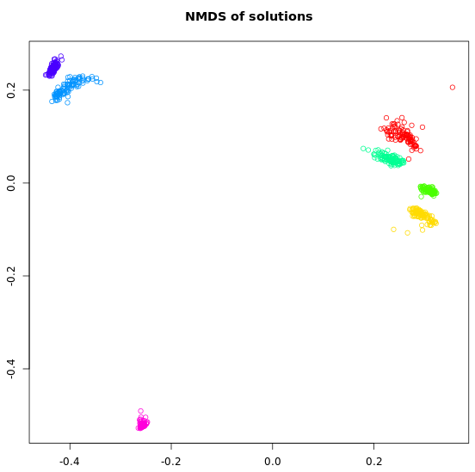

Bray-Curtis dissimilarity of solutions

Selecting “Dendogram” with the “Cluster” control displays a dendogram of the dissimilarity of each zone for the 100 solutions. A legend shows the colour of each zone.
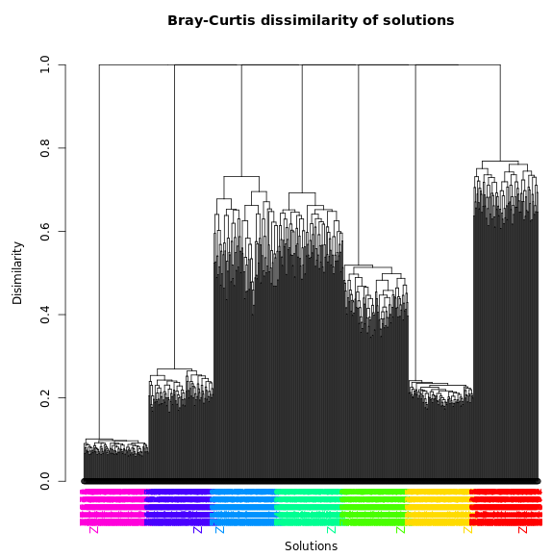
Only unique solutions are displayed.

Download a dataset

The “Download a dataset” screen looks like this:

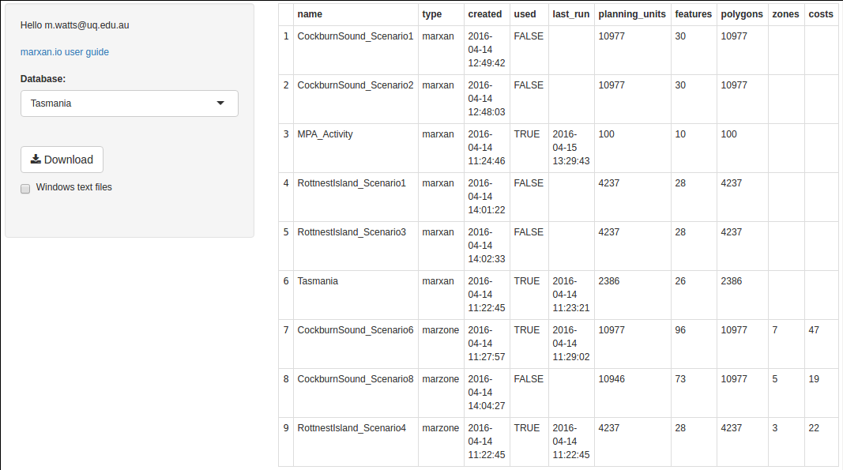
A control panel on the left allows you to select a dataset and download it. A table on the right displays a list of your datasets and summary statistics for each dataset.

To download a dataset and it's analysis output files, simply select the dataset with the “Database” control and click the “Download” button.
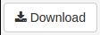

A zip file will then be downloaded that contains the input and output ascii files for your dataset, and a shapefile with your planning units. By default, the ascii files are encoded with unix style end of line terminators suitable for Linux and Mac platforms.

If you want the ascii files encoded with windows style end of line terminators suitable for Windows platform, make sure the “Windows text files” check box is checked before you press the “Download” button.

Acknowledgements

Marxan acknowledges funding from Nectar. Nectar is supported by the Australian Government through the National Collaborative Research Infrastructure Strategy (NCRIS).

References

Ball, I.R., H.P. Possingham, and M. Watts. 2009. Marxan and relatives: Software for spatial conservation prioritisation. Chapter 14: Pages 185-195 in Spatial conservation prioritisation: Quantitative methods and computational tools. Eds Moilanen, A., K.A. Wilson, and H.P. Possingham. Oxford University Press, Oxford, UK.

R Development Core Team (2008). R: A language and environment for
statistical computing. R Foundation for Statistical Computing, Vienna, Austria. ISBN 3-900051-07-0, URL http://www.R-project.org.

Shiny server, by the RStudio Team (2015). RStudio: Integrated Development for R. RStudio, Inc., Boston, MA URL http://www.rstudio.com/.

Watts, M.E. and Possingham, H.P. 2013. Marxan.net: Cloud infrastructure for systematic conservation planning. URL http://marxan.net

Watts, M.E, I.R. Ball, R.R. Stewart, C.J. Klein, K. Wilson, C. Steinback, R. Lourival, L. Kircher, and H.P. Possingham. 2009. Marxan with Zones: software for optimal conservation based land- and sea-use zoning, Environmental Modelling & Software (2009), doi:10.1016/j.envsoft.2009.06.005

--------------------------------------------------------------

