AUTH2 Solution

Matthew A. Weidner (Twitter - @jopawp)

Category: Enumeration and Exploitation

Difficulty: Hard

The auth2 binary can be identified as a 64-bit ELF compiled on GNU/Linux using the file command on Kali Linux. Executing the file prompts the user for a passcode and responds with the message “WRONG PASSCODE. DON’T QUIT!” Using a disassembler or debugger, such as objdump, gdb, or radare2, the file’s 64-bit assembly language instructions can be analyzed. Radare2 is used in this solution.

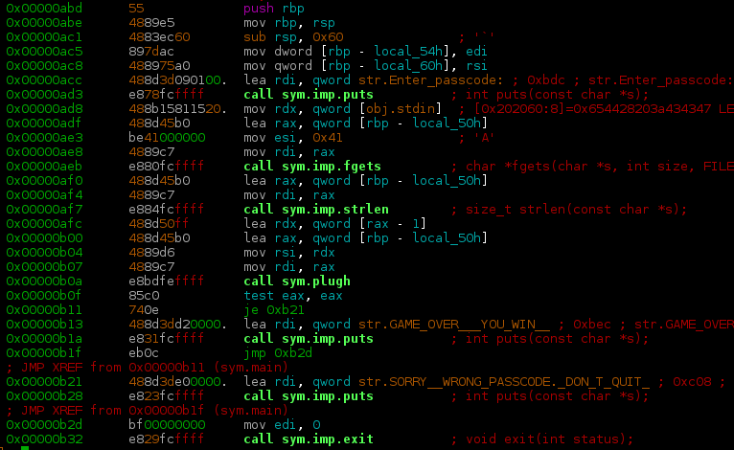

Figure : Function main()

Examination of the main() function (Fig. 1) reveals the program prints a passcode prompt, reads user input using fgets(), and then calls another function, plugh(), passing the user’s input as the only parameter (rbp – local_50h).

The plugh() function (Fig. 2) moves a bunch of single bytes into the stack area and then calls the xyzzy() function, again passing the user’s input along (rbp – local_58h). Upon returning from xyzzy(), a loop is entered that does a byte-by-byte comparison of two memory regions on the stack (rbp + rax - 0x50 and rbp + rax – 0x30).

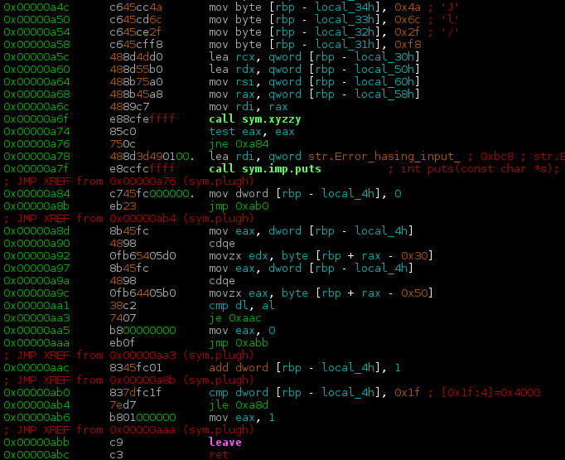

Figure : Function plugh()

The xyzzy() function (Fig. 3) looks interesting! It appears to be calculating the SHA256 hash of the user’s input (rbp – local_58h). A quick Google of the function names SHA256_Update() and SHA256_Final() reveals these are part of the OpenSSL library of cryptographic functions.

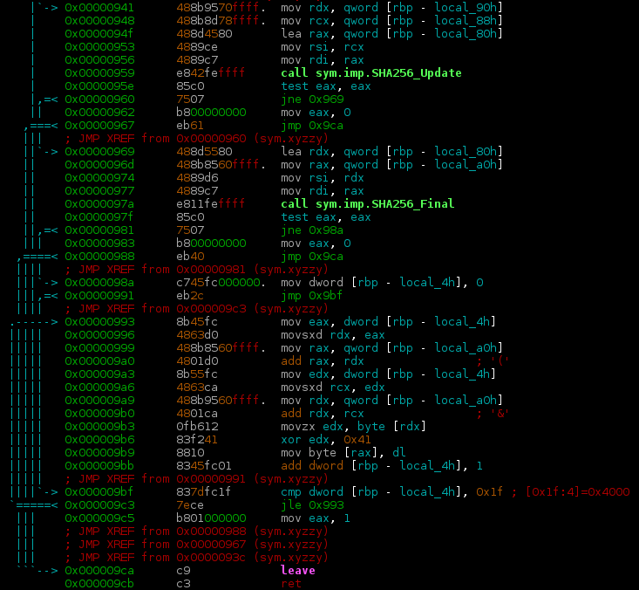

Figure : Function xyzzy()

At this point we know that the user’s input is being hashed with SHA256. Let’s look at what is happening to the hash value. According to the OpenSSL sha256.c source code (<https://github.com/openssl/openssl/blob/master/crypto/sha/sha256.c>), SHA25_Final() receives two parameters. The first is a pointer to a variable that will hold the hash value. The second is the SHA256Context, which is only important for OpenSSL’s internal workings. The Linux x64 ABI (<http://refspecs.linuxbase.org/elf/x86-64-abi-0.99.pdf>), which defines how parameters are passed, states the first four parameters of a function call are passed using registers: rdi, rsi, rdx, rcx. Looking at the xyzzy() function at the point where SHA256_Final() is called, rdi is loaded with the address stored at rbp – local_a0h. This is where the result of the hash calculation is being stored. After finalizing the hash calculation with SHA256_Final(), the code loops a total of 32 (0x1f + 1) times, each time performing an xor operation. It gets a byte from the stack (base address stored at rbp – local_a0h plus an offset being that is incremented with each iteration and stored at rbp – local_4h), xor’s it with 0x41, and overwrites the original byte on the stack with the new value. This means that the result of the SHA256 hash calculation is encrypted using a single byte xor operation with the key 0x41. When program flow returns to plugh() that encrypted hash value is compared, byte-by-byte, with the static values moved into the stack area at the beginning of the plugh() function. If all the bytes match, this triggers the “GAME OVER – YOU WIN!” message. Those static values must be the xor encrypted SHA256 hash value of the correct passcode (Fig. 4).

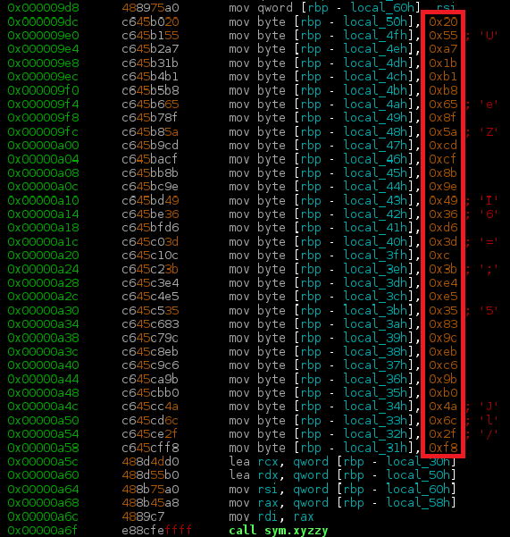

Figure : Xor encrypted SHA256 value of passcode

Since the xor operation is its own inverse, xoring each byte indicated in Fig. 4 with 0x41 will obtain the original SHA256 hash. This can be done with a simple python script (Fig. 5) The decrypted SHA256 value corresponds to the input passcode that will trigger the “GAME OVER – YOU WIN!” message.

Decrypting the encrypted hash value results in the hash:

6114e65af0f924ce1b8c8ecadf0877977c4d7aa5a474c2ddaa87daf10b2d6eb9

Crackstation.net (Fig. 6), hashcat, or John the Ripper (Fig. 5) can then be used with the rockyou wordlist to crack the hash.

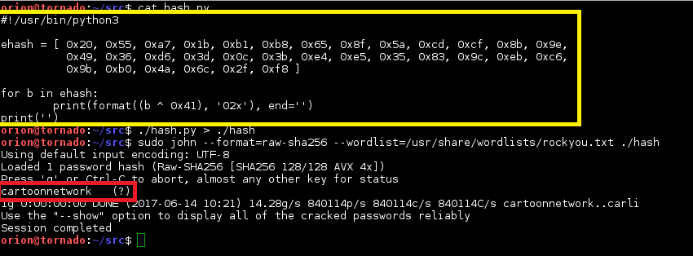

Figure 5: Python script to xor decrypt the hash and cracking the hash with john

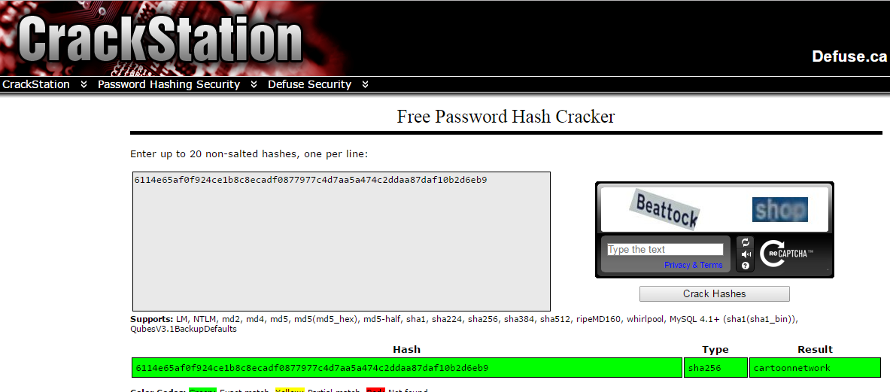

Figure 6: Crackstation.net

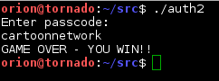

Figure : Win