Maps

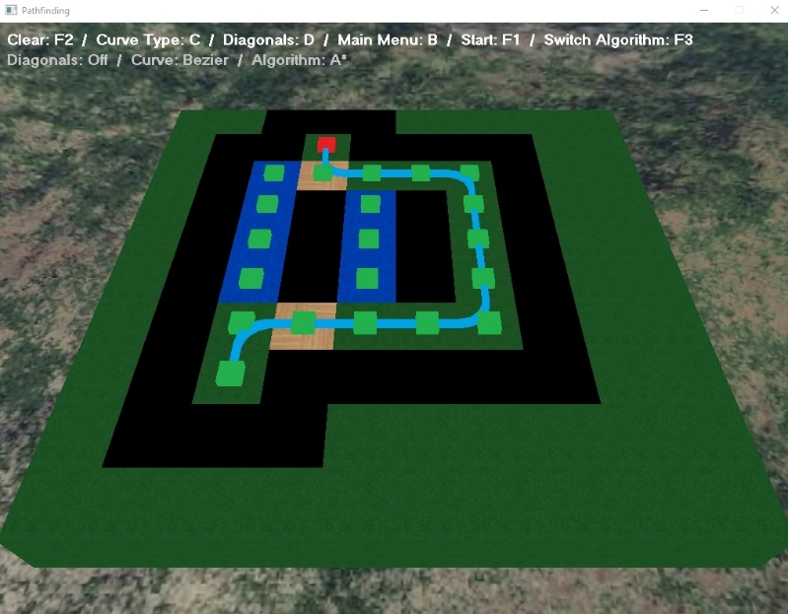

You can see how the A\* algorithm takes the route around the water because it’s cheaper to do so

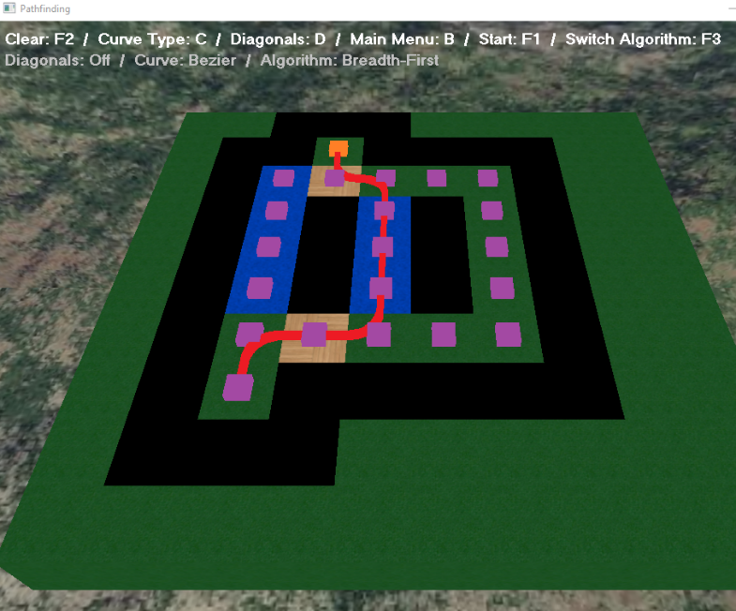

The Breadth-First search algorithm on the other hand doesn’t take into account the scores so will return a path but in this case, it’s slower than A\*

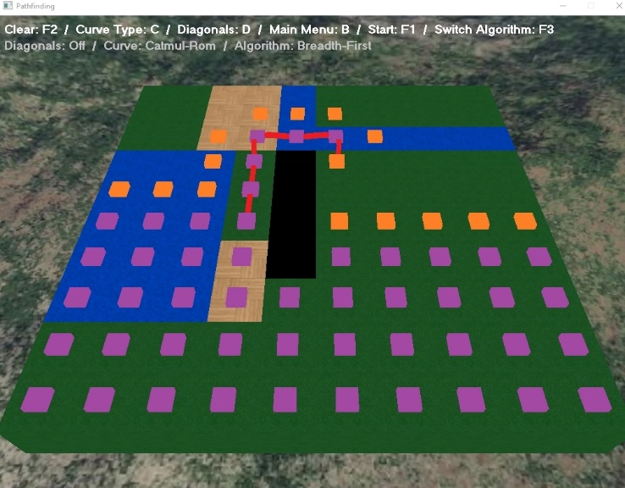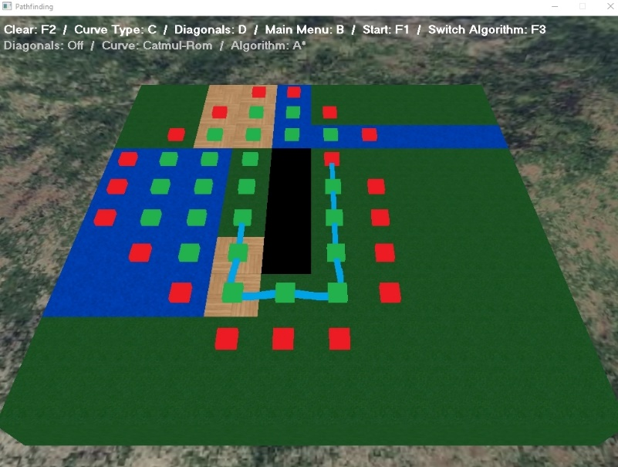

On a different map (using Catmull-Rom splines), A\* again chooses the optimal route, going around the water

You can see how Breadth-First search is less efficient in it’s search (the size of the closed list) and goes through the water which is less optimal.