**CS3096 Computational Intelligence Laboratory**

**Practice Problems** 01/10/2018

1. Consider the following figure that represents a student's room. Furniture, walls ,windows and corners are marked in the figure. Create a PROLOG program that represents the given information and can answer the following queries.

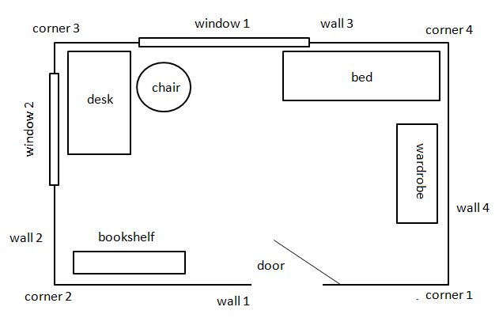

Represent this student's room such that the following queries (and similar queries) are possible:

1. Which furniture is in the room?
2. How many doors, windows, tables, ... are in the room?
3. Where is the deskn and the chair, ... ?
4. What is at the wall 2, at the window 1, ... ?
5. What is in the corner 4, ... ?