**The Market and Well Being: Report 3**

Daniel Cirkovic, Matt Goldsmith, Connor Brubaker, Odessa Reyno, Claire Ganci

*Stats PhD - 300, Stats MS - 700, Stats PhD - 300, Stats MS - 700, Civil Eng MS - 300*

Programming/Theory, Programming/Theory, Programming/Theory, Presentation/Writing, Writing

**Abstract:** The following report explores the validity of championing stock market performance as a proxy for the well being, economic or otherwise, of the general public. In Part I, two datasets, the S&P 500 index and real U.S. median household income from 1969 to 2017, are introduced. In Part II, proper transformations of the data are made to conduct initial statistical analyses. Part III introduces a new dataset, the US Consumer Sentiment Index, and fits a multivariate model to the entire dataset, exploring the complicated relationship between the series.

**Part I:**

**Introduction:**

In recent years, the performance of the stock market has often been hailed as an indicator of the general economic well being of the United States. Commonly, positive fluctuations in the stock market are viewed as a vote of confidence towards future economic conditions by investors (Bosworth et al., 1975). It is unclear, however, whether gains in the market correlate to tangible improvements in the economic well being of the working class. The relationship between the stock market and a population’s well being is complex, but simple analyses may provide salient insights into such a relationship.

In order to explore the relationship between the performance of the market and the well being of individuals, the S&P 500 price and median household income from 1969 to 2017 are analyzed. The S&P 500 data are taken from Standard & Poor’s website, while the median household income data are provided by the U.S. Census Bureau. The S&P 500 is an average of the stock prices among the 500 largest companies in stock exchange, weighted by the total value of their shares. It is an indicator of stock market health or performance. Both series are in terms of real U.S. dollars, meaning they have been adjusted for inflation in terms of 2017 dollars. Thus, the two series can be viewed in terms of what they would have been worth in today’s dollars, relatively speaking. From an initial glance, the series seem to be correlated to some extent, as they both trend upwards. They also seem to share dips and spikes, though those in the income series are experienced later than those in the S&P 500.

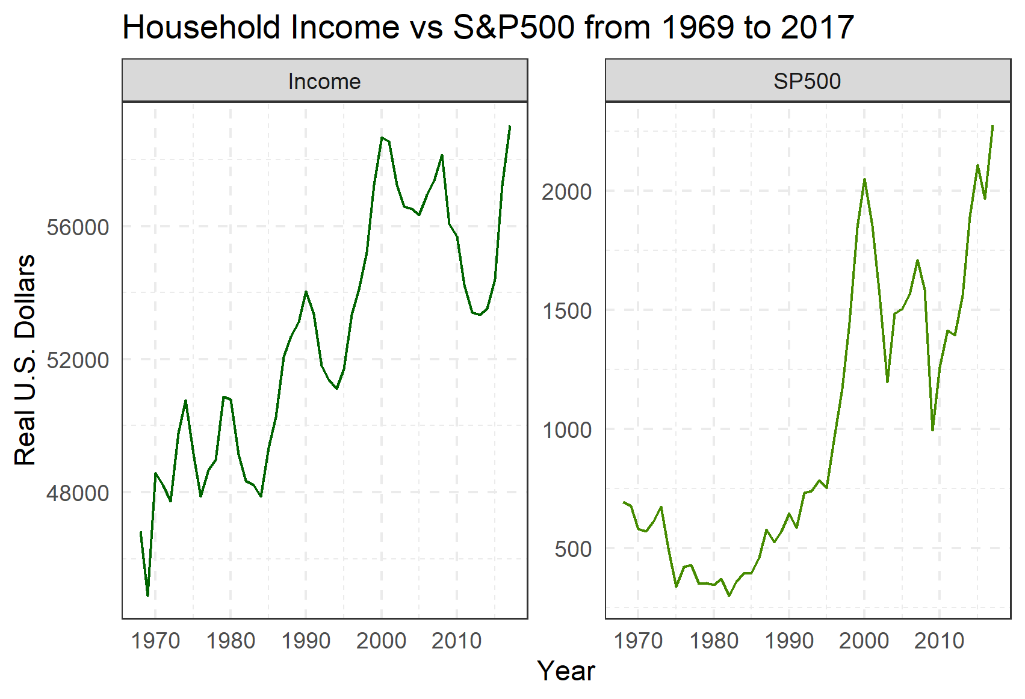

**Figure 1:** Time series plots of Household Income vs S&P 500 in real U.S. Dollars

The ultimate goal of analyzing the two datasets would be to determine if they are correlated, and if so to what degree. If such a connection is present, this may lend some credence to the claim that stock market performance can be used as a proxy for the general economic well being of a population. This analysis could be executed with a hypothesis test of independence (see Hong, 1996, for example). Further, it would be interesting to see whether the series are predictive of one another and what their predictions may indicate about the future.

**Part II:**

**Transforming to Stationarity:**

In order to understand the correlation between the stock market performance and individual well being, the two data series must first be converted to stationarity. Doing so allows for stable estimation of the mean, autocorrelation and autocovariance functions. To eliminate the upwards trend in the two series, differencing was performed. In particular, for the S&P data, the difference of logarithm transformation was applied, similar to the Dow Jones Industrial Average example in the textbook (Example 1.3, page 3). Since both the Dow Jones and S&P 500 are financial indices, this transformation yields a series that can be interpreted as the return of the index at year *t*. For the U.S. Median Income series, lag 1 differences were applied. The natural interpretation of the resulting series is the change in median income from year *t*-1 to year *t*.

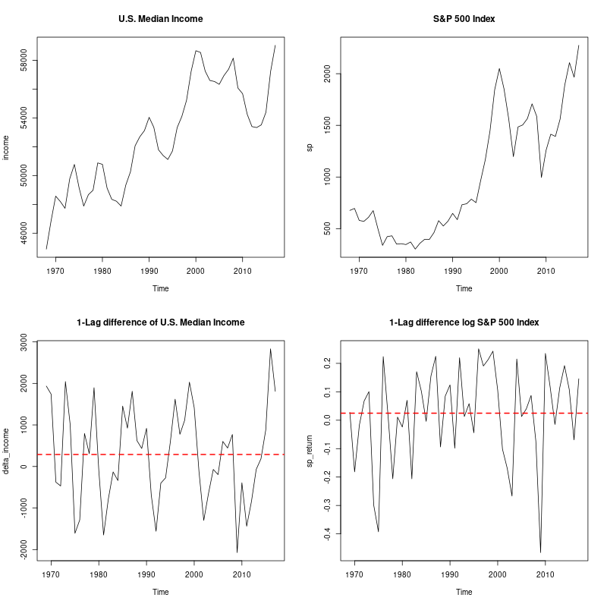

**Figure 2:** Time series plots of the S&P 500 Index and U.S. Median Income, before and after transformations to stationarity.

The resulting series are clearly stationary; they vary about their means and have constant variability over time. The differenced U.S. Median income series seems cyclical, while the differenced log S&P 500 series varies in a patternless fashion.

**Autocorrelation and Partial Autocorrelation Analysis:**

Figure 3 displays the sample autocorrelation and partial autocorrelations of the stationary series. The differenced income series has significant lag 1 autocorrelation and partial autocorrelation coefficients, and cuts off for all larger lags. This is indicative of perhaps an AR(1), or perhaps an ARMA(1,1) model. Interestingly, the log-differenced S&P 500 series has no significant autocorrelation, nor partial autocorrelation coefficients, implying that the series may be nothing more than just white noise once transformed. This makes modeling very simple, as a mean only model would suffice for the log differenced S&P 500 series.

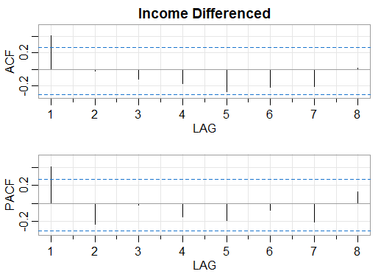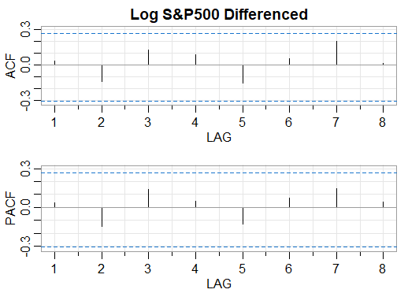

**Figure 3:** ACF and PACF of stationary Income and S&P 500 series

Figure 4 displays the cross-correlation function between the differenced income series and the log-differenced S&P 500 series. Interestingly, the next year's differenced income value is positively correlated with this year's log-differenced S&P 500 value. That is, the differenced income is positively correlated with the previous year’s log differenced S&P 500 value. This corresponds exactly to the dips in income that were experienced one year after the dips in the S&P 500 seen in Figure 1. This lends credence to the claim that the market and well-being are correlated, and this relationship can be solidified later via multivariate (VARMA) models.

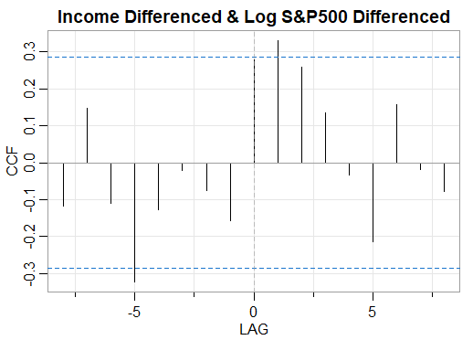

**Figure 4:** Cross-correlation between differenced Income and log differenced S&P 500 series

To further investigate the lag 0 correlation, the Spearman Rank Correlation, which ranks each data point and then finds the correlation between the ranks, is utilized. The estimated correlation coefficient for the stationary Household Income and S&P 500 series is $\hat{}ρ$ = 0.27, implying a small, positive correlation. A one sided z-test ($H_{A}:ρ>0$) returned a z-score of 1.87, indicating a statistically significant correlation. Though, this test is performed *a posteriori*; the results must be taken with caution.

**Fitting and Forecasting:**

An AR(1) is fit to the differenced income series, which is denoted by $∇I_{t}$*.* The AR(1) is fit via the “sarima” function in R, which utilizes maximum likelihood estimation (or unconditional least squares). The fitted model equation is given by

$∇\hat{I_{t}}$ = $0.465_{(0.132)}∇I_{t-1}$

The AR(1) coefficient is significant, falling outside 3 standard deviations of the standard error given by 0.132. The estimate of the variance of the innovations is given by $\hat{σ^{2}} = 1117717$, which seems large at first, but seems reasonable considering the scale of the data is in thousands of dollars. The 7 year ahead forecast for the differenced income series is given in Figure 5.

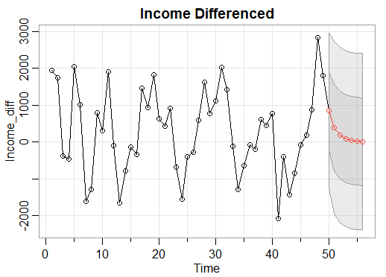

**Figure 5:** Differenced Income predictions from an AR(1) model.

As mentioned previously, modeling the white noise, log differenced S&P 500 data (denoted $∇log(S_{t})$) is quite simple. A mean-only model is fit using the “lm” function in R, with model equation $∇log\hat{}(S_{t}) = 0.024_{(0.024)}$ with estimated error variance $\hat{σ^{2}} =0.029$. The estimated mean is within 1 standard error of 0, implying that the sample mean is not statistically significant and the best model is given by $∇log\hat{}(S_{t}) = 0.$ Thus, any future prediction of $∇log(S_{t})$ would be $∇log\hat{}(S_{t}) = 0$, which seems unusual, but given that the data is reasonably white noise, the result is expected.

Note that however, the interest is not in predicting values for the differenced series, but instead in predicting the original series. Without any additional theory, predictions for the income series can be obtained by reversing the differencing. Figure 6 displays the predictions for the original income series.

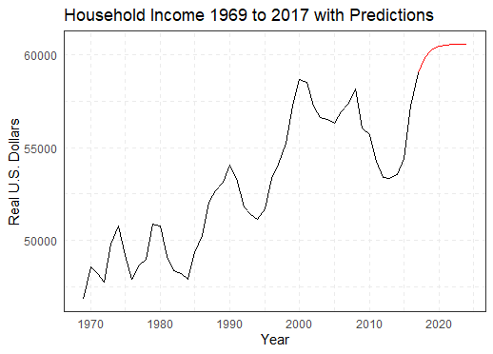

**Figure 6:** Predictions for the original Household Income series.

**Diagnostics:**

Figure 7 displays diagnostics for the AR(1) differenced income model. See that the model residuals are stationary; they vary about 0 and have a relatively constant variance. The ACF of the residuals also indicate that they are uncorrelated, and hence white noise. Normality of the residuals is also satisfied since the residuals fall neatly along the qq-line, with very slight deviation in the tails. Therefore, for this model all assumptions are satisfied. For the mean-only S&P 500 model, one can view Figures 2 and 3 since the residuals are equivalent to the original data. Hence, all modeling assumptions are satisfied.

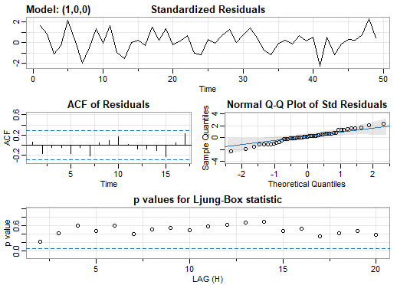

**Figure 7:** Diagnostics for the AR(1) differenced Income model.

**Part III:**

Previously, an AR(1) model was fit to $∇I_{t}$ and a mean only-model to $∇log(S_{t})$, since at the time only tools to model stationary series were used. Now, however, their nonstationary counterparts, $I_{t}$ and $log(S_{t})$, can be addressed via integrated models. Luckily, the model formulation is already complete, as the integrated components simply correspond to lag 1 differences. Hence, an ARI(1, 1) model is fit to $I_{t}$ and a simple integrated model is fit to $log(S_{t})$. Note that nothing major changes from the previous models; the estimated model coefficients and standard errors are the same as before. Now, the software provides estimates for $I_{t}$ and $log(S_{t})$ as shown in Figure 8.

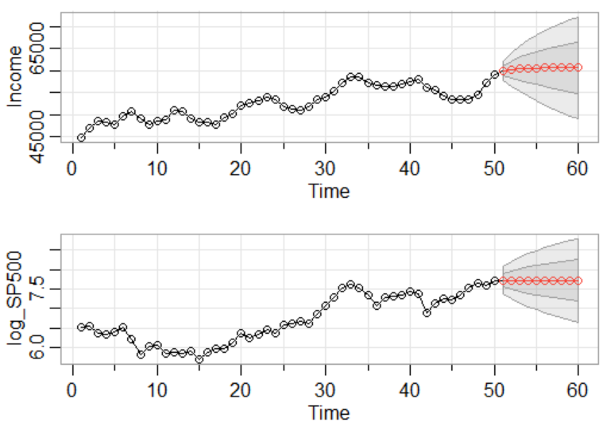

**Figure 8:** Forecasts for ARI(1) and integrated models

To get predictions for $S_{t}$ instead of $log(S_{t})$, one would simply exponentiate. However, these predictions are quite boring, since $∇log(S_{t})$ was fit to a zero-mean model, giving a constant predicted value. For brevity, model diagnostics are performed later when fitting a multivariate model.

As recommended by Dr. Pourahmadi, the University of Michigan Index of Consumer Sentiment is added to the analysis. The Index of Consumer Sentiment represents attitudes among consumers in the United States towards their own financial situation as well as their views towards future economic conditions. The index is computed from survey responses of 50 questions sent to American households, excluding Alaska and Hawaii. Throughout, the Index of Consumer Sentiment at year $t$ is represented as $C_{t}$. Figure 9 displays a plot of the consumer sentiment data along with its associated correlogram and partial correlogram.

**Figure 9:** US Index of Consumer Sentiment from 1969 to 2017

The data appears to already be relatively stationary with a mean value of 85. Looking closely at the correlograms, the ACF plot appears to tail-off while the Partial ACF plot appears to have a cut-off after lag 1. Based on these two plots, an AR(1) model is the best fit for the data. The fitted model is given by

$\hat{C_{t}}=86.0{27}_{(3.917)}+0.73_{(0.095)}{\hat{C}}_{t-1}$

where the estimation innovation variance is given by 61.18. For brevity, model diagnostics will be analyzed once a multivariate model is fitted.

A seven-year-ahead forecast is given in Figure 10.

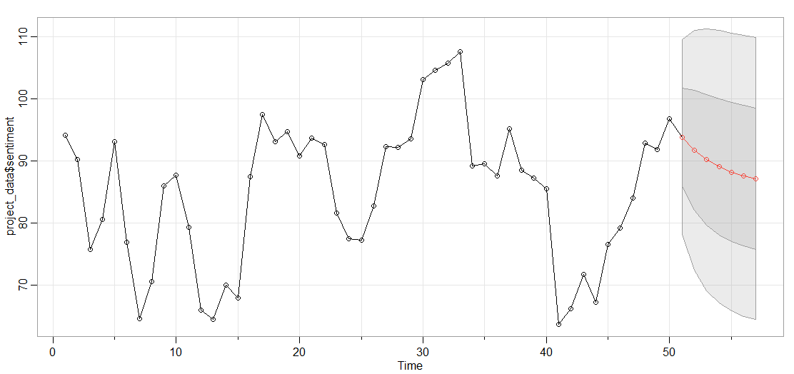

**Figure 10:** Prediction ofUS Index of Consumer Sentiment from 2018 to 2024

Previously, all series were analyzed marginally. However, the economy is a complex, interwoven system. It would thus be reasonable to assume that accounting for the relationships between our series would result in more accurate and representative predictions. Towards this end, let

**X**t = [*I*t , *S*t , *C*t ]T. It has already been well established that the components of **X**t are stationary. To assess the relationships between the components of **X**t, their autocorrelation and crosscorrelation functions are observed.

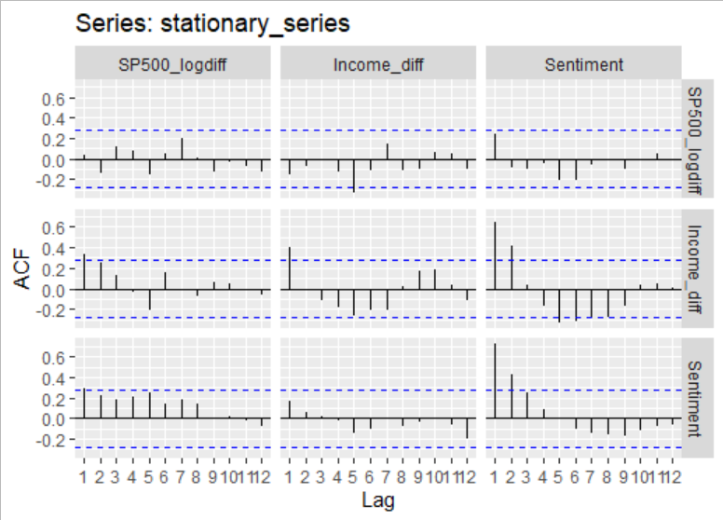

**Figure 11:** Autocorrelation and cross-correlation functions of **X**t up to lag 12.

Clearly, the series exhibit cross-correlation. For example, consumer sentiment is highly correlated with future values of the differenced income series. There also seems to be very slight correlation between consumer sentiment and future log-differenced S&P 500 values. Hence, it is reasonable to assume a multivariate model would leverage this information for better prediction.

Motivated by the univariate analyses, a VAR(1) model is fit to **X**t since in those analyses, the largest model order was 1. A potentially larger VAR model could be considered, since significant cross-correlations beyond lag 1 were observed. However, this would result in a large number of parameters, which when compared to the sample size (*n* = 50), could result in an overparameterized model and estimation issues. Thus, with model parsimony in mind, a VAR(1) should be sufficient. The fitted model is given by **X**t **= X**t-1 where

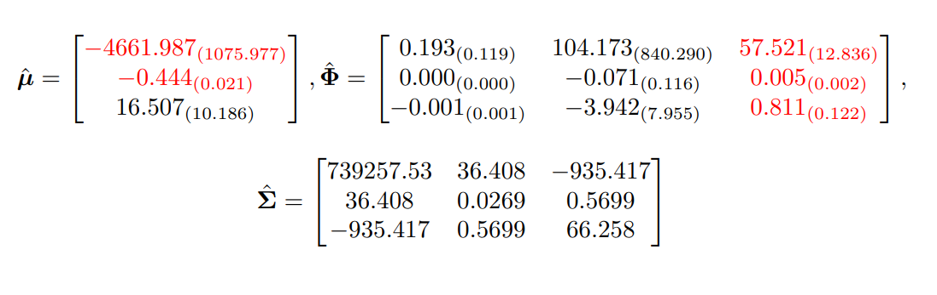

$\hat{Σ}$ is the estimated covariance matrix of the innovations and the elements highlighted in red are statistically significant. Interestingly, when accounting for the other series, the income AR coefficient is no longer statistically significant. Clearly, however, the addition of the consumer sentiment data has added a great deal of information to the system; its own AR coefficient as well as the coefficients that control the relationship between sentiment and the other variables are significant. Hence, consumer sentiment is likely predictive of differenced income and log-differenced S&P 500. Figure 12 displays residual diagnostics for the VAR(1) model.

**Figure 12:** VAR(1) residual diagnostic plots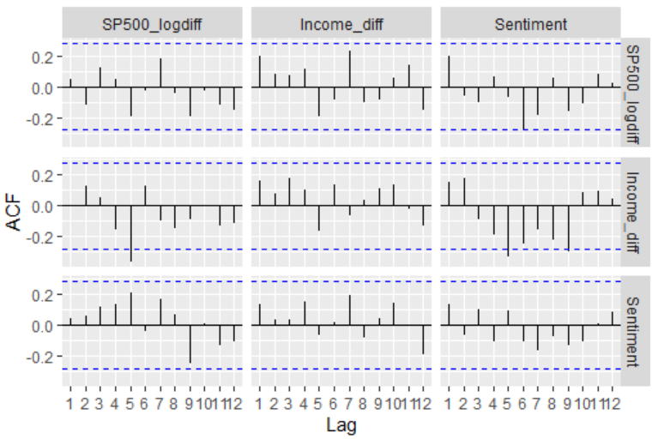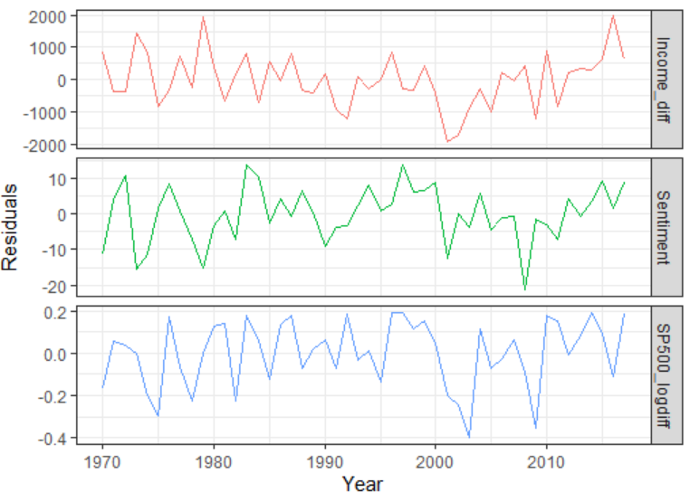

The residuals associated with the VAR(1) model are reasonably white noise; they vary about a mean of zero and do not exhibit any heteroskedasticity. There is some slight correlation between the sentiment and differenced income residuals, but it is minor. With model parsimony in mind, the correlation is likely not worth modeling with the additional cost the extra parameters would incur.

The left-hand panel of Figure 13 displays the predictions and associated 80% prediction intervals for **X**t from the VAR(1) model, which, as expected, all converge to the mean. As before, however, the main interest lies in predictions for the original series. The right-hand panel of figure 13 displays these predictions in black, which were obtained by reversing the transformations. The grey lines represent predictions obtained from the univariate models. It is clear that leveraging information from the other series changes the predictions, and likely makes them more accurate.

**Figure 13:** Predictions of the VAR(1) model, along with prediction for the original series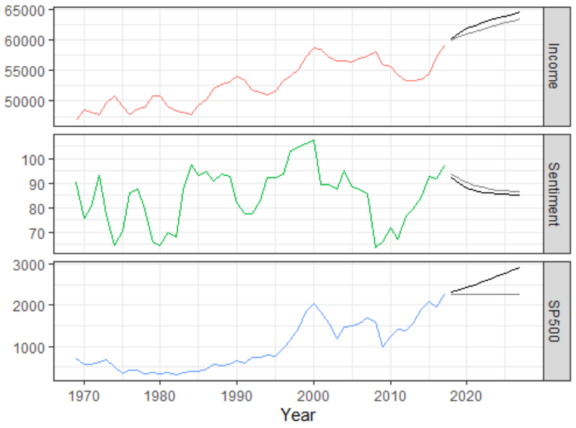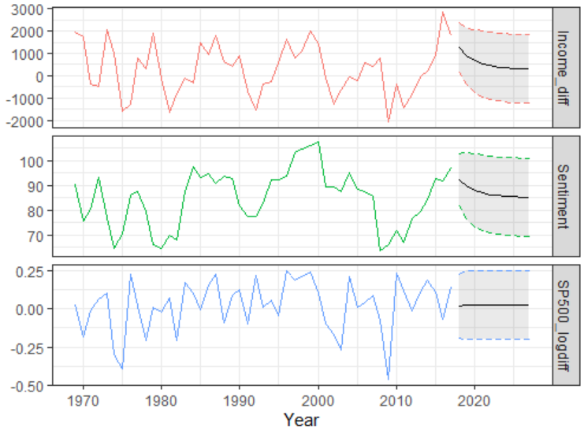

**Conclusion:**

The relationship between consumer sentiment, stock market performance, and population well-being is complex, far more complex than a single analysis can uncover. Initially, it was found that shocks in the stock market were experienced one year later in income, tying the two phenomena together. However, upon introduction of the consumer sentiment data, this relationship became weaker in comparison. It seems that consumer sentiment is the most influential factor when predicting both income and the S&P 500. This is relatively unsurprising; the stock market is known to be speculative, hence if consumers feel that economic conditions are unwell, it is likely that the stock market will fall correspondingly. Additionally, the consumer sentiment index is computed from a survey that asks individuals how they feel about their own economic conditions. If they feel that their economic stability is threatened, it is not beyond the pale to believe that their income has been or will be affected in the near future. The analysis, although elementary, gives interesting insights into how emotionally driven the economy truly is; numbers on a balance sheet do not capture the whole story.

**References:**

Bosworth, B., Hymans, S., & Modigliani, F. (1975). The stock market and the economy. *Brookings Papers on Economic Activity*, *1975*(2), 257-300.

Hong, Y. (1996). Testing for independence between two covariance stationary time series. *Biometrika*, *83*(3), 615-625.

Semega, J. L., Fontenot, K. R., & Kollar, M. A. (2017). Income and poverty in the United States: 2016. *Current Population Reports*, (P60-259).

Shumway, R., & Stoffer, D. (2019). *Time series: A data analysis approach using R*. Chapman and Hall.

Standard & Poor's. (2021, June 10). *S&P 500®*. S&P 500® - S&P Dow Jones Indices. <https://www.spglobal.com/spdji/en/indices/equity/sp-500/#overview>.

University of Michigan. (2020, December 23). Surveys of consumers - survey information. <https://data.sca.isr.umich.edu/survey-info.php>.