

Final Report
School of Computer Science
Faculty of Engineering AND PHYSICAL SCIENCES

Machine Learning Classification Model of Chess Playing Styles trained using Game Data
Matthew Hughes

Submitted in accordance with the requirements for the degree of
MEng, BSc Computer Science

2025/2026

COMP3931 Individual Project

The candidate confirms that the following have been submitted:

Items | Format | Recipient(s) and Date
Final Report | PDF file | Uploaded to Minerva (DD/MM/YY)
Link to online code repository | URL | Sent to supervisor and assessor (DD/MM/YY)

The candidate confirms that the work submitted is their own and the appropriate credit has been given where reference has been made to the work of others.

I understand that failure to attribute material which is obtained from another source may be considered as plagiarism.

Matthew Hughes

© 2026 The University of Leeds and Matthew Hughes

Summary

Acknowledgements
<This page should contain any acknowledgements to those who have assisted with your work. Where you have worked as part of a team, you should, where appropriate, reference to any contribution made by others to the project.>
Note that it is not acceptable to solicit assistance on ‘proof reading’ which is defined as “the systematic checking and identification of errors in spelling, punctuation, grammar and sentence construction, formatting and layout in the text”; see
https:://www.leeds.ac.uk/secretariat/documents/proof_reading_policy.pdf

Table of Contents
Summary iii
Acknowledgements iv
Table of Contents v
Chapter 1 Level 1 Heading with ‘heading 1’ Style 1
1.1 Level 2 Heading with ‘heading 2’ Style 1
1.1.1 Level 3 Heading with ‘heading 3’ Style 1
1.1.1.1 Level 4 Heading with ‘heading 4’ Style Error! Bookmark not defined.
Chapter 2 Tables and Figures 2
2.1 Tables using the ‘table caption’ and ‘table description’ Styles 2
2.2 Figures using the ‘figure caption’ and ‘figure description’ Styles 2
List of References 4
Appendix A Self-appraisal 6
A.1 Level 2 Heading with ‘heading 2’
A.1.1 Level 3 Heading with ‘heading 3’ Style
A.1.1.1 Level 4 Heading with ‘heading 4’ Style
Appendix B External materials 6
B.1 Level 2 Heading with ‘heading 2’ Style

Chapter 1
Introduction
<Recommend using ‘Heading 1’ for chapter titles, ‘Heading 2’ style for section headings, ‘Heading 3’ for subsection headings, and ‘Heading 4’ for sub-subsection headings, but whatever you choose you must be consistent. Don’t forget that text (other than headings) should be 11 point.>

Outline
This project aims to apply machine learning techniques to identify and classify distinct playing styles in chess from historical game data. Chess players exhibit remarkably different approaches to the game - some prefer aggressive attacks and material sacrifices, while others favour patient manoeuvring and solid defensive structures. However, analysing a player's style typically requires manual review of many games by experienced players, making it time-intensive and subjective.
The computer science challenge lies in teaching a computer to recognise these qualitative patterns automatically. Unlike simpler problems such as predicting who will win a game (based on ratings or positions), style classification requires the system to understand how players make decisions, not just whether those decisions are objectively good. The computer must learn to extract meaningful patterns from the complexity of chess where billions of possible positions exist and the "best" move often depends on context rather than fixed rules. This involves designing algorithms that can analyse thousands of games, identify consistent behavioural patterns across different situations, and classify them into distinct style categories, all while handling the challenge that the same player might employ different styles in different games.
The goal is to create a practical tool that allows average chess players to understand their own playing tendencies without needing expert analysis or deep technical knowledge. This project addresses a real-world need by making style analysis accessible, moving beyond existing chess tools that focus primarily on finding the strongest moves rather than understanding human playing patterns.

Chapter 2
Background Research
The challenge of automatically identifying chess playing styles has been approached from several angles in prior research, each with distinct methodologies and limitations.

2.1 Playing Style Classification
Chess players exhibit distinct strategic approaches that extend beyond finding the strongest individual moves. These playing styles represent fundamental differences in how players conceptualise and execute their game plans, reflecting different risk tolerances, positional philosophies, and decision-making preferences.
Aggressive play prioritizes seizing initiative and creating immediate tactical threats, often at the cost of material equality. Players adopting this style actively seek sharp positions with complex tactics, frequently initiating early attacks on the opponent's king. The aggressive approach is characterised by a willingness to sacrifice material for compensation such as development advantages or exposed king positions. From a computational perspective, aggressive play manifests through elevated rates of checks, captures, material sacrifices, and early attacking moves.
Positional play emphasises accumulating long-term strategic advantages through superior pawn structure, piece placement, and space control rather than immediate tactical strikes. This style is characterized by prophylactic thinking, where moves prevent opponent plans while incrementally improving one's position. Positional players favour strategic over material sacrifices and consistently find moves that maintain or improve positional evaluation without creating immediate threats. Notable practitioners include Anatoly Karpov and Tigran Petrosian. Computationally, this style appears through elevated rates of prophylactic moves, positional sacrifices, and best move accuracy.
Defensive play represents a reactive rather than proactive strategic approach, prioritising solid positions and risk minimisation. Players employing this style focus on neutralising opponent threats through simplification, piece trades, and counterattacking from stable positions. When facing pressure, defensive players characteristically trade pieces to reduce attacking potential, retreat from aggressive squares, and make moves that consolidate rather than expand. Computationally, defensive patterns manifest through high rates of simplifications, retreating moves, trades when material down, and passive moves that maintain evaluation without active engagement.

2.2 Previous Clustering and Classification Approaches
Jayasekara (2018) demonstrated that distinct playing styles in chess are computationally differentiable through machine learning techniques. By analysing games from top-level players, the research showed that clustering methods could successfully group games according to playing styles, with classification algorithms including Logistic Regression, Naïve Bayes, and Random Forest achieving accurate mappings between extracted features and predetermined style categories. This work established the feasibility of automated style classification and showed that Random Forest classifiers are particularly effective for this task. However, Jayasekara's approach relied on assumed playing styles for professional players rather than developing a systematic labelling methodology and did not address how such systems could be deployed for average players seeking to understand their own styles.

2.3 Feature Engineering
When applying machine learning to chess style analysis, a fundamental challenge is determining the characteristics in a game are meaningful in relation to playing styles. Feature engineering aims to extract quantifiable attributes from raw game data and will help us in tackling this problem.
Traditional chess engines rely heavily on hand-crafted evaluation functions developed by experts. Silver et al. (2018) noted that "state-of-the-art programs are based on powerful engines that search many millions of positions, leveraging handcrafted domain expertise and sophisticated domain adaptations.” These systems required chess masters to manually encode positional concepts such as centre control, king safety, and pawn structure into explicit, quantifiable features. While effective for engine strength, this approach presents limitations for style classification, as it is applied in the context of objective evaluation over behavioural characterisation. However, despite the different use case, there still exists a subset of features from the ones used in chess engines that can provide playing style insights.

2.4 Feature Design for Style Classification
Research specifically targeting playing style has developed features that characterize decision-making tendencies rather than position quality. A predictive modelling study extracted eight distinct features to differentiate styles among elite players including Magnus Carlsen, Hikaru Nakamura, and Garry Kasparov (Aniketh Kalagara, 2024). These features ranged from game length (distinguishing patient players who prefer lengthy strategic battles from those seeking quick tactical victories) to trade frequency (capturing willingness to simplify positions versus maintaining tension). The research successfully trained models to distinguish between players, establishing that behavioural features could serve as effective style discriminators.
A key difference to observe here is that the mentioned research focuses on a selected five players, all of whom are well-known grandmasters at the very upper echelons of chess skill, while this project uses games from random players to attempt to create a more relatable model.

2.5 Learned Representation
The development of the chess engine AlphaZero marked a paradigm shift away from hand-crafted features toward learned representations. Unlike traditional engines requiring explicit feature engineering, AlphaZero achieved superhuman performance "starting from random play, and given no domain knowledge except the game rules" (Technology Networks, 2018). Through self-play and deep reinforcement learning, it automatically discovered relevant positional concepts without human intervention, eliminating the need for explicit feature design.
Like before, this approach targets optimal play rather than human style characterization. The Maia Chess project from McIlroy-Young et al. (2020) adapted AlphaZero's deep learning architecture specifically for modelling human behaviour, training separate neural networks on games from players at different rating levels. Rather than hand-crafting features, Maia learned representations directly from millions of human games, achieving significantly higher accuracy in predicting human moves than traditional engines. This demonstrated that neural networks could capture subtle behavioural patterns without explicit feature engineering, though at the cost of model interpretability.

2.6 Practical Considerations
For this project we must consider the implications of our approach. If we opt for hand-crafted feature engineering, we gain interpretability since we can identify which behaviour patterns distinguish different playing styles. On the other hand, learned representations with neural networks may provide better accuracy and be able detect more subtle behaviour patterns that are not caught by experts. The downside is that it introduces a ‘black box’ because we are unable to interpret these patterns.
Another consideration we must address is that of computational power. This project will be conducted on limited hardware compared to that of other projects such as the Maia Chess project. What this means is that we could potentially be forced to sacrifice some accuracy to keep the project within a reasonable scope, and the results of certain approaches will yield results that are affected by our constraint of processing power. For example, training the model on games using a chess engine on a higher depth would grant access to a more accurate set of best possible moves but would take a significantly longer amount of time. Even inputting more games into the pre-processing pipeline would give more reliable results but would take longer than this project warrants.

Chapter 3
Methodology
This chapter describes the approach taken to develop a machine learning-based chess playing style classifier that enables the average chess player to understand their general playing style. The methodology addresses the core requirement of creating an accessible tool rather than a complex game analysis system. The approach was structured into five phases, each with defined deliverables aligned to the project objectives established in Chapter 1.

3.1 Overview of Methodology
The project is split into 5 distinct stages of development: data preprocessing, training the Random Forest model, training the Neural Network, model evaluation and comparison, and publication of the resulting tools.
Using a phased approach allows us to efficiently allocate time and resources. It minimises the refactoring of code compared to a non-structured project plan and arranges the development process such that each stage produces a deliverable and addresses an objective of the project.
Stage 1 will focus on the first objective which is to develop and validate a labelled dataset on which the models can be trained. In this stage, we include the design and implementation of domain-specific features to increase model accuracy.
Stages 2, 3, and 3.5 are centred around the development of the three classification models: Random Forest, Feedforward Neural Network, and XGBoost respectively. XGBoost was added as a third model to broaden the comparative analysis with a gradient boosting approach, which operates on fundamentally different ensemble principles to the other two methods. It will utilise the labelled data from the previous stage to produce models capable of classifying a user’s playing style from a game.
Stage 4 consists of evaluating and comparing the two models based on performance metrics such as accuracy, precision, F1 score, etc. Here, we will also look at which model is more suitable for the average player, and which one should be chosen based on different hardware.
Stage 5 looks at delivering the products of all previous stages through an accessible medium that allows users to input a chess game that they have played and receive a chess playing style.
GitHub is the chosen version control tool used throughout the project.
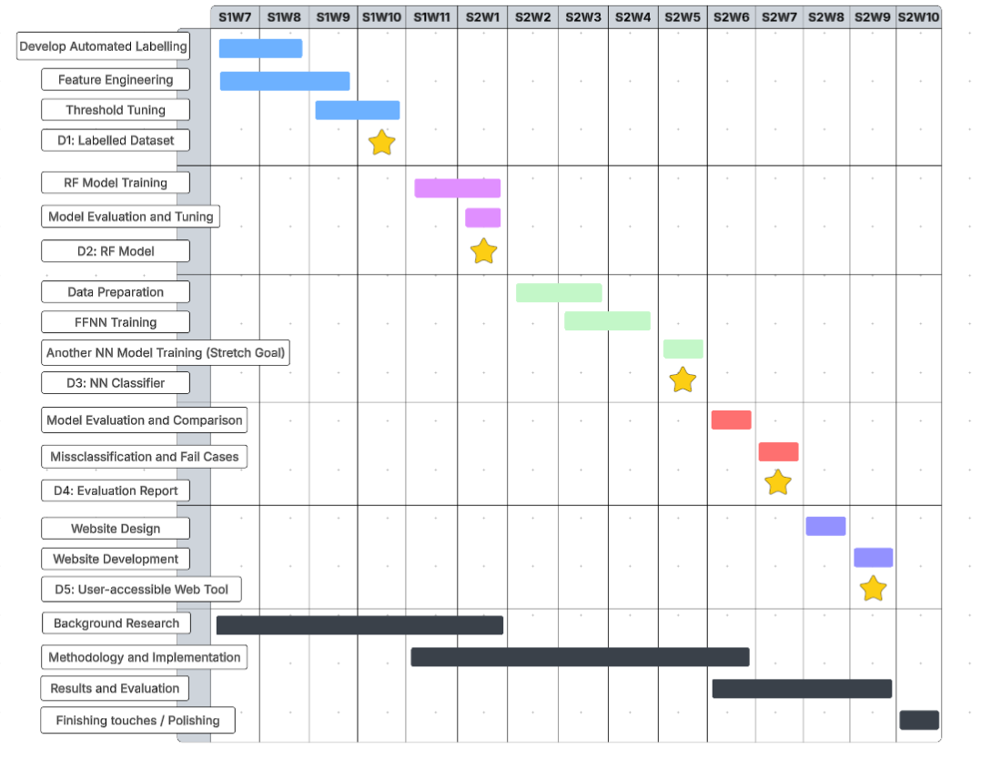

3.2 Project Management
Figure 3.2 A Gantt Chart showing the project plan over two semesters.
This project adopted a milestone-driven development methodology, structured around five deliverables (D1–D5) that correspond directly to the five project objectives. This approach was chosen over a waterfall model because the outputs of each phase directly inform the design decisions of the next; for example, feature engineering from the labelling phase is also used in the training of the Random Forest model. Version control was maintained throughout using Git, with the project repository hosted on GitHub. All source code and processing scripts were committed incrementally, providing a full trail of development decisions and ensuring reproducibility of all results. Figure 3.2 shows the rough estimates of each stage of development.

3.3 Data Collection and Preparation Pipeline

3.3.1 Data Source
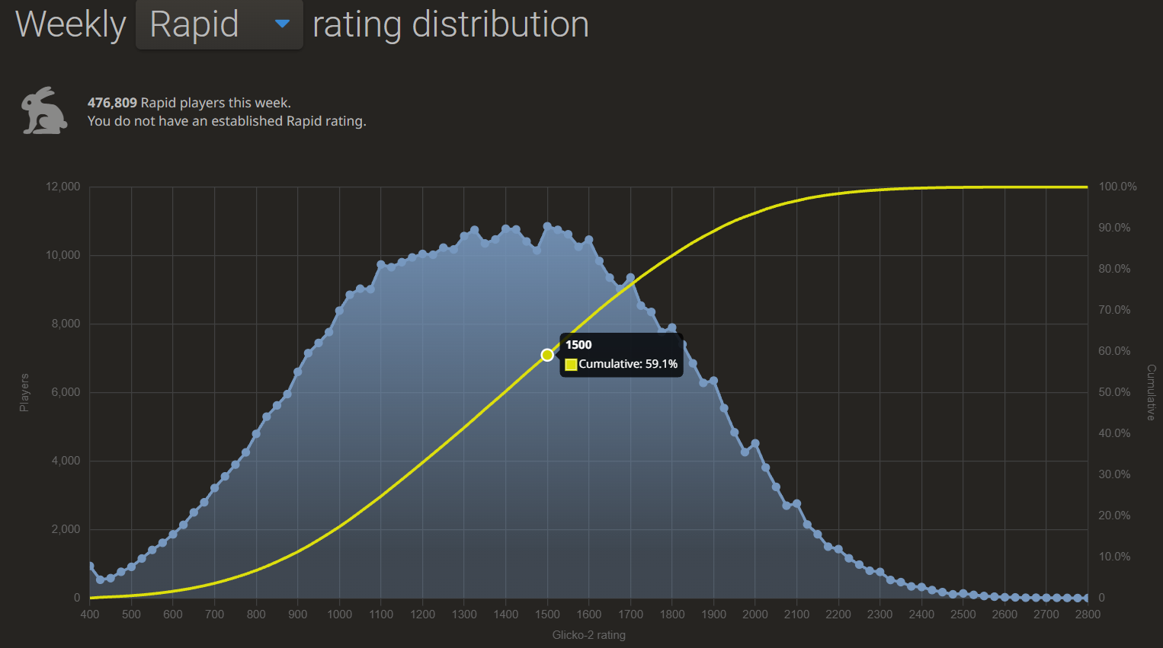
Before anything else, we must prepare and validate data to ensure that it is reliable and usable for training our models. This was chosen as the first phase since it makes it easier during subsequent phases to design models around the data that we have. If we created the training procedure first, we would require data to test its performance anyway, so it makes sense to start with the data preparation.
Figure 3.3.1 A graph showing the weekly rating distribution of the Lichess Open Database from 15th January 2026.
The Lichess Open Database of chess games provides large sets of games from players of all skill ratings from each year. We will be using the move sequence and the skill rating of each player from each game from one of the years, up until a variable maximum of games: we chose 1000 games, which means 2000 labelled items. Another consideration is the skill rating diversity; a minimum rating of 1500 was applied so the script would only label the games of players with that rating or higher. To clarify, games where a player of at least 1500 is against a player of below 1500 would only yield one labelled game. The reason for this minimum rating is that we want to try to eliminate games where players make many blunders or mistakes because these moves would affect the quality of the dataset and are more representative of skill limitation rather than playing styles. We also avoid noise in the dataset, for example a lower-skilled player might make an unintentional prophylactic move, which would otherwise be detected via feature engineering and cause the algorithm to label that player’s style as ‘positional’, when in reality the player did not perform the move with positional play in mind. Lastly, 1500 rating is the top 40.9% of all players on Lichess, as seen in Figure 3.1, so it is a reasonable choice when developing a tool to be used by the average player. Although these statistics are from 2026, the Glicko-2 rating system ensures that the median rating does not deviate significantly from 1500.
Balanced class distribution was established as a design goal. However, achieving perfect balance proved difficult due to the inherently aggressive nature of chess at the 1500+ rating level, where players more frequently make captures and attacks than passive or defensive moves. Threshold tuning was applied iteratively to reduce class imbalance as much as possible while preserving the behavioural validity of each label.

3.3.3 Feature Extraction
We have just mentioned feature engineering, which is vital part of our preprocessing pipeline. For this, we defined 20 distinct features that can be extracted from each game using the help of a chess engine, Stockfish.
Stockfish was selected as the chess engine for position evaluation due to its widespread adoption in chess research and its status as the strongest open-source engine available, ensuring that position evaluations are both reliable and reproducible by other researchers.
Each game was analysed move-by-move and for each position, the engine evaluated the board state before and after the move, enabling identification of move characteristics such as evaluation changes, threats created, and positional improvements. Specific algorithms detected prophylactic play by finding moves that maintained evaluation without creating immediate threats or checks. Defensive patterns were recognized through retreat detection (pieces moving out of attacks) and passive move identification (moves with minimal evaluation change and no aggressive characteristics).
Labels were assigned to each game via rule-based thresholding applied to the extracted feature set, rather than through manual annotation or unsupervised clustering. This approach was chosen for scalability across a large dataset and to ensure that labels reflect consistent, reproducible criteria rather than subjective human judgement.
One feature that was considered but ultimately not used as a metric to classify any playing style was the opening choice. While there is no doubt that certain openings might be indications of the nature of the game about to be played, such as the French defence often leading to a closed game that favours a more positional player, there were some reasons why opening choice is not used as a feature.
Firstly, a player’s choice of opening can be influenced by factors unrelated to their playing style. For example, a player might have chosen the London opening because they saw it online and wanted to try it in an online game or perhaps a friend had recommended the Caro-Kann defence and they wanted to experiment. Secondly, openings may theoretically favour a playing style, but this might not always match the player using it. If a player opts for the French defence, they could end up playing it aggressively instead of positionally by going for unexpected early attacks. Additionally, at lower ratings, there is usually less intention when deciding what opening to use. It is less of a conscious philosophical choice about how they want to play the game and more of a memorisation of moves to get them through the early game.

3.4 Random Forest Classifier
Next, we have the training of the two models: Random Forest and Neural Network. The decision to separate these two into individual phases of development was guided by the characteristics of each approach. The Random Forest model is selected to be trained first because it is a much more interpretable method than the Neural Network, meaning that we are more likely to be able to understand the reasoning behind a classification.
Random Forest was selected as the initial classification model due to its suitability for structured feature data of the kind produced by the Stockfish analysis pipeline. As an ensemble method that aggregates predictions across many decision trees trained on bootstrap samples of the training data, Random Forest is inherently resistant to overfitting and performs well on moderate-sized datasets without requiring extensive hyperparameter optimisation. For this project, the decision to use Random Forest first is also because it produces interpretable feature importance rankings, allowing us to examine which behavioural features contribute most to classification decisions. This interpretability is valuable both for validating that the model is learning meaningful patterns and for informing discussion about which aspects of chess behaviour most strongly distinguish playing styles.

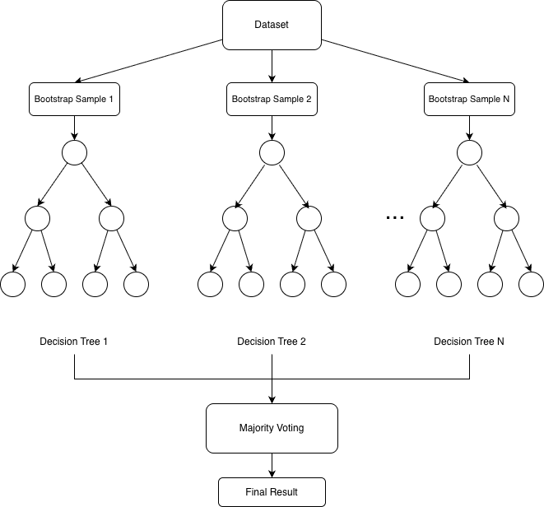
Figure 3.4.1 Architectural overview of the Random Forest classifier, showing how the dataset is used to train N independent decision trees whose outputs are combined via majority voting to produce a final playstyle classification.
The dataset was divided into an 80% training set and 20% test set using stratified sampling to maintain class balance across both partitions. Stratification is particularly important for this problem because the four classes are not perfectly balanced; without it, the minority class (balanced) could be underrepresented in either partition, leading to unreliable evaluation. Although Random Forest does not strictly require feature scaling due to its use of decision boundaries rather than distance-based calculations, Normalisation was applied to maintain consistency with the neural network pipeline and ensure that both models received identically pre-processed input, although Random Forest does not strictly require feature scaling.
Evaluation was conducted using per-class precision, recall, and F1-score in addition to overall accuracy. Per-class metrics were chosen over accuracy alone because in a four-class classification problem, aggregate accuracy can mask poor performance on individual classes. A confusion matrix was also generated to identify specific misclassification patterns between styles. Feature importance rankings were extracted from the trained model to identify which of the behavioural features extracted during the preprocessing stage contribute most to classification decisions.
Upon completion, three artifacts were saved to ensure reproducibility and enable deployment: the trained model serialised using joblib, the fitted StandardScaler for consistent preprocessing of new data, and the ordered list of feature column names to ensure correct input structure. These artifacts enable the web interface to load the trained model and apply identical preprocessing to user-submitted games without retraining.

3.5 Feed-Forward Neural Network
To provide a comparison against the Random Forest baseline, a Feedforward Neural Network (FFNN) was developed as the second classification model. While the Random Forest was selected for its interpretability, a neural network was chosen for its capacity to learn non-linear relationships between features that tree-based models may not capture as effectively. The comparison between these two different approaches is central to the project's evaluation, as it allows us to assess whether a more complex model architecture yields improved classification performance on chess behavioural data.
The same labelled dataset used to train the Random Forest was used for the FFNN, ensuring a fair comparison between the two models. Unlike Random Forest, neural networks are sensitive to the magnitude of input values, so feature normalisation was applied using standardisation, transforming each feature to have zero mean and unit variance. The normalisation parameters were derived exclusively from the training set and then applied to the validation and test sets, preventing any information leakage from the test set.
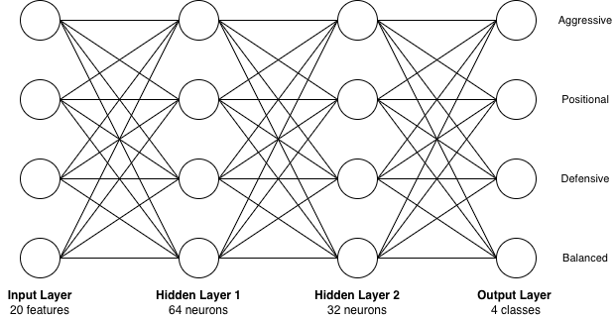
The dataset was divided into three splits: 70% for training, 10% for validation, and 20% for testing, using stratified sampling to maintain class balance across all splits. A fixed random seed was used throughout to ensure reproducibility. The validation split was used during model development to monitor generalisation performance, with the test set reserved solely for final evaluation.

Figure 3.5.1 Architecture of the feedforward neural network, showing the input layer (20 features), two fully connected hidden layers with ReLU activation and Dropout regularisation (rate 0.3), and the output layer producing a probability distribution over the four playstyle classes.
A fully connected feedforward architecture with two hidden layers was designed for this task. The input layer accepts the feature vector for each game, followed by two hidden layers with progressively smaller sizes. ReLU was chosen as the activation function for the hidden layers since it is the standard default activation function in modern neural networks and due to its computational efficiency. The output layer consists of 4 neurons corresponding to the four playstyle classes. Dropout regularisation was applied after each hidden layer to reduce overfitting, which is a particular concern given the relatively small size of the dataset.
Cross-entropy loss was used as the objective function, which is standard for multi-class classification tasks. The Adam (Adaptive Moment Estimation) optimiser was selected for its adaptive learning rate behaviour, which generally converges faster than standard stochastic gradient descent (SGD) on small tabular datasets. Early stopping was implemented to halt training if validation accuracy showed no improvement over a defined number of consecutive epochs, with the model weights corresponding to the best validation accuracy preserved and restored at the end of training. This ensures the final model reflects peak generalisation performance rather than the state at the last epoch.
The trained model was evaluated on the held-out test set using the same metrics as the Random Forest (overall accuracy, per-class precision, recall, and F1-score) to enable direct comparison between the two approaches. A confusion matrix was also produced to identify which playstyle classes were most frequently misclassified. These results are discussed in the evaluation chapter alongside the Random Forest results.
The FFNN was implemented using PyTorch rather than scikit-learn due to the greater flexibility it provides in defining custom architectures, loss functions, and training procedures. The architecture consists of an input layer accepting all features produced by the Stockfish analysis pipeline (the same feature set used by the Random Forest), two fully connected hidden layers with 64 and 32 neurons respectively, and an output layer with 4 neurons corresponding to the four playstyle classes. ReLU activation functions were applied after each hidden layer to introduce non-linearity, and dropout regularisation at a rate of 0.3 was applied after each hidden layer to reduce overfitting during training.
StandardScaler normalisation was applied to transform all features to zero mean and unit variance, with the scaler fitted exclusively on the training data and then applied to the validation and test sets to prevent data leakage. The data was split into three partitions: 70% for training, 10% for validation, and 20% for testing, all using stratified sampling to preserve class proportions. This differs from the Random Forest's two-way split because the FFNN requires a separate validation set for monitoring generalisation during training and for early stopping decisions.
Training used the Adam optimiser with a learning rate of 0.001 and cross-entropy loss, which is the standard loss function for multi-class classification tasks. Data was processed in batches of 32 samples, with the training set shuffled at each epoch to prevent the model from learning ordering patterns. An early stopping mechanism with a patience of 15 epochs was implemented to halt training if validation accuracy ceased to improve, preventing unnecessary computation and overfitting. The maximum number of training epochs was set to 100, though early stopping typically terminated training before this limit was reached.

3.6 Extreme Gradient Boosting Classifier
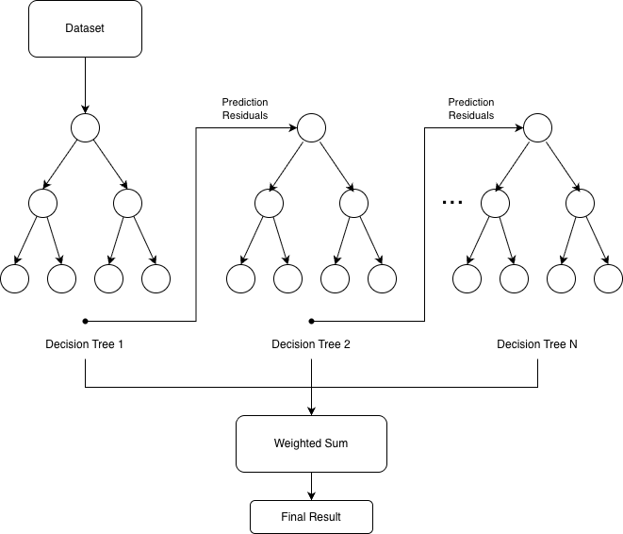
To further broaden the comparative analysis, an XGBoost (Extreme Gradient Boosting) classifier was implemented as a third model alongside the Random Forest and FFNN. Unlike Random Forest, which builds trees independently in parallel, XGBoost is a gradient boosting method that constructs trees sequentially, with each tree trained to correct the residual errors of the previous ones. The objective function combines a standard classification loss with a regularisation term that penalises model complexity, which helps control overfitting without relying solely on depth constraints or early stopping. XGBoost was selected because it represents a fundamentally different ensemble strategy to Random Forest while still operating on the same tabular feature data, making it a meaningful addition to the comparative analysis.

Figure 3.6.1 Architectural overview of the XGBoost classifier, showing how each decision tree is trained sequentially on the residual errors of the previous tree, with outputs combined via weighted sum to produce a final playstyle classification.

Figure 3.3.4 illustrates this sequential construction process, in which each tree is trained on the residual errors produced by the preceding tree, with all tree outputs combined via weighted sum to produce the final classification.
The same labelled dataset and feature set used for the Random Forest and FFNN were used to train the XGBoost model, ensuring that all three models receive identical input and can be evaluated on a consistent basis. The dataset was divided into an 80% training set and 20% test set using stratified sampling to preserve class balance across both partitions, consistent with the Random Forest split. Normalisation was applied for consistency with the other models, although gradient boosting methods are not sensitive to feature scaling in the same way neural networks are.
The configuration used 200 estimators, a maximum tree depth of 6, a learning rate of 0.1, and subsampling rates of 0.8 for both instances and features per tree. These values were selected as a reasonable starting configuration based on common practice for tabular classification tasks rather than through systematic hyperparameter search.
Evaluation was conducted using the same metrics as the other two models - overall accuracy, per-class precision, recall, and F1-score - alongside a confusion matrix to identify misclassification patterns between playstyle classes. Feature importance scores were also extracted to compare which behavioural features XGBoost weighted most heavily against those identified by the Random Forest. These results are discussed in the evaluation chapter alongside those of the Random Forest and FFNN.

The model was implemented using scikit-learn's RandomForestClassifier with 100 estimators, unlimited tree depth, and otherwise default parameters, which were found to produce strong classification performance without the need for extensive hyperparameter tuning. A fixed random seed of 42 was used throughout to ensure reproducibility. All available CPU cores were utilised during training via the n_jobs parameter to minimise computation time.

2.1 Table example
Heading One | Heading Two | Heading Three
1.1 | 1.2 | 1.3
1.21 | 1.22 | 12.3
12.31 | 12.32 | 12.33
Text before table. Text before table. Text before table. Text before table. Text before table. Text before table. Text before table. Text before table. Text before table. Text before table.

Table 2.1 This is the table description in the ‘table description’ style.

2.2 Figure example
Figures can be added using the Illustrations section of the Insert tab.
Figure 2.1 This is the figure description in the ‘figure description’ style.

Chapter 4
Implementation and Validation
This chapter describes the construction and validation of the three core system components developed to address the project objectives: the automated dataset labelling pipeline, the Random Forest classifier, and the two comparative models - a feedforward neural network and an XGBoost classifier. Each component was implemented iteratively, with validation conducted at each stage to confirm correct behaviour before proceeding. The chapter documents the key design decisions made during implementation, the challenges encountered and how they were resolved, and the testing performed to establish confidence in each deliverable.

4.1 Dataset Construction and Labelling Pipeline
The first phase produced the labelled dataset on which all three models are trained. The pipeline is implemented across two modules - chess_analyzer.py and processing.py - handling game analysis and batch processing respectively.
4.1.1 Engine Configuration and Feature Extraction
The ChessGameAnalyzer class wraps Stockfish, configured with a 4096MB hash table and 8 processing threads to maximise cache reuse and reduce per-game processing time. Analysis was performed at depth 18, which provides reliable positional evaluation while remaining computationally tractable given the hardware constraints discussed in Section 2.6. A shallower depth would introduce noise into centipawn loss calculations; deeper analysis was not practical at the volume required.
For each player's turn, the engine evaluates the position before and after the move is played. The difference gives the centipawn loss for that move, accumulated and averaged across the game. The engine's principal variation before each move is also retrieved to determine whether the player found the top engine choice, contributing to the best_moves_found count. Mate scores are mapped to ±10,000 centipawns to prevent undefined behaviour during arithmetic.
Twenty features are extracted per player per game across five categories: aggression (checks_given, captures_made, material_sacrifices, early_attacks, king_safety_risks), positional (prophylactic_moves, positional_sacrifices), defensive (simplifications, defensive_moves, counterattacks, retreat_moves, trades_when_losing, passive_moves), tactical (avg_centipawn_loss, best_moves_found, tactical_shots, blunders), and general (complex_positions). Each feature operationalises a behavioural concept described in Section 2.1; for example, a material sacrifice is recorded when a higher-value piece captures a lower-value piece, yet evaluation does not deteriorate beyond 50 centipawns, and a prophylactic move is recorded when a quiet move produces a small positive evaluation shift without constituting a direct threat.
4.1.2 Labelling and Threshold Calibration
The PlaystyleLabeler assigns one of four labels - aggressive, positional, defensive, or balanced - using a scoring mechanism rather than independent hard thresholds. Each feature ratio is compared against a calibrated threshold, with matching features contributing a point score to the corresponding style's total. The style with the highest score is assigned, provided it reaches a minimum of 2.0; games where no style exceeds this floor are labelled balanced. Centipawn loss thresholds are adjusted dynamically by Elo rating to avoid conflating high accuracy with positional style in stronger players.
Arriving at the final thresholds required iterative calibration. Initial values produced severe class imbalance - approximately 53% aggressive and 3.5% defensive - because aggression thresholds were insufficiently discriminating and the defensive feature set lacked the retreat_moves, trades_when_losing, and passive_moves indicators. Both issues were addressed: the three defensive features were added, and aggression thresholds were raised to require a stronger behavioural signal. The pipeline was re-run after each adjustment until the distribution stabilised across all four classes without any single class dominating.
4.1.3 Batch Processing and Validation
BatchGameProcessor applies the pipeline at scale, filtering out games where either player falls below the 1500 Elo minimum or the game is shorter than 20 moves, as very short games do not yield meaningful behavioural ratios. Results are saved at configurable intervals to guard against data loss during long runs.
Validation was conducted by inspecting labels for a sample of games from players with known stylistic tendencies, confirming that aggressive, positional, and defensive games received appropriate labels. Feature distributions within each class were also examined to confirm that they separated in expected directions, for instance, that the aggressive class exhibited a higher mean captures-per-move than the positional class, providing confidence that the labeller captured genuine behavioural differences.

Chapter 5
Results, Evaluation and Discussion
<Results, evaluation (including user evaluation) etc. should be described in one or more chapters. See the `Results and Evaluation' criterion in the mark scheme for the sorts of material that may be included here.
Outcomes of your project. Discussion of the aim and context of your project and what you achieved in that regard. Everything that comes under the `Results and Discussion' criterion in the mark scheme that has not been addressed in an earlier chapter should be included in this final chapter. The following section headings are suggestions only.>

5.1 Evaluation
<Text in 11-point size and 1.5 line spacing.>

5.2 Conclusions
<Text in 11-point size and 1.5 line spacing.>

5.3 Future work
<Text in 11-point size and 1.5 line spacing.>

List of References
<It is expected that the list would reflect the breadth and depth of scholarly research undertaken by the student during the course of the project
The format of referencing is nor prescribed, but you must use one style appropriately and consistently>

Appendix A
Self-appraisal
<This appendix must contain everything covered under the ’self-appraisal’ criterion in the mark scheme. Although there is no length limit for this section, 2-4 pages will normally be suﬃcient. The format of this section is not prescribed, but you may like to consider the following sections and subsections.>

A.1 Critical self-evaluation

A.2 Personal reﬂection and lessons learned

A.3 Legal, social, ethical and professional issues
<Refer to each of these issues in turn. If one or more is not relevant to your project, you should still explain why you think it was not relevant.>

A.3.1 Legal issues
<Discussion of legal issues>

A.3.2 Social issues

<Discussion of social issues>

A.3.3 Ethical issues

<Discussion of ethical issues>

A.3.4 Professional issues
<Discussion of professional Issues>

Appendix B
External Materials
<This appendix should provide a brief record of materials used in the solution that are not the student's own work. Such materials might be pieces of codes made available from a research group/company or from the internet, datasets prepared by external users or any preliminary materials/drafts/notes provided by a supervisor. It should be clear what was used as ready-made components and what was developed as part of the project. This appendix should be included even if no external materials were used, in which case a statement to that effect is all that is required.>

