Jacob Keogh N9216111 Portfolio

Testing:

Selenium was used to create a testing suite for all of the criteria except for uploading, which I haven’t been able to automate.

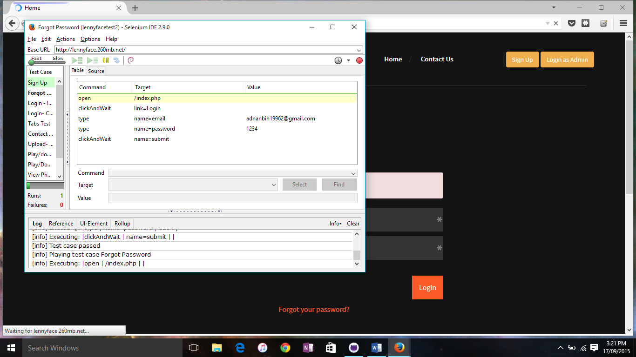

* Signing up a new user
  + Rejected if the email is already used
  + Rejected if the email is invalid
* Logging in
  + Only works with valid email and password
* Forgot password feature
* Contact Us
  + When you’re logged in as well as when you’re not
* Viewing and downloading the media files (ebook hasn’t been added to testing yet)
* Browsing through every tab
* Logging out

Everything tested so far has been functional

I also worked on the front end of the system, which is currently using a template for the UI. An original UI made with Bootstrap will be added in release 2, as it was not seen as a priority in the early stages. The template was used to keep the website functional and appealing through all stages of development.