CIT 140 | SYSTEMS ANALYSIS PORTFOLIO

Analyst Portfolio Review
Weeks 1 to 7: Meridian Forge and Cedar Junction

Prepared by | Matthew Le
Course | CIT 140, San Bernardino Valley College
Instructor | Dr. Malik Stalbert
Review date | November 4, 2026
Version | 1.0 (Week 8 portfolio review)
Prepared for | Client review request W08-B01

Complete originals: github.com/mattyle19782020-netizen/CIT140-Portfolio
All case names, people and records in this packet are fictional teaching material. This review explains completed analysis. It does not authorize spending, operating equipment, or any operational change.

Client Overview
This packet gives you one place to understand the analysis completed over seven weeks: what each piece of work examined, what the evidence actually shows, why it matters to you, and what is still unknown. Each section shows a readable excerpt or diagram from the original and points to the complete file in the project repository.

Two separate cases
The same analysis methods were applied to two unrelated organizations. They are kept apart throughout, and a finding in one case says nothing about the other.
Case | Weeks | What was examined
Meridian Forge Robotics | Weeks 1, 2, 3, 7 | A robotics manufacturer. A retired test reached robot MR-17 in a QA cell (Weeks 1 to 3). Later, a set of machine inspection records was checked for data quality (Week 7).
Cedar Junction | Weeks 4, 5, 6 | A city setting. A clinic appointment process where booking and readiness drift apart (Weeks 4 and 5), and a routing system for drone inspection reports that sends some reports to the wrong department (Week 6).

How to read each section
Every weekly section answers the same four questions in plain language: what I examined, what the evidence shows, why it matters to you, and what remains uncertain along with the next check. Source records are named by their case ID (for example, W05-S01). Anything that is my proposal rather than established evidence is labeled as a proposal.

What this packet is not
It is not a new design, a prototype, or a full requirements specification. It does not claim any proposal was approved, any test was run, or any missing record was found unless the evidence says so. Known gaps in the original work are listed in the Closing Review and in the Evidence List rather than hidden.

Contents
Each section names its case and artifact. The complete original files stay in their weekly repository folders; their locations are in the Evidence List.
Week | Section | Case | Page
 | Client Overview |  | 2
Week 1 | Problem Brief: why did a retired test reach MR-17? | Meridian Forge | 4
Week 2 | Business Case Recommendation: is the review worth doing? | Meridian Forge | 5
Week 3 | Stakeholder Map: whose knowledge and authority are needed? | Meridian Forge | 7
Week 4 | Validated Requirements Set: what must the system do? | Cedar Junction | 9
Week 5 | As-Is Process Model: how does the work run today? | Cedar Junction | 11
Week 6 | Data-Flow Model: where does the information go? | Cedar Junction | 13
Week 7 | Data-Quality Report: can the records be trusted? | Meridian Forge | 16
 | Response to Client Brief W08-B01 | Meridian Forge | 18
 | Closing Review | Both | 19
 | Evidence List and Inventory Status | Both | 20

Week 1: Problem Brief
Case: Meridian Forge Robotics Artifact: Problem Brief (PDF, 6 pages)
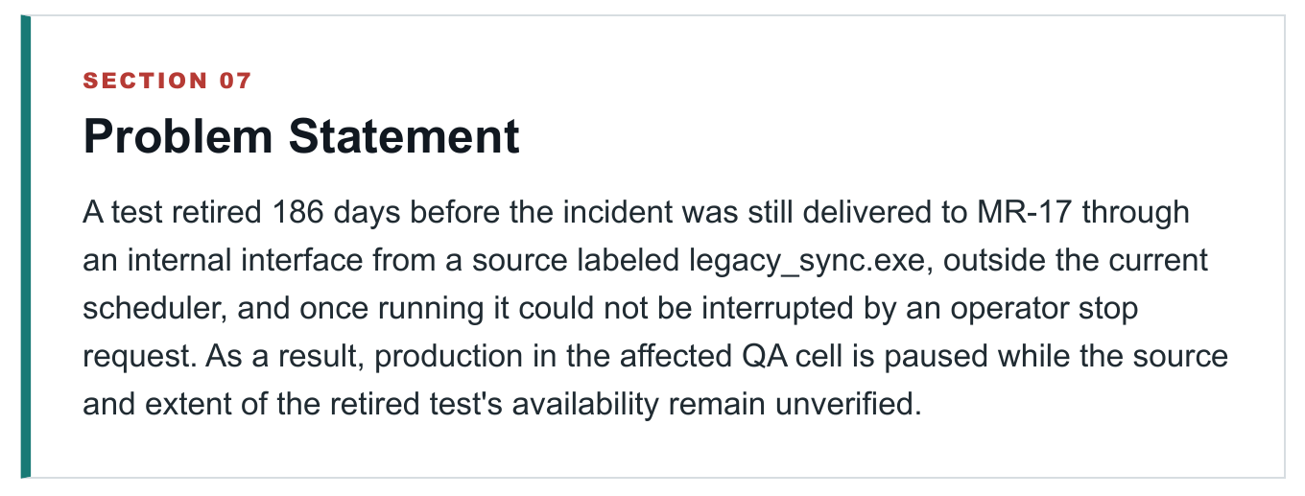
Figure 1. Problem Statement, Section 07 of the Week 1 Problem Brief. Full original: Week01_Something_Isnt_Adding_Up/artifact/Le_Matthew_CIT140_Week01_Problem_Brief.pdf

Explanation for the client
What I examined. Why robot MR-17 started running Test K-44, a test that had been retired, and why an operator could not stop it.
What the evidence shows. The incident log records MR-17 accepting TEST_K44_START at 02:13:07 and answering an operator stop request at 02:14:02 with ACTIVE_INSTRUCTION_PENDING, so the test kept running. The maintenance archive shows K-44 was retired 186 days earlier, and the current scheduler has no assignment for it. The command telemetry labels the source of the command legacy_sync.exe.
Why it matters to you. A test the company believed was gone still reached a robot through a route outside the scheduler, and once it started, the normal stop did not work. Production in the affected QA cell is paused until that route is understood.
What remains uncertain, and the next check. A source label is not a cause. Nobody has confirmed who owns legacy_sync.exe, why it is still running, or whether other copies of K-44 exist elsewhere. The next check is the service records for legacy_sync.exe alongside MR-17's full software history, which has not been reviewed.
Sources. Incident log (Nia Voss, Night QA Supervisor); maintenance archive; command telemetry (Elias Chen, Robotics Systems Engineer); current scheduling console.
Term. legacy_sync.exe is the name of an internal service that appears in the command record. Its owner and purpose are unverified. The brief defines the problem only and does not recommend a fix.

Week 2: Business Case Recommendation
Case: Meridian Forge Robotics Artifact: Business Case Recommendation (PDF, 5 pages)
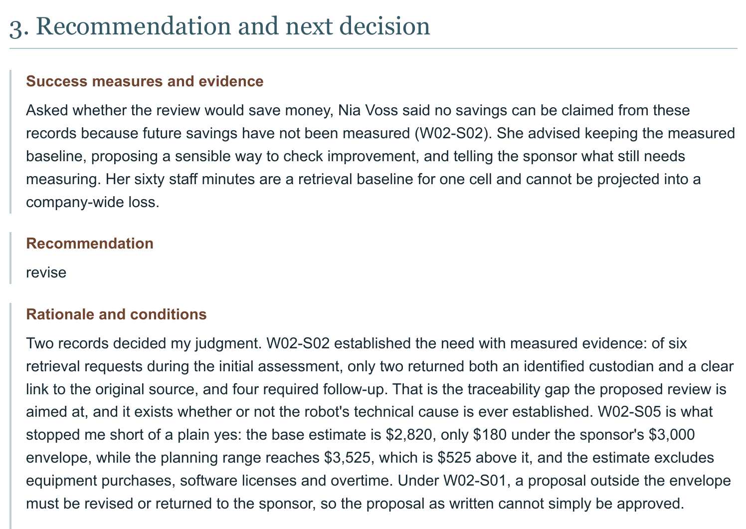
Figure 2. Recommendation and rationale, Section 3 of the Week 2 Business Case. Full original: Week02_Is_This_Project_Worth_Doing/artifact/Le_Matthew_CIT140_Week02_Business_Case.pdf

Explanation for the client
What I examined. Whether a bounded QA Control Review of the affected cell is worth doing, and within what budget, schedule and access limits.
What the evidence shows. Of six record requests during the initial assessment, only two came back with both a named custodian and a clear link to the original source; four needed follow-up (W02-S02). The base estimate is $2,820 against the sponsor's $3,000 planning envelope, but the planning range reaches $3,525, and the estimate leaves out equipment, licenses and overtime (W02-S05).
Why it matters to you. The traceability problem is real and measured, but the plan only fits its budget and its ten-day limit if every assumption holds, including read-only export access that has been requested and not confirmed (W02-S04).
Proposal, not approved. My recommendation was to revise: cap the work at 48 staff hours and $2,820 and confirm export access before starting. It is a recommendation to the sponsor, not an authorization. No savings were measured, so none are claimed.
What remains uncertain, and the next check. Whether export access will be granted and when. Elias Chen should confirm the access date, and Mara Ilyan should have the excluded costs priced or ruled out in writing.
Sources. W02-S01 to W02-S05: sponsor request, retrieval workload, scope, capacity and access limits, and the estimate sheet.
Known gap. Two fields in the submitted original end mid-sentence: condition 2 under Rationale and the final sentence of the Next step. The saved JSON shows the same truncation, so the original was submitted that way. It is left unaltered and listed in the Closing Review.

Week 3: Stakeholder Map
Case: Meridian Forge Robotics Artifact: Stakeholder Map (PDF, 5 pages) and Book Form (PDF, 1 page)
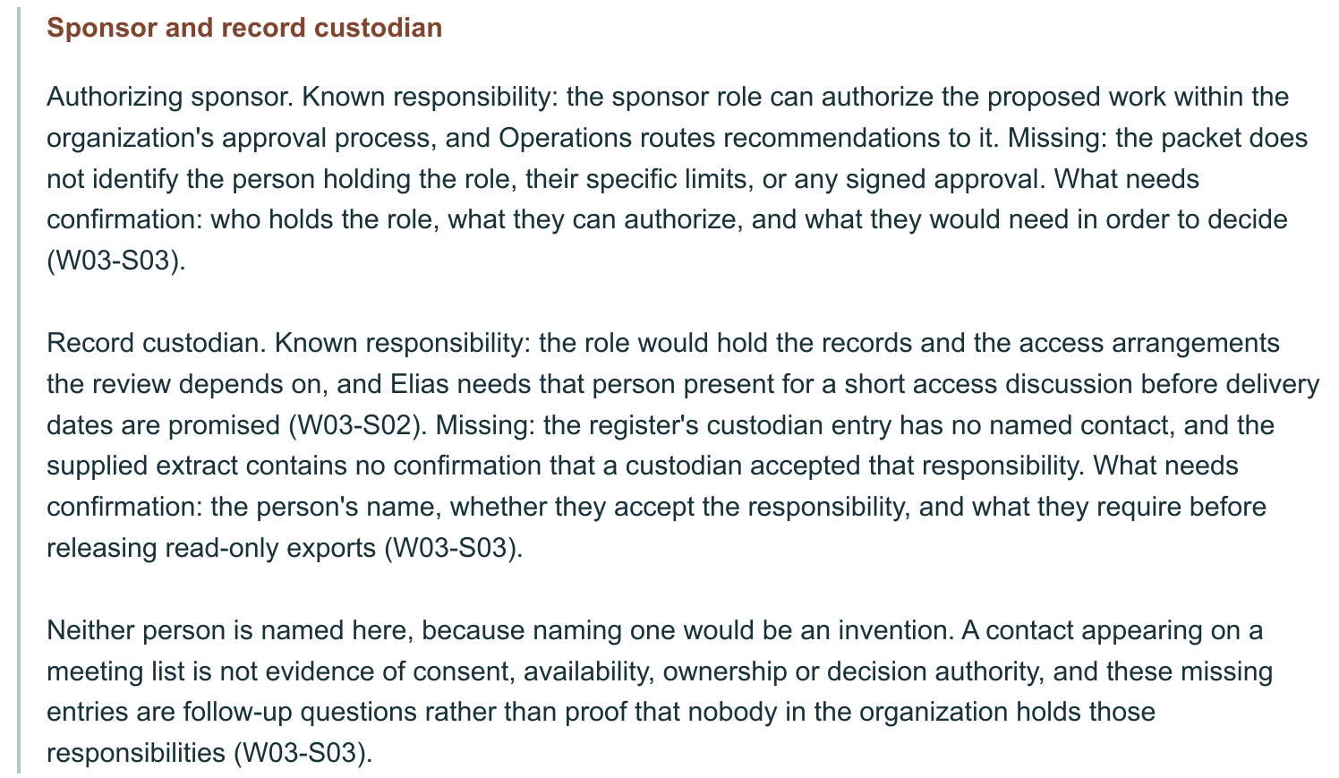
Figure 3. Sponsor and record custodian, Section 1 of the Week 3 Stakeholder Map. Full original: Week03_Who_Has_A_Stake/artifact/Le_Matthew_CIT140_Week03_Stakeholder_Map.pdf

Explanation for the client
What I examined. Who is affected by the proposed review, and whose knowledge or authority is needed before it can go ahead.
What the evidence shows. Engineering (Elias Chen) can interpret the records but cannot approve spending, and Operations (Mara Ilyan) can convene people and route a recommendation but is not the approver (W03-S02, W03-S04). The participation register lists a sponsor role and a record custodian role but names neither person and records no acceptance (W03-S03). The night-shift operators who run the cell have not been interviewed (W03-S01).
Why it matters to you. The review depends on two people nobody has identified: the one who can authorize it and the one who can release the records. Planning around unnamed roles risks scheduling work that no one has the authority to start.
Proposal, not agreed. Keep a daytime session for Operations, Engineering and QA, and add a short interview with a night-shift operator. Neither Mara nor Nia has agreed to this, and no operator has been selected.
What remains uncertain, and the next check. Operations names the record custodian and the sponsor and confirms what each can approve, and Nia Voss helps identify an operator willing to take part. A name on a meeting list would not count as either confirmation.
Sources. W03-S01 to W03-S04: QA and Engineering participation notes, the participation and authority register, and the Operations consultation request. The Book Form (Attention First, prompts 32 and 33) shaped the interview questions.
Term. A record custodian is the person responsible for holding records and granting access to them.

Week 4: Validated Requirements Set
Case: Cedar Junction Artifact: Validated Requirements Set (PDF, 9 pages)
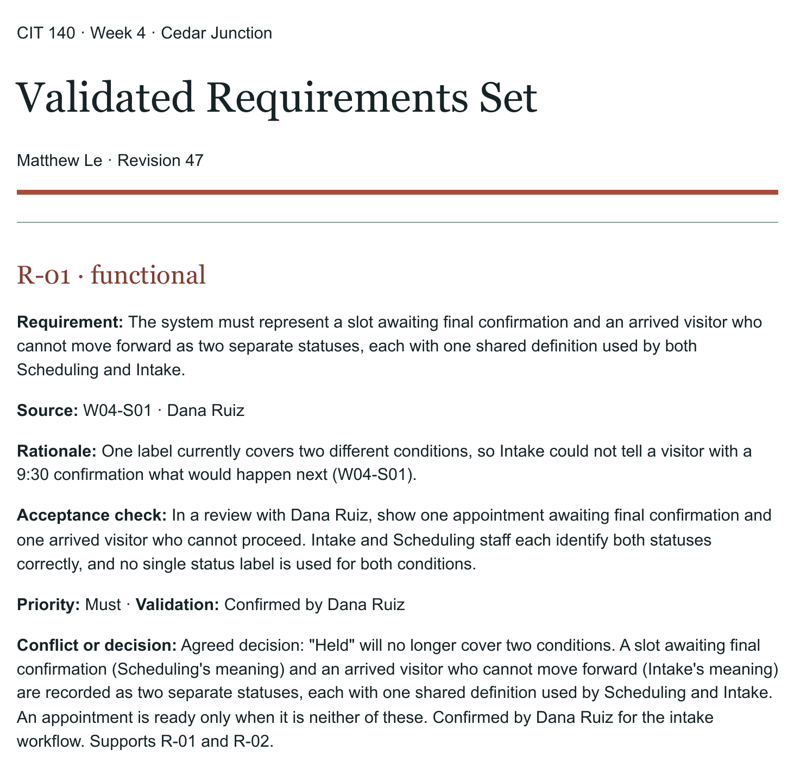
Figure 4. Requirement R-01, page 1 of the Week 4 Validated Requirements Set. Full original: Week04/CIT140-Week04-Validated-Requirements.pdf

Explanation for the client
What I examined. What the clinic appointment system must do, and how someone could check each need was met.
What the evidence shows. Eight requirements, each confirmed by the stakeholder who owns it and each with an acceptance check. For example, Scheduling and Intake were both using the word "Held" for two different conditions: a slot still awaiting confirmation, and a visitor who has arrived but cannot move forward. R-01 separates them into two statuses (W04-S01, confirmed by Dana Ruiz). R-03 allows a same-day slot to be offered only when a room and a qualified clinician are both confirmed, not just because the calendar is open (W04-S02, confirmed by Dr. Lena Okafor).
Why it matters to you. Each requirement can be tested before anything is built, and every one traces back to the person who confirmed it, so a future design can be checked against something agreed rather than something assumed.
What remains uncertain, and the next check. These are confirmed needs, not a design. No screen, status label or product has been chosen. The next check is running each acceptance check with its owner once a design exists.
Sources. W04-S01 (Dana Ruiz, Intake), W04-S02 (Dr. Lena Okafor, Clinical Operations), W04-S03 (Priya Shah, access and communication), W04-S04 (Jordan Kim, access and audit).
Term. An acceptance check is the test that shows whether a requirement has been met.

Week 5: As-Is Process Model
Case: Cedar Junction Artifact: Current-process swimlane model (.drawio and 2-page PDF)
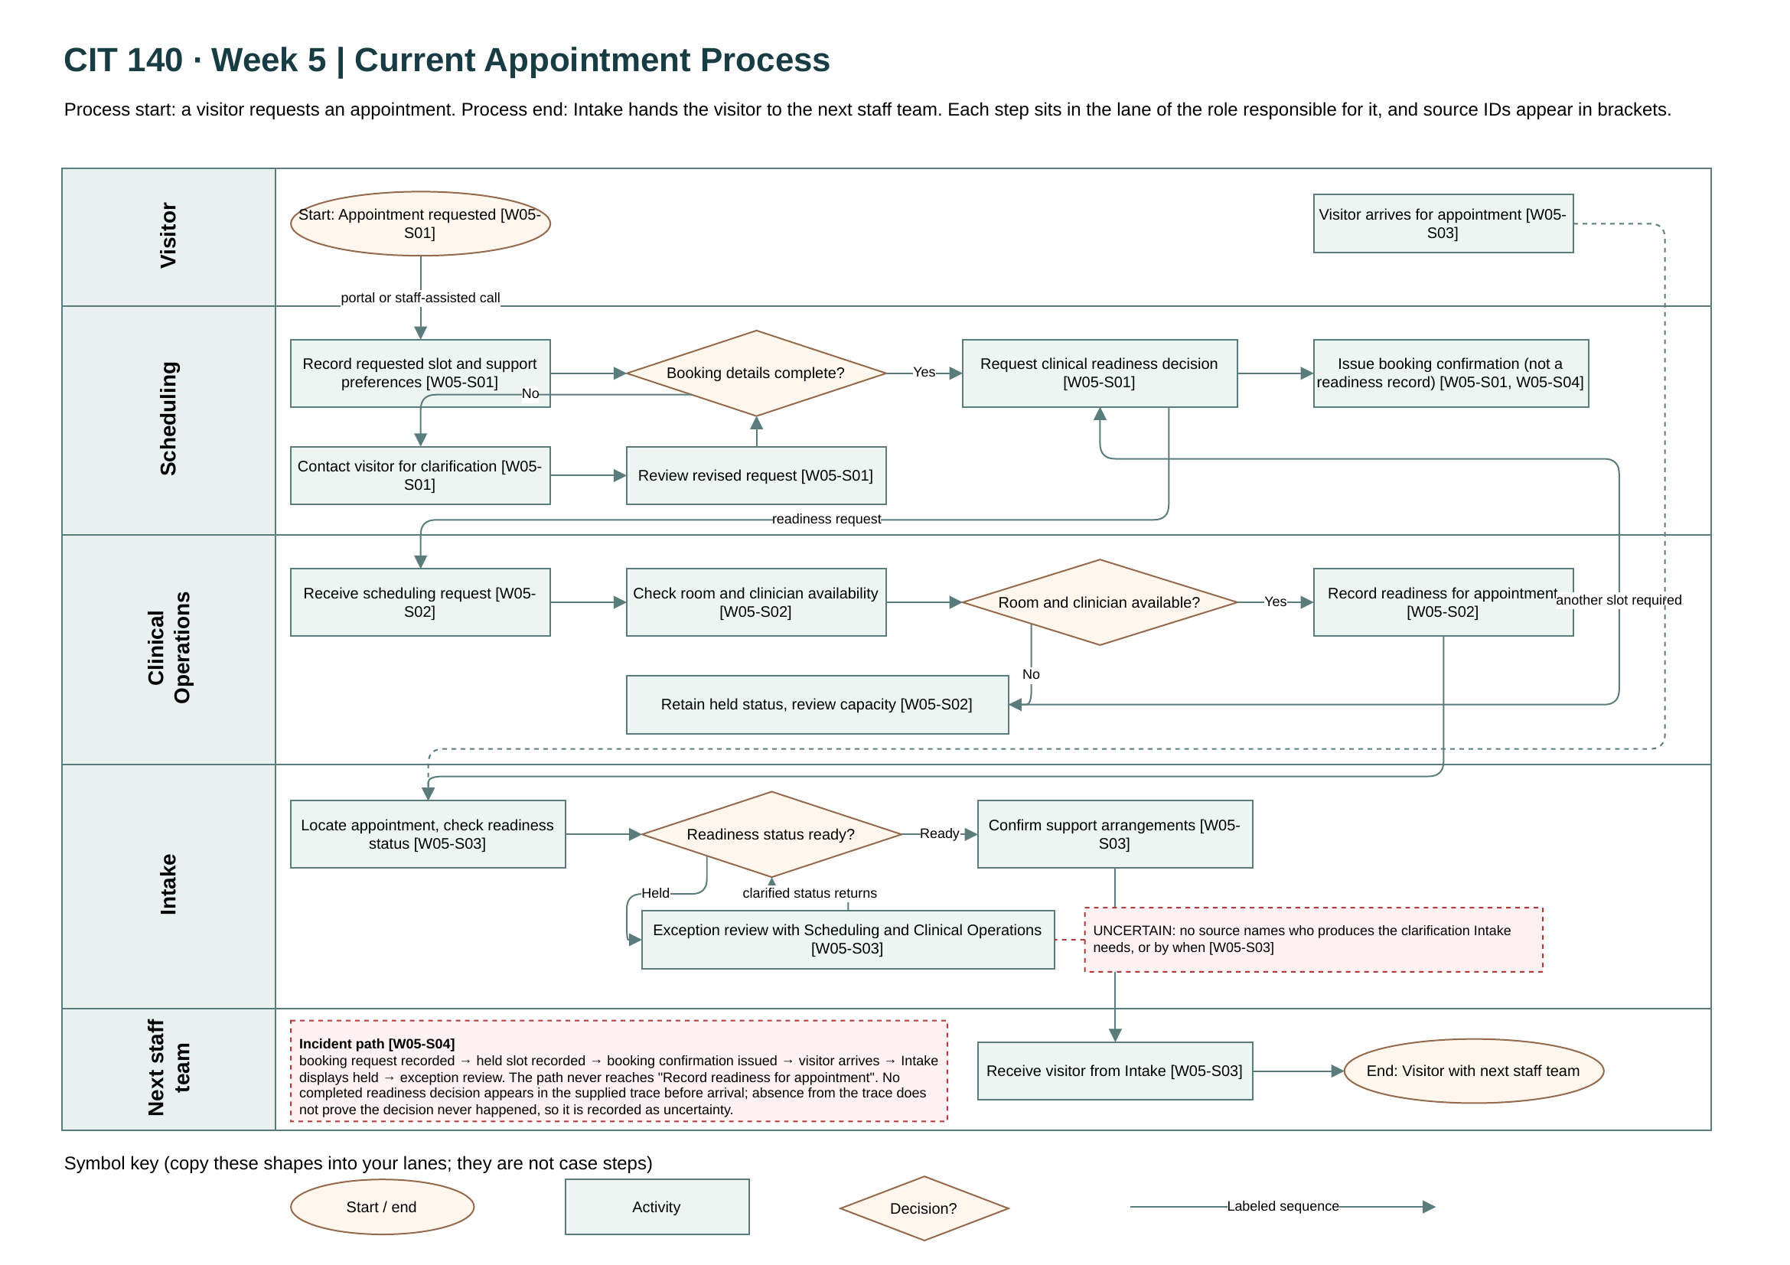
Figure 5. Current appointment process, page 1 of the Week 5 model. Full original: Week05/Artifact/Le_Matthew_CIT140_Week05_As_Is_Process_Model.pdf

Week 5 explanation for the client (Cedar Junction)
What I examined. How the clinic's appointment work runs today, from a visitor's request to Intake handing the visitor to the next staff team, and where it stalls.
What the evidence shows. The booking confirmation and the clinical readiness decision are two separate records (W05-S01), so a visitor can hold a confirmation while the slot is still held. In the incident trace, the path goes from booking confirmation to the visitor arriving and Intake opening an exception review, without ever reaching "Record readiness for appointment" (W05-S04).
Why it matters to you. A visitor sees a confirmed appointment while staff see one that is not ready. When Intake opens an exception review, no source names who must produce the clarification or how quickly (W05-S03), so the visitor waits on a step nobody owns.
What remains uncertain, and the next check. The trace shows no readiness decision before arrival, but absence from a trace does not prove the decision never happened. No stakeholder has reviewed this model. The next check is the full appointment record and the owner of the readiness record in Clinical Operations.
Correction made during the work. I first drew the booking confirmation and the readiness decision as one step, then split them after checking W05-S01. That split is what makes the incident path visible.
Sources. W05-S01 Scheduling, W05-S02 Clinical Operations, W05-S03 Intake, W05-S04 incident record review. Supporting evidence: Discord post and Mission Receipt in the Week05 folder.
Terms. In a swimlane diagram each horizontal band is one role, so you can see who does each step. A diamond is a decision with labeled branches.

Week 6: Data-Flow Model
Case: Cedar Junction Artifact: Inspection Report Routing System data-flow model (.drawio and 3-page PDF)
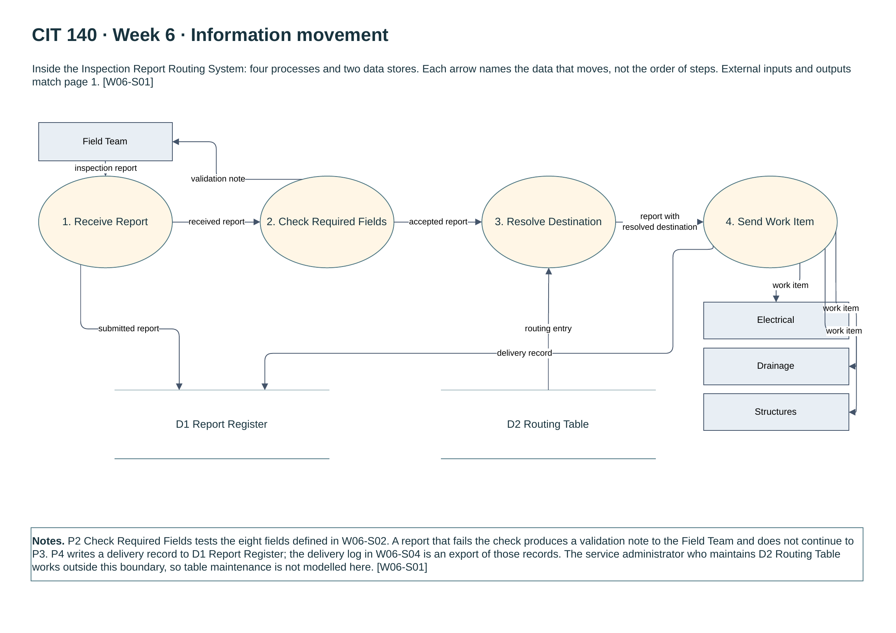
Figure 6. Information movement inside the routing system, page 2 of the Week 6 model. Full original: Week06/Artifact/Le_Matthew_CIT140_Week06_Data_Flow_Model.pdf

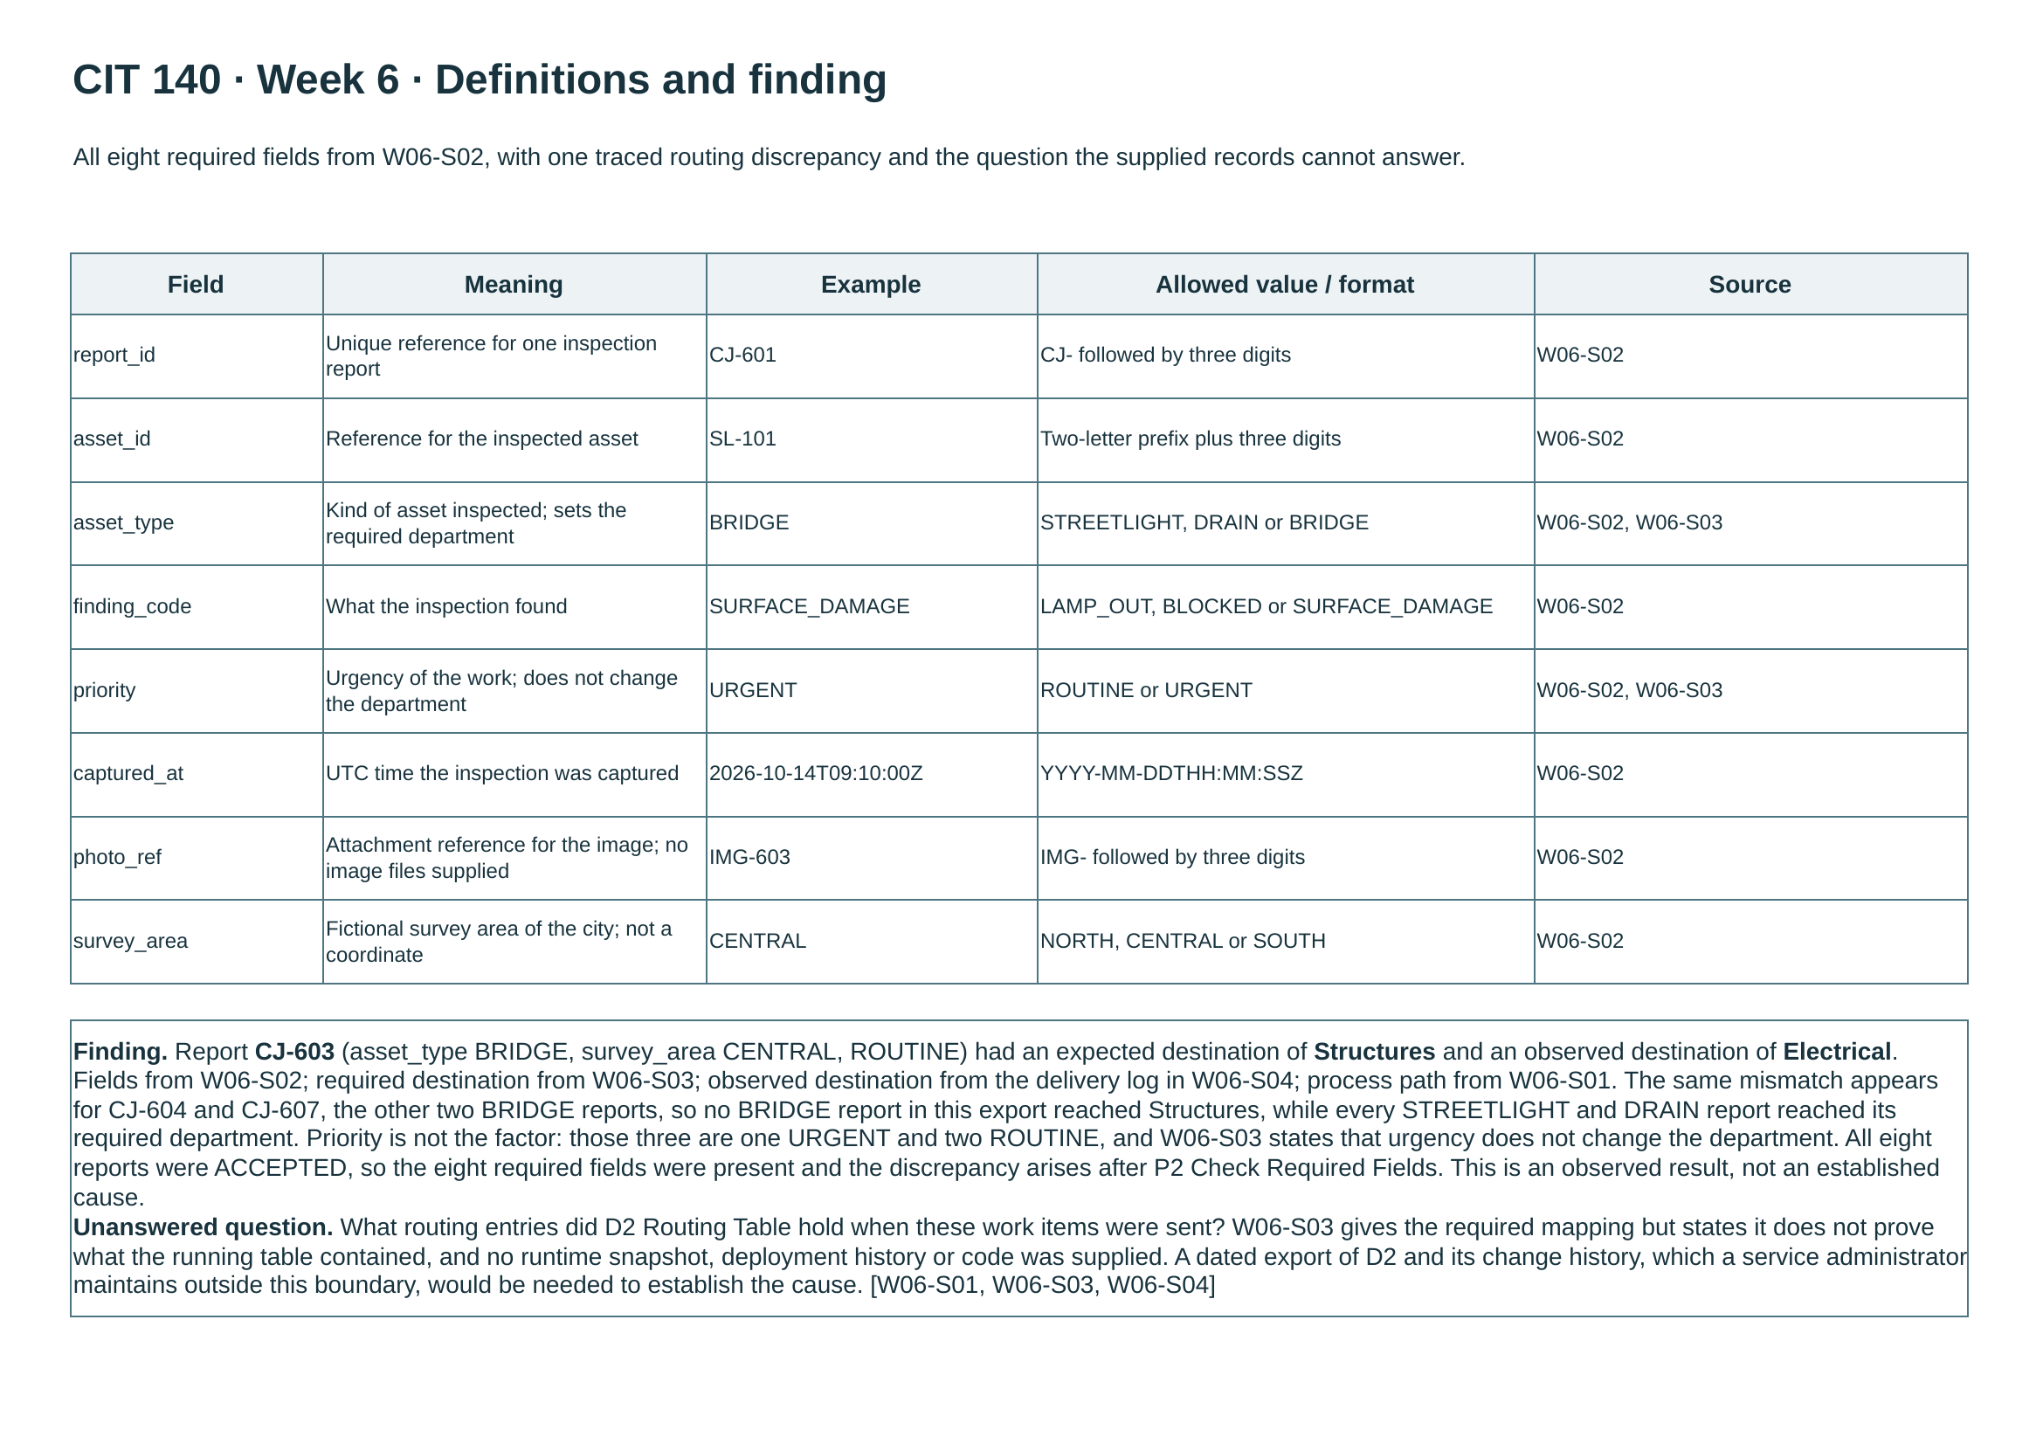
Figure 7. Data definitions and the traced finding, page 3 of the Week 6 model. Full original: Week06/Artifact/Le_Matthew_CIT140_Week06_Data_Flow_Model.pdf

Week 6 explanation for the client (Cedar Junction)
What I examined. Where one drone inspection report goes, from the Field Team that captures it to the city department that has to act on it.
What the evidence shows. All three BRIDGE reports in the delivery log (CJ-603, CJ-604 and CJ-607) passed the field check but were delivered to Electrical instead of the required Structures department. Every streetlight and drain report reached its correct department (W06-S03, W06-S04). Priority was not the factor: one of the three was URGENT and two were ROUTINE.
Why it matters to you. A structural problem on a bridge could sit in the wrong department's queue while the system shows it as delivered. The error appears after the report is accepted, so the field check gives no warning.
What remains uncertain, and the next check. This is an observed result, not an established cause. The required mapping (W06-S03) says where reports should go but not what the live routing table actually held. The next check is a dated export of the D2 Routing Table and its change history from the service administrator who maintains it.
Sources. W06-S01 system boundary and processes, W06-S02 report fields, W06-S03 required destinations, W06-S04 delivery log.
Terms. A data-flow model shows what information moves and where, not the order of steps. D1 and D2 are data stores, the places the system keeps records.

Week 7: Data-Quality Report
Case: Meridian Forge Robotics Artifact: Excel workbook with saved query, 2-page Report PDF, Applied Steps screenshot
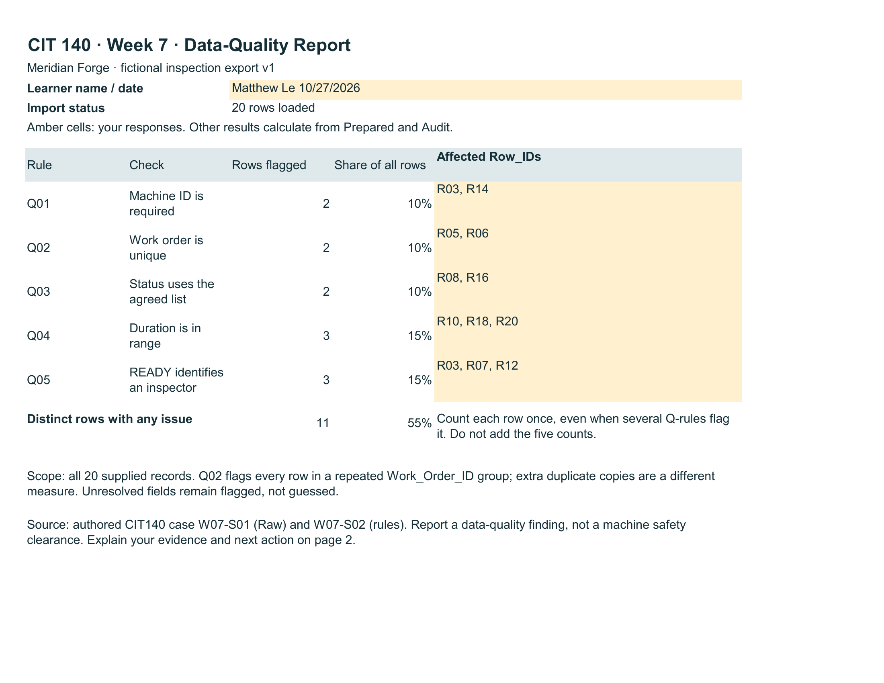
Figure 8. Rule check results, page 1 of the Week 7 Report. Full originals: Week07/Artifact/Le_Matthew_CIT140_Week07.pdf

Week 7 explanation for the client (Meridian Forge)
What I examined. Whether 20 machine inspection records can be trusted for their stated purpose, especially the rows marked READY.
What the evidence shows. Five data-quality rules (W07-S02) were applied after cleaning the Status field. Eleven of the 20 rows (55 percent) fail at least one rule. The rule counts add to 12 because one row, R03, fails two rules at once, so it is counted once in the total. Of the eight rows that read READY, four fail at least one rule.
Why it matters to you. In this file, a READY label is not dependable evidence that an inspection was completed and can be attributed to a machine and a person. Half of the READY rows cannot support that label as recorded.
What remains uncertain, and the next check. The rules test whether values are present and well formed, not whether they are true. Nothing in this export is an independent observation of a machine, so it cannot show whether any machine is safe. Flagged values were left unchanged rather than guessed. The next check is for the Maintenance Records Owner and Shift Supervisor to verify the flagged rows against the original inspection records, then refresh the query and rerun the rules.
Sources. W07-S01 inspection records (Raw sheet), W07-S02 rules Q01 to Q05, W07-S03 limits and roles. Workbook: Week07/Artifact/Le_Matthew_CIT140_Week07.xlsx.
Terms. Power Query is the Excel tool that saves cleaning steps so they can be rerun with one refresh. The distinct total counts each affected row once, even if several rules flag it.

Response to Client Brief W08-B01
Case: Meridian Forge Robotics Artifact: Week 7 Data-Quality Report
The brief asks for one finding from the most recent case, the source or rule behind it, why it matters, and what must be checked before any design decision. It also notes that a READY label or a passed formatting check does not prove a machine is physically safe.

Finding
Half of the records labeled READY fail at least one data-quality rule. Of the eight rows that read READY after the Status field was cleaned, four are flagged:
Row | Rule failed | Recorded value
R03 | Q01 and Q05 | Machine_ID is blank and Inspector_ID is blank, while Status reads READY.
R07 | Q05 | Status reads READY with no Inspector_ID.
R12 | Q05 | Status reads READY with no Inspector_ID.
R10 | Q04 | Status reads READY with Inspection_Minutes recorded as 0, outside the allowed 1 to 60.

Source and rule
Rules Q01 (Machine ID is required), Q04 (duration is in range) and Q05 (a READY row must identify an inspector) from W07-S02, applied in the Audit sheet of Week07/Artifact/Le_Matthew_CIT140_Week07.xlsx. The counts appear on page 1 of the Week 7 Report PDF. The limits on what the data can prove come from W07-S03.

Why you should care
If READY is used to schedule, release or sign off equipment, half of those decisions would rest on a record that cannot be tied to a specific machine, a named inspector, or a valid inspection time. That is a records problem, and it says nothing either way about whether those machines are safe. I have not inspected any machine and did not fill in or correct any value; blank and invalid fields were left as they were.

Check needed before a design decision
First, the Shift Supervisor confirms whether R03, R07 and R12 were actually completed and by whom, and the Maintenance Records Owner checks R03's machine and R10's duration against the original inspection records. After any confirmed correction, the query is refreshed and Q01, Q04 and Q05 are rerun.
The question to answer before choosing a design: at what point in the current process does a record become READY, and does anything at that point require an inspector and a valid duration first? The answer decides whether a fix belongs at data entry, at review, or somewhere else. The records supplied do not answer it.

Closing Review

How my analysis improved since Week 1
In Week 1 I separated verified facts from assumptions, but mainly by labeling them. By the later weeks I was checking my own work against the records and changing it when they disagreed. In Week 5 I drew the booking confirmation and the readiness decision as one step, then split them after rereading W05-S01, and that correction is what exposed the incident path. In Week 6 I tested whether report priority explained the misrouting and the delivery log showed it did not. In Week 7 the checks became rules anyone can rerun with one refresh, and the report says plainly what the data cannot prove. The improvement is less about naming uncertainty and more about testing a claim before writing it down.

Unfinished work and known gaps
Item | Status
Week 2 | Two fields in the submitted Business Case end mid-sentence (condition 2 and the last Next step sentence). The JSON source shows the same truncation. Left unaltered; the graded original keeps its own rules.
Week 3 | The Stakeholder Map refers to the book evidence as a .jpg file. The file in the repository is Le_Matthew_CIT140_Week03_Book_Form.pdf.
Week 4 | The requirements PDF is stored directly in the Week04 folder with its original download name rather than in an Artifact subfolder. It is complete and linked; it was not moved, so earlier links still work.
Week 7 | The workbook saved in the repository had longer wording in two Report answers than the exported PDF. The matching workbook is committed with this review.
All cases | Questions the original evidence could not answer remain open: the owner of legacy_sync.exe (Week 1), whether the sponsor approved the capped review (Week 2), who the sponsor and record custodian are (Week 3), who owns the Intake exception review (Week 5), what the live routing table held (Week 6), and whether the flagged Week 7 rows are confirmed or corrected. No stakeholder has reviewed the Week 5 or Week 6 models.

What I need to understand before comparing solutions or testing a design
Meridian Forge. Where in the current process a record becomes READY and who owns that step; and who owns legacy_sync.exe and whether retired tests can still be issued through it. Without those, any proposed control could be placed at the wrong point.
Cedar Junction. Who owns the Intake exception review and how fast it must respond, and what the live routing table contained when the bridge reports were sent. Both are needed before deciding whether the fix is a process change, a data change, or both.
For testing. The Week 4 acceptance checks are ready-made test cases, each with an owner who confirmed it. The Week 7 counts (11 of 20 rows flagged, 4 of 8 READY rows flagged) are a measured baseline that any change can be compared against by rerunning the same saved query. Comparing options should start from those, not from an untested assumption.

Evidence List and Inventory Status
Every file below is in the project repository. Select a file name to open the complete original on GitHub.
Week | Case | File and folder | Status
1 | Meridian Forge | Le_Matthew_CIT140_Week01_Problem_Brief.pdf  Week01_Something_Isnt_Adding_Up/artifact/ | Complete
1 | Meridian Forge | CIT140-Week01-Meridian-Forge-Evidence-Packet.docx  Week01_Something_Isnt_Adding_Up/evidence/ | Supporting evidence
2 | Meridian Forge | Le_Matthew_CIT140_Week02_Business_Case.pdf  Week02_Is_This_Project_Worth_Doing/artifact/ | Complete, two truncated fields
2 | Meridian Forge | CIT140-Week02-Business-Case-r020.json  Week02_Is_This_Project_Worth_Doing/artifact/ | Editable source
2 | Meridian Forge | Week02_Repository_Check.png  Week02_Is_This_Project_Worth_Doing/artifact/ | Supporting evidence
2 | Meridian Forge | CIT140-W02-Decision-Packet.pdf  Week02_Is_This_Project_Worth_Doing/evidence/ | Case source packet
3 | Meridian Forge | Le_Matthew_CIT140_Week03_Stakeholder_Map.pdf  Week03_Who_Has_A_Stake/artifact/ | Complete
3 | Meridian Forge | Le_Matthew_CIT140_Week03_Book_Form.pdf  Week03_Who_Has_A_Stake/artifact/ | Complete (cited as .jpg in report)
4 | Cedar Junction | CIT140-Week04-Validated-Requirements.pdf  Week04/ | Complete
5 | Cedar Junction | Le_Matthew_CIT140_Week05_As_Is_Process_Model.drawio  Week05/Artifact/ | Editable model
5 | Cedar Junction | Le_Matthew_CIT140_Week05_As_Is_Process_Model.pdf  Week05/Artifact/ | Complete
5 | Cedar Junction | Week05_Discord_Post.png  Week05/Evidence/ | Discussion evidence
5 | Cedar Junction | Week05_Mission_Receipt.pdf  Week05/Receipt/ | Receipt
6 | Cedar Junction | Le_Matthew_CIT140_Week06_Data_Flow_Model.drawio  Week06/Artifact/ | Editable model
6 | Cedar Junction | Le_Matthew_CIT140_Week06_Data_Flow_Model.pdf  Week06/Artifact/ | Complete
6 | Cedar Junction | Week06_Mission_Receipt.pdf  Week06/Receipt/ | Receipt
7 | Meridian Forge | Le_Matthew_CIT140_Week07.xlsx  Week07/Artifact/ | Complete, wording synced this week
7 | Meridian Forge | Le_Matthew_CIT140_Week07.pdf  Week07/Artifact/ | Complete
7 | Meridian Forge | Query_Applied_Steps.png  Week07/Artifact/ | Complete
7 | Meridian Forge | Week07_Mission_Receipt.pdf  Week07/Receipt/ | Receipt
8 | Both | Le_Matthew_CIT140_Week08_Portfolio.pdf  Week08/Artifact/ | This packet
8 | Both | Le_Matthew_CIT140_Week08_Portfolio.docx  Week08/Artifact/ | Editable copy

Repository home: https://github.com/mattyle19782020-netizen/CIT140-Portfolio
Each weekly folder also contains a notes subfolder with the working field notes used to build that week's artifact.

