Brief research about background knowledge

SC : Physical links between brain areas

FC : in the context of resting-state functional MRI, refers to coherent slow spontaneous in the blood oxygenation level dependent

* FC commonly used to assess whole brain dynamics and function.
* Both shows specific alterations during aging and brain disorders.
* Seems to have there are strong correlation between them, but casual relation remains unknown. ( Relationship between SC and FC may vary with age and sex.)
* SC-FC coupling : Coupling between structure connectivity and its functional counterparts was computed as Pearson’s correlation coefficient between these two measures. The structure of the work flow looks like this. ( Image from ref 2)

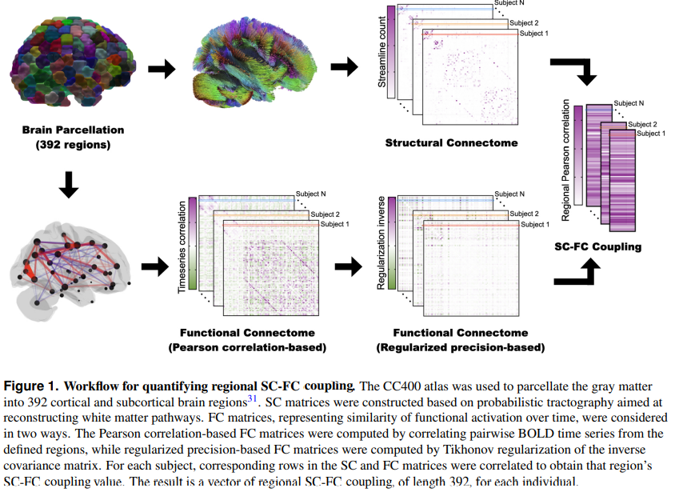

So the paper from reference 2 looks quite similar with what we want to do. They quantified the SC-FC coupling of their target group(age, sex, cognition) They also made glm model. The new concept might be SC-FC coupling. But I found how to compute this coupling and the python code from the author.

[scfc-coupling/generate_data.py at main · zijin-gu/scfc-coupling (github.com)](https://github.com/zijin-gu/scfc-coupling/blob/main/generate_data.py)

Last paper is highly related with one of our interest. In this paper they analyzed the SC-FC coupling in drug users (THC : cannabis users) .

Since we can get SC-FC coupling from paper2 so we can do similar work in the last paper.

This plot is from the paper3. CB(drug user) HC(Healthy control).

* 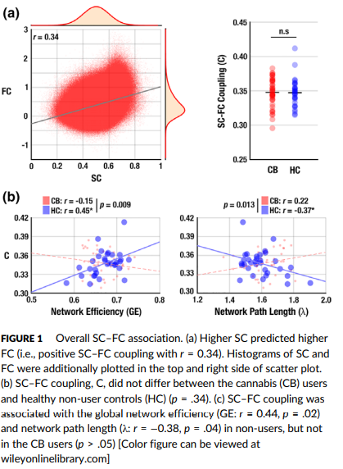

Also I got some good example that we can use the plot that I made. Before making SC-FC coupling, show each subject’s MRI and plot in each group(drug users/ healthy users)

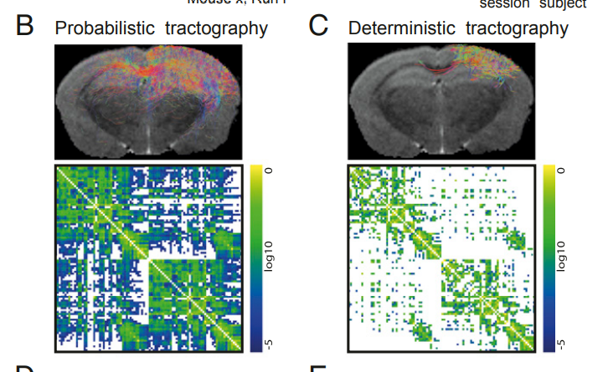

* ( Showing MRI : (can get from GUI program from the website) and the plot might be more informative) (ref 1)

Reference

1. Individual structural features constrain the mouse functional connectome Francesca Melozzia,1, Eyal Bergmannb,1, Julie A. Harrisc , Itamar Kahnb,2, Viktor Jirsaa,2,3, and Christophe Bernarda,2,3
2. Regional structural-functional connectome coupling 2 is heritable and associated with age, sex and 3 cognition in adults Zijin Gu1 , Keith Wakefield Jamison2 , Mert Rory Sabuncu1,2, and Amy Kuceyeski2,*
3. Aberrant structural–functional coupling in adult cannabis users Dae-Jin Kim1 | Ashley M. Schnakenberg Martin1 | Yong-Wook Shin2 | Hang Joon Jo3 | Hu Cheng1,4 | Sharlene D. Newman1,4 | Olaf Sporns1,5 | William P. Hetrick1 | Eli Calkins1 | Brian F. O'Donnell1
4. Development of structure–function coupling in human brain networks during youth”-Graham L. Baum, Zaixu Cui, David R. Roalf, Rastko Ciric, Richard F. Betzel, Bart Larsen
5. Revisiting correlation-based functional connectivity and its relationship with structural connectivity Raphaël Liégeois 1,2, Augusto Santos1 , Vincenzo Matta3 , Dimitri Van De Ville1,2, and Ali H. Sayed1