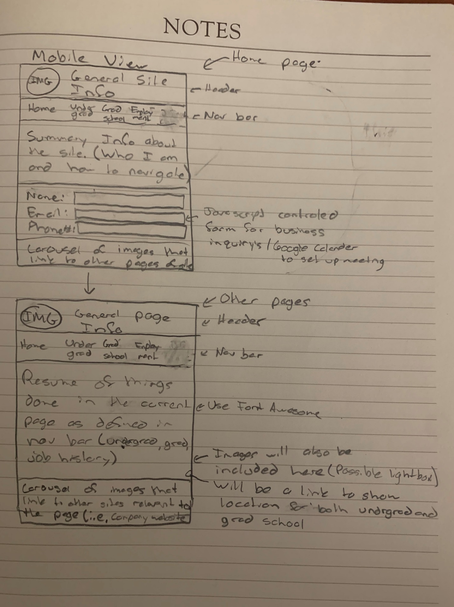

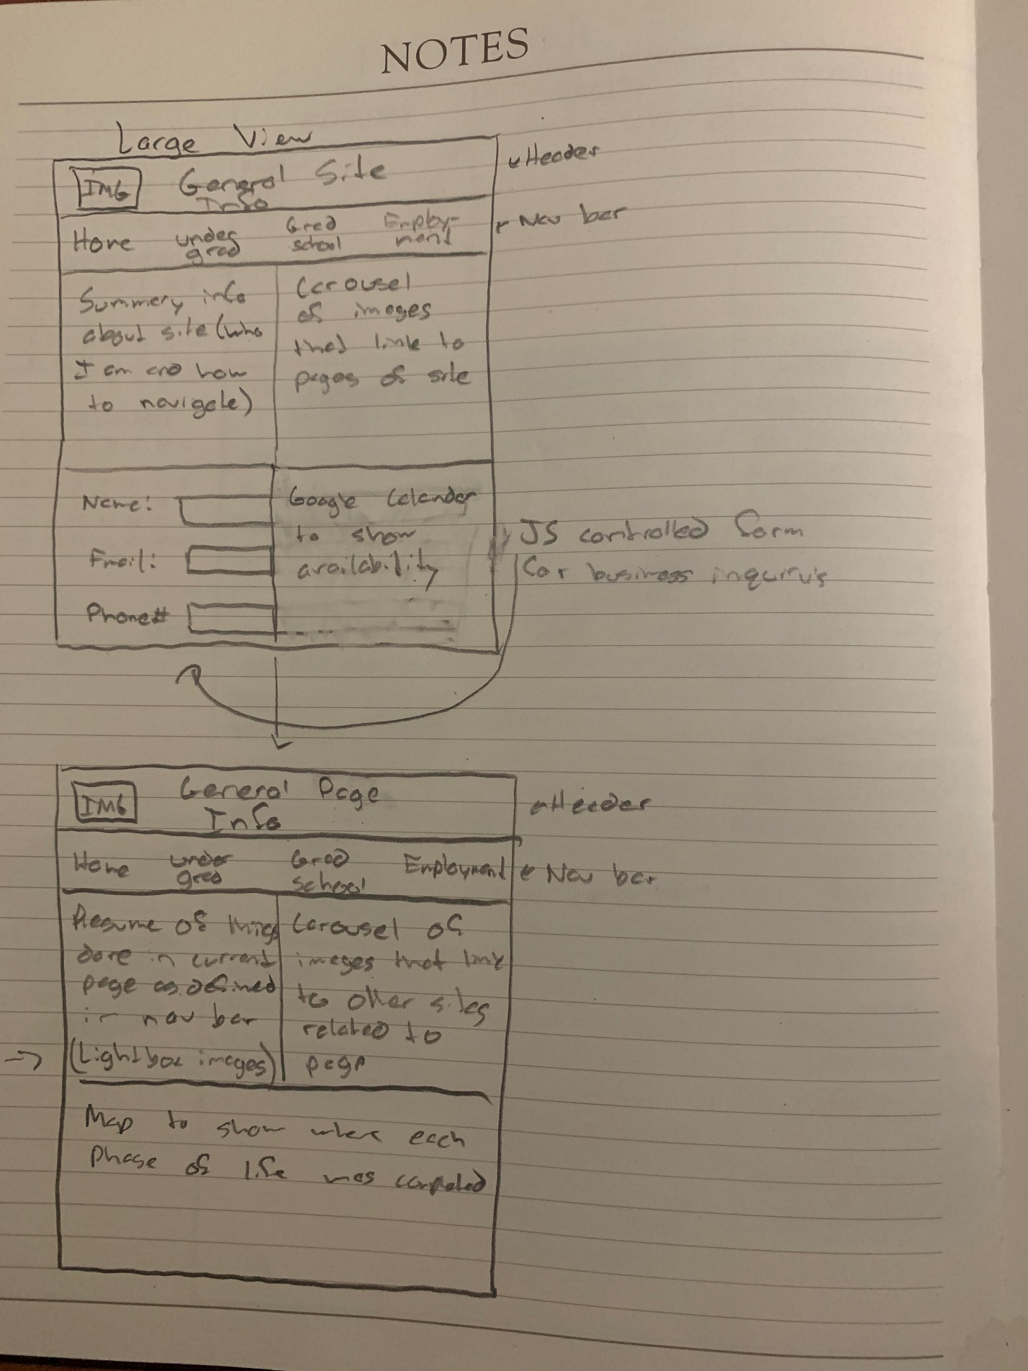

# Mobile View Write Up:

The mobile view wire frame contains two main sketches. The first is of the home page. It contains a header with an image of me as well as the general information for the site. Under the header it contains a nav bar that will allow the user to easily click between each page. Under the nav bar will be general information about me and how to navigate the site. Under that will be a form with verification through JavaScript that can be filled in for business inquiry’s as well as an agenda view google calendar to show my upcoming availability. Lastly, at the bottom will be a carousel of images relevant to the other pages on the site. For each of the other pages, as defined in the nav bar, the header will be styled the same but with information relevant to the page. The nav bar will be exactly the same. Underneath the nav bar will be a resume of things done at that particular stage of my life. There will also be lightbox images in this section relevant to the page. There will also be a link to a map of the location where I performed each stage of my life. At the bottom will be a carousel of images that link to relevant sites.

# Large View Write Up:

The large view will contain all of the same information as the mobile view. For the home page, the header and nav bar will remain relatively the same except that the image will be scaled up and the nav bar will also be scaled accordingly with the screen. The summary of the site will be directly under the nav bar, but with the carousel of images to its right. The form and calendar will be at the bottom, but this time the calendar will be in a traditional month layout. For the other pages, the content will be the same as the mobile view. The only difference will be that the carousel of images will be beside my resume of things I’ve done. Instead of a link to a map there will be a map at the bottom to show the location where I performed the stage of my life indicated in the page.