Federal, State, and Local Governments: How Campaign Finances are Raised and Spent?

This lesson will cover campaign finances and the key roles they play in the campaigns of the politicians and leaders we elect into power across all levels of government: Federal, State, and Local.

- Warm-up question (5 minutes): Have you seen ads of leaders or politicians asking for donations and money on social media, YouTube, or while on TV? Even if you haven’t, if you did see your leaders asking for money on a screen, would you donate to them?
  - Let them talk about the question for about 3 minutes
  - Then transition to the topic of Political Campaigns, and in particular Campaign Finances.

- Lecture Time: Slideshow presentation (<10minutes):
  - General Overview:
    - What is a Campaign?
    - Why do they need money?
    - Where does the money come from?
    - What does campaign money do?
    - How is it spent?
    - Rules regarding the process
    - Timeline
    - Big Idea
    - Questions and End

- Games #1: Campaign Signals
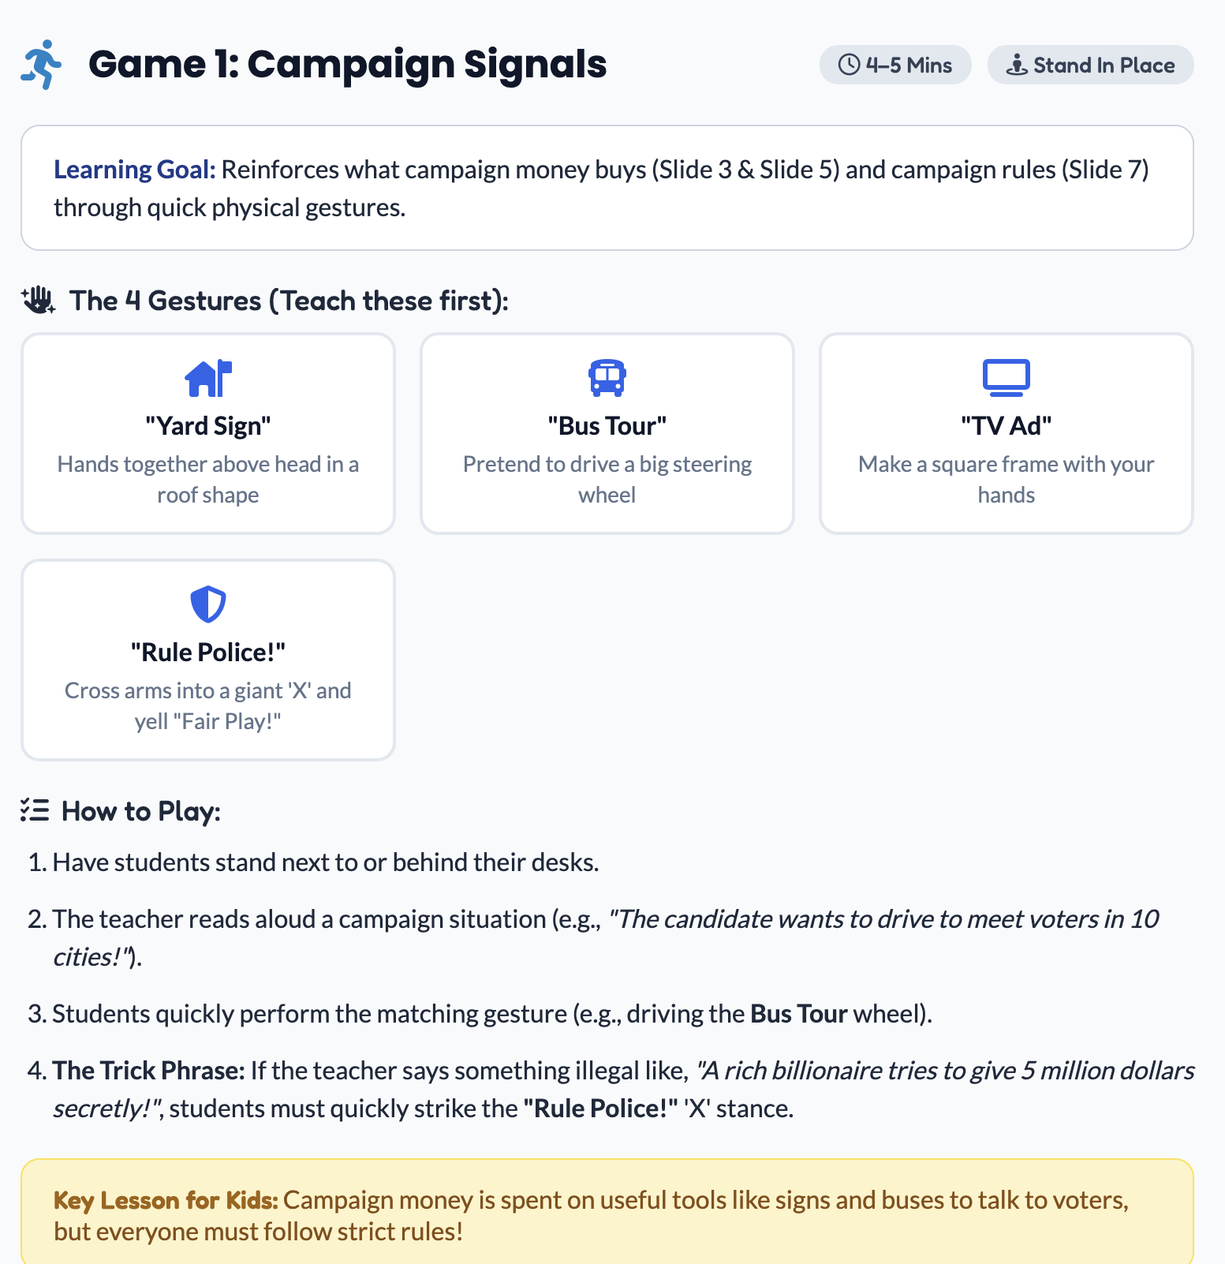

- Game #2: The Coin Clapper Election

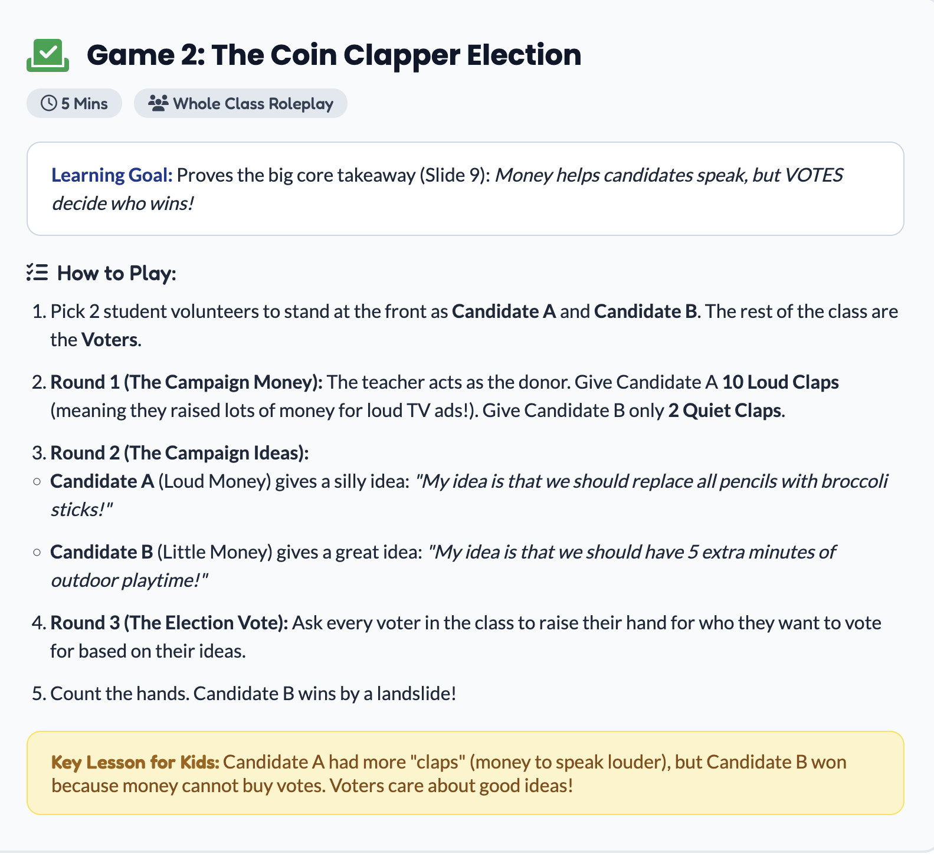

- Wrap-up Questions (5 minutes):
  - What do you think the best way to get donations and money for campaigns is?
  - If you were a politician, what way would you choose to raise money for your campaign?

