1way tracking for dataset 1: RMSE = 0.016797
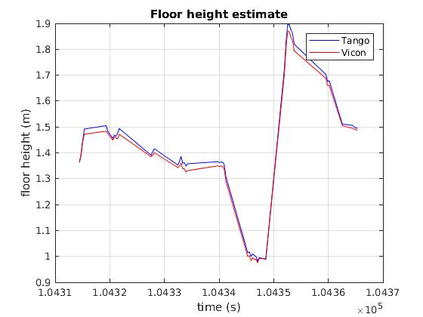

2way tracking for dataset 1: RMSE = 0.016755

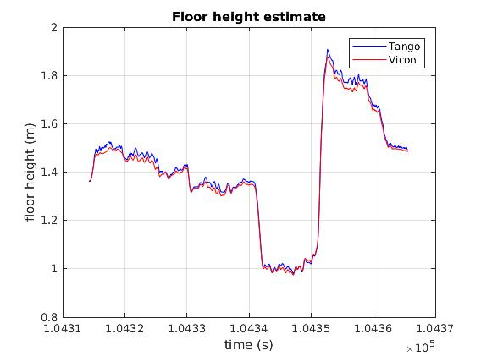

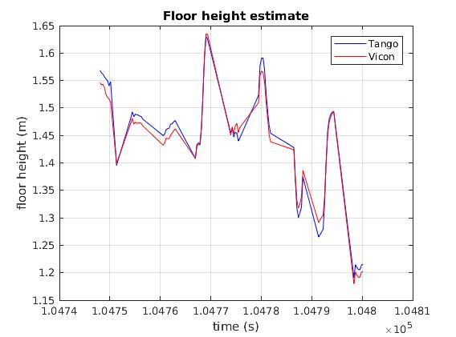
1way tracking for dataset 3: RMSE = 0.015884

For this dataset, we are dropping a large number of images due to status.

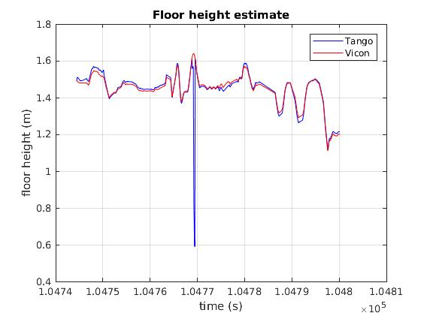
2-way tracking dataset 3:
RMSE = 0.045774

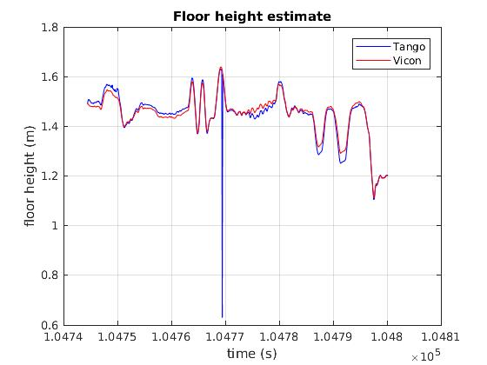
1-way tracking dataset 3:
(WITHOUT dropping as many images)
(21 total dropped)

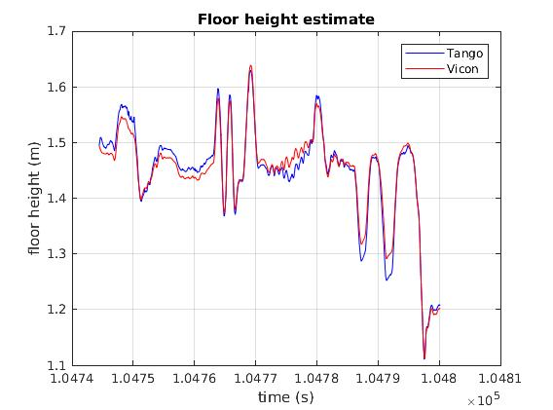
RMSE = 0.015553

1-way tracking dataset 3: (right to left)
WITHOUT dropping as many images
(21 total dropped)

RMSE = 0.015227

