
Ben-Gurion University of the Negev
Faculty of Engineering Science
School of Electrical and Computer Engineering
Dept. of Electrical and Computer Engineering

Fourth Year Engineering Project
Final Report
Design and Implementation of a Hovering Autonomous Underwater Vehicle (HAUV)
Project number: p-2026-126
Student: Matty Rotman - 314834367
Supervisor: Hugo Guterman
Submitting date: July 26th, 2026

Table of Contents

Table of Contents 2
Abstract 7
Project Goals - Project Deliverables and Scope Definition 9
Goal 1, Autonomous Mission Execution 9
Goal 2, Operation Stability and Precision 9
Goal 3, Real-Time Control and Telemetry 9
Project Deliveries 9
In Scope 9
Out of Scope 9
Introduction 10
Final Technical Specifications 12
1. Physical Characteristics 12
2. Propulsion 12
3. Sensors 12
4. Processing Units 12
5. Communication and Networking 12
6. Power 13
7. Software Architecture and Packages 14
Approach Taken to Solve the Problem and Engineering Design 16
System Architecture 16
Design Components 16
Doppler Velocity Log (DVL) Integration 17
QGroundControl (QGC) Integration 18
Guided Mode (Autonomous “Go-to-Location”) 18
Acoustic (USBL) Control Link 19
Safety Systems 19
Design Considerations 20
Simulation Verification (ROS 2 Gazebo) 22
Manual Driving 22
Depth Hold 23
Autonomous Go-to-Location 24
Leak Failsafe 25
The Simulated Environment 25
Findings and Limitations 26
Final Acceptance Tests 26
1. QGroundControl Telemetry and Control 27
2. System Health Check 27
3. Doppler Velocity Log 27
4. Autonomous Guided Mode (bench-safe) 27
5. Leak Auto-Surface Failsafe 27
6. Acoustic (USBL) Link 28
Problems and Solutions 29
1. Broken sensor logic and cluttered ROS communication 29
2. Running all sensors at once on a single I²C bus 29
3. Unreliable debugging and power during development 29
4. Accurate underwater velocity 29
5. MAVLink Bridge 29
6. Incompatible Python libraries 30
7. Persistent ESP32 lock-up 30
Recommendations and Conclusions 31
Summary of Work 31
Comparison of Results with Project Goals 31
Advantages and Disadvantages 31
Recommendations for Future Work 32
Conclusions 32
References 33
Appendices 34
Appendix A, Operating the vehicle (hauv.sh) 34
Appendix B, QGC MAVLink telemetry messages 34
Appendix C, Connecting QGroundControl 35
Appendix D, HAUV Operator's Manual 36
1 About the HAUV 36
1.1 What the HAUV is 36
1.2 The two computers inside 36
1.3 The main parts 36
1.4 Inside the vehicle, the electronics 37
1.5 What you need before you start 38
2 Safety First 38
2.1 The golden rules 38
2.2 Before every dive 38
3 Network Setup 39
3.1 The addresses 39
3.2 Setting your laptop address 39
4 Connecting QGroundControl 39
4.1 Connecting with a cable (Ethernet) 40
4.2 Connecting with sound (Acoustic / USBL) 40
4.3 DVL settings (for reference only) 41
5 Starting the HAUV 42
5.1 The batteries 42
5.2 Power on 43
5.3 Starting the software 43
5.4 Check everything works 43
6 Reading the Screen 44
6.1 The parts of the screen 44
6.2 The numbers you must watch 44
6.3 Warning messages 44
7 Driving the HAUV 45
7.1 The controller 45
7.2 Your first drive 46
8 Flight Modes 46
8.1 Manual 46
8.2 Stabilize 46
8.3 Guided, “Go to location” 46
9 Safety Features 47
9.1 Leak, the vehicle swims up by itself 47
9.2 Lost control link 47
10 Indicator Lights 47
11 After the Dive 47
12 Troubleshooting 48
12.1 Common problems 48
12.2 Useful checks 49
Appendix E, Project Timeline 50
Phase 1, Initialisation and Design (October–December 2025) 50
Phase 2, Simulation and Physical Setup (December 2025–January 2026) 50
Phase 3, Core Development (January–March 2026) 50
Phase 4, Hardware Integration and Testing (March–May 2026) 50
Phase 5, Validation and Final Testing (June–July 2026) 50
Appendix F, Budget Estimation 51

Abstract
Autonomous Underwater Vehicles (AUV) are self-contained robots that are capable of executing complex tasks in underwater environments with little to no direct human interactions.
Unlike conventional submarines, AUVs eliminate the need for complex human support systems, enhancing their efficiency and accessibility while providing superior maneuverability compared to submarines of comparable size.
The main goal of the project is to develop an unmanned hovering autonomous underwater vehicle, which, compared to its off-the-shelf counterparts, will be designed for improved accuracy and higher speeds.
The AUV will incorporate a Master-Slave architecture, an operator using an off the shelf command and control system will assign the AUV an objective, a location, and the AUV using its processing units will navigate to its designated destination in the shortest possible time while keeping its balance while conducting the required measurements using its onboard sensors, sending them real time to its operator.
Ultimately, a proof of concept (POC) will be realized, showcasing an AUV capable of operating in the open sea while being easily controlled with minimal human intervention.

Keywords: HAUV, Robotics, Command and Control, sensors, Autonomous, Data Processing, Stability Control, User Experience, Maneuverability, Sea Exploration.
תקציר
כלי רכב תת-ימיים (AUV) הם רובוטים עצמיים המסוגלים לבצע משימות מורכבות בסביבות ימיות עם מעט מאוד אינטראקציה ישירה עם בני אדם.
בניגוד לצוללות קונבנציונליות, AUV אינם דורשות מערכות תומכות חיים מורכבות, מה שמיעל אותן ומנגיש אותן תוך מתן יכולת תמרון עדיפה בהשוואה לצוללות בגודל דומה.
מטרת הפרויקט היא פיתוח כלי רכב תת-ימי אוטונומי מרחף בלתי מאויש (HAUV) אשר בהשוואה למקביליו המסחריים ייועד לדיוק גבוה יותר ולמהירויות גבוהות יותר.
ה-AUV בעל ארכיטקטורה מסוג Master-Slave, בה מפעיל משתמש במערכת שליטה ובקרה (שו"ב) מסחרית יקצה משימה ו-AUV על ידי שימוש במחשבים שלו ינווט ליעד המיועד בזמן הקצר ביותר תוך שמירה על יציבותו וביצוע המדידות הנדרשות באמצעות החיישנים המובנים שלו ולבסוף ישלח את הנתונים בזמן אמת למפעיל.
בסופו של הדבר תתבצע הוכחת היתכנות (POC) שיפתח AUV המסוגל לפעול בים הפותח תוך שליטה קלה במינימום התערבות אנושית.
מילות מפתח: HAUV, רובוטיקה, שליטה ובקרה, חיישנים, אוטונומיות, עיבוד נתונים, בקרת יציבות, חווית משתמש, יכולות תמרון, חקר ימי.

Project Goals - Project Deliverables and Scope Definition
Building on the existing HAUV platform, this continuation project pursued the three goals defined in the preliminary design, restated here in the terms used for the final evaluation.

Goal 1 — Autonomous Mission Execution
Goal: Perform a complete autonomous operation without direct human intervention.
Success criteria: The system successfully executes a complete area scan and marks a specific target in the final experiment while in autonomous-mission mode.

Goal 2 — Operation Stability and Precision
Goal: Maintain high stability and navigation accuracy throughout the mission.
Success criteria: The system holds the key parameters, depth stability, mission-tracking accuracy and object-detection reliability, within the required operational thresholds.

Goal 3 — Real-Time Control and Telemetry
Goal: Ensure continuous monitoring and a live data flow between the HAUV and the operator.
Success criteria: The system successfully measures and transmits real-time data from the onboard sensors to the operator.

Project Deliveries
- Software and control system, a high-level control system running on the UP Board under the ROS 2 framework, together with a real-time control system on an ESP32 microcontroller for motor and sensor management.
- Simulation environment, a complete simulation of the HAUV on the ROS 2 Gazebo simulator, for validating movement, sensor data and control algorithms before physical implementation.
- Physical proof of concept, a functional HAUV integrating sensors, motor control and communications, aimed at navigation and stabilisation.

In Scope
- Development of stability and navigation control algorithms.
- Integration of navigation sensors.
- Validation through simulation and testing.
- Implementation of communication between the HAUV and the operator.

Out of Scope
- Mechanical chassis fabrication, the HAUV's chassis is produced by a separate mechanical team.
- Full waterproofing and open-sea trials, the prototype is not water-resistant, so testing in open-sea conditions was not conducted.

Introduction
Autonomous Underwater Vehicles (AUVs) are self-contained robots capable of executing complex tasks in underwater environments with little to no direct human interaction. First developed in the late 1950s, the Self-Propelled Underwater Research Vehicle (SPURV) operated at 2.2 m/s for 5.5 hours, the field has since matured from specialised research platforms into versatile, modular systems, and AUVs are today a standard tool in academic and industrial work ranging from seafloor mapping to environmental monitoring [1].
While AUVs have become increasingly affordable and capable, commercially available hovering AUVs (HAUVs) such as the Blue Robotics BlueROV2 are designed as general-purpose systems that prioritise rated depth, operational range and ease of use over extreme precision or high-speed, tailored manoeuvres. This performance gap motivates a bespoke HAUV whose thruster configuration and control algorithms are optimised specifically for improved accuracy and higher speed [2].
Locating an underwater vehicle with GPS is largely ineffective, because high-frequency electromagnetic waves attenuate rapidly even at shallow depths, and GPS spoofing and jamming add reliability and security concerns. Acoustic methods are used instead: a Doppler Velocity Log (DVL) estimates the vehicle's velocity relative to the seafloor from the Doppler shift of emitted acoustic pulses, and fusing this with inertial measurements yields position over time without surfacing, while acoustic beacons provide absolute positioning by time-of-flight [3]. High-level processing runs on an Intel-based UP Board; ARM platforms such as the Raspberry Pi offer an alternative with lower power and heat and a path to an on-board AI module for computer-vision tasks [4].
The control software is built on the Robot Operating System 2 (ROS 2) together with the Gazebo simulation environment, which allows models and logic developed in simulation to be deployed onto the hardware with few modifications and enables risk-free testing by replicating underwater conditions before the vehicle enters the water [5]. The command-and-control link between the HAUV and its operator is bridged by the MAVLink protocol through the QGroundControl (QGC) station, a lightweight, vehicle-agnostic, cross-platform interface whose extensible mission-planning support suits the bespoke autonomous missions required here [6].
This continuation project builds on the earlier stage of the work, which delivered a bench prototype of the dual-computer, ROS 2-based HAUV but left it operated through custom scripts over a wired link, without autonomous point-to-point navigation or an untethered control path, and with several sensor drivers inoperative. The present work integrates the vehicle with QGroundControl through a purpose-built MAVLink bridge, adds a fully autonomous Guided (go-to-location) mode with depth hold and station-keeping, introduces an acoustic (USBL) control channel for cable-free operation, integrates the DVL for velocity, and implements on-board leak, link-loss and attitude failsafes, all while retaining the dual-processor design in which a Linux UP Board runs high-level guidance and telemetry and an ESP32 microcontroller handles real-time motor and sensor tasks.

Final Technical Specifications
The overall architecture of the HAUV, how power and data are distributed across the vehicle, is summarised in the block diagram below.
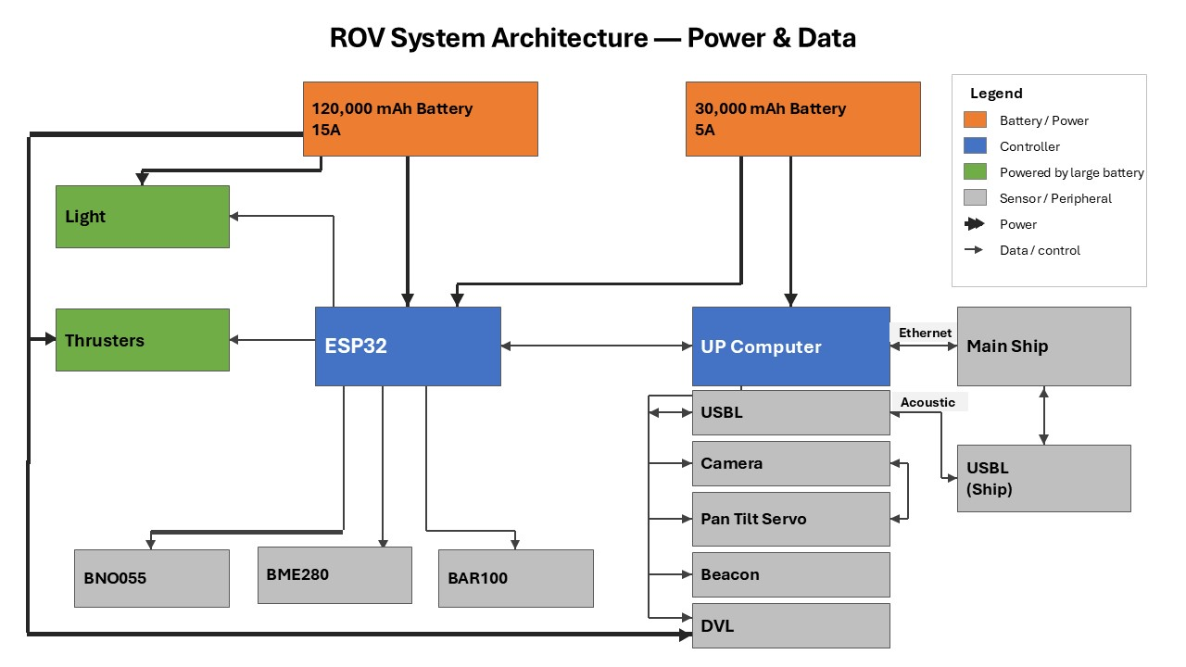
Figure 1 — HAUV system block diagram: power distribution and data/control paths.
The vehicle retains the physical platform and core sensor suite of the earlier stage; the specifications below consolidate that platform with the computing, communication and software additions delivered in this project.

1. Physical Characteristics
- Dimensions: 70 cm x 25 cm x 20 cm
- Frame material: Vslot aluminium profiles
- Manoeuvrability: hovering-class, multiple degrees of freedom (surge, sway, heave, yaw, pitch)

2. Propulsion
- Thrusters: 6 × Blue Robotics T200
- Configuration: two front and two rear thrusters angled inward at 45°, plus one front and one rear vertical thruster
- Motor command: PWM in microseconds, neutral 1500 µs, full range 1100–1900 µs; all thrusters initialised to 1500 µs before operation

3. Sensors
- GPS: u-blox receiver providing a surface position fix for the navigation core
- Depth, temprature & pressure water resistant: Blue Robotics BAR100
- Temperature & humidity: Bosch BME280 electronics monitoring.
- Leak sensor: Blue roboticsleak sensor with 4 probes.
- Doppler Velocity Log (DVL): Teledyne Pathfinder for velocity over the seafloor.
- Inertial Measurement Unit (IMU): Bosch BNO055 for orientation data.
- Accostic position and communication: Advanced Navigation Subsonus.

4. Processing Units
- Main computer, UP Board: Ubuntu 20.04 with ROS 2 Foxy for high-level guidance, sensor fusion, navigation and QGC telemetry
- Real-time microcontroller, ESP32: runs micro-ROS for motor PWM, lights and real-time sensor acquisition
- Division of labour: the UP Board handles autonomy and communication; the ESP32 guarantees deterministic, low-latency motor and sensor timingx

5. Communication and Networking
- Ethernet (TCP/IP): Primary tethered link. Carries DVL data and general above-/below-water communication through the Blue Robotics Ethernet switch, and transports QGC MAVLink telemetry over UDP.
- Acoustic (USBL): Untethered link over a pair of Subsonus acoustic modems. Carries compact telemetry and operator commands (no video), allowing cable-free operation.
- UART (serial): UP Board ↔ ESP32 over micro-ROS at 115200 baud; a separate FTDI UART is used for ESP32 debug output.
- I²C: ESP32 ↔ all environmental/orientation sensors (BNO055, BAR100, BME280) through a Blue Robotics I2C Bus Splitter board.
- 5 V PWM: Drives the thruster ESCs, camera pan-tilt servo and the lights.
The system uses static IP addresses on the 192.168.168.x/24 subnet, with a common ROS_DOMAIN_ID across all machines. The key devices and endpoints are summarised below.
Device | Address / Port
UP Board (main computer) | 192.168.168.101
Doppler Velocity Log (DVL) | 192.168.168.102, cmd 1033, binary 1034, string 1037
Operator PC / ground station | 192.168.168.100
Subsonus USBL (surface unit) | 168.254.1.80
Subsonus USBL (subsea unit) | 168.254.1.79
QGC MAVLink, Ethernet | UDP 14550
QGC MAVLink, acoustic bridge | UDP 14551 (127.0.0.1)
ESP32 serial | 115200 baud (Silicon Labs CP2102, auto-detected)

Table 1, Network devices and endpoints.

6. Power
- Battery 1: 12 V lithium pack powering the computing and electronics domain, UP Board, DVL, Ethernet switch and beacon.
- Battery 2: 12 V lithium pack dedicated to the thrusters and lights, isolating high motor currents from the sensitive electronics.
- DC-DC conversion: A step-down converter provides the regulated 5 V rail for the electronics from the 12 V supply.
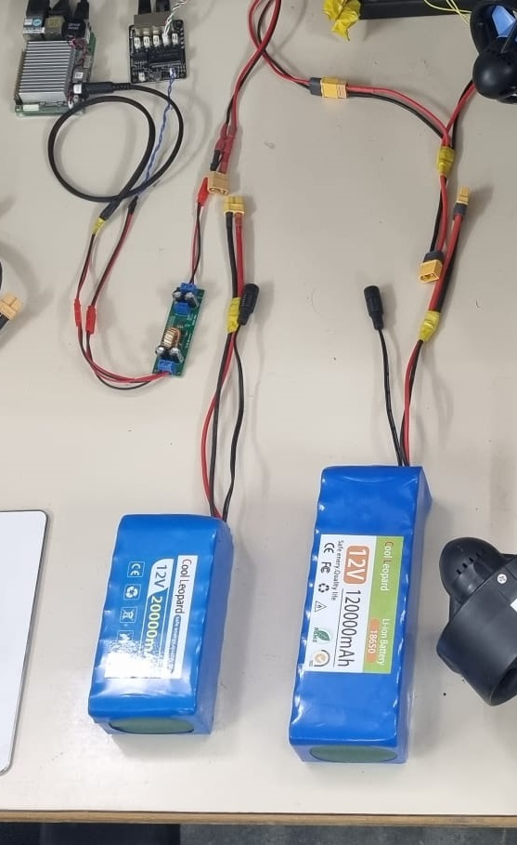
Figure 2 — The two 12 V lithium packs and the step-down converter (small green board).

7. Software Architecture and Packages
- Operating system: Ubuntu 20.04 on the UP Board, with ROS 2 Foxy as the robotics middleware coordinating all high-level tasks.
- Microcontroller framework: The ESP32 runs FreeRTOS with micro-ROS (Arduino), exchanging sensor and actuator data with the UP Board over the serial link.
- Operating tool: A single management script, hauv.sh, is the one entry point for running and inspecting the stack, start, stop, restart, check (per-sensor OK/LOW/FAIL health at rate), status, topics, echo and view.
The software is organised into ROS 2 packages, each with a well-defined responsibility:
Package | Responsibility
autopilot_pkg | guidance_node (mode switching, PID stabilisation, motor mixing, Guided/GOTO, leak failsafe), dvl_node, subsonus_node, acoustic_bridge_node, health_monitor_node
mavlink_bridge_pkg | Bridges ROS 2 topics to QGroundControl over UDP MAVLink
camera_pkg | USB camera → /camera_image
gps_pkg | u-blox GPS → /gps/fix
my_launch_pkg | Launch-file definitions
esp_sketches/rov_esp_main | ESP32 firmware (micro-ROS), sensor publishing and PWM outputs

Table 2, ROS 2 packages and responsibilities
Data flows between the vehicle's sensors, the guidance core and the ground station through a small set of ROS 2 topics:
Topic | Type | Notes
/esp32/bno055_data | Twist | linear.x/y/z = yaw / pitch / roll (BNO055)
/esp32/bar100_data | Vector3 | x = depth (m), y = pressure, z = temperature
/esp32/leak | Float64 | 0.0 = dry, 1.0 = leak
/dvl/velocity_data | Twist | linear.x/y/z = velocity over ground
/motor_data | Twist | Motors 1–6 as PWM µs (1100–1900, neutral 1500)
/lights_servo_data | Vector3 | light 1, light 2, camera-servo angle
/guidance/goto_target | NavSatFix | Guided-mode destination

Table 3, Key ROS 2 topics

Approach Taken to Solve the Problem and Engineering Design
The goal of this stage was to turn the existing HAUV platform into a vehicle that can be operated from a standard ground station, navigate autonomously, and protect itself in a fault. Reaching it meant reuse of the existing hardware, new software subsystems for control and communication, and putting it through rigorous testing.

System Architecture
The HAUV keeps a dual-computer architecture that cleanly separates deterministic low-level control from higher-level autonomy. The system is composed of three main subsystems:
- Ground station: An operator running QGroundControl on a PC, connected to the vehicle either over the Ethernet tether or over the acoustic (USBL) link.
- Underwater pressure vessel: Houses the core electronics, the UP Board and the ESP32, together with the orientation, depth and environmental sensors.
- Underwater components: The exposed hardware: six T200 thrusters, the lights, the camera, the DVL and the acoustic beacon.
The system splits across two computers, the UP Board (ROS 2) for high-level guidance, navigation and QGC telemetry, and the ESP32 (micro-ROS) for real-time motor, light and sensor control, linked by a guidance_node that fuses the inputs and a bridge node that relays telemetry over Ethernet or the acoustic link.

Design Components
The core electronics are mounted together on the vehicle's electronics tray:
- UP Board, the main computer (identifiable by its large heatsink).
- Indicator light, solid when the ESP32 is communicating with ROS 2; off when the link is down.
- ESP32, the real-time motor and sensor controller.
- Thruster (one of six Blue Robotics T200 units).
- I²C connector, to the environmental/temperature sensor, via the custom breakout board.
- GPS antenna, surface fix used as the origin for navigation.
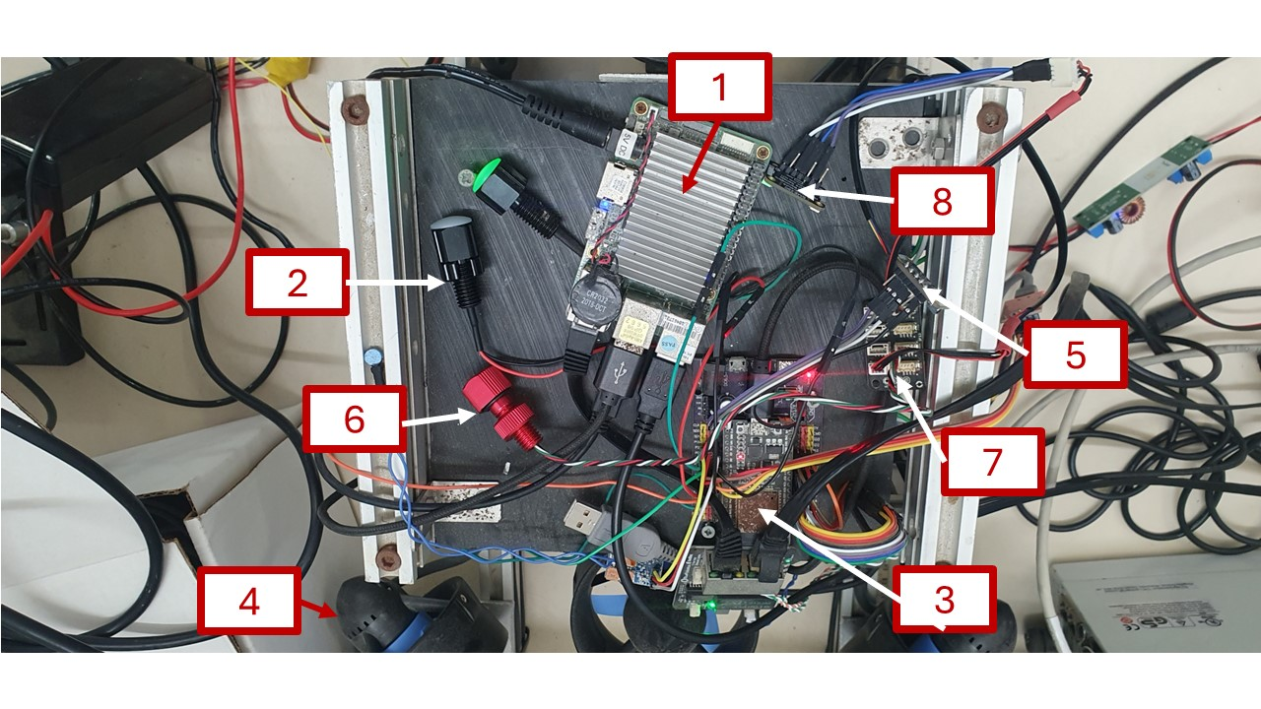
Figure 3 Electronics:(1) UPBoard, (2) indicator, (3) ESP32, (4) thruster, (5) BNO055, (6) BAR100, (7) I2C board, (8) BME.

Doppler Velocity Log (DVL) Integration
Precise underwater navigation depends on an accurate velocity measurement, which cannot be obtained reliably by integrating accelerations over time. A Teledyne Pathfinder Doppler Velocity Log (DVL) was integrated to measure the vehicle's velocity relative to the sea floor directly. The dvl_node connects to the DVL over Ethernet (192.168.168.102), parses its output over UDP in its PD6 format and republishes it on /dvl/velocity_data for the guidance core and the telemetry bridges. The DVL is configured through its own web interface (Figure 4).
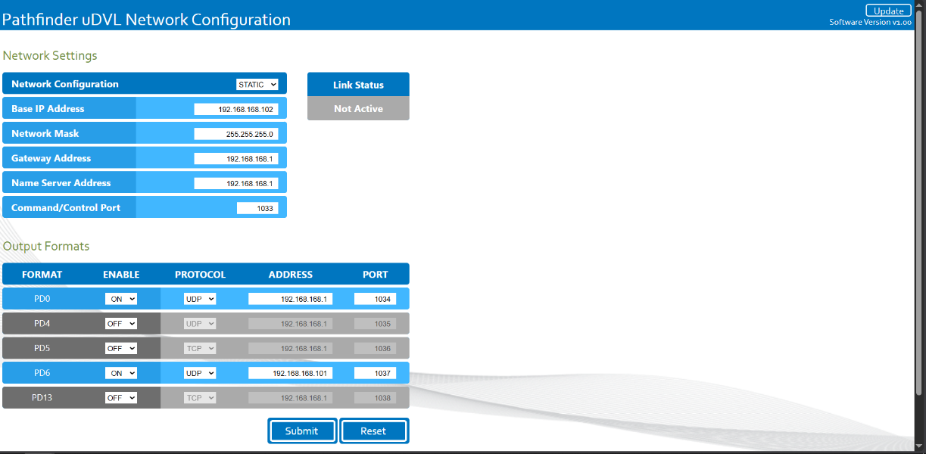
Figure 4 — DVL web configuration: static IP 192.168.168.102 and the enabled PD0 / PD6 UDP output formats.

QGroundControl (QGC) Integration
The vehicle was connected to QGroundControl (QGC), a common open-source ground-control station, through a MAVLink bridge node. The bridge is plain Python on ROS 2 with no external MAVLink library, so it is easy to deploy and extend.
- Telemetry: The bridge streams four MAVLink messages to QGC, HEARTBEAT (1 Hz; vehicle alive and armed state), ATTITUDE (20 Hz; roll, pitch and yaw from the BNO055), GLOBAL_POSITION_INT (20 Hz; position and velocity derived from the DVL) and SYS_STATUS (20 Hz; battery, sensors and health).
- Commands: It translates QGC MANUAL_CONTROL (joystick) messages into motor PWM on /motor_data, so the vehicle can be flown directly from the QGC Fly view.
On the operator side the PC is placed on the vehicle subnet (192.168.168.100) and QGC is pointed at a UDP link to 192.168.168.101:14550.

Guided Mode (Autonomous “Go-to-Location”)
Guided mode lets the operator click a point in QGC and have the vehicle navigate there autonomously, then hold position. It runs entirely on the UP Board, so the control link is only needed to send the target and to abort. This is the as-built form of the Autonomous Mission mode defined in the preliminary design; the three planned modes, Manual, Assisted and Autonomous Mission, correspond to the Manual, Stabilize and Guided modes used in this report.
When a target is received (as a NavSatFix on /guidance/goto_target), the guidance node computes the great-circle bearing and haversine distance from the current GPS fix to the target and drives the vehicle in three coordinated behaviours:
- Heading and transit: The vehicle yaws to the target bearing using the BNO055 heading, then drives forward, forward thrust is gated off until the heading is aligned, capped for safety, and ramped down as it approaches.
- Depth hold: The depth measured at engagement is captured and held on the vertical thrusters with a proportional law and a small dead-band, so the vehicle stays level en route. At the surface this keeps the verticals neutral, which is bench-safe.
- Loiter on arrival: Within a few metres of the target the vehicle does not stop and drift; it keeps pursuing the target gently and holding depth until the operator takes over.
The manoeuvre aborts safely, returning to Manual with neutral thrusters, on any joystick deflection, a switch to Manual mode, loss of the operator link (no input for several seconds), or an implausibly distant target.

Acoustic (USBL) Control Link
To allow cable-free operation, an acoustic control path was built around a pair of Subsonus USBL modems. It mirrors the wired workflow, via a dedicated python script, The bridge carries compact telemetry and the full command set over the acoustic link; video is intentionally omitted, as it is not feasible over the limited acoustic bandwidth.
- Vehicle side: acoustic_bridge_node packages telemetry and unpacks commands over the modem link.
- Operator side: a small bridge program relays between QGC's MAVLink UDP and the acoustic packets, and annunciates link loss to the operator.
Both modems must be submerged to communicate. The modems are configured through their Ethernet web interface (Figure 5), where each unit is given a static address on its own subnet.
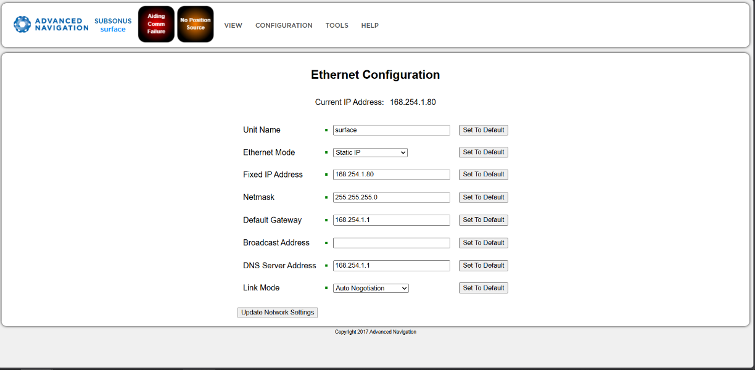
Figure 5 — Subsonus USBL Ethernet configuration (surface unit).

Safety Systems
A central aim of this stage was for the vehicle to protect itself. Three independent safety mechanisms were implemented, all designed to remain effective even if the link is degraded or lost.
- Leak → auto-surface: On a confirmed leak the guidance node latches an emergency ascent that overrides every other mode, stopping lateral motion and driving the vertical thrusters up to the surface. It runs on the vehicle itself, so it works even if the link drops, and it alerts the operator with a repeated QGC warning.
- Link-loss failsafe: If the operator link goes quiet for more than a few seconds, the thrusters are commanded to neutral, so a lost connection cannot leave the vehicle driving away on its own.
- Attitude safety envelope: Commanded thrust is scaled back when pitch or roll become extreme, reducing the risk of the vehicle tumbling or losing controllability in an unstable attitude.

Design Considerations
- Interoperability: Building on MAVLink and QGroundControl, with a dependency-free Python bridge, lets the vehicle be operated with standard, well-supported tooling and keeps the integration easy to extend (e.g. video, missions, parameter tuning).
- Separation of concerns: Real-time motor and sensor tasks run on the ESP32, while autonomy and telemetry run on the UP Board, placing deterministic control and higher-level computation each where it belongs.
- Autonomy on the vehicle: Guided navigation and the leak failsafe execute on-board, so they continue to work when the communication link is degraded or cut.
- Safety-first defaults: Failsafes fail toward the surface and toward neutral thrust, and the vehicle is motion-free at the surface, making bench and shallow-water testing safe.

Simulation Verification (ROS 2 Gazebo)

Vehicle CAD Model
A full 3D CAD model of the HAUV was built in Autodesk Fusion. It uses off-the-shelf watertight enclosures from Blue Robotics for the electronics and batteries, so those parts can simply be bought, while the rest of the vehicle, the frame, trays and mounts, is simple and can be fabricated easily. This model is the proof-of-concept design for the vehicle, and it was the basis for the Gazebo simulation.
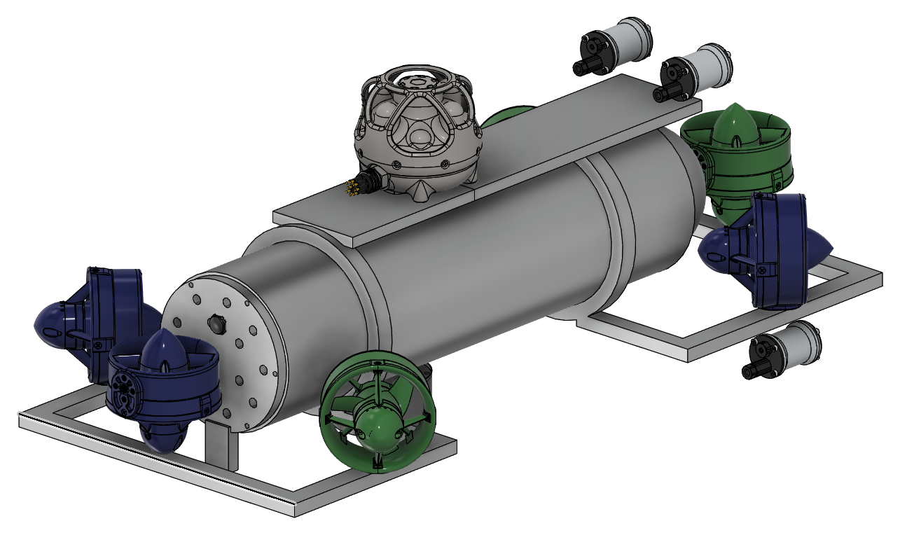
Figure 6 — 3D CAD model of the HAUV (Autodesk Fusion 360).
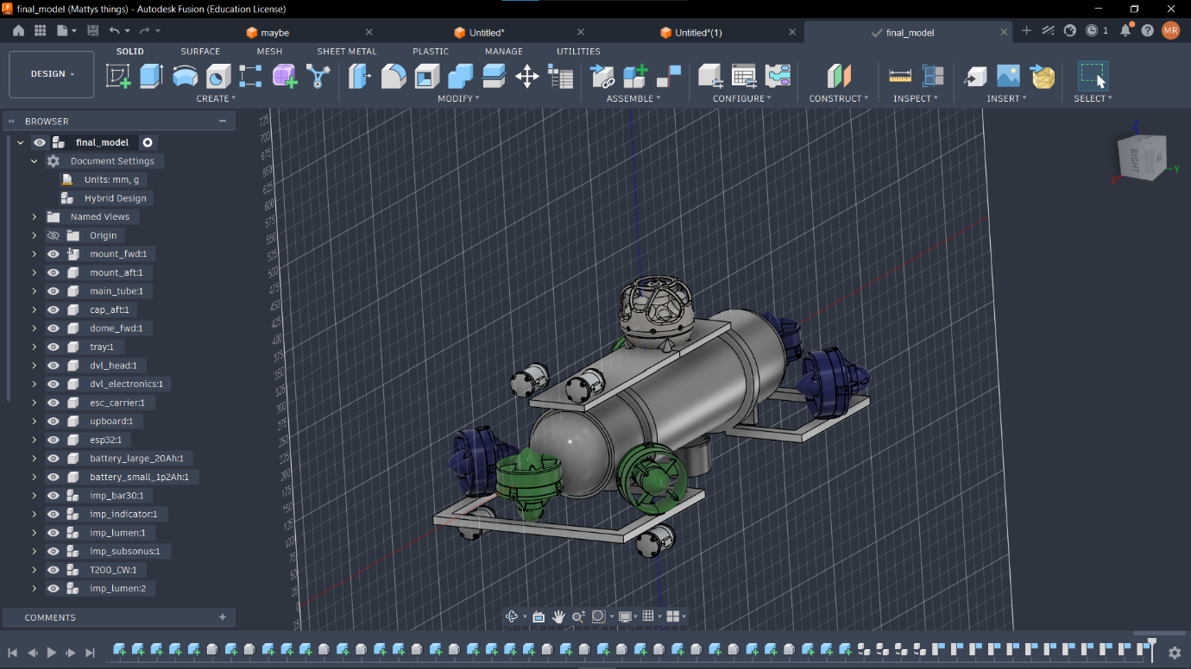
Figure 7 — The CAD assembly in Fusion 360, showing all the vehicle components.
Before any hardware testing, the control software was tested in a Gazebo simulation of the HAUV (the 5-inch, 13.6 kg hull). The same guidance_node that runs on the real vehicle was flown against the model: bridge nodes fed it simulated sensor data and turned its motor commands into thruster forces, so the code could not tell it was not on the real vehicle. A scripted pilot stood in for the operator, and every result below comes from recorded data.
The software was exercised across four scenarios, manual driving, depth hold, autonomous go-to-location and the leak failsafe, and of 24 automated checks, 23 passed. The single failure is deliberate and records a real defect in guidance_node (out-of-range joystick PWM) rather than a problem with the simulation.

Manual Driving
Each stick axis was driven to full deflection in turn. Every command produced motion on its own axis with negligible cross-coupling: forward gave 0.85 m/s of surge, strafe reached 0.88 m/s to port, and a yaw command produced 65 °/s of rotation rather than a strafe, confirming the rear-thruster geometry is correct.
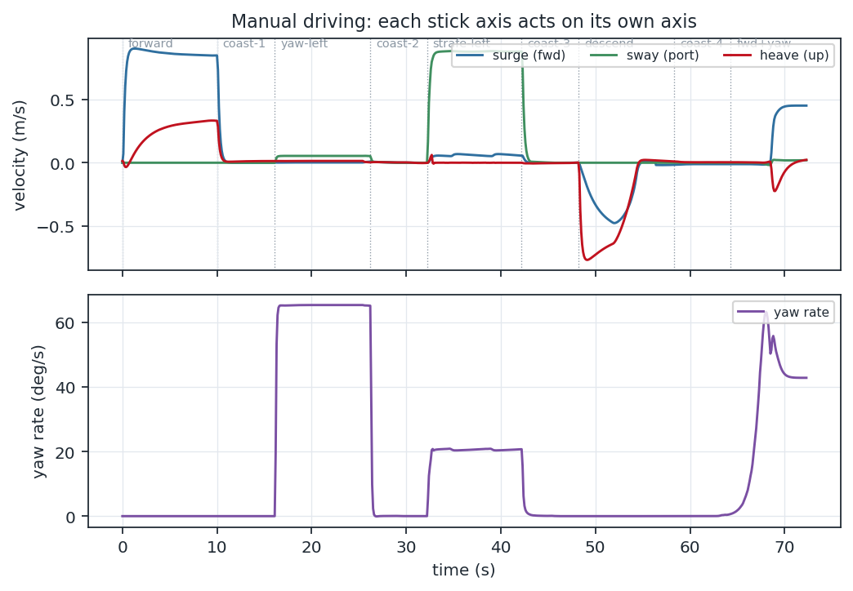
Figure 8 — Body-frame velocities and yaw rate through the manual sequence. Each command acts on its own axis.

Depth Hold
Placed at 6 m and told to hold station, the vehicle isolated the vertical loop. Depth stayed within 0.30 m of the engage depth over 90 s, exactly the no-thrust deadband, and the tightest a deadbanded controller can hold, against the 0.90 m of buoyant rise that would have occurred with no control. Mean vertical-thruster output was 1493 µs, i.e. actively pushing down, confirming the depth-hold gain has the correct sign.
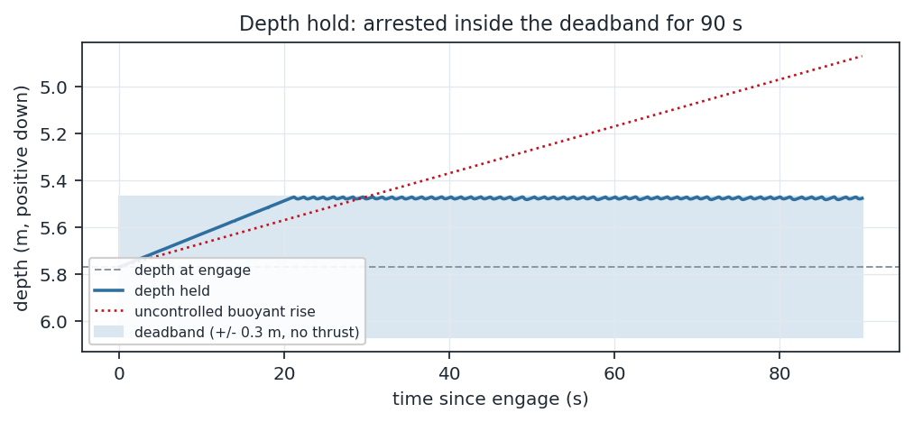
Figure 9 — Depth held inside the deadband over 90 s; the dotted line is the uncontrolled buoyant rise.

Autonomous Go-to-Location
A target was placed 29.1 m away and astern. The vehicle turned the short way round, drove in, ramped down on approach and closed to 1.49 m in 57 s, with zero backtrack over the entire transit. Depth varied by only 0.32 m while under way, confirming that depth hold works in transit and not only at rest. On arrival the vehicle station-kept for 60 s without leaving the 4 m arrival radius, and a stick deflection returned it cleanly to manual with every motor at 1500 µs.
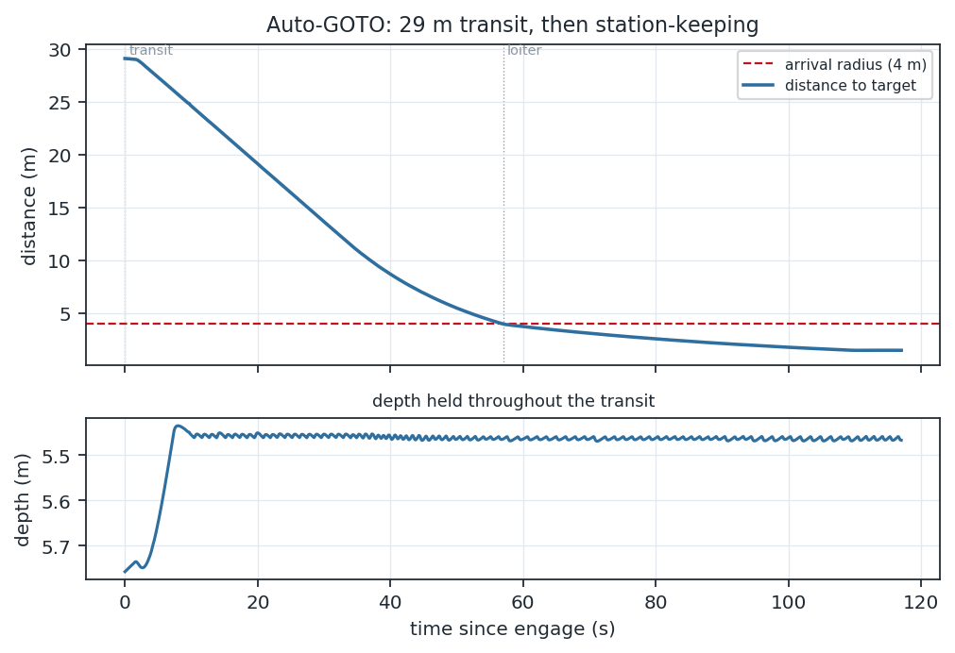
Figure 10 — Distance to target and depth: a 29 m transit in ~57 s, then station-keeping with depth held.
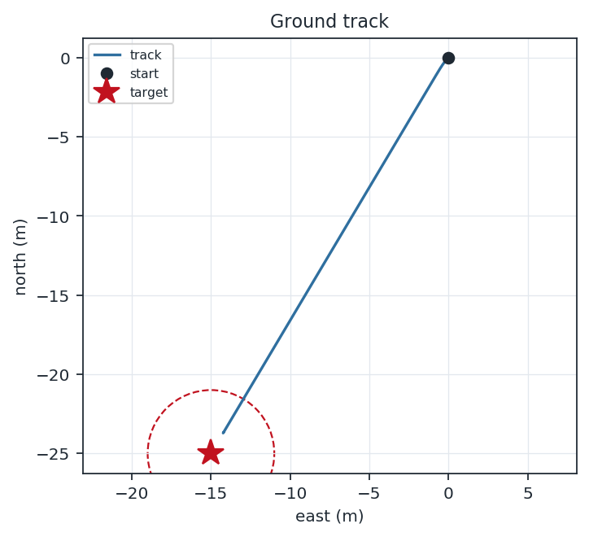
Figure 11 — Ground track in the north-east plane, closing inside the 4 m arrival radius.

Leak Failsafe
A leak was asserted at 7.8 m depth. The failsafe latched after the required two consecutive wet samples and logged “LEAK DETECTED, auto-surfacing”. The horizontal thrusters went to exactly 1500 µs and the verticals to 1820 µs (the commanded 0.8 ascent) until the vehicle reached 0.08 m, whereupon thrust was released and it held at the surface; five seconds of dry readings then auto-cleared it back to manual. The ascent direction proved correct, the vehicle surfaced rather than dived.
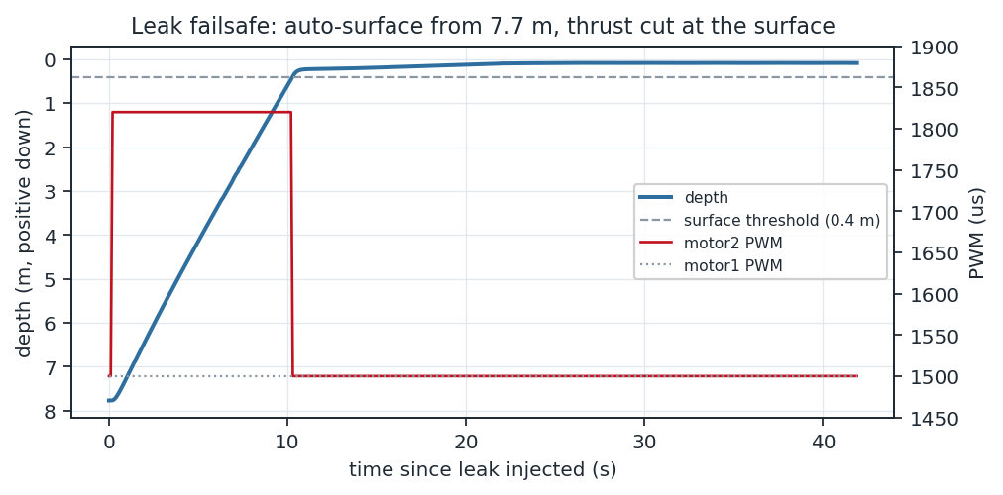
Figure 12 — Leak failsafe: auto-surface from 7.8 m, with thrust cut at the surface.

The Simulated Environment
The figure below shows the hull holding depth in the simulated water column, 801 mm overall, with the vertical thrusters carried on outriggers, and visibility falls off with range by design, with fog applied from 3 m to 35 m.
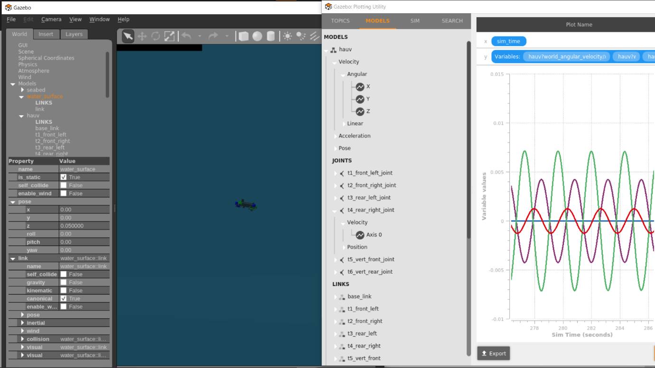
Figure 13 — HAUV simlulated in Gazebo with it's velocity graphs.

Findings and Limitations
Flying the software surfaced one control-software defect. The joystick branch of the motor mixer does not clamp its PWM to the 1100–1900 µs range, full forward combined with full yaw produced 2183 µs, and the firmware silently drops out-of-range commands, which can freeze two of the four horizontal thrusters while turning and driving; this is the single deliberate failing check, fixed with a one-line clamp.
These results bound what can be concluded: drag is linear and isotropic, so the speeds are indicative rather than predictive; the water surface is a rigid slab; no DVL or USBL is simulated, so GOTO navigates on the synthesised GPS fix; and the verified control signs are the model's, not the hardware's.

Final Acceptance Tests
This section describes the experiments used to validate the integrated system, the telemetry link, the sensors, the autonomous Guided mode, the safety failsafes and the acoustic channel. Testing was carried out in the laboratory and on the bench; full underwater testing remains for a future, water-resistant build.
The vehicle's live state was also visualised in RViz: its URDF model, driven by the real-time TF tree from the on-board sensors, gives a 3-D view of the HAUV's orientation and thruster layout during operation (Figure 14).
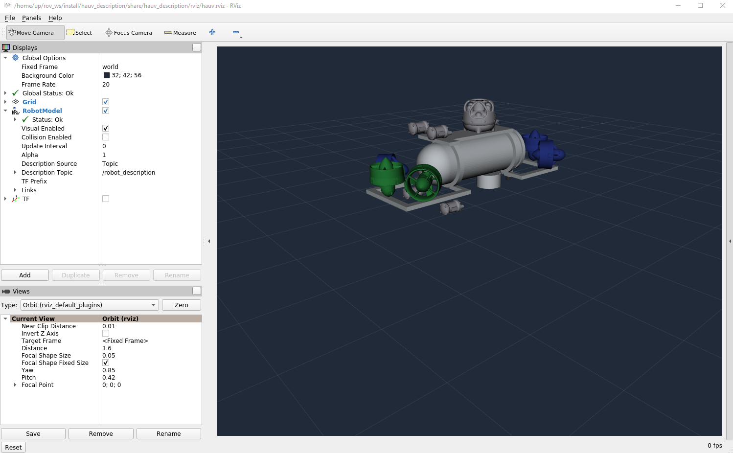
Figure 14 — Live RViz visualisation of the HAUV, driven by the vehicle's URDF model and real-time TF tree.

1. QGroundControl Telemetry and Control
- Telemetry: With QGC connected over Ethernet, the MAVLink Inspector confirmed all four message types arriving at their design rates, HEARTBEAT at ~1 Hz and ATTITUDE, GLOBAL_POSITION_INT and SYS_STATUS at ~20 Hz. The QGC attitude indicator tracked the BNO055 as the vehicle was tilted by hand.
- Control: Joystick input in the QGC Fly view was translated by the bridge into motor commands on /motor_data, and the thrusters responded in real time, confirming the command path QGC → bridge → guidance → ESP32 → motors.
- Auto-discovery: QGC connected without manual pairing, the bridge learned QGC's address from the first packet and replied to it.

2. System Health Check
The hauv.sh check command samples every sensor topic and reports OK / LOW / FAIL together with the measured rate, giving a one-command view of system integrity. A representative result showed the IMU, environmental and leak topics all reporting at ~22 Hz, while the DVL correctly reported FAIL out of water, expected behaviour, as the DVL needs water and a bottom to range against. This test doubles as a fast diagnostic: a genuinely missing sensor is flagged and pointed at its node.

3. Doppler Velocity Log
The DVL was configured through its web interface (network settings and enabled output formats) and its velocity output verified on the /dvl/velocity_data topic, confirming correct parsing and republishing by dvl_node for use by the guidance core and the telemetry bridges.

4. Autonomous Guided Mode (bench-safe)
- Navigation: On a QGC “Go-to-location” command the vehicle entered Guided mode, computed the distance and bearing from its GPS fix to the target, and yawed toward the bearing before driving forward, confirming the full command chain into calculate_goto_motor_speeds.
- Depth hold: Because the depth-hold law keeps the vertical thrusters neutral when the vehicle is at its engaged (surface) depth, the manoeuvre is motion-free vertically on the bench, allowing safe out-of-water testing.
- Aborts: Every abort path was verified to return the vehicle to Manual with motors neutral, any joystick deflection, a switch to Manual mode, a comms timeout, or a target beyond the maximum range.

5. Leak Auto-Surface Failsafe
The failsafe was exercised safely by injecting a simulated leak at the surface. The guidance log showed the expected sequence, the leak latching the emergency auto-surface (“LEAK DETECTED”) and, once the sensor read dry again, auto-recovering (“Leak cleared”). Because the vehicle was at the surface, the vertical thrusters stayed neutral, so the test was motion-free, and the emergency alert was raised in QGC.

6. Acoustic (USBL) Link
Over the acoustic bridge, QGC operated the vehicle using the compact telemetry packet, and loss of the acoustic link was annunciated to the operator. As the navigation runs on the UP Board, the acoustic link is only needed to send a target and to abort, not throughout the run, which keeps the untethered mode robust to intermittent acoustic conditions.

Problems and Solutions
Several substantial engineering problems had to be solved during this stage, spanning software, sensors, communication and hardware reliability.

1. Broken sensor logic and cluttered ROS communication
- Problem: The inherited codebase had broken sensor logic and a cluttered set of ROS topics, which made the vehicle's state hard to trust and to debug.
- Solution: After building working proficiency in ROS 2, the codebase was refactored: the broken sensor logic was restored, unused topics were pruned, and a dedicated temperature topic was added new brand new adafruit BME sensor. This produced a clean, reliable data flow that the new autonomy and telemetry features could build on.

2. Running all sensors at once on a single I²C bus
- Problem: The sensors could not all be operated simultaneously, the initial wiring was limited to three devices, which was insufficient for the full sensor suite.
- Solution: A dedicated I²C breakout board was added, allowing the BNO055, BAR100 and BME280 to share the bus and operate together. A BMP280/BME280 hardware mismatch was also identified and the drivers updated and later relaced with a roer adafruit as it its i2c address couldn’t be realce and was identical to the bno.

3. Unreliable debugging and power during development
- Problem: An interfering LCD screen and an unstable battery supply made bench development unreliable.
- Solution: The LCD was replaced with a stable UART debug channel (a dedicated FTDI serial line), and the development setup was powered from a wall charger instead of the battery, giving a stable and repeatable bench environment.

4. Accurate underwater velocity
- Problem: Deriving velocity by integrating accelerations accumulates drift and is impractical for navigation.
- Solution: A dedicated I²C breakout board let the BNO055, BAR100 and BME280 share the bus. A BMP280/BME280 mismatch was corrected in the drivers, and the environmental sensor was later swapped for an Adafruit board after its fixed I²C address was found to clash with the BNO055.

5. MAVLink Bridge
- Problem: Building a MAVLink bridge that QGroundControl will accept is non-trivial, since QGroundControl is designed for aerial drones rather than underwater vehicles.
- Solution: The MAVLink bridge was written to present the vehicle as an ArduSub device, which unlocks QGroundControl's built-in underwater (submarine) capabilities.

6. Incompatible Python libraries
- Problem: The Subsonus and DVL Python libraries were incompatible with the HAUV's Python version.
- Solution: Bespoke scripts were written to communicate with the devices directly, reusing the relevant code from the vendor libraries. This removed the Python-version dependency and left the codebase cleaner and easier to maintain.

7. Persistent ESP32 lock-up
- Problem: The ESP32 would intermittently lock up, its indicator LED going solid while all sensor topics died, the moment the software stack started, taking every sensor down with it.
- Solution: Two root causes were found and fixed. A failing BAR100 depth sensor was pulling the I²C bus low and freezing the firmware on its first read (only after the micro-ROS agent connected); and the start-up script's reset pulse never actually reset this board, so it was swapped for an esptool hard reset, the only software reset it honours, letting the stack restart cleanly without a manual button press.

8. Work halted due to the Iran War
- Problem: From March to mid-July the war with Iran closed the campus and called me up for reserve duty, so lab work stopped for several months.
- Solution: While the lab was closed I worked on the parts that did not need it, the Gazebo simulation and the CAD model and returned to on-site work once the campus reopened.

Recommendations and Conclusions

Summary of Work
This stage advanced the HAUV from a bench prototype into an operable, autonomous and self-protecting vehicle. It was integrated with QGroundControl through a custom MAVLink bridge; an autonomous Guided (go-to-location) mode was added; an untethered acoustic (USBL) control channel was implemented; a Doppler Velocity Log was integrated for velocity measurement; and on-board leak, link-loss and attitude failsafes were built. These capabilities rest on substantial systems-integration and reliability work: refactoring the codebase, building a custom I²C breakout board, and diagnosing and resolving a persistent ESP32 lock-up. As in the earlier stage, the vehicle has not yet been deployed in a water-resistant enclosure, so live underwater testing remains incomplete.

Comparison of Results with Project Goals
The four project goals were largely met in the laboratory and on the bench. QGC connects automatically and displays all four telemetry streams at their target rates, with joystick input driving the thrusters (Goal 1). Guided mode computes the bearing and distance to a selected target and drives toward it with depth hold and station-keeping, aborting safely on operator input or link loss (Goal 2). The acoustic bridge carries the same telemetry and commands without a cable (Goal 3). The leak auto-surface, link-loss failsafe and single-command operation were demonstrated on the bench (Goal 4). What remains unverified is the vehicle's behaviour in the water: two navigation sign conventions (yaw and depth direction) are one-line flips to confirm during the first in-water run, and full underwater performance is still to be validated.

Advantages and Disadvantages
Advantages:
- Operable with standard, off-the-shelf tools (QGroundControl over MAVLink).
- Two control links, a wired tether with full telemetry and video, and an untethered acoustic link.
- On-board autonomy and failsafes that keep working when the operator link is degraded or cut.
- Modular, refactored software with a single-command operating and diagnostics tool.
Disadvantages:
- Not yet water-resistant, so real-world underwater applicability is unverified.
- Surface station-keeping is only as tight as the GPS fix; underwater USBL positioning would be tighter.
- The acoustic link carries only compact telemetry and no video.

Recommendations for Future Work
- Water-resistant enclosure and live underwater trials to validate navigation, depth hold and the failsafes in the water, including the two sign-convention checks.
- Underwater positioning: feed USBL/DVL-based position into the navigation core (replacing the surface-GPS origin) for tight underwater station-keeping.
- Mission planning: extend the MAVLink bridge with waypoint missions and parameter tuning through QGC.
- A two-LED status subsystem and a power-cycle-capable hardware watchdog for the ESP32 to enable automatic recovery from a lock-up.
- Video or richer telemetry over the acoustic path through improved compression.

Conclusions
This project turned the HAUV into a vehicle that can be flown from a standard ground station over either a wired or a wireless link, navigate autonomously to a target, and protect itself in a fault. Combined with a refactored and more reliable software base, the platform is now a solid foundation for the remaining step: a water-resistant build and live underwater validation.

References
- Ewart, T. E., “Observations from Straight Line Isobaric Runs of SPURV,” Joint Oceanography Assembly, Edinburgh (UK), 13 Sep. 1976.
- Blue Robotics, “BlueROV2 – Underwater ROV.” [Online]. Available: https://bluerobotics.com/store/rov/bluerov2/ (accessed Nov. 15, 2024).
- J. J. Leonard and A. Bahr, “Autonomous Underwater Vehicle Navigation,” in Springer Handbook of Ocean Engineering, 2016, pp. 341–358.
- R. V. Aroca and L. M. G. Gonçalves, “Towards green data centers: A comparison of x86 and ARM architectures power efficiency,” Journal of Parallel and Distributed Computing, vol. 72, no. 12, pp. 1770–1780, 2012.
- G. Andreescu, C.-D. Căleanu and S. Nanu, “Simulation environment for mobile robots testing using ROS and Gazebo,” in Proc. 20th Int. Conf. System Theory, Control and Computing (ICSTCC), Sinaia, Romania, 2016, pp. 329–334.
- C. Ramirez-Atencia and D. Camacho, “Extending QGroundControl for Automated Mission Planning of UAVs,” Sensors, vol. 18, no. 7, p. 2339, 2018.

Appendices

Appendix A — Operating the vehicle (hauv.sh)
The entire software stack is run and inspected through a single management script on the UP Board.
Command | Action
./hauv.sh start [--ethernet | --acoustic] | Start the full stack (default: Ethernet / tethered)
./hauv.sh stop | Stop everything
./hauv.sh restart [--ethernet | --acoustic] | Stop, then start
./hauv.sh check | Sample every sensor topic and report OK / LOW / FAIL with rate
./hauv.sh status | List the running node sessions
./hauv.sh topics | List live topics with their short names
./hauv.sh echo <NAME|/topic> | Stream one topic's values (e.g. echo DEPTH)
./hauv.sh view <node> | Attach to a node's log (Ctrl-A D to detach)

Table A1, hauv.sh operating commands

Appendix B — QGC MAVLink telemetry messages
Message | Rate | Source | Fields
HEARTBEAT | 1 Hz | Bridge | Vehicle type, armed state, mode
ATTITUDE | 20 Hz | BNO055 | Roll, pitch, yaw
GLOBAL_POSITION_INT | 20 Hz | DVL | Position, velocity, heading
SYS_STATUS | 20 Hz | Sensors | Battery, sensor health, error counts
MANUAL_CONTROL (in) | event | QGC | Joystick axes → motor PWM on /motor_data

Table B1, MAVLink messages exchanged with QGroundControl

Appendix C — Connecting QGroundControl
Over Ethernet (normal): set the operator PC to 192.168.168.100 (netmask 255.255.255.0), verify with ping 192.168.168.101, then add a UDP comm link to 192.168.168.101:14550. Turn QGC's UDP AutoConnect off so it does not grab the wrong endpoint.
Over acoustic (untethered): with both Subsonus modems in the water, start the vehicle with ./hauv.sh start --acoustic, run one instance of the PC-side acoustic bridge, and point QGC at a UDP link to 127.0.0.1:14551. Telemetry is compact and there is no video on the acoustic link.

Appendix D — HAUV Operator's Manual
HAUV, Hybrid Underwater Vehicle, Operator's Manual
How to set up, drive and look after the HAUV
Draft v1.0, 19 July 2026
This manual is written in simple language on purpose. Read Chapter 2 (Safety) before you touch the vehicle. Proprietary document, do not share outside the team.

1 About the HAUV

1.1 What the HAUV is
The HAUV is a small underwater robot. You drive it from a laptop on the shore or on a boat. It can also drive itself to a point on the map. In simple words:
- You look at a screen. The screen shows a map, a video picture and numbers.
- You hold a game controller. You push the sticks. The robot moves.
- If you want, you click a point on the map. The robot swims there by itself.

1.2 The two computers inside
The HAUV has two computers. They do different jobs. It helps to know which one does what when something goes wrong.
Computer | What it does
UP Board | The “brain”. It thinks. It talks to your laptop, reads the GPS and the DVL, decides where to go, and runs the safety rules.
ESP32 | The “muscles”. It turns the motors, switches the lights, and reads the depth sensor, the compass and the leak sensor.

The two computers talk to each other over a small cable inside the vehicle. If that link breaks, the green light on the ESP32 goes off (see Chapter 10).

1.3 The main parts
Figure 1.1 shows the vehicle with the main parts numbered. The numbers match the table below.
# | Part | What it is for
1 | Subsonus (USBL modem) | Talks to the surface with sound, so the vehicle can be controlled with no cable.
2 | Electronics tray | Holds the two computers and the boards. See Section 1.4.
3 | Lights | Two sets of lamps. You switch them from the controller.
4 | Thrusters | The propellers that move the vehicle.
5 | Camera | Sends the live picture to your screen.
6 | DVL | Measures speed over the sea floor.

1.4 Inside the vehicle — the electronics
Figure 1.2 shows the electronics tray with the main boards numbered. You do not need to touch these to drive the vehicle. It helps to know where they are when something stops working.
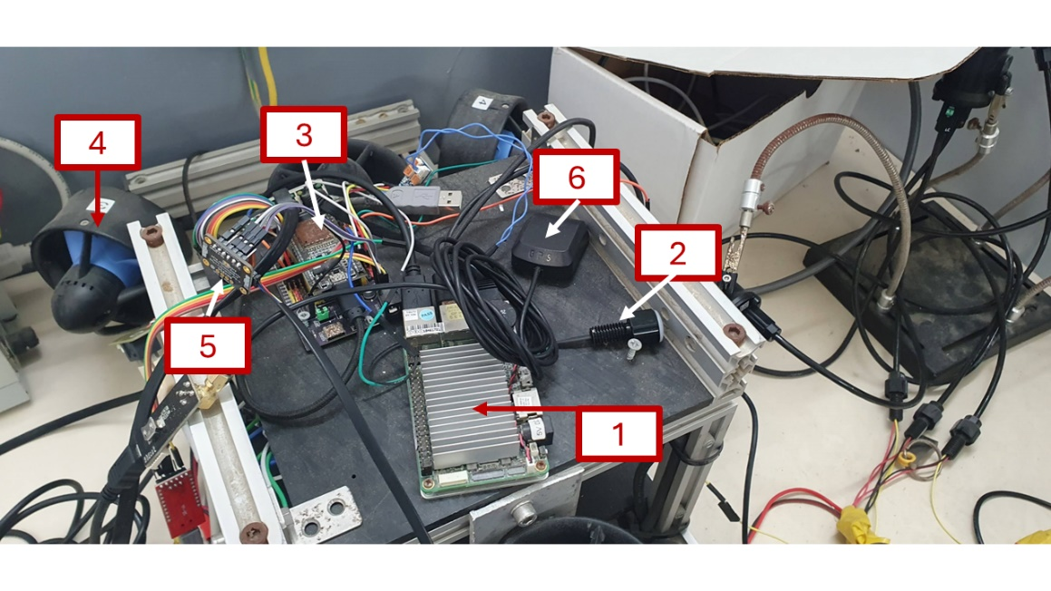
Figure 1.2: The electronics tray. The numbers match the table below.
# | Part | What it is for
1 | UP Board | The “brain”, the board with the big metal heatsink.
2 | Indicator light | The status light. Tells you if the two computers are talking. See Chapter 10.
3 | ESP32 | The “muscles”, the board with the coloured wires.
4 | Thruster | One of the propellers.
5 | I2C connector | Goes to the temperature sensor.
6 | GPS antenna | The small black square marked GPS. Gives the position on the surface.

1.5 What you need before you start
1. The HAUV vehicle, charged.
2. A laptop with QGroundControl installed. We call it QGC.
3. An Xbox-style game controller, plugged into the laptop.
4. A network cable (for the cable mode), or the two Subsonus modems (for the sound mode).
5. A bucket of fresh water for washing the vehicle after the dive.

2 Safety First
Warning! The propellers can cut your fingers. They can start turning at any time when the vehicle is powered on. Keep hands, hair and clothes away.

2.1 The golden rules
1. Never stand next to the propellers when the vehicle is powered on.
2. Always power the vehicle off before you carry it.
3. Do not open the vehicle when it is wet. Dry the outside first.
4. Do not run the thrusters in air for a long time. They need water to stay cool.
5. If you see water inside, stop. Take the vehicle out. Dry it. Find the leak.
6. Do not charge a battery that is hot or damaged.
7. One person drives. One person watches the vehicle and the cable.

2.2 Before every dive
1. Look at the vehicle. Are all screws in place? Is anything broken?
2. Check that all plugs are pushed in fully.
3. Check that the lid is closed and tight.
4. Check the battery is charged.
5. Check the propellers turn freely and nothing is stuck in them.
Note. If anything looks wrong, do not dive. It is always cheaper to fix it on the table than at the bottom of the sea.

3 Network Setup
The laptop, the vehicle and the sensors all talk over a network. Each one has its own address. The addresses must be correct or nothing will connect.

3.1 The addresses
Device | Address | Notes
Your laptop (QGC) | 192.168.168.100 | You set this by hand.
UP Board (the brain) | 192.168.168.101 | Fixed. Do not change.
DVL | 192.168.168.102 | Fixed. Do not change.
Subsonus on the surface | 168.254.1.80 | Only for the sound mode.

3.2 Setting your laptop address
1. Open Network settings on your laptop.
2. Find the wired (Ethernet) connection.
3. Choose Manual / Static address.
4. Type address 192.168.168.100 and mask 255.255.255.0.
5. Save.
Tip. To test it, open a terminal and type ping 192.168.168.101. If you get replies, the network is good. If you get nothing, check the cable and the address.

4 Connecting QGroundControl
There are two ways to talk to the HAUV:
Way | When to use it
Cable (Ethernet) | Normal work. Fast. You get video and all the numbers.
Sound (Acoustic / USBL) | When the vehicle is under water with no cable. Slow. No video. Only the important numbers.

4.1 Connecting with a cable (Ethernet)
This is the normal way. Do this first when you are learning.
1. Plug the network cable between the laptop and the vehicle.
2. Power the vehicle on.
3. Open QGroundControl on the laptop.
4. Click the Q logo in the top left corner, then Application Settings.
5. Choose Comm Links on the left.
6. Click Add.
7. Fill in the window: Name: HAUV UP Board; Type: UDP; Port: 14550; Server Address: 192.168.168.101:14550, then press Add Server.
8. Click Save.
9. Select HAUV UP Board in the list and click Connect.
Note. Turn AutoConnect to UDP off on the General page. If you leave it on, QGC may connect to the wrong thing and the vehicle will look dead. When it works you will see the vehicle appear on the map and the numbers at the bottom of the screen will start moving.

4.2 Connecting with sound (Acoustic / USBL)
Use this when the vehicle is under water and there is no cable. It is slower. You will not get video. You need two Subsonus modems: one on the surface (in the water, next to you) and one on the vehicle.
1. Put the surface modem in the water. It must be in the water to work.
2. Power both modems on.
3. Open the surface modem page in a web browser. Check the settings match Figure 4.2 (address 168.254.1.80).
4. On the vehicle, start the system in sound mode (see Section 5.3).
5. On the laptop, run the bridge program once: python tools/acoustic_qgc_bridge.py
6. In QGC, connect to 127.0.0.1:14551.

Figure 4.2: The Subsonus surface unit settings page. The address must be 168.254.1.80.
Warning! Run only one copy of the bridge program. If you start it twice, the commands fight each other and the vehicle behaves strangely.
Warning! Both modems must be in the water. Out of the water they cannot hear each other and you will see ACOUSTIC LINK LOST on the screen.

4.3 DVL settings (for reference only)
The DVL is already set up. You do not normally touch it. Figure 4.3 shows the correct settings, in case you ever need to check them.

Figure 4.3: DVL network page. Address 192.168.168.102, command port 1033, outputs PD0 and PD6 switched ON.

5 Starting the HAUV

5.1 The batteries
The HAUV runs on two 12 V lithium battery packs, shown in Figure 5.1. One pack feeds the computers, the other feeds the thrusters. The thick red and black wires join them to the vehicle with yellow plugs.

Figure 5.1: The two 12 V battery packs and how they connect. Red is plus (+), black is minus (–). The small green board is the voltage converter that drops 12 V down for the electronics.
Connecting a battery:
1. Check the vehicle is switched off first.
2. Match the colours: red to red, black to black.
3. Push the yellow plug straight in until it clicks. Do not force it sideways.
4. Check nothing is loose and no bare metal is showing.
Warning! Never join red to black. A short circuit makes a big spark, ruins the battery and can start a fire.
Warning! Do not charge a battery that is hot, swollen or damaged. Do not leave batteries charging without somebody nearby.
Note. Charge both packs after every dive. A pack left flat for a long time can be damaged for good.

5.2 Power on
1. Check Chapter 2 again. Hands away from the propellers.
2. Switch the vehicle on.
3. Wait about 30 seconds. The computers need time to wake up.

5.3 Starting the software
All the software is started with one tool called hauv.sh. You run it on the UP Board (the vehicle's brain), through a terminal.
Command | What it does
./hauv.sh start | Starts everything, cable mode. This is the normal one.
./hauv.sh start --acoustic | Starts everything, sound mode (no cable).
./hauv.sh stop | Stops everything.
./hauv.sh restart | Stops, then starts again.
./hauv.sh check | Tests every sensor and says OK or FAIL.
./hauv.sh status | Shows what is running.
./hauv.sh topics | Lists the live data channels.
./hauv.sh echo DEPTH | Shows live values, for example the depth.
./hauv.sh view mavlink | Opens the log of one program. Press Ctrl+A then D to leave.
./hauv.sh help | Shows help and the short names.

5.4 Check everything works
Before you put the vehicle in the water, run ./hauv.sh check. It tests each sensor for a few seconds and prints OK, LOW or FAIL.
Result | Meaning
OK | Good. Nothing to do.
LOW | The sensor works but sends data slowly. Usually still fine.
FAIL | No data at all. Fix this before diving.
-- | This sensor only sends data sometimes. Not a problem.

Note. The DVL will say FAIL when the vehicle is out of the water. This is normal. The DVL needs water and a sea floor to see. It will work once you are in the water.

6 Reading the Screen
The main QGC screen is called the Fly View. This is what you look at while driving.

6.1 The parts of the screen
Where | What it shows
Middle | The map. The small vehicle symbol is your HAUV.
Top, yellow or red bar | Warning messages. Read these. See Section 6.3.
Bottom left | The camera picture. Says “WAITING FOR VIDEO” if there is none.
Bottom right | The numbers: depth, roll, temperature, speed, position, time.
Far bottom right | The compass. Shows which way the vehicle points.
Left side | Buttons: Land, Return, Pause, Actions.
Top right | Video record and photo buttons, and the settings gear.

6.2 The numbers you must watch
Number | Why it matters
Depth | How deep you are, in metres. Watch this all the time.
Roll | How much the vehicle is leaning. A big number means it is tipping over.
Ground Speed | How fast you are moving.
Latitude / Longitude | Where you are on the map (surface only).
Temperature | The water temperature.

6.3 Warning messages
Messages appear in a coloured bar at the top of the screen. Red and yellow ones are important.
Message | What to do
LEAK! Auto-surfacing | Most serious. Water is inside. The vehicle is already swimming up by itself. Get it out of the water. See Section 9.1.
ACOUSTIC LINK LOST | The sound link stopped. Check both modems are in the water and powered. See Chapter 12.
FAIL: ... | A sensor stopped working. The name after FAIL is the sensor.

Note. The leak message repeats every 3 seconds while the leak is there, so you cannot miss it.

7 Driving the HAUV

7.1 The controller
Hold the controller with both hands. The two sticks do the moving.
# | Control | What it does on the HAUV
3 | Left stick | Up / down: move forward and backward. Left / right: slide sideways (crab). The nose keeps pointing the same way.
1 | Right stick | Left / right: turn left and right. Up / down: go up and down in the water.
A | A button | Switch one set of lights on and off.
B | B button | Switch the other set of lights on and off.
5 | LB shoulder | Tilt the camera up.
10 | RB shoulder | Tilt the camera down. (This button also switches the mode.)

The parts not used for driving are: 2 (D-pad), 4 (Back), 6 and 9 (the two triggers), 7 (Xbox button), 8 (Start), and the X and Y buttons.
Tip. Push the sticks gently. Small movements are enough. The vehicle is heavy and keeps moving after you let go.

7.2 Your first drive
1. Put the vehicle in the water. Hold it until you are ready.
2. Check the screen. The depth should be near 0.
3. Push the left stick forward a little. The vehicle should move forward.
4. Pull it back. The vehicle should stop and go back.
5. Turn with the right stick. Watch the compass move.
6. Push the right stick down a little to go deeper. Watch the depth number grow.
Warning! Always know where the vehicle is. If you cannot see it and the screen is frozen, stop and bring it back.

8 Flight Modes
The vehicle has three modes. You change them in QGC, at the top of the screen.

8.1 Manual
You control everything with the controller. The vehicle does only what you tell it. Use this most of the time.

8.2 Stabilize
The vehicle tries to stay level by itself. You still drive it. Use this if the vehicle is rolling or tipping too much.

8.3 Guided — “Go to location”
The vehicle drives itself to a point you choose on the map. It keeps its depth on the way, and when it arrives it stays there instead of drifting away.
How to use it:
1. Make sure the vehicle has a GPS position (it must be on the surface).
2. On the map, click the place you want to go.
3. Choose Go to location.
4. The vehicle turns towards the point, then swims to it.
5. When it arrives, it stays there and holds its position and depth.
How to stop it (any of these work): move any stick on the controller; change the mode to Manual in QGC; or if the link is lost for 5 seconds, the vehicle stops by itself.
Warning! This only works on the surface for now, because it uses GPS. Under water there is no GPS.

9 Safety Features
These work by themselves. You do not switch them on.

9.1 Leak — the vehicle swims up by itself
If water gets inside, the leak sensor sees it. Then: the vehicle stops all sideways movement; it drives its up/down thrusters to go up to the surface; it stays on the surface; and your screen shows LEAK! Auto-surfacing in red, again and again.
This ignores everything else. Even if you are driving, or the vehicle is going to a point by itself, the leak wins and the vehicle goes up.
What you must do: do not fight it, let it come up; take the vehicle out of the water; dry the outside, then open it and find the water; do not dive again until you find why water came in.
Note. This works even if the cable or the sound link is broken. The decision is made inside the vehicle, not on your laptop.
Note. When the sensor is dry again for 5 seconds, the vehicle gives control back to you automatically. If the sensor stays wet, it stays on the surface, that is on purpose.

9.2 Lost control link
If the vehicle stops hearing your controller for about 1.5 seconds, it sets all thrusters to stop. It will not keep driving away with the last command.

10 Indicator Lights
There is a small green light on the electronics board inside the vehicle. It tells you if the two computers are talking to each other.
Green light | Meaning
On, steady | Good. The two computers are talking. Sensors and motors work.
Off | Bad. They are not talking. The motors will not answer. See Chapter 12.

Note. Just after you switch the vehicle on, the green light is on for a short time before the connection is really made. Wait about 30 seconds before you trust it.

11 After the Dive
1. Bring the vehicle out of the water. Two people if it is heavy.
2. Switch the vehicle off.
3. Wash the outside with fresh water. Salt water eats metal.
4. Pay attention to the propellers. Remove weed, sand and plastic.
5. Dry the vehicle with a cloth.
6. Only when it is dry outside, open it and check for water inside.
7. Charge the battery.
8. Copy any recorded data off the vehicle.
Warning! Never put the vehicle away wet or with a flat battery.

12 Troubleshooting

12.1 Common problems
Problem | What to try
QGC does not connect | 1. Check the network cable. 2. Check your laptop address is 192.168.168.100. 3. ping 192.168.168.101. 4. Check the link settings match the QGC Edit-Link window. 5. Turn AutoConnect UDP off in QGC.
Vehicle shows on screen but nothing moves | The two computers are not talking. Check the green light (Chapter 10). Restart with ./hauv.sh restart.
No video picture | Video only works over the cable, never over sound. Check the cable mode is running.
DVL says FAIL | Normal out of the water. If it still fails in the water, check the DVL settings.
ACOUSTIC LINK LOST | 1. Both modems must be in the water. 2. Check both are powered. 3. Check only one bridge program is running on the laptop. 4. Check the surface modem address (168.254.1.80).
Some sensors say FAIL | Run ./hauv.sh check to see which. Restart with ./hauv.sh restart. If it still fails, the sensor or its plug is bad.
Vehicle drifts away in Go to location | The GPS is only accurate to a few metres. This is normal. Take manual control if you need to be exact.
Vehicle keeps swimming up and will not stop | This is the leak failsafe. There is water inside. See Section 9.1. Get it out of the water.

12.2 Useful checks
Command | Use it to
./hauv.sh check | See which sensors are alive.
./hauv.sh status | See which programs are running.
./hauv.sh echo DEPTH | Watch the depth value live.
./hauv.sh echo LEAK | Check the leak sensor (0 = dry, 1 = water).
./hauv.sh view guidance | Read the messages from the driving program.
./hauv.sh restart | The general “switch it off and on again”.

Tip. If you are lost, ./hauv.sh restart fixes most software problems. It does not fix broken cables or wet electronics.

Appendix E — Project Timeline
The project was carried out by a single student across five phases, from initial design through validation. The planned timeline was as follows.

Phase 1 — Initialisation and Design (October–December 2025)
- Define the system requirements.
- Review the code and components available in the lab.
- Learn the ROS framework.
- Milestone, submission of the Preliminary Design Review (PDR).

Phase 2 — Simulation and Physical Setup (December 2025–January 2026)
- Set up the software development environment in Linux.
- Learn QGroundControl as the communication framework.
- Implement basic control and operation in the simulation.

Phase 3 — Core Development (January–March 2026)
- Develop the drivers and integrate the sensors.
- Develop autonomous navigation with sensor fusion.
- Integrate the system with QGroundControl for operator control.
- Milestone, readiness of the simulation.

Phase 4 — Hardware Integration and Testing (March–May 2026)
- Finish assembling the electronic stack.
- Dry-test the communication between the HAUV and QGroundControl.
- Milestone, readiness of the hardware.

Phase 5 — Validation and Final Testing (June–July 2026)
- Wet testing in a controlled environment.
- Execute all three modes of control.
- Write the final report.
- Milestone, final project presentation and demonstration of the POC.

Appendix F — Budget Estimation
The budget estimate covers the critical hardware components required for the HAUV proof of concept. All software used is open-source, so no software expenses are incurred, and a 10% contingency was allocated for unforeseen costs. The total estimated budget is USD 16,583.
Item | Qty | Unit Price | Subtotal | Notes
Remotely Operated Vehicle | 1 | $4,900 | $4,900 | Blue Robotics BlueROV2
Doppler Velocity Log (DVL) | 1 | $8,000 | $8,000 | Teledyne Pathfinder OEM
Thrusters | 6 | $200 | $1,200 | Blue Robotics T200
Electronic Speed Controllers | 6 | $38 | $228 | Blue Robotics Basic ESC
Lights | 2 | $160 | $320 | Blue Robotics Lumen Subsea Light
Ethernet Switch | 1 | $175 | $175 | Blue Robotics
UP Board | 1 | $100 | $100 | Main processing unit
Camera | 1 | $100 | $100 | Blue Robotics Low-Light Camera
Beacon | 1 | $80 | $80 | Blue Robotics
Pan-Tilt Servo | 1 | $64 | $64 | Blue Robotics Camera Tilt Mount
Frames | 1 | $50 | $50 | Aluminium profiles
Leak Sensor | 1 | $35 | $35 | Blue Robotics SOS Leak Sensor
Battery 2 (120,000 mAh) | 1 | $31 | $31 | For motors and lights
ESP32 WROOM & 38-Pin Expansion Board | 1 | $30 | $30 | Real-time microcontroller with additional I/O
Battery 1 (30,000 mAh) | 1 | $25 | $25 | For UP Board, DVL and other components
Indicator | 1 | $15 | $15 | Blue Robotics
Miscellaneous | – | – | $100 | Cables, connectors, etc.
Contingency (10%) | – | – | $1,130 | Covers unexpected expenses
Total Budget |  |  | $16,583

