**Lab_Assignment-3**

**Team-1**

**1)Vinay Maturi**

**2)Dave Walsh**

**Video Link:** <https://youtu.be/u3A_J0uAuG4>

*This part is to implement MapReduce algorithms for finding Facebook Common Friends problems and run the map reduce in Apache Spark.

**Code:**

This is the scala code for fiding common facebook friends in a facebook friends list.

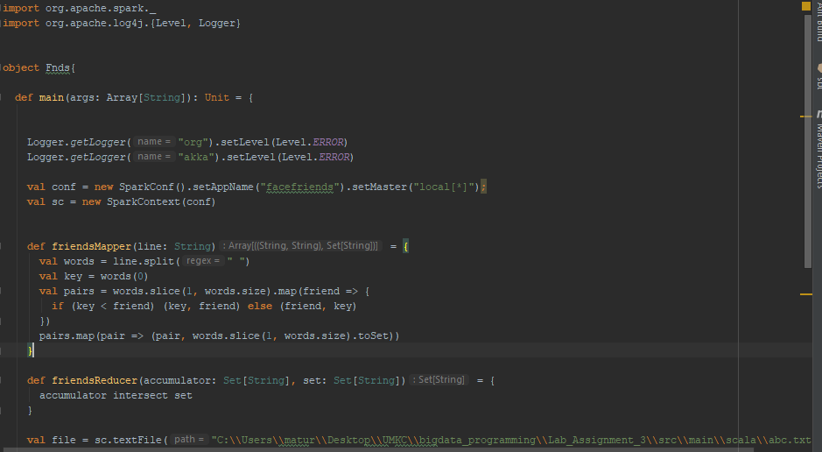

**INPUT:**

The input is taken in the following format

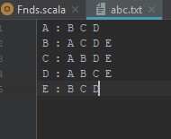

**Output:**

The output describes the common friends of each friend with the other friend.

