**CSEE5590/490: Python and Deep Learning Programming (2018 Fall)**

**LAB ASSGINEMENT 1**

**Team ID:- 13**

**Partner 1:** Kamal Tej Veerapaneni Class id - 31

**Partner 2:** Vinay maturi vinay Class id - 17

YouTube Link: https://youtu.be/DrIvZlsu9jg

**Introduction:**

In this Lab Assignment we have worked on the following tasks.

1)Finding the first non-repeated character in a given string.

2)Removing the content from file_1 which present in file_2

3)List of students who attend “Python Class” but not “web Development”

4)Hospital Management System using various classes and inheritance.

5)Programming a code which downloads the html webpage containing a table using Request Library and then parsing the page using the beautifulsoup library.

**Objectives:**

Applying dictionaries, array, and iterations in strings for finding the first non-repeated characters in string.

Looping, splitting and respective methods are used for removing contents from file_1 which are present in also file_2

Creating 2 lists for each class and then using a loop we can remove the members from python class list who are in common with the web development class.

Using various classes, constructors inheritance and attribute keywords like **kw different sections of the task were completed.

Downloaded the html webpages which contain a table and parsed it using beautifulsoup library.

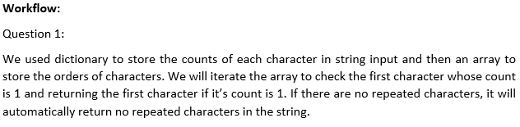

**Code Snippet**

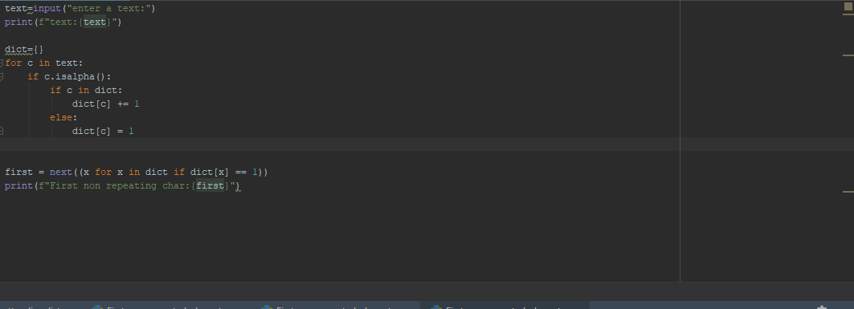

**Output:**



**Question 2:**

Each file is split into words and taken into a single string separately for both the files.

Those strings are split into separate lists where words are stored in lists separately for each string generated from each file.

Once the two lists are generated from the two files, each word from the list_1 is checked with the word list of list_2 and then removed if matched with the list_2 word list.

--File_1 is split into words and stored in

for line in f:  
 str1.append(line.strip().lower())

--File_2 is split into words and stored in

for line in f:  
 str2.append(line.strip())

--List of words are created using the following code.

s1=list(str1[0].split(" "))

s2=list(str2[0].split(" "))

Using 2 for loops the common words of list_1 will be removed by matching with the list of words of List_2.

**CODE:**

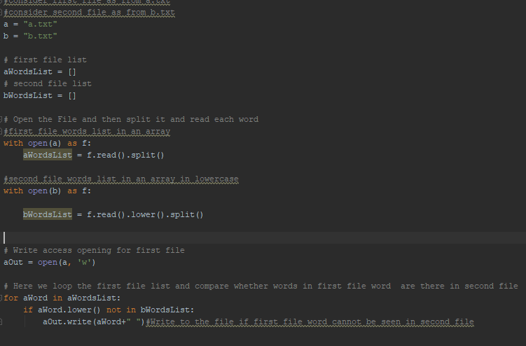

**Output:**



**Question 3:**

In this section we are taking the list of students of Python and Web_Devolopment classes separately into two lists using “while” loop. Next using a line of code we found the list of people who attend python class but not web development.

**CODE:**

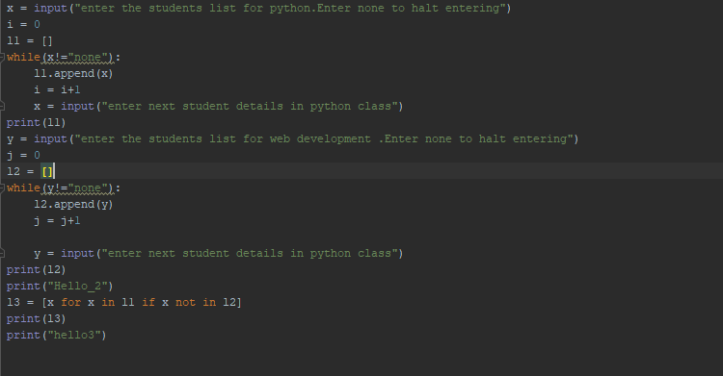

**Output:**

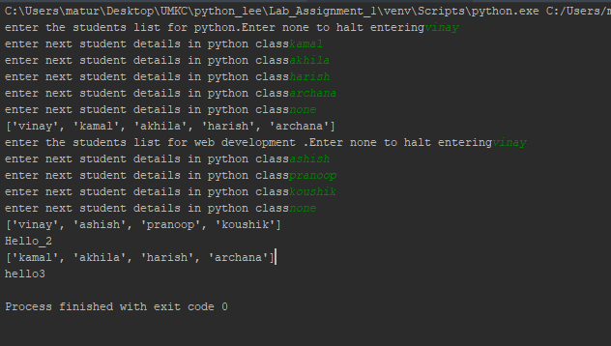

**Question 4:**

In this we have used 5 classes named as Patient, Doctor, Clerk, Nurse, Emergency.

In this we have showed inheritance by taking Patient class as base class and Multiple inheritance is applied Using “Nurse” class with “clerk” and “doctor” class. For passing the arguments in multiple inheritance we have used **super** key word and **\*\*kw**  for passing the arguments as key value pairs.

Along with this we have used private member in base class “Patient” to find out the number of patients received by the doctor.

The code and output are as follows

**Code Snippet:**

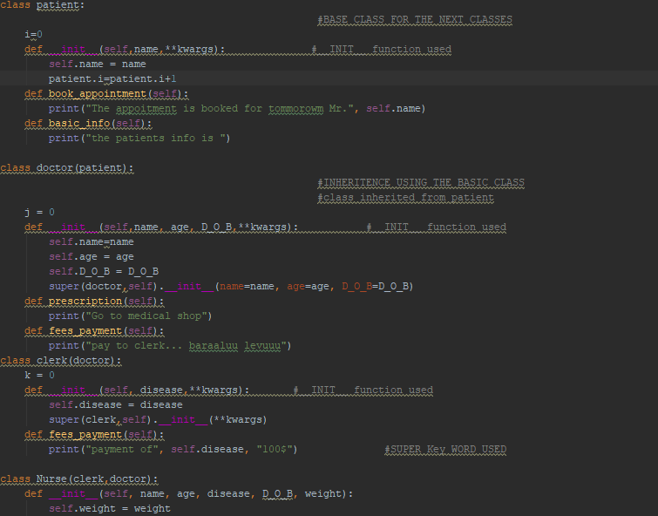

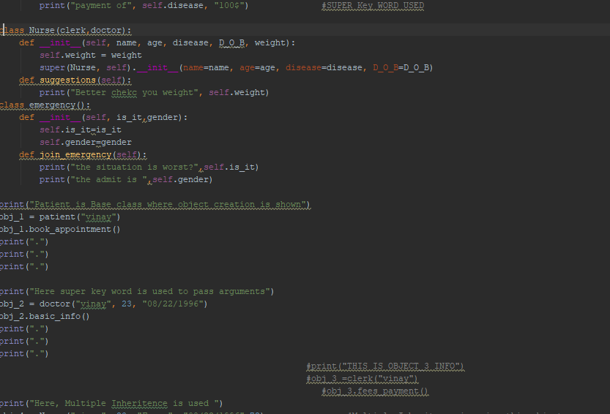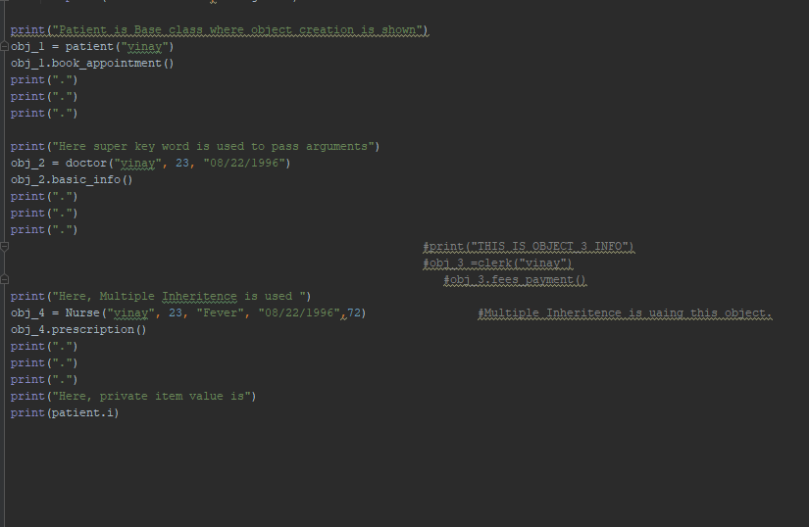

**Output:**

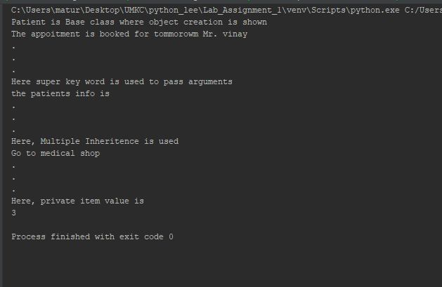

**Question 5:**

In this, we import the url through request library and assign link to a variable and then open the link and converts it in to html using soup = BeautifulSoup(getLink, “html.parser”) and prints the header for the wiki page

**Code Snippet**

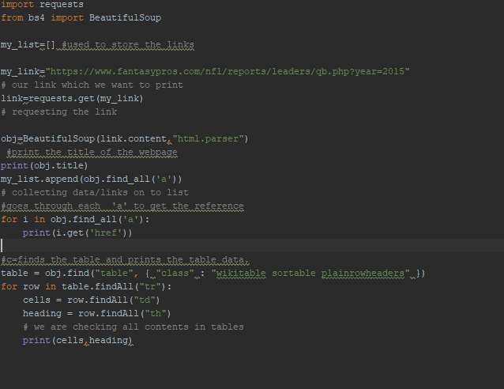

**Output:**

