Speed Limit – roadmap and checklist
Nov 5, 2026 · @M
The MVP with the neural network, router, LLM component and GUI can be finished by Sunday 8 Nov, and the rest (texts, diagrams, presentation) by Friday 13 Nov. With 24.5 available hours from Friday morning, about 18.5 hours go to the project and 6 to studying.

Day-by-day plan
The riskiest part (data and neural network) goes into the Friday four-hour block; texts and diagrams are easier and go into the evenings. From Friday morning 24.5 hours are available (Friday has only a 4-hour block), of which about 18.5 go to the project and 6 to studying for the exam.
Date | Time | What we do | Output
Thursday 5 Nov | 0.5 h | Project folder, package installation, read slides 2–11 and 14–19 of the case study, decide the LLM approach | Environment ready
Friday 6 Nov, morning | 0.5 h | Run the first data exploration (script from Claude), look at the output | Data overview
Friday 6 Nov | 4 h | Data cleaning and imputation, merging sensors and accidents into the hourly table (1.25 h), features and neural network training (1.5 h), router and speed-limit selection (1 h), backup (0.25 h). Router tests and the data class diagram are postponed to later. | Working predict() and router
Saturday 7 Nov | 0 h | School and chauffeur duty
Sunday 8 Nov | 4 h | 4 router tests (0.5 h), air-quality LLM component as a mock (1 h), GUI in Streamlit (1.5 h), end-to-end test (0.5 h), buffer (0.5 h) to finish the neural network if it was not completed on Friday | MVP done
Monday 9 Nov | 3 h | Stakeholders, non-functional requirements, glossary, assumptions (1 h), EU AI Act (0.5 h), 5 LLM component tests (0.5 h), data class diagram and analysis of data errors (0.5 h), year N+1 analysis (0.5 h). No studying. | Slide texts
Tuesday 10 Nov | 3 h | Architecture (training and production), sequence diagram, 5 tests per component, change requests, human-in-the-loop | Diagrams and slide texts
Wednesday 11 Nov | 3 h | Assembling the final presentation and lessons learned (2 h), studying (1 h) | First version of the deck
Thursday 12 Nov | 3 h | Polishing the deck, backup demo video (1.5 h), studying (1.5 h) | Finished deck
Friday 13 Nov | 4 h | Submission (0.5 h), studying (3.5 h) | Submitted
Saturday 14 Nov | – | Exam and presentation, or submission of results if you do not get a turn
If something does not fit in time, cut in this order: 1. backup demo video (screenshots are enough), 2. GUI appearance (a simple form is enough), 3. scope of tests (fewer tests for secondary components). Do not cut studying on Thursday and Friday; the exam is 50 % of the grade.

Task checklist
Each exercise becomes one or two slides in the final presentation.
- ☐ SpeedLimit01: stakeholders
- ☐ SpeedLimit04: EU AI Act (no / yes / yes with measures, with justification)
- ☐ SpeedLimit07: non-functional requirements
- ☐ Complete system requirements, specifications, assumptions and glossary (case study slide 14)
- ☐ Data class diagram and analysis of data errors
- ☐ Data cleaning and imputation (code and description)
- ☐ Feature engineering (inputs, predicted attribute, how they are computed)
- ☐ Neural network training and evaluation
- ☐ SpeedLimit10b: 4 router tests (table)
- ☐ SpeedLimit10c: 5 LLM component tests (input, golden answer, source)
- ☐ SpeedLimit21: architecture (training and production), component names and description, diagram
- ☐ SpeedLimit21: 5 tests for each component and answers to 3 change requests
- ☐ SpeedLimit32b: human-in-the-loop (where and which skills)
- ☐ Sequence diagram
- ☐ Year N+1 analysis: is retraining needed?
- ☐ MVP: GUI with temperature, water and light, production phase
- ☐ Final presentation for management including lessons learned

Tools
VS Code with Python is enough, Word is not needed. Write the results straight into one presentation file so you do not write anything twice.
Purpose | Tool | Installation
Code, data, neural network | Python 3.10 or newer in VS Code | pip install pandas numpy scikit-learn matplotlib streamlit requests
Neural network | MLPRegressor from scikit-learn (sufficient; it is a neural network, TensorFlow is not needed) | in the packages above
GUI | Streamlit | in the packages above
LLM component | API key for an LLM (OpenAI or Anthropic), or a mock without a key | pip install openai or anthropic, key in the file .env
Diagrams | Mermaid (I write it for you, you view it at mermaid.live) or diagrams.net | nothing, runs in the browser
Final presentation | PowerPoint | you have it
Notes | Slides with speaker notes | nothing

What is unusual in the data
Findings from the supplied CSV files. Case study slide 17 lists errors, but most of them are not present in these files, so base the analysis on the actual data.
- Years N and N+1 have identical sensor readings. The sensor file for year N+1 is, apart from the header, byte-for-byte identical to the one for year N. The only difference is in the accidents (997 records in year N, 844 in year N+1). Retraining must be judged by the accidents, and this must be stated in the presentation.
- Errors from slide 17 that are present: sensor 19 has no description, sensors 7, 10 and 17 have no readings, code T appears twice in SensorTypes (temperature and traffic), the data contains only January, wind direction is non-zero even at zero wind speed.
- Errors from slide 17 that are not present: missing readings, duplicates, the text NULL in the month, wind direction above 360 degrees, extreme value of sensor 11. Every sensor has exactly 744 readings (31 days times 24 hours).
- Errors the slide does not mention: the hour in the accidents is 1 to 24, in the readings 0 to 23 (offset when joining), one accident record is completely empty (24 Jan, 15:45), code W in SensorTypes has an extra trailing space, decimal comma and a BOM character in the CSVs, the light unit in SensorTypes is lux but SPEC1 speaks of millilux (in this data it does not change the result: there are 354 dark hours under both interpretations).
- Sensors are redundant. Three water sensors (1, 8, 11), three light sensors (2, 9, 12) and three temperature sensors (15, 18, 19) measure the same thing with small deviations; they need to be averaged.
- Unclear target of the network. The assignment says the network learns the relationship between weather, current limit and number of near-accidents. I propose predicting the number of near-accidents per hour and choosing the limit as the highest of 40, 50, 60, 70, 80 at which the prediction does not exceed 1 per hour (REQ1).
- Air-quality data are missing. Sensor AP is air pressure, not air quality. The LLM component will therefore receive made-up or external values (the API is still to be determined).
- Evaluation criteria and submission format are missing. Ask the lecturer in what form (PowerPoint or PDF) and where to submit if you do not get a turn.
- The irrigation file (IMS) is not part of the assignment. It is a different project by the same author. It serves as a model of what a finished piece of work looks like (requirements, glossary, code from prompts, errors and fixes, tests, architecture, lessons learned).

Tracking:
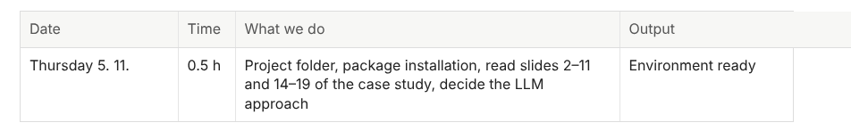
Done 5.11.2026
- Folder created here: C:\SKOLA\IMC Krems an der Donau\1. Semester\Software Engineering for AI - SEA1VO\SL\Speed Limit project mb
- Installation of the packages for VS Code done
- Read the slides – read
- LLM approach: simulation (mock), because this is only a school project; I do not want to pay for the API.

Done 6.11.2026 morning
1. Yes, I looked at the summary results from Claude. Claude did the mathematical and statistical calculations and pointed out differences and anomalies.

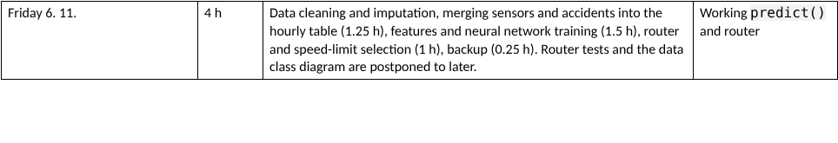
Partially done 6.11.2026
- Data cleaning and imputation + merging sensors and accidents into the hourly table – ok
- Neural network training is done
- Router – I familiarised myself with it. These are rules (guardrails) applied before the AI gets to decide.
- Backup created on my GitHub.

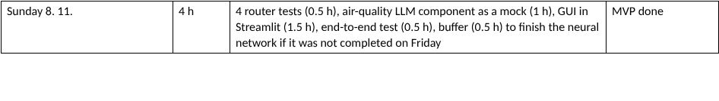

I talked with Claude and with a real person, and it would probably be advisable to make one more, longer version of the presentation, so that the teacher can look through it on their own, with everything explained without my narration.
Proposed structure (approximately 35 slides):
Part | Slides
Introduction: title slide, “how to read this presentation”, project summary | 3
Requirements: stakeholders, system requirements and specifications, non-functional requirements, glossary, assumptions, EU AI Act | 7
Data: class diagram, data errors and fixes, data cleaning | 4
Neural network: features, training, results and an honest conclusion | 4
Router and speed-limit selection, including tests | 2
LLM component: design, mock, tests | 3
Architecture: components, sequence diagram, component tests, change requests, human-in-the-loop | 7
MVP and GUI (screenshots), year N+1, lessons learned | 4
Appendix: prompts and comparison of results with and without AI | 1 to 3

Project summary – status as of Saturday 7 Nov 2026
Course Software Engineering for AI (IMC Krems), project “Speed Limit”. The system chooses a speed limit (40–80 km/h) from road and weather conditions: a router with fixed rules (Software 1.0), a neural network (Software 2.0), an LLM component for air quality (Software 3.0, mocked) and a Streamlit GUI.

What has been done so far
- Setup (5 Nov). Project folder, packages installed, lecture slides and case study read, decision to use a mock LLM instead of a paid API.
- Data exploration (script 01). Redundant sensors (3× water, 3× light, 3× temperature), sensor 19 undocumented, years N and N+1 have identical sensor readings (only the accidents differ), accident hour is 1–24 but readings are 0–23, one empty accident record.
- Cleaning and hourly table (script 02). Redundant sensors averaged, gaps filled by linear interpolation, limit rounded to 40–80, empty accident record removed, near-accidents (SPEC4) counted per hour. Result: 744 rows per year.
- Neural network (script 03). MLPRegressor (16, 8) with StandardScaler predicts near-accidents per hour; 75/25 split, compared with the “always predict the mean” baseline. Honest finding: the counts behave like random noise (mean 1.296, variance 1.293) and the network is not better than the baseline – this goes into the presentation as a result and a lessons-learned point.
- Router and limit choice (speedlimit_core.py). Dark if light < 500, ice risk if water > 1000 µm and temperature < 0 °C, otherwise default 80 km/h (REQ3). Otherwise the network is asked for 80, 70, … 40 and the highest limit with a prediction ≤ 1 is taken (REQ1); fallback 40 km/h, negative predictions clipped to 0.
- Router tests prepared (test_router.py). 4 test groups (equivalence classes and boundary values) plus 14 deliberately broken versions of the router (mutants); all mutants are detected. To be run on Sunday.
- Scripts in English. All scripts and their text reports are in English so they can be submitted.
- Presentations. 13-slide deck and a 35-slide self-explanatory deck (main path, car animation, background #EFE8D8); the slides that depend on my own results are still to be filled in.
- Study material and plan. 19-page digest of the nine lectures, and this roadmap with checklist and timetable.
- Backup. Project saved to my own GitHub account.

Which script is for what
File | Kind | What it does | Reads → writes / when to use
01_explore_data.py | Run (optional) | Read-only first look at the data: sizes, sensors and types, ranges, accidents, year N vs N+1. | CSV → explore_report.txt. Once at the start, or when the data changes.
02_prepare_data.py | Run (step 1) | Cleaning, averaging of redundant sensors, imputation, join with accidents, hourly table. | CSV → hourly_dataset_N.csv, hourly_dataset_Nplus1.csv, cleaning_log.txt. Run first.
03_train_model.py | Run (step 2) | Features, train/test split, trains the neural network, evaluates against the baseline, shows demo decisions. | hourly_dataset_*.csv → speedlimit_model.joblib, training_report.txt. Run after 02.
speedlimit_core.py | Library – never run directly | Shared logic: specification constants, make_features(), router (is_dark, is_ice_risk, router_uses_nn), choose_limit(), final_speed_limit(). | Imported by 03, test_router.py and later the GUI. Change it only when the rules change.
test_router.py | Run (tests) | Router tests T1–T4 and a mutation check of the tests themselves. | Needs only speedlimit_core.py. Run on Sunday and after every change to the router.
LLM mock, GUI | Not written yet | Air-quality LLM component (mock) and Streamlit GUI that calls final_speed_limit(). | Planned for Sunday 8 Nov.
Recommended order: python 02_prepare_data.py → python 03_train_model.py → python test_router.py. Script 01 is optional. All scripts take the folder with the CSV files as an optional argument (by default the folder they are in).

Decisions worth remembering
- Target of the network = near-accidents per hour; the limit is derived from its predictions, not predicted directly.
- Assumptions: sensor 19 = temperature, sensor 16 = traffic, accident hour minus 1 to match the readings, lux and millilux give the same 354 dark hours.
- The router (rules) runs before the network, so the safety-critical cases never depend on a model that cannot be explained.

Still to do
Sunday 8 Nov: run router tests, build the LLM mock (+5 tests), Streamlit GUI, end-to-end test. Then: stakeholders, non-functional requirements, glossary, assumptions, EU AI Act, data class diagram, year N+1 analysis, architecture, sequence diagram, component tests, change requests, human-in-the-loop, final deck with lessons learned. Open question for the lecturer: submission format and the slide limit.
Sharing note: keep the GitHub repository private and invite only the classmate; do not upload the case-study documents or lecture PDFs.

