# heading 1

## heading 2

This is the text of the first page.

'definately' is a wrong ...

'definitely' is correct ...

'defintly' is also wrong ...

This is the text of the second page.

2026-03-18: graduation ceremony

2027-03-18: Entrance Ceremony

The day of the week is not confirmed .

This is an example of a long sentence. This is an example of a long sentence. This is an example of a long sentence. This is an example of a long sentence. This is an example of a long sentence.



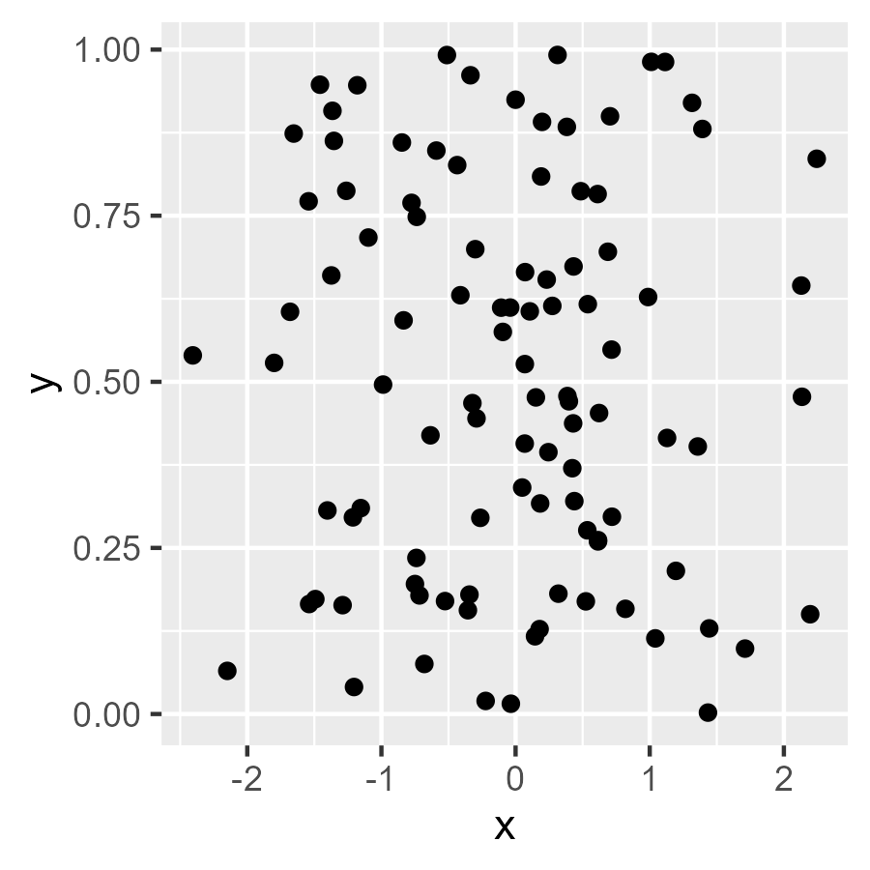

| manufacturer | model | displ | year | cyl | trans |
| --- | --- | --- | --- | --- | --- |
| audi | a4 | 1.8 | 1999 | 4 | auto(l5) |
| audi | a4 | 1.8 | 1999 | 4 | manual(m5) |
| audi | a4 | 2.0 | 2008 | 4 | manual(m6) |
| audi | a4 | 2.0 | 2008 | 4 | auto(av) |
| audi | a4 | 2.8 | 1999 | 6 | auto(l5) |
| audi | a4 | 2.8 | 1999 | 6 | manual(m5) |

This is an uncommented section.This is the text of the section to which the comment was added.