Introduction to Communism
Matvei Ivanov and Kris Karlov
Written in 2018

Chapter 1 — What is communism?
Communism is a system where the means of production are owned by the community. The means of production are the tools that are needed to produce something. For example, machines in a factory are means of production.
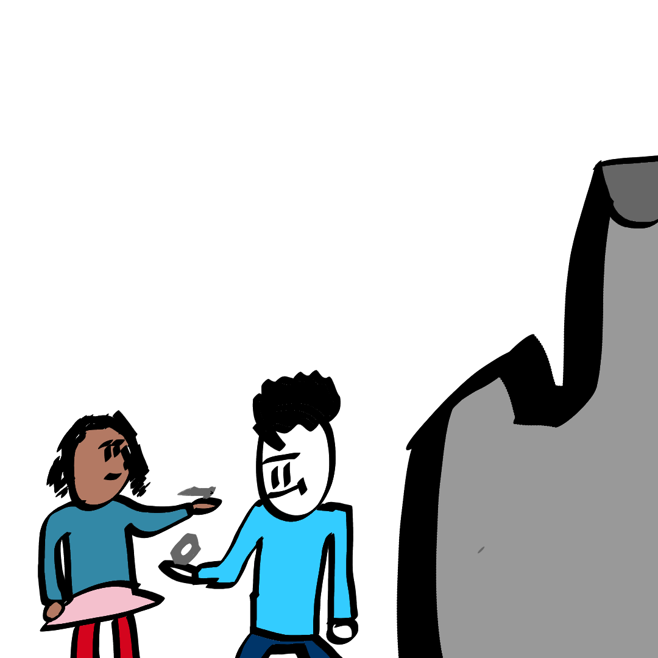Illustration 1: Under communism, the workers decide how much of what to produce
It is different from the system most of the world has now. That system is called capitalism. It lets certain people or groups own the means of production while all other people work for them.
Because the owners of the means of production under capitalism, who are also called the bourgeoisie, want to continue owning them, they often spread lies about what communism is and what happens happens while we get to it.
Often, they say that communism is when everyone owns everything. This is wrong. Only the means of production are owned by the community. The things that aren't used to produce something, also called personal property, can still be owned by a single person. Someone can still own a watch or a bicycle under communism. But the factories that produce watches or bicycles are owned by the community.
Sometimes they also call anything the state does communism. This is also wrong. Actually, there is no state under communism. It just isn't necessary. There are no reasons to fight about the means of production because they're already owned by everyone. And if someone wants to get them for themselves or starts a fight about personal property, the community will resist them.
Very often they say that communism is impossible, that humans will naturally try to get the most for themselves and only themselves. But they're wrong. Early humans didn't have a single group owning the means of production. It was better for them to help their community, because they couldn't live without it: the community defended each other against the many dangers that were there.
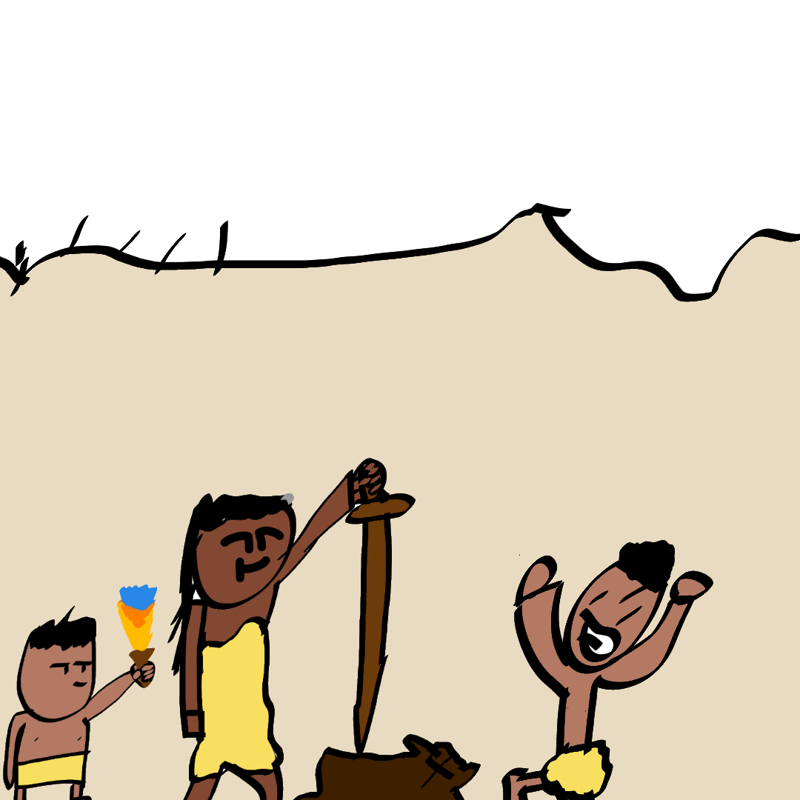Illustration 2: A group of early humans fighting a lion. Each of them couldn't do that alone, but in a strong community, they can.
Some say that the times have changed, the system became more complicated, and communism can't exist now. It's true that it's not possible to immediately make a society communist now. This is why there is a step towards it called socialism. Socialism is possible, and it exists right now in a few countries.

Chapter 2 — Why do we need communism?
You see, the workers do almost all the work and the bourgeoisie do barely any. Even though the bourgeoisie does a small amount of work they get much much higher wages than the workers. We need to abolish (remove) this flaw. The best route is through Socialism and Communism.
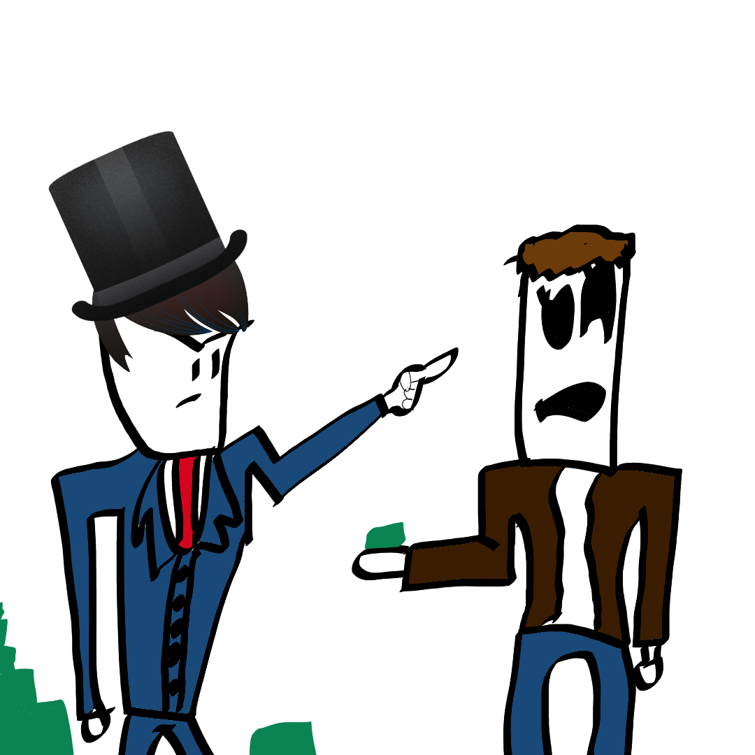Illustration 3: A bourgeois telling a worker where and how to work, while getting most of the money
As we stated before, in communism the workers own the factories. Another great benefit of communism is the removal of money. This might sound silly; But you see, without money, there are no taxes and big projects (for example a new road) don't need money which means it can be done well and fast.
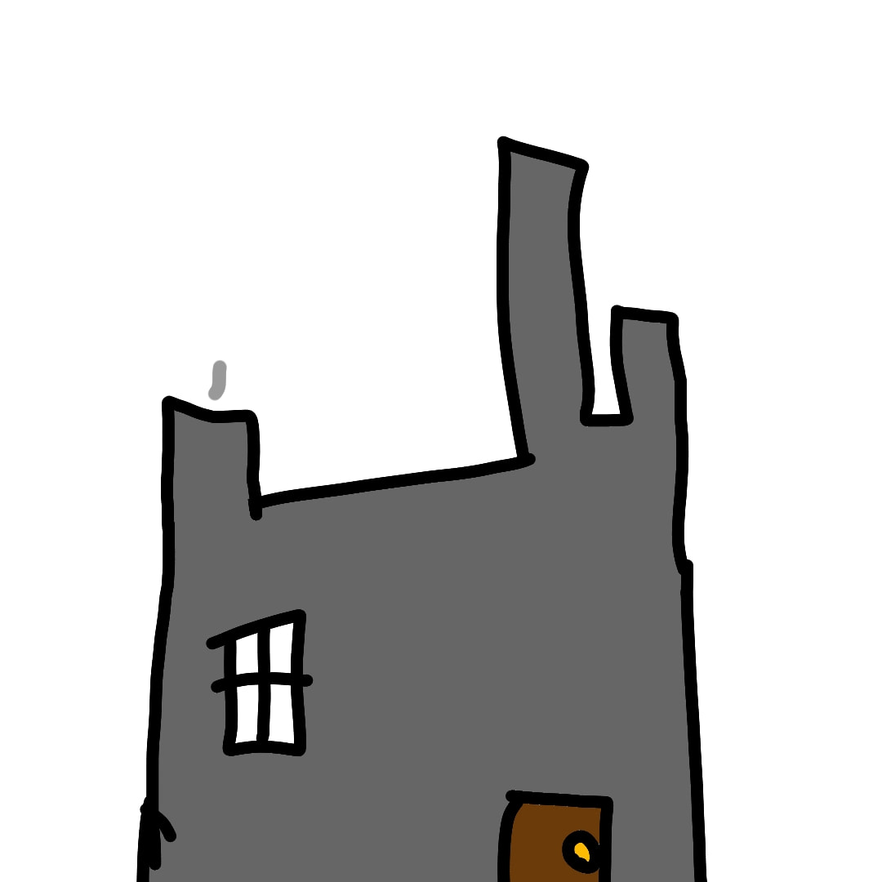Illustration 4: A factory, which is owned by the workers under communism and by the bourgeoisie under capitalism
Under Communism, there is also no government. This is good because then the people must choose decisions.
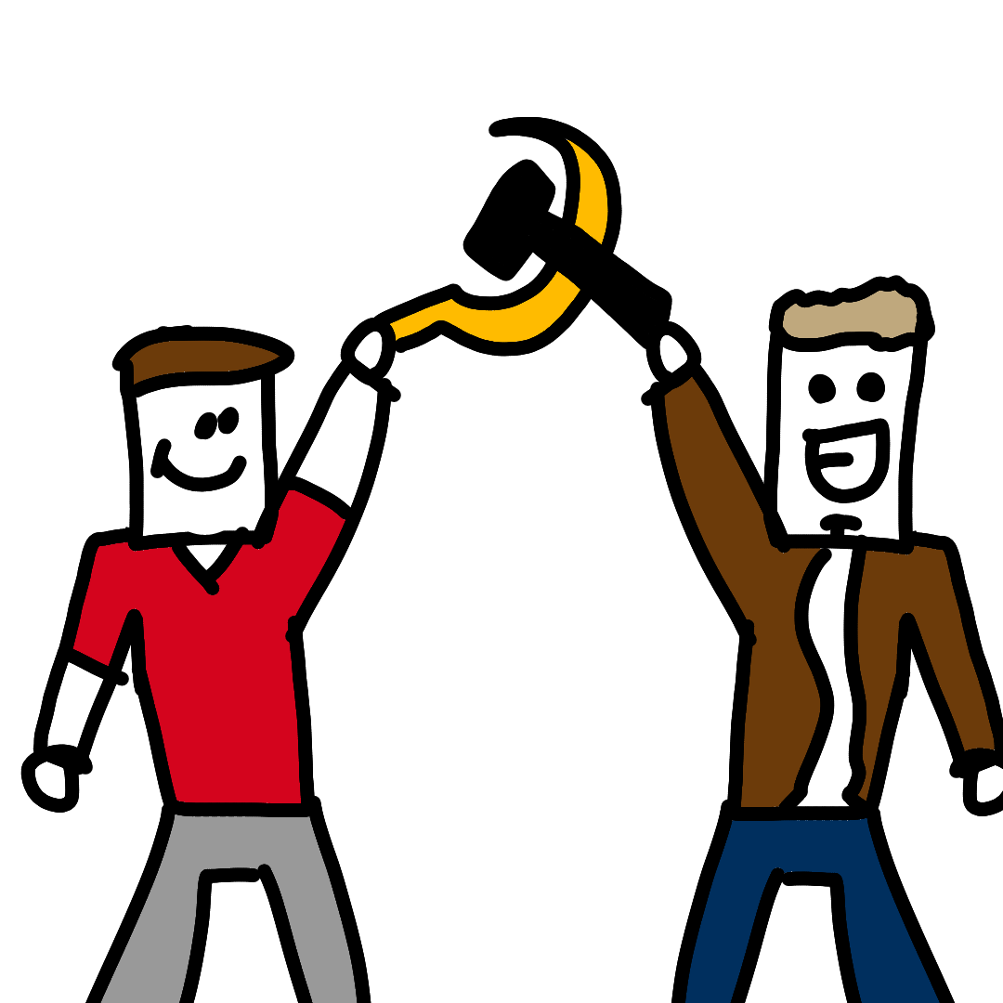Illustration 5: Under communism, the people themselves decide. So the decisions actually make the people happy, not some small group richer.

Before Communism there should be Socialism. Socialism has a planned economy which means that random spikes in costs do not happen. Socialism does have money in its early stages; But after it has labour vouchers.
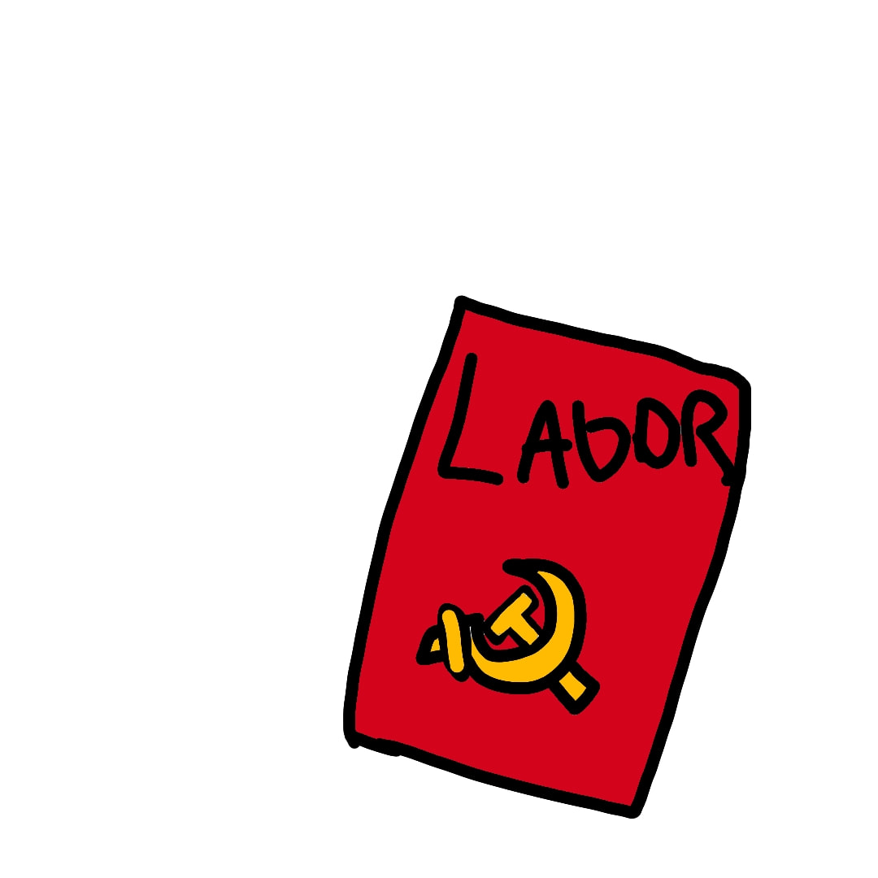Illustration 6: A labour voucher.
Labour vouchers are money that disappears after it is spent. This is so that people cannot make things extremely expensive and get huge profits. We might discuss this more in a later paper.

Chapter 3 — How do we get to communism?
The best route to communism is (sadly) violent.
The party usually stages a revolution that stops the current capitalist government and replaces it with a socialist one. Socialism is the step before communism.
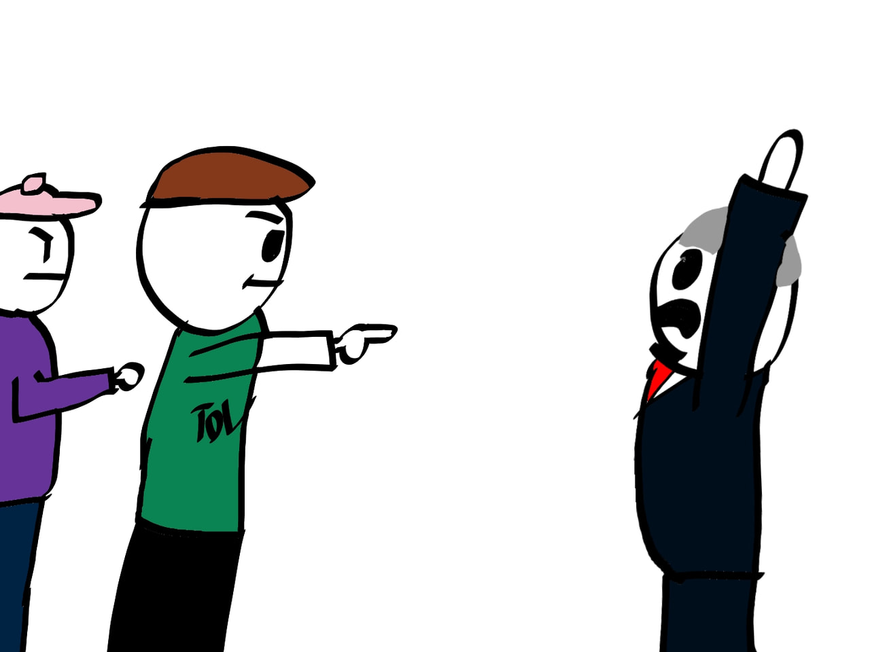Illustration 7: Two revolutionaries attacking a capitalist
Under socialism, the people and the government do communist reforms that make the country get closer to communism. In socialism, the government slowly fades away into communism. Socialism still has a government.
But the socialist government is different from a capitalist one. It doesn't allow a single person to own means of production. So the government gets the money that the owners of the means of production get under capitalism. It then uses that money for projects like a new road and for paying those who can't work, for example old people. Such a government doesn't need taxes anymore. That's why many socialist countries, for example Albania and the DPR Korea, abolished taxes.

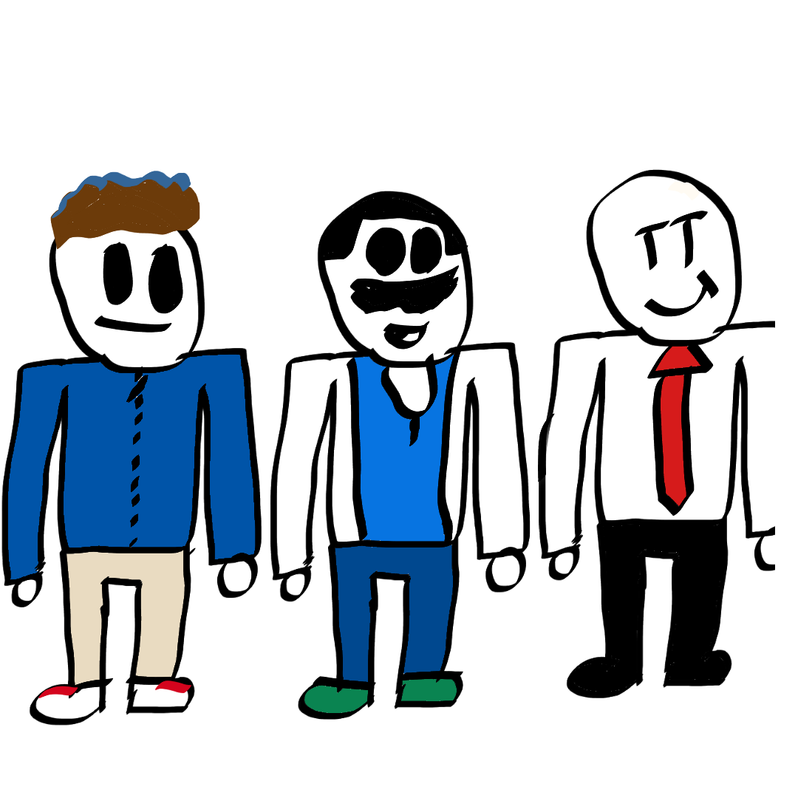Illustration 8: Three workers, who live better under socialism than under capitalism

The reason we need socialism and we can't skip straight to communism? It is because opposing forces (capitalists) can easily stop the land. Going straight to communism (anarchy) has been successfully done once before without falling in Africa. It survives because no one wants it to fall.
For communism to start you need world socialism.

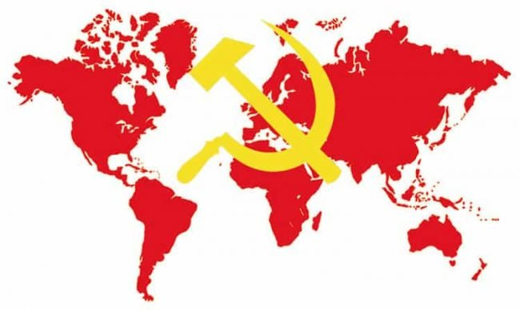Illustration 9: A communist world
Once the socialist government is no longer needed and falls, full communism starts.
That's how we get into communism!

Chapter 4 — Notable communists and their tendencies
All over the world there were and are communists. Because there are differences between various countries, communism and socialism can't be the same everywhere. Also, communists think differently on what is most important for building communism. This is why there are various tendencies. This chapter will be about the most important tendencies and their supporters.

Marxism — Karl Marx and Friedrich Engels
Karl Marx and Friedrich Engels lived in the 19th century, when capitalism just started developing. They looked at how capitalism worked and saw the many problems it brings. So they proposed another system, communism.
Although communism existed long before Marx and Engels, they were the first who wrote about what exactly communism is and how it will happen. While they did not fight for communism themselves, they helped organize the parties that did and criticized the ones that did it wrong.
Most communists' ideas rely on Marx's and Engels's theories, also called Marxism. This is why those who want us to believe that communism is wrong often tell us that Marx and Engels are wrong.

Marxism-Leninism — Wladimir Lenin and Josif Stalin
Wladimir Lenin led the first successful communist revolution in 1917, which resulted in a socialist Soviet Union. Because the capitalist world didn't want Soviet socialism, they invaded it and tried to stop it. But the Soviet communists successfully resisted that invasion and started building socialism.
Lenin wrote a lot about what exactly must happen during and after the revolution. But he also looked at capitalism. While Marx saw only the initial stage of capitalism and could only predict what would happen later, Lenin saw how it developed and that Marx was right with these predictions.
He called the new stage of capitalism imperialism. Under imperialism, not only the means of production are in the hands of a few people, but also most of the money is in a few countries. These countries build roads, buildings and other useful things everywhere else, but only to get ressources for themselves, not to help anyone living there.
Because it also gets money and ressources from the rest of the world, not only its own country, the bourgeoisie of these few countries can let some workers live well. This often makes these workers ignore the problems caused by capitalism because they're not affected much by them. The bourgeoisie then tells us that anyone can be like these workers, making revolution even more difficult.
Josif Stalin didn't have many new ideas. But he led Soviet socialism to success using the Marxist-Leninist theories.
Stalin's government is often criticized for being too violent. But violence was needed to resist the constant attacks on the Soviet Union from outside. Because when its capitalist enemies could no longer directly invade it, they tried destroying the Soviet Union from inside. And there were enemies of communism in the Soviet Union itself, too.
With Stalin leading the Soviet Union, it also won a war against the German fascists, which were invading most of Europe. Although the USA and the UK helped the Soviet Union later in that war, it achieved an important victory in 1942 without help from outside. This victory stopped the German invasion and let the Soviets invade Germany instead.

Marxism-Leninism-Maoism — Mao Tse-tung
Mao Tse-tung was the leader of the Chinese communists, which had to fight against the Japanese invaders and against Chinese anti-communists. They could not use the same tactics as the Soviet communists. So they fought a protracted people's war.
They spent a very long time fighting, but in the end, the Chinese communists won.
Following tactics are used in a protracted people's war:
- Attack weak and isolated enemy forces first
- Encircle the enemy with a much stronger force
- Try to defeat the enemy when he is on the move
- Fight many battles in a short time without rest
- Use the ressources taken from the enemy
Maoism has another important idea: the mass line. It means that the correct ideas come from the masses of the people and that the party's task to collect these ideas and to use them.
The Chinese communists were not the only ones following Maoism. For example, the communists on the Phillipines and in India are currently fighting with Maoist tactics.

Hoxhaism — Enver Hoxha
Enver Hoxha and the Albanian communists fought against the occupation by the Italian and German fascists. They were successful and Hoxha became leader of socialist Albania.
Hoxha closely followed the example of the Soviet Union while it was led by Stalin. But after Stalin died and Khrushev, who became leader of the Soviet Union, said that the accusations against Stalin were true, Hoxha distanced himself from that country and called it revisionist.
He also accused the Maoists of being revisionists and cooperating with the west. Albania itself didn't cooperate with the west. Shortly after Albania became independent, the UK actually attacked it.

Juche — Kim Il Sung
Kim Il Sung led the communist guerillas fighting against the Japanese occupation of Korea (from 1910 to 1945). After Korea became independent, he wanted to build socialism in Korea. But the USA occupied South Korea. So North Korea, which also calls itself the Democratic People's Republic of Korea, invaded the south because they didn't want the USA to occupy any part of their country. But that invasion wasn't successful and caused a lot of destruction on both sides.
They had to rebuild most of their infrastructure because it was destroyed in the war. And they did it. For some time, their conditions were quite good.
But then, a series of economic problems and natural disasters happened. The East Bloc returned to capitalism and fell, so they lost most of their trading partners. The natural disasters destroyed their fields, so they could not grow any food. The west refused to trade with them. So there was a famine. The west then blamed it on the government of the DPR Korea.
But instead of falling or abandoning socialism, the DPR Korea tried become a self-reliant country and was mostly successful. Now, the conditions have become much better. But there are still problems with the things that they can't produce themselves.
Because of these events, independence is very important in Juche, their tendency. They don't want anyone telling their country what to do. But the western imperialists want to also control their country. This is why the west still refuses to let anyone trade with the DPR Korea and sometimes even tries to destroy it from the inside or threatens to invade it.

Trotskyism — Leon Trotsky
Leon Trotsky fought in the revolution of 1917, but was against what happened after it. He thought that it was impossible to make the Soviet Union socialist by itself and demanded an alliance with the capitalist countries surrounding it.
He often opposed the decisions of the Soviet communist party and tried to get a part of the party over to his side. So he was expelled from the Soviet Union. Then, he lied to the capitalist media about the Soviet Union and Stalin's leadership to make them look bad.

Sources and further reading
Chapter 1, 2 and 3:
- Marx, Engels, Lenin
Chapter 4:
- Mao:
  - Quotations from Chairman Mao Tse-tung
- Hoxha:
  - Eurocommunism is Anti-communism
  - With Stalin: Memoirs from my meetings with Stalin

