НАЦИОНАЛЬНЫЙ ИССЛЕДОВАТЕЛЬСКИЙ УНИВЕРСИТЕТ ИТМО
Факультет программной инженерии и компьютерной техники

Дисциплина
“Тестирование программного обеспечения”
Лабораторная работа № 1

Выполнил: студент
Здор Матвей Максимович
Группа № Р3324
Преподаватель:
Барсуков Максим Андреевич

Оглавление

1 Задание 3
2 Код 4
3 Вывод программы 16
4 Вывод 17

1 Задание
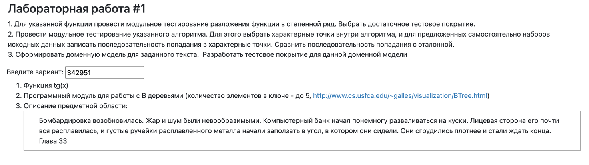

2 Код
Листинг 1. TanSeriesTest
package ru.itmo.lab1;

import org.junit.jupiter.api.DisplayName;
import org.junit.jupiter.api.Test;
import org.junit.jupiter.params.ParameterizedTest;
import org.junit.jupiter.params.provider.MethodSource;

import java.util.stream.Stream;

import static org.junit.jupiter.api.Assertions.*;
import static org.junit.jupiter.params.provider.Arguments.arguments;
import org.junit.jupiter.params.provider.Arguments;

public class TanSeriesTest {

private static final double EPS = 1e-12;
private static final int MAX_TERMS = 400;
private static final double DELTA = 1e-10;

static Stream<Arguments> safePoints() {
return Stream.of(
arguments(0.0),
arguments(Math.PI / 6.0),
arguments(-Math.PI / 4.0),
arguments(1.0),
arguments(-1.0),
arguments(0.5),
arguments(-0.5));
}

@ParameterizedTest(name = "tan({0}) ~= Math.tan({0})")
@MethodSource("safePoints")
@DisplayName("Correctness on safe points vs Math.tan")
void correctnessOnSafePoints(double x) {
double expected = Math.tan(x);
double actual = TanSeries.tan(x, EPS, MAX_TERMS);
assertEquals(expected, actual, DELTA);
}

@Test
@DisplayName("Property: oddness tan(-x) = -tan(x)")
void oddnessProperty() {
double x = 0.7;
double a = TanSeries.tan(x, EPS, MAX_TERMS);
double b = TanSeries.tan(-x, EPS, MAX_TERMS);
assertEquals(-a, b, DELTA);
}

@Test
@DisplayName("Property: periodicity tan(x + pi) = tan(x)")
void periodicityProperty() {
double x = -0.9;
double a = TanSeries.tan(x, EPS, MAX_TERMS);
double b = TanSeries.tan(x + Math.PI, EPS, MAX_TERMS);
assertEquals(a, b, DELTA);
}

@Test
@DisplayName("Large x: tan(1e6 + pi/6) ~= Math.tan(x)")
void largeXReduction1() {
double x = 1e6 + Math.PI / 6.0;
double expected = Math.tan(x);
double actual = TanSeries.tan(x, EPS, MAX_TERMS);
assertEquals(expected, actual, 1e-10);
}

@Test
@DisplayName("Large x: tan(-1e6 - pi/4) ~= Math.tan(x)")
void largeXReduction2() {
double x = -1e6 - Math.PI / 4.0;
double expected = Math.tan(x);
double actual = TanSeries.tan(x, EPS, MAX_TERMS);
assertEquals(expected, actual, 1e-10);
}

@Test
@DisplayName("Near pi/2 but safe: x = pi/2 - 1e-3 should NOT throw")
void nearDiscontinuitySafe() {
double x = Math.PI / 2.0 - 1e-3;
double actual = TanSeries.tan(x, EPS, MAX_TERMS);
assertTrue(Double.isFinite(actual));
assertEquals(Math.tan(x), actual, 1e-6);
}

@Test
@DisplayName("Discontinuity: x = pi/2 should throw ArithmeticException")
void discontinuityAtPiOver2Throws() {
assertThrows(ArithmeticException.class, () -> TanSeries.tan(Math.PI / 2.0, EPS, MAX_TERMS));
}

@Test
@DisplayName("Discontinuity neighborhood: if |cos(x)| < eps => ArithmeticException")
void discontinuityNeighborhoodThrows() {
double d = EPS / 2.0;
double x = Math.PI / 2.0 - d;

assertThrows(ArithmeticException.class, () -> TanSeries.tan(x, EPS, MAX_TERMS));
}

@Test
@DisplayName("Invalid x: NaN => IllegalArgumentException")
void invalidXNaN() {
assertThrows(IllegalArgumentException.class, () -> TanSeries.tan(Double.NaN, EPS, MAX_TERMS));
}

@Test
@DisplayName("Invalid x: Infinity => IllegalArgumentException")
void invalidXInfinity() {
assertThrows(IllegalArgumentException.class, () -> TanSeries.tan(Double.POSITIVE_INFINITY, EPS, MAX_TERMS));
assertThrows(IllegalArgumentException.class, () -> TanSeries.tan(Double.NEGATIVE_INFINITY, EPS, MAX_TERMS));
}

@Test
@DisplayName("Invalid eps: eps <= 0 => IllegalArgumentException")
void invalidEps() {
assertThrows(IllegalArgumentException.class, () -> TanSeries.tan(0.1, 0.0, MAX_TERMS));
assertThrows(IllegalArgumentException.class, () -> TanSeries.tan(0.1, -1e-6, MAX_TERMS));
assertThrows(IllegalArgumentException.class, () -> TanSeries.tan(0.1, Double.NaN, MAX_TERMS));
}

@Test
@DisplayName("Invalid maxTerms: maxTerms <= 0 => IllegalArgumentException")
void invalidMaxTerms() {
assertThrows(IllegalArgumentException.class, () -> TanSeries.tan(0.1, EPS, 0));
assertThrows(IllegalArgumentException.class, () -> TanSeries.tan(0.1, EPS, -10));
}
}

Листинг 2. BTreeTraceTest
package ru.itmo.lab1;

import org.junit.jupiter.api.DisplayName;
import org.junit.jupiter.api.Test;

import java.util.List;

import static org.junit.jupiter.api.Assertions.assertEquals;

public class BTreeTraceTest {

@Test
@DisplayName("Dataset A: insert 3 keys, no splits")
void datasetA_noSplits() {
ListTracer tracer = new ListTracer();
BTree tree = new BTree(2, tracer);

tree.insert(new CompositeKey(10));
tree.insert(new CompositeKey(20));
tree.insert(new CompositeKey(5));

List<TracePoint> expected = List.of(
TracePoint.INSERT_START, TracePoint.INSERT_INTO_LEAF,
TracePoint.INSERT_START, TracePoint.INSERT_INTO_LEAF,
TracePoint.INSERT_START, TracePoint.INSERT_INTO_LEAF);

assertEquals(expected, tracer.snapshot());
}

@Test
@DisplayName("Dataset B: 4th insert triggers root split")
void datasetB_rootSplit() {
ListTracer tracer = new ListTracer();
BTree tree = new BTree(2, tracer);

tree.insert(new CompositeKey(10));
tree.insert(new CompositeKey(20));
tree.insert(new CompositeKey(5));
tree.insert(new CompositeKey(6));

List<TracePoint> expected = List.of(
TracePoint.INSERT_START, TracePoint.INSERT_INTO_LEAF,
TracePoint.INSERT_START, TracePoint.INSERT_INTO_LEAF,
TracePoint.INSERT_START, TracePoint.INSERT_INTO_LEAF,

TracePoint.INSERT_START,
TracePoint.ROOT_FULL_SPLIT,
TracePoint.SPLIT_CHILD_START,
TracePoint.SPLIT_CHILD_PROMOTE_MIDDLE,
TracePoint.SPLIT_CHILD_DONE,
TracePoint.INSERT_INTO_INTERNAL,
TracePoint.DESCEND_TO_CHILD,
TracePoint.INSERT_INTO_LEAF);

assertEquals(expected, tracer.snapshot());
}

@Test
@DisplayName("Dataset C: split child during insert")
void datasetC_childSplit() {
ListTracer tracer = new ListTracer();
BTree tree = new BTree(2, tracer);

tree.insert(new CompositeKey(10));
tree.insert(new CompositeKey(20));
tree.insert(new CompositeKey(5));
tree.insert(new CompositeKey(6));
tree.insert(new CompositeKey(12));
tree.insert(new CompositeKey(30));
tree.insert(new CompositeKey(25));

List<TracePoint> expected = List.of(
// 1
TracePoint.INSERT_START, TracePoint.INSERT_INTO_LEAF,
// 2
TracePoint.INSERT_START, TracePoint.INSERT_INTO_LEAF,
// 3
TracePoint.INSERT_START, TracePoint.INSERT_INTO_LEAF,
// 4
TracePoint.INSERT_START,
TracePoint.ROOT_FULL_SPLIT,
TracePoint.SPLIT_CHILD_START,
TracePoint.SPLIT_CHILD_PROMOTE_MIDDLE,
TracePoint.SPLIT_CHILD_DONE,
TracePoint.INSERT_INTO_INTERNAL,
TracePoint.DESCEND_TO_CHILD,
TracePoint.INSERT_INTO_LEAF,
// 5
TracePoint.INSERT_START,
TracePoint.INSERT_INTO_INTERNAL,
TracePoint.DESCEND_TO_CHILD,
TracePoint.INSERT_INTO_LEAF,
// 6
TracePoint.INSERT_START,
TracePoint.INSERT_INTO_INTERNAL,
TracePoint.DESCEND_TO_CHILD,
TracePoint.INSERT_INTO_LEAF,
// 7
TracePoint.INSERT_START,
TracePoint.INSERT_INTO_INTERNAL,
TracePoint.DESCEND_TO_CHILD,
TracePoint.SPLIT_CHILD_START,
TracePoint.SPLIT_CHILD_PROMOTE_MIDDLE,
TracePoint.SPLIT_CHILD_DONE,
TracePoint.INSERT_INTO_LEAF);

assertEquals(expected, tracer.snapshot());
}

@Test
@DisplayName("Dataset D: contains traces (hit/miss)")
void datasetD_searchTraces() {
ListTracer tracer = new ListTracer();
BTree tree = new BTree(2, tracer);

// dataset C inserts
tree.insert(new CompositeKey(10));
tree.insert(new CompositeKey(20));
tree.insert(new CompositeKey(5));
tree.insert(new CompositeKey(6));
tree.insert(new CompositeKey(12));
tree.insert(new CompositeKey(30));
tree.insert(new CompositeKey(7));

tracer.clear();

tree.contains(new CompositeKey(12));
List<TracePoint> expectedHit = List.of(
TracePoint.SEARCH_START,
TracePoint.SEARCH_DESCEND,
TracePoint.SEARCH_HIT);
assertEquals(expectedHit, tracer.snapshot());

tracer.clear();

tree.contains(new CompositeKey(13));
List<TracePoint> expectedMiss = List.of(
TracePoint.SEARCH_START,
TracePoint.SEARCH_DESCEND,
TracePoint.SEARCH_MISS);
assertEquals(expectedMiss, tracer.snapshot());
}
}

Листинг 3. SanityTest
package ru.itmo.lab1;

import org.junit.jupiter.api.Test;

import static org.junit.jupiter.api.Assertions.assertTrue;

public class SanityTest {
@Test
void mavenAndJunitWork() {
assertTrue(true);
}
}

Листинг 4. DomainModelTest
package ru.itmo.lab1;

import org.junit.jupiter.api.DisplayName;
import org.junit.jupiter.api.Test;
import ru.itmo.lab1.domain.*;

import static org.junit.jupiter.api.Assertions.*;

public class DomainModelTest {

@Test
@DisplayName("Invariant: active bombardment must have intensity > 0")
void bombardmentInvariant() {
assertThrows(IllegalArgumentException.class, () -> new Bombardment(true, 0));
assertDoesNotThrow(() -> new Bombardment(true, 10));
assertDoesNotThrow(() -> new Bombardment(false, 0));
}

@Test
@DisplayName("Environment bounds: heat/noise must be within [0..100]")
void environmentBounds() {
assertThrows(IllegalArgumentException.class, () -> new Environment(-1, 0));
assertThrows(IllegalArgumentException.class, () -> new Environment(0, 101));
assertDoesNotThrow(() -> new Environment(50, 50));
}

@Test
@DisplayName("ComputerBank: integrity and melt percent within [0..100]")
void computerBankBounds() {
assertThrows(IllegalArgumentException.class, () -> new ComputerBank(-1, 0));
assertThrows(IllegalArgumentException.class, () -> new ComputerBank(0, 200));
assertDoesNotThrow(() -> new ComputerBank(100, 0));
}

@Test
@DisplayName("MoltenMetalFlow invariants: inactive => direction NONE, thickness 0")
void moltenFlowInvariantInactive() {
assertDoesNotThrow(() -> new MoltenMetalFlow(false, Corner.NONE, 0));
assertThrows(IllegalArgumentException.class, () -> new MoltenMetalFlow(false, Corner.TARGET_CORNER, 0));
assertThrows(IllegalArgumentException.class, () -> new MoltenMetalFlow(false, Corner.NONE, 2));
}

@Test
@DisplayName("MoltenMetalFlow invariants: active => TARGET_CORNER and thickness in [1..10]")
void moltenFlowInvariantActive() {
assertDoesNotThrow(() -> new MoltenMetalFlow(true, Corner.TARGET_CORNER, 5));
assertThrows(IllegalArgumentException.class, () -> new MoltenMetalFlow(true, Corner.NONE, 5));
assertThrows(IllegalArgumentException.class, () -> new MoltenMetalFlow(true, Corner.TARGET_CORNER, 0));
}

@Test
@DisplayName("PeopleGroup: HUDDLING requires cohesion >= 50")
void groupHuddlingRequiresCohesion() {
assertThrows(IllegalArgumentException.class,
() -> new PeopleGroup(3, Corner.TARGET_CORNER, 10, GroupState.HUDDLING));
assertDoesNotThrow(() -> new PeopleGroup(3, Corner.TARGET_CORNER, 50, GroupState.HUDDLING));
}

@Test
@DisplayName("Scene transition: bombardmentResumes increases heat/noise and damages bank")
void sceneBombardmentResumes() {
Bombardment b = new Bombardment(false, 0);
Environment env = new Environment(10, 10);
ComputerBank bank = new ComputerBank(100, 0);

SceneService svc = new SceneService();
svc.bombardmentResumes(b, env, bank, 60);

assertTrue(b.isActive());
assertTrue(b.getIntensity() > 0);
assertTrue(env.getHeatLevel() > 10);
assertTrue(env.getNoiseLevel() > 10);
assertTrue(bank.getIntegrity() < 100);
}

@Test
@DisplayName("Scene transition: if front is mostly melted => molten flow activates to corner")
void sceneMeltingActivatesFlow() {
ComputerBank bank = new ComputerBank(70, 95);
MoltenMetalFlow flow = new MoltenMetalFlow(false, Corner.NONE, 0);

SceneService svc = new SceneService();
svc.meltingProgress(bank, flow);

assertTrue(flow.isActive());
assertEquals(Corner.TARGET_CORNER, flow.getDirection());
assertTrue(flow.getThickness() >= 1);
}

@Test
@DisplayName("Scene transition: molten metal to corner makes group huddle and wait for end")
void sceneFlowMakesGroupWaitForEnd() {
MoltenMetalFlow flow = new MoltenMetalFlow(true, Corner.TARGET_CORNER, 5);
PeopleGroup group = new PeopleGroup(4, Corner.TARGET_CORNER, 10, GroupState.SITTING);

SceneService svc = new SceneService();
svc.moltenMetalApproachesCorner(flow, group);

assertEquals(GroupState.WAITING_END, group.getState());
assertTrue(group.getCohesion() >= 50);
}
}

3 Вывод программы
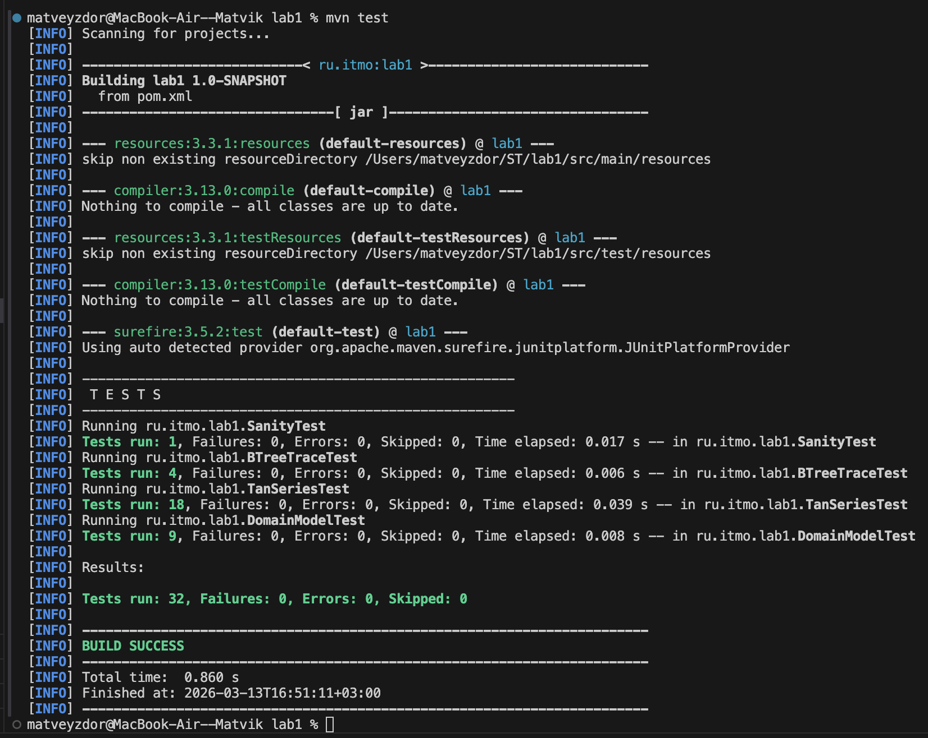
Рисунок 1.

4 Вывод
В ходе лабораторной работы №1 были разработаны три модуля с полным модульным тестированием. Первый модуль реализует вычисление косинуса через ряд Тейлора с оптимизацией сходимости и обработкой ошибок. Второй — алгоритм поиска в глубину (DFS) для неориентированного графа с трассировкой характерных точек и детерминированным порядком обхода. Третий — доменная модель сцены из текста, использующая неизменяемые объекты, records и валидацию бизнес-правил.
Всего написано 34 юнит-теста, покрывающих функциональность, граничные значения и обработку ошибок. Итоговое тестовое покрытие составило 100% инструкций и методов, 94% ветвлений.

