Auto Assign Customer Discount Group - concept

Intern Project

Date: 18.08.2022

Author: Mateusz Wysocki

Internship supervisor: Łukasz Jessa

Contents

Chapter 1 Story 1-3

Chapter 2 Solution Requirements 2-3

Chapter 3 Concept of modification 3-4

3.1. New and extended pages 3-4

3.1.1. Auto Assign Customer Disc. Group Setup 3-4

3.1.2. Sales & Receivables Setup 3-4

3.1.3. Customer Card 3-5

3.1.4. Auto Assign Customer Disc. Group History 3-6

3.2. New Actions 3-8

3.2.1. Auto Assign To Disc. Group 3-8

3.2.2. Auto Assign All Cust. Disc. Group Report 3-9

Chapter 4 Tests 4-10

# Story

Sales Company with high volume of customers (grouped into 10 segments) needs to simplify the process of managing the sales discounts. Currently salespersons are responsibly to assign proper discount based on the customer turnover from the last 3 months. Unfortunately that is time-consuming and error prone process. Therefore Sales Company would like to improve that process by making it fully automated under Business Central platform they currently use.

# Solution Requirements

* **It should be possible to define a list of the pairs: turnover level and applicable discount group. It should not be possible to delete customer discount group if used in such setup.**
* **Additionally It should be also possible to define the time period for which turnover should be taken into account when auto-applying proper customer discount group.**
* **Solution needs to be enabled to affects Business Central standard logic. By default, after installation, functionality should be disabled.**
* **User should be able to run feature auto-assign customer discount group for the specific customer.**
* **Alternatively should be possible to run auto-assign as a report for the filtered customers (or schedule as a background task).**
* **Auto-assigned customer discount group is valid only within defined period.**
* **User should be able to access all previously auto-assigned customer discounts groups for the specific customer.**
* **Information about who and when run last auto-assign discount group check should be easily access from the customer card.**
* **Auto-assign should be skipped for the customer with valid auto-assign customer discount group.**
* **Solution should auto-assign customer discount group for the newly created customers.**
* **It should not be possible to issue a sales document for the customer with not valid auto-assign customer discount group.**
* **It should not be possible to manually manipulate with customer discount group.**

# Concept of modification

## New and extended pages

### Auto Assign Customer Disc. Group Setup

New page will have two fields. ‘Customer Disc. Group Code’ field represents existing ‘Customer Disc. Group’. ‘Threshold Amount’ is used for set threshold that must be met for assign to group.

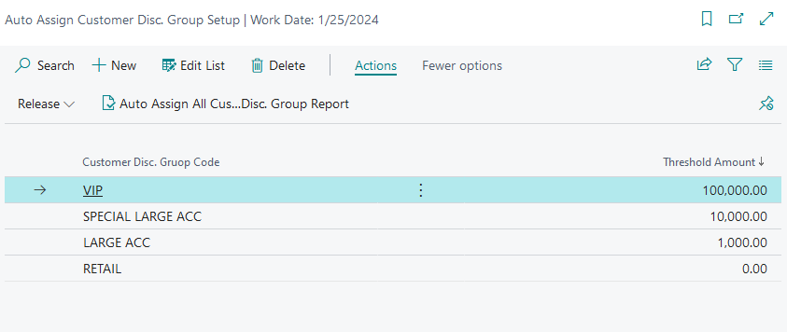

### Sales & Receivables Setup

Page will be extended by new fields and setup group. ‘Auto Assign Customer Discount Group’ will group all setup from new functionality. In this setup functionality can be enabled on or disabled by ‘Enable Functionality’ field.

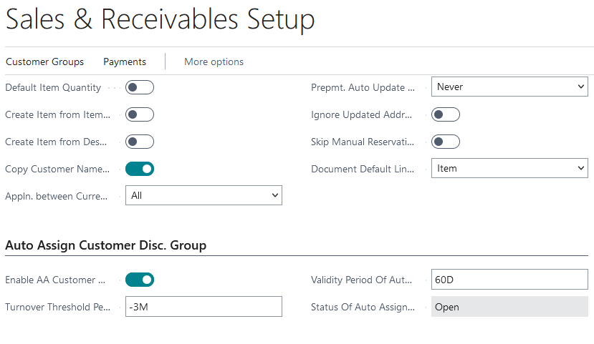

### Customer Card

Page will be extended by new fields. All new fields will be grouped into ‘Invoicing’ group.

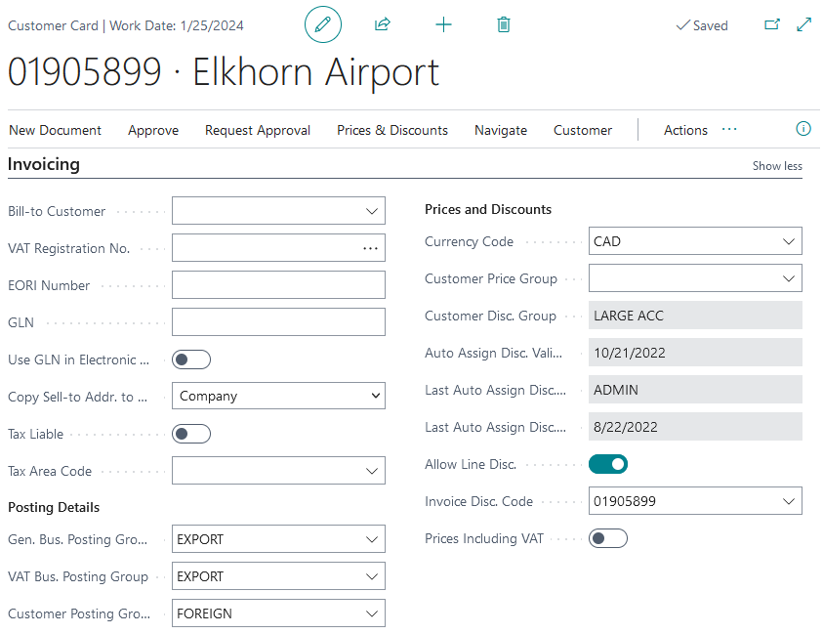

When functionality is enabled It is not possible to manually manipulate with customer discount group.

When functionality is disabled new fields are invisible and It is possible to manually manipulate with customer discount group.

### Auto Assign Customer Disc. Group History

New page will store information of every auto assignment.

When history page is opened by action in Customer Card page, history page will be filtred by ‘Customer No.’.

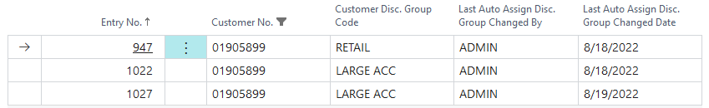

## New Actions

### Auto Assign To Disc. Group

New action in Customer Card will be added. Action will auto assign customer to Disc. Group by Balance from a certain point in time defined in Sales & Receivables Setup.

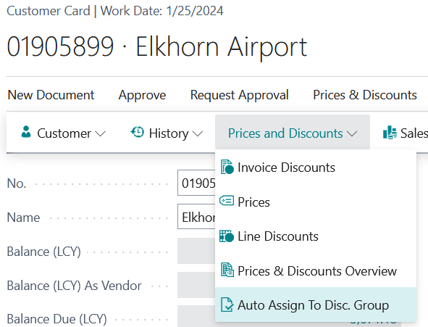

### Auto Assign All Cust. Disc. Group Report

New action in Auto Assign Customer To Disc. Group Setup will be added.

Action will show request page. Action enable to auto assign all customers to discount group.

# Tests

|  |  |  |  |
| --- | --- | --- | --- |
| **L.P.** | **Given** | **When** | **Then** |
| 1 | Value of Auto Assigned Cust. Disc. Group is true. | Value of Auto Assigned Cust. Disc. is changed for false. Option "No" is selected from Confirm window. | Value of Auto Assigned Cust. Disc. Group is true. |
| 2 | Value of Auto Assigned Cust. Disc. Group is true. | Value of Auto Assigned Cust. Disc. is changed for false. Option "Yes" is selected from Confirm window. | Value of Auto Assigned Cust. Disc. Group is false. |
| 3 | In IMW Req. Auto. Cust. Disc. Gr. table only one record has value 0 in required field. Status is "Open". | "Release" action is started in Requirements Auto Ass. Disc. Group page. | Status is changed for "Released". |
| 4 | In IMW Req. Auto. Cust. Disc. Gr. table all records have different value then 0 in required field. Status is "Open". | "Release" action is started in Requirements Auto Ass. Disc. Group page. | Status is not changed for "Released". Status still is "Open". |
| 5 | Customer has no discount group. Value of Auto Assigned Cust. Disc. Group is true. Status is "Released". | "Auto Assign To Disc. Group" action is started in Customer Card page. | Customer is allocated to discount group. |
| 6 | Customer has no discount group. Value of Auto Assigned Cust. Disc. Group is true. Status is "Released". | "Auto Assign To Disc. Group" action is started in Customer Card page. | New record is added to "Assign To Cust. Disc. Group History" |
| 7 | Value of Auto Assigned Cust. Disc. Group is true. Status is "Released". | "Auto Assign Customers To Disc. Group" action is started in Auto Ass. Disc. Group page. | New records are added to "Assign To Cust. Disc. Group History" |
| 8 | Customer has no discount group. Value of Auto Assigned Cust. Disc. Group is true. | Customer is added to Sales Order. | Error. Customer can't be added. |

|  |  |  |  |
| --- | --- | --- | --- |
| 9 | Customer has discount group. Value of Auto Assigned Cust. Disc. Group is true. Auto Assgined Disc. Expiration Date is expired. | Customer is added to Sales Order. | Error. Customer can't be added. |
| 10 | Value of Auto Assigned Cust. Disc. Group is true. Status is "Released". | New Customer is created. | Customer is allocated to discount group. |
| 11 | Value of Auto Assigned Cust. Disc. Group is true. Status is "Open". | New Customer is created. | Customer is not allocated to discount group. |
| 12 | One discount group has not requirement. | In Requirements Auto Ass. Disc. Group page new record is created. Code is salected. Threshold has the same value like other. | Error. Other Threshold has the same value. |