Writing Reports with R Markdown

matthewbrown

2022-10-21

This report was prepared for the UN. It analyzes the relationship between a country’s GDP, life expectancy, and CO2 emissions. Our goal was to determine to what degree a country’s economic strength or weakness may be related to its public health status and impact on climate pollution. We hypothesize that life expectancy and CO2 emissions will increase with a country’s GDP.

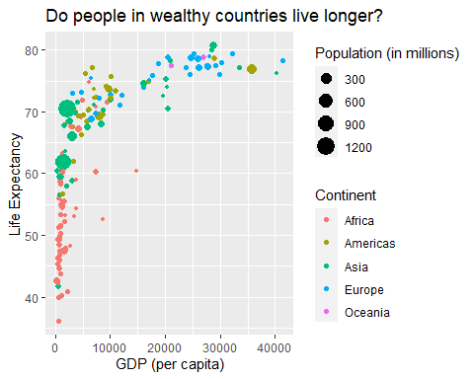

n_countries <- gapminder_1997 %>%  
 select(country) %>%  
 n_distinct()  
  
min_gdp <- gapminder_1997 %>%  
 summarize(min = round(min(gdpPercap)))  
  
max_gdp <- gapminder_1997 %>%  
 summarize(max = signif(max(gdpPercap), 1))

The above plot shows the relationship between GDP per capita and life expectancy for a total of 142 countries. For these countries economic wealth ranged from a minimum of $312 to a maximum of $4^{4} per capita

| Summary of Data |  |
| --- | --- |
| Number of countries | 142 |
| Minimum GDP per cap | 312 |
| Maximum GDP per cap | 4^{4} |

gapminder_1997 %>%  
 filter(continent == "Oceania") %>%  
 kable()

| country | pop | continent | lifeExp | gdpPercap |
| --- | --- | --- | --- | --- |
| Australia | 18565243 | Oceania | 78.83 | 26997.94 |
| New Zealand | 3676187 | Oceania | 77.55 | 21050.41 |

## lists

### unordered lists

* **Python**
  + I don’t know Python
* *filter*
* ***automating plot making***
* [Markdown Guide](https://www.markdownguide.org/basic-syntax/)

### ordered lists

1. **Python**
2. *filter*
3. ***automating plot making***
4. Markdown Guide (<https://www.markdownguide.org/basic-syntax/>)